St Francis Primary School Curriculum Information for Parents/Carers
Primary 2a and 2b
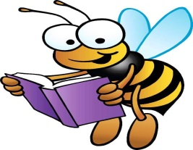  Literacy and English | In Term 3, Primary 2 will be continuing to recognise and write new sounds to help us spell new words. They will also read and say the sounds and listen for the word themselves. Children will be given more opportunities to participate in ‘Talk for Write’ writing activities. They will explore the genre of Fairytale writing and recall various classic fairytale stories. They will continue to use and create their own stories using story maps. They will explore reading with expression and answering literal and inferential comprehension questions about their class novel.
Numeracy and Maths  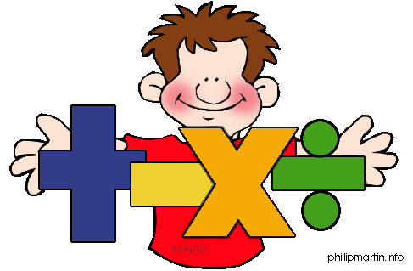 | This term the children will be focusing on rounding whole numbers to the nearest 10 and 100. They will also practise sharing equally into equal groups as well as learning multiplication facts. They will utilise multiplication strategies such as skip counting and repeated groups to help them remember the facts. P2 will also explore measurement. Children will measure the length, weight and volume of various items. They will learn to make sensible predictions and record their findings. They will also make comparisons between measurements.
  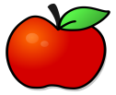  Health and Wellbeing /PE | In Health and Wellbeing this term, children will explore different emotions the PATHs programme. They will learn about the importance of asking someone for help and hot to solve problems such as a misunderstanding in the playground. In P.E. the children will focus on hockey and rebound games. Please remember that Primary 2 have gym on the following days:  Wednesday and Friday  Please ensure that your child has a yellow or white t-shirt, dark shorts and a pair of slip-on gym shoes (if possible) on these days. All jewellery should be removed.
  Religious Education | This term the children will have the opportunity to explore forgiveness and how to forgive others. Children will learn about the Holy Trinity as well as the symbols of Baptism. We will also explore celebrations from other faiths such as Eid.
Sciences  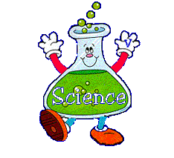 | This term we will explore senses and sound. Children will conduct experiments learning about the five senses. Children will learn to work as a team and take on various roles such as team leader, recorder and timekeeper. They will make predictions with their peers and evaluate their findings.
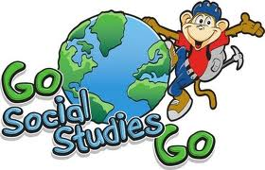  Social Studies | Children will continue to participate in outdoor learning activities. Children will have opportunities for personal and learning skills development in areas such as communication, problem solving, information technology, working with others and thinking skills.

Technologies  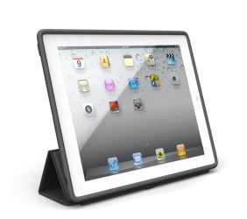 | In I.C.T. this term the children will have the opportunity to use the smartboard across their learning. Children will use the iPad and learn to use the keyboard to type their name and some known words. They will give instructions and program a device (Sphero) and they will explain the order they need things to happen.
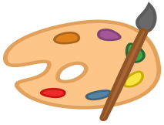  Expressive Arts  Music/ Drama/ Art/ Dance  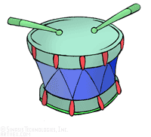 | Music:  The children will be learning to play percussion instruments. They will learn about the different families in the orchestra and what they sound like.  Art:  In art this term children will create art inspired by artists such as Andy Warhol. They will offer and receive feedback regarding some of their completed artwork.  Drama:  Pupils will explore movement, voice and expression when roleplaying as a character from a familiar story. They will offer constructive feedback to their peers.
Modern Languages      This Photo by Unknown Author is licensed under CC BY-SA | Children will continue to engage in daily conversations in French regarding their classroom commands, numbers and colours. In addition, Primary 2 will learn about French food such as ‘La galette des rois’ and they will explore what a traditional French market looks like.
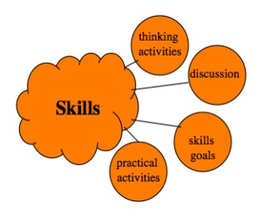  Interdisciplinary Learning | Our topic this term will be ‘Living and Non-Living’ which will be explored through Literacy, Expressive Arts, Science and Social Studies. Children will discuss characteristics of living and non-living things and sort them. They will also explore various animal categories and participate in various team challenges to create and present information about their chosen animal.

