St Francis Primary School Curriculum Information for Parents/Carers
Primary 4 Term 3
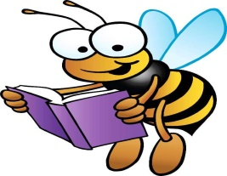  Literacy and English | This term Primary 4 will be using Unit 6 Phonics International. They will also be completing Talk for Writing exploring the report of Marvellous Monsters to develop our report writing skills. We are continuing to read a range of fiction and non-fiction books. They will also be continuing to answer and create questions based on our class novel Gangsta Granny.
Numeracy and Maths  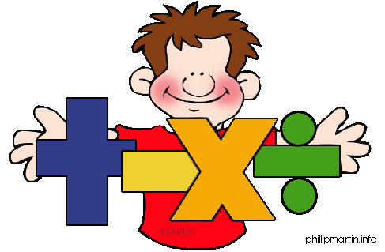 | This term P4 be learning about money, exploring different coins and how to make different amounts. We will also be using our knowledge of addition, subtraction, multiplication and division to calculate totals.  They will also be learning continuing to revise multiplication tables, such as 4x, 6, 7x. We will also be learning how to add/subtract larger numbers using the carry over method or exchanging.  They will continue to apply their knowledge to simple word problems.  We will also explore the concept of chance and uncertainty.
Health and Wellbeing /PE  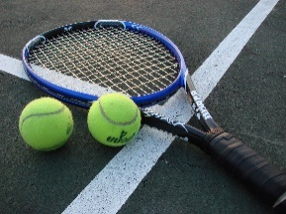   | In Health and Wellbeing this term we will be learning about the importance of being respectful and including others. The children will continue to compliment one another and show appreciation for each other’s talents and gifts.  In P.E. we will be developing their movements skills through netball which will be led by sports leaders from February. Before then we will be learning some Badminton skills, looking at how to use a racquet appropriately and how to aim and hit a shuttlecock.
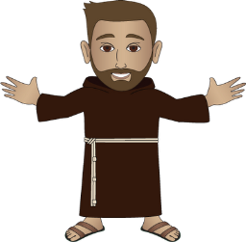  Religious Education | We will be preparing for Sacraments this term, P4 have their First Communion in June. We will be exploring the life of Jesus and why these sacraments are important.  For Laudato Si week, we will be exploring the importance of looking after our planet and the importance of recycling. We will also be looking at the importance of small acts of love and examine how we show love to others each day.  They will be continuing to learn about the Gospel Values i.e. Peace, Kindness, Integrity and Courage, in class and at Assemblies.
Sciences  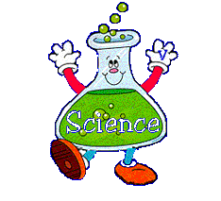 | P4 will be studying illnesses, looking at germs and how they spread and the impact different illnesses can have on us.  We will also be exploring electricity, looking at different electricity sources and at circuits.
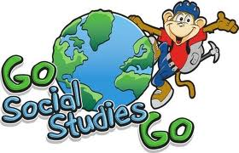  Social Studies | P4 will be learning about the local are and how to use maps with Miss Murray.

Technologies  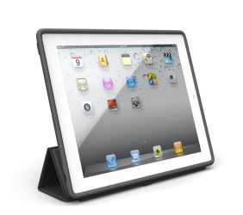 | In I.C.T. this term the children will learn how to take pictures and how to annotate an image. They will be using apps like Sumdog, Garageband, ClickerWriter and BookCreator. We will be revising typing on the iPads.  Children will learn about the importance of being safe online and the importance of being careful with what they search for on the internet.
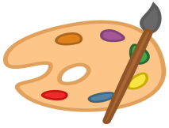  Expressive Arts  Music/ Drama/ Art/ Dance  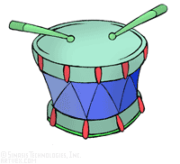 | Music:  P4 will be learning hymns, to prepare us for our Reconciliation/Communion.  Art:  In Art this term P4 will be creating Cubism art inspired by the artist Pablo Picasso.  Dance:  Children will learn some Scottish Highland Dancing for Robert Burns night.
Modern Languages      This Photo by Unknown Author is licensed under CC BY-SA | P4 will continue to develop their spoken Spanish and French.  They will be reinforcing vocabulary related to greetings, the weather and classroom objects.
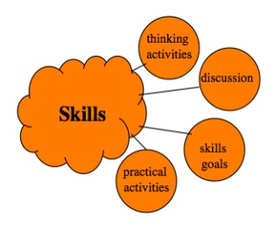  Interdisciplinary Learning | - See Science and Social Studies above.

