St Francis Primary School Curriculum Information for Parents/Carers
Primary 6 – Term 2 – November 2024
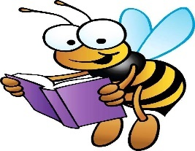  Literacy and English | In Literacy and English, we will continue to develop our fiction reading skills through a variety of texts, including this term’s class novel, ‘The Breadwinner’ by Deborah Ellis. We will also continue to develop non-fiction reading skills through exploring a range of non-fiction texts linked to our topic. We will use topic and library books to locate key information to be used for specific purposes. In addition, we will explore the exciting worlds of fantasy and science fiction writing, learning how to create imaginative settings, unique characters, and thrilling plots. We will work on building detailed worlds, developing character arcs, and using descriptive language to bring our short stories to life. We will continue to develop our grammar and spelling through the use of Write on Track and Phonics International resources. Additionally, we will continue to develop our talking and listening skills by asking and answering a range of questions, linked to both our class novel and topic.
Numeracy and Maths   | In Numeracy, we will be developing our understanding of multiplication and division. We will be learning to multiply and divide numbers up to 4 digits by a one-digit number (with remainders). We will be challenged further by learning to multiply four digits by a 2-digit number. We will be learning to identify common factors of two numbers and to develop our understanding of prime numbers, prime factors and composite (non-prime) numbers. Furthermore, we will be solving division problems with decimals using place value counters. Additionally, we will be learning to add and subtract decimals up to 2 decimal places.  In Maths, we will be comparing costs and determining the affordability within a given budget. In line with this, we will be learning to demonstrate an understanding of the benefits and risks of using bank cards and digital technologies. We will also be learning to calculate profit and loss accurately. We will be learning to recognise and understand the properties of equilateral, isosceles, scalene and right-angled triangles, as well as developing an understanding of side and angle properties of triangles, squares, rectangles, rhombus, parallelogram, trapezium and a kite. Lastly, we will be using a compass to draw circle designs and use associated language, such as; circumference, centre, radius and diameter.
    Health and Wellbeing /PE | In Health and Wellbeing, we will be exploring the firework safety code and learning ways to keep ourselves, pets and others safe around fireworks. Through Developing the Young workforce, we will be developing our understanding of the meaning of preferences and recognising that everyone is different whilst identifying our own strengths. We will continue to progress in the PATHS program, applying our learning to real-life situations with a particular focus on consequences, obstacles, solving problems and setting and reaching goals. In P.E, we will be developing our ball skills; sending, receiving, travelling/controlling, attacking/defending, as well as, developing our team work skills.  P6a – Monday and Wednesday  P6b – Tuesday and Wednesday  Children should wear their PE kit to school on PE days/no jewellery.
Religious Education  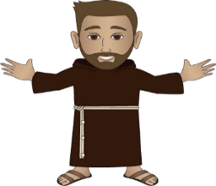 | During Religious Education lessons, we will be revising the story of Pentecost Acts 2: 1-21 and the power of the Holy Spirit. Children will be working in groups to discuss why God calls us to be saints and how the Holy Spirit can help us on this journey. We will be exploring the story of the life of Saint Columbus and learning that a pilgrimage is an important part of spiritual life for many Christians. We will understand that Advent is a season in the liturgical year when we prepare for the coming of Jesus at Christmas. Additionally, we will be reading from the Gospel of Saint Matthew to develop our understanding that Jesus was human and divine. Children will know that He had ancestors as we do and in line with this, create their own family tree. Lastly, we will revise our learning on the liturgical colours. We will be discussing what colours will be worn in church during Advent. We will demonstrate our understanding of the vestments and their names worn by the priest on various occasions throughout the liturgical year.
  Technologies | In technologies, we will be investigating how product design and development have been influenced by changing lifestyles. We will be exploring the famous inventions of Scottish inventors Alexander Graham Bell and John Logie Baird, and how the phone/TV have changed over time. Additionally, we will be following a design brief and selecting a famous piece of Scottish Architecture to recreate a futuristic version (3D model).
Modern Languages     | This term in Spanish, we will be exploring both language skills and cultural traditions. We are focusing on numbers from 0 to 30, helping pupils count and recognise numbers confidently. We’re also learning a range of colours, so pupils can describe the world around them in Spanish. To build conversational skills, we’re practising everyday greetings like “Hola” (hello), “Buenos días” (good morning), and “¿Cómo estás?” (how are you?), allowing students to engage in simple conversations with each other. As we approach the holiday season, we’ll also be learning about Spanish Christmas traditions, including festive foods, customs, and holiday phrases, giving pupils a glimpse into how the season is celebrated in Spanish-speaking countries.
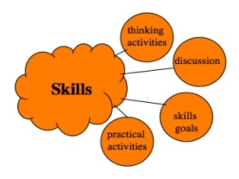  Interdisciplinary Learning | Our IDL topic this term is ‘Scotland – the Story of the Land.’ We will be working cooperatively to research the heritage of Scottish Architecture and discuss how this has evolved from original creations, through periods of time, to current day. In line with this, we will create an architect scaled drawing using division by power of tens to convert metric units and calculate perimeter and area. We will be exploring different features of Scotland’s landscape and can provide a basic explanation of how these are formed. In line with this, we will be examining causes of a natural disaster such as a volcano, earthquake or extreme weather event. We will be looking at both the positive and negative impacts of natural disasters on people and the landscape.  Furthermore, we will be exploring advantages and disadvantages of a land use development proposal. We will have the opportunity to present information in any preferred form on the local area including local area names, two major employers/types of employment, for example, call centres, local attractions, leisure facilities. We will also be providing an explanation as to why our local physical environment influences the way in which people use land in comparison to a contrasting area.

