St Francis Primary School Curriculum Information for Parents/Carers
Primary 3.2
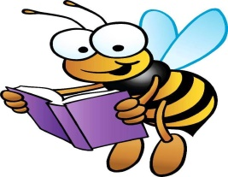  Literacy and English | In Term 2, Primary 3.2 will be continuing to recognise and write new sounds and digraphs using Phonics International. They will also blend and build words using known sounds through daily phonics activities. Children will be given more opportunities to participate in ‘Talk for Write’ writing activities. They will explore the genre of Instructions and act out the instructions story maps. They will continue to use and create their own story maps. In their writing they will include multiple openers, adjectives, verbs and connectives in their sentences. They will explore how basic punctuation affects emphasis in statements, questions, commands and exclamations and use when reading aloud.
Numeracy and Maths   | This term the children are continuing to work with numbers 0-100 and beyond. The children will be focusing on subtraction strategies such as counting back, partitioning and bridging through 10. The children will learn to tell the time using half past, quarter to and quarter past using both analogue and digital clocks. P3.2 will also revise days of the week, months of the year and order them. Children will also explore different ways of recording data. They will collect and show data by creating graphs and charts to show information.
    Health and Wellbeing /PE | In Health and Wellbeing this term, children will explore different emotions the PATHs programme. They will learn about the importance of diet, exercise, mental wellbeing and having a growth mindset. In P.E. the children will focus on gymnastics. Please remember that Primary 3.2 have gym on the following days:  Tuesdays  Fridays  Please ensure that your child has a yellow or white t-shirt, dark shorts and a pair of slip-on gym shoes (if possible) on these days. All jewellery should be removed.
  Religious Education | This term the children will have the opportunity to participate in Mass. Children will listen to the story of Christmas and the role of Saints. We will also explore celebrations from other faiths such as Diwali.
Sciences | This term we will explore senses and sound. Children will conduct experiments using different instruments to explore pitch and vibrations. They will take part in different experiments such as the smell test. They will make predictions with their peers and evaluate their findings.
  Social Studies | Children will participate in outdoor learning activities in order to explore the five senses. Children will discuss the features of different seasons and signs of different seasons.

Technologies  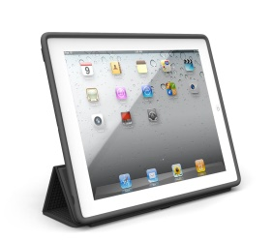 | In I.C.T. this term the children will have the opportunity to use the smartboard across their learning. Children will use the iPad and learn how to find information on a search engine. They will discuss the importance of being appropriate and safe online. Children will also learn to code and control a robot toy (Microbit) so that it can follow a simple instruction.
  Expressive Arts  Music/ Drama/ Art/ Dance  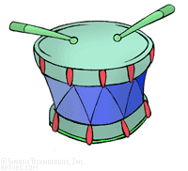 | Music:  The children will be participating in the school Nativity this term. They will learn different festive songs and explore different melodies and harmonies.  Art:  In art this term children will create art based on their topic of sustainability. They will use different materials to create different objects.  Drama:  Pupils will explore their voice and movement through their role in the Nativity and creating freeze frames relating to their topic. Also, children will give feedback to their classmates on their performances.
Modern Languages      This Photo by Unknown Author is licensed under CC BY-SA | Children will continue to engage in daily conversations in French regarding their classroom commands, numbers and colours. In addition, Primary 3.2 will explore traditional French Christmas stories and songs.
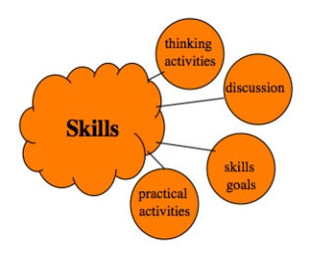  Interdisciplinary Learning | Our topic this term will be ‘Sustainability’ which will be explored through Literacy, Expressive Arts, Science and Social Studies. Children will discuss Climate Change and what we can do for Climate Change. They will also explore various natural disasters and participate in various team challenges to build and create strong houses and bridges to withstand the natural disasters.

