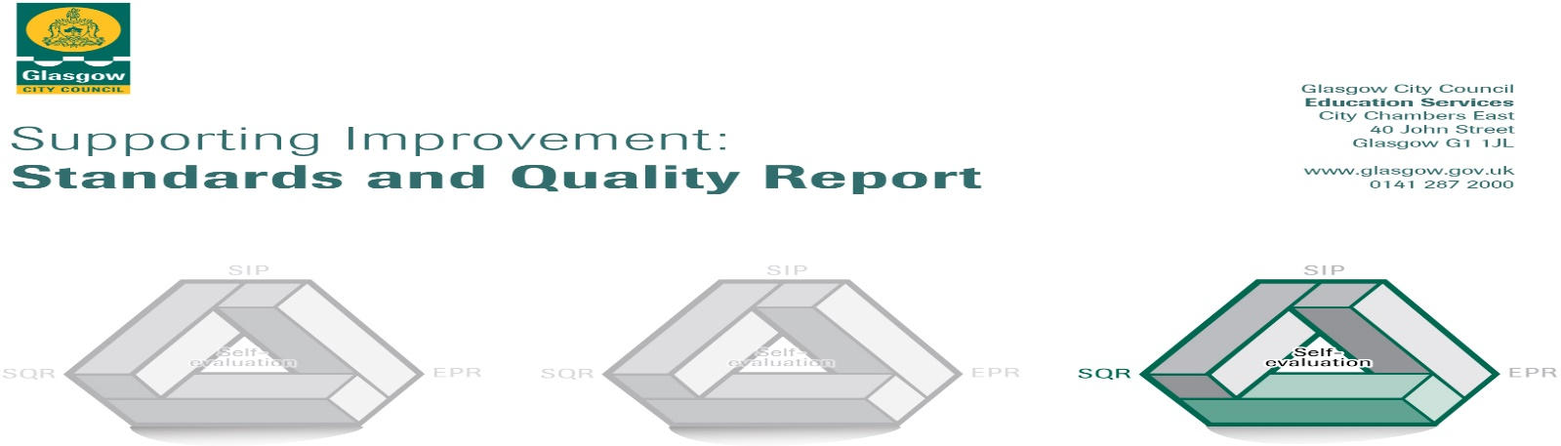

Session 22-23

The summary report is provided for parents/careers and partners to outline our achievements this session and our priorities for next session. Throughout this session we have taken forward our priorities as detailed in our school improvement plan. Through our processes of self-evaluation, we have identified how we can improve outcomes for our children and young people.

|  |  |
| --- | --- |
|  | **Our achievements and improvements this year.** |
| We would like to highlight the following improvements/achievements: **session 22-23** |

|  |  |
| --- | --- |
|  | **Here is what we plan to improve next year.** |
| **St Francis nursery class improvement priorities for session 23-24**   * All staff to continue in professional review via the CEP process with a focus on effective questioning and Learning intentions to ensure a consistent approach to the Learning and Teaching cycle. * Further develop teaching strategies to support Talking and Listening * Further develop teaching strategies to support problem solving skills in Numeracy * Apply for LCFE friendly accreditation for session 23-24 * Select 1 nurture principle to engage staff in further development of nurture/complete online nurture modules * Develop Families in Partnership to target families as part of transition/stay and play etc * Arrange a calendar of workshops for parents/carers for session 23-24 |

|  |  |
| --- | --- |
|  | **How can you find out more information about our school?** |
| Please contact us directly if you require further information or if you wish to comment on the report.  The contact e-mail address is: headteacher@st-francis-pri.glasgow.sch.uk  Our telephone number is: 0141 429 3687  Our school address is: 430 Old Rutherglen Road  Gorbals  Glasgow  G5 0PA  Further information is available in: newsletters, the school website, and the school handbook |