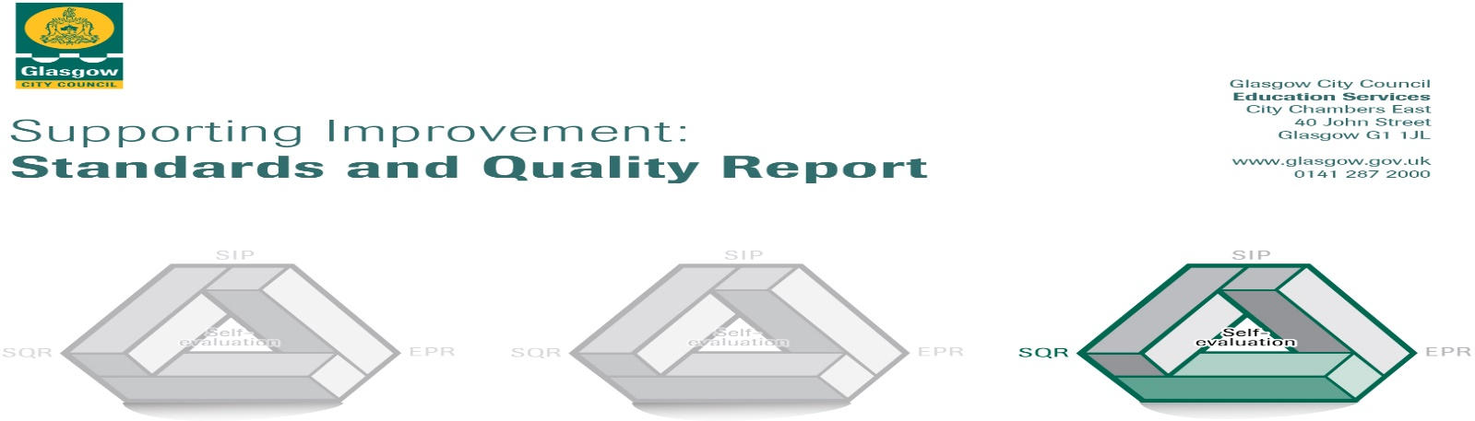
St Francis’ Primary and Nursery Class
Session 22-23
The summary report is provided for parents/careers and partners to outline our achievements this session and our priorities for next session. Throughout this session we have taken forward our priorities as detailed in our school improvement plan. Through our processes of self-evaluation, we have identified how we can improve outcomes for our children and young people.

Our achievements and improvements this year.
Our staff have all been trained in Nurture and each class now has a calm corner. All our staff are trained in restorative practices to help children find a more positive solution to arguments and fallouts.

Our Community Support Worker has continued to support a number of families. This has allowed us to provide them with a number of opportunities including a weekly uniform exchange, a link with Morrison’s food shop, free legal advice, one to one support for identified children in school: exploring issues, worries and concerns that they have and identifying strategies and supports for each young person and engagement with United Glasgow to raise awareness of issues affecting the community.

3.1 Ensuring wellbeing, Quality and Inclusion

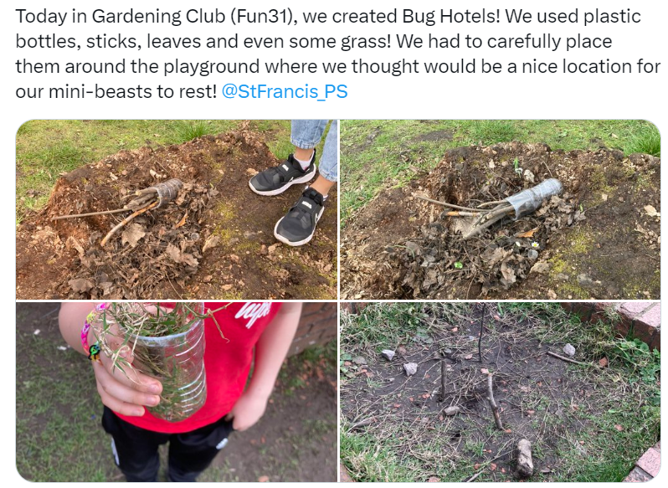

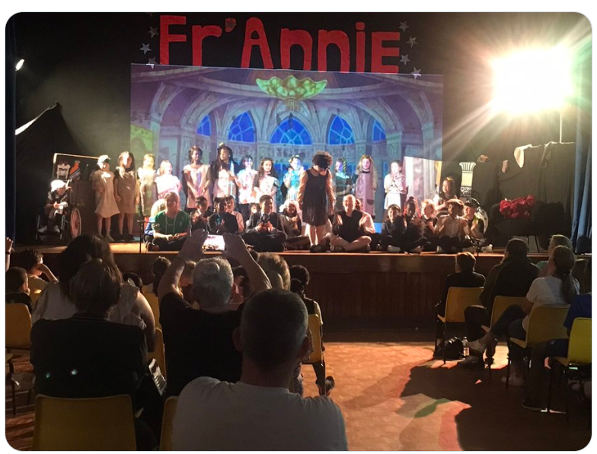

This year we trialled ‘Fun 31’ as part of our Rights Respecting action plan. Children from all stages have weekly opportunities to engage in fun activities with a different member of staff and children from different stages. This has been huge success and we are keen to build on this next year.

This year we had an end of term school show ‘Fr’Annie’ the children were outstanding in their performance which had a very positive impact on their self-confidence. We look forward to working with the children to select our next production!

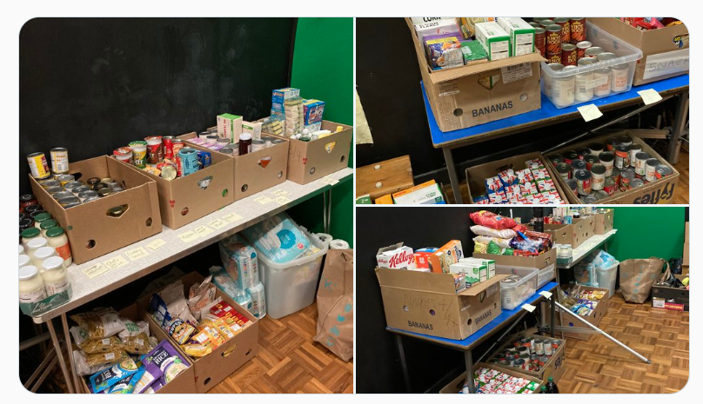

1.1 Leadership of change

Our school is a happy, inclusive and welcoming environment where all children feel included, safe and nurtured.

Our staff build and sustain positive relationships which is demonstrated each day in the classroom, this has helped to improve our overall attainment.

There is a growing confidence amongst our staff as they share their creativity and innovation by engaging in leadership opportunities such as the Eco club, Digital club and morning football club.

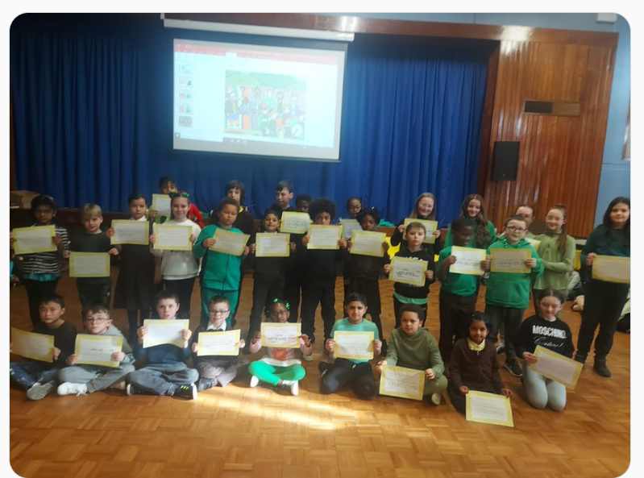

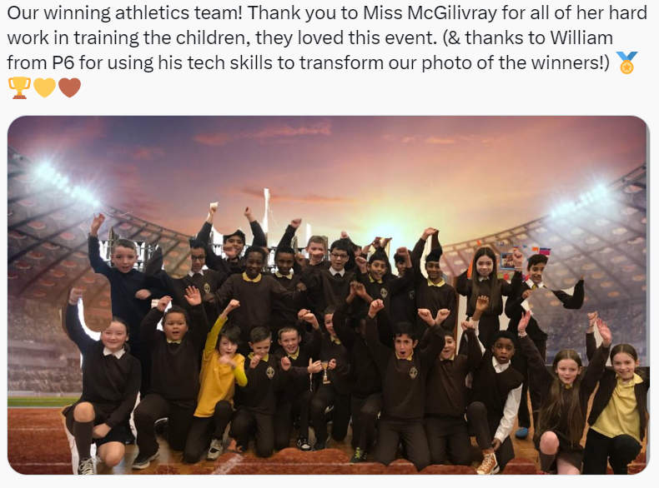

Our Vision, Values and Aims are clear and updated with families and staff annually to ensure there is a shared understanding of our purpose.

The curriculum rationale is also updated annually to ensure all staff are clear on the needs and interventions for the school year. This is evident in almost all our classes.

Here is what we plan to improve next year.
St Francis’ Primary and Nursery Class improvement priorities for session 23-24

Please click on the link below:

- Raise attainment in reading by improving our reading strategies
- Continue to provide a consistent approach to the delivery of Phonics
- Raise attainment in writing using ‘Write on Track’ resource
- Raise attainment in numeracy by improving our problem-solving strategies
- Raise staff confidence in teaching and assessing Glasgow Counts strategies
- Review our teaching approaches to ensure we are meeting the needs of all learning styles
- Increase staff confidence to provide different types of feedback for learners about their work

How can you find out more information about our school?
Please contact us directly if you require further information or if you wish to comment on the report.

The contact e-mail address is: headteacher@st-francis-pri.glasgow.sch.uk

Our telephone number is: 0141 429 3687

Our school address is: 430 Old Rutherglen Road
Gorbals
Glasgow
G5 0PA
Further information is available in: newsletters, the school website, and the school handbook

