

**Home Learning Challenges: How Many Trees**

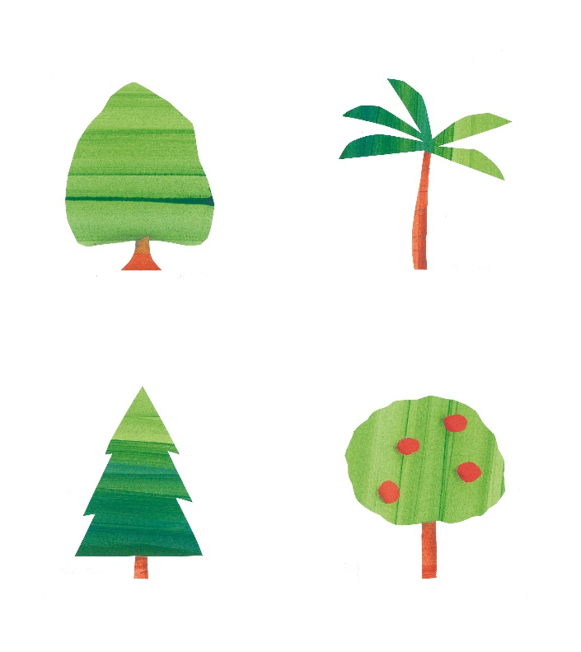

Read the book How Many Trees together and notice the different animals in the story. Have you seen any of these animals in your local area? Talk about the different types of wildlife near you.

_ _ _ _ _ _ _ _ _ _ _ _ _ _ _ _ _ _ _ _ _ _ _ _ _ _ _ _ _ _ _ _ _ _ _ _ _ _ _

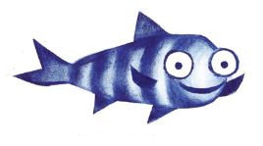

Collect leaves and greenery from your garden or local area. Can you find out what kind of tree they’re from? Create labels to show the names of the different trees and plants.

_ _ _ _ _ _ _ _ _ _ _ _ _ _ _ _ _ _ _ _ _ _ _ _ _ _ _ _ _ _ _ _ _ _ _ _ _ _ _



Experiment with leaves you have collected to make a piece of art. You could make a collage or try creating a pattern by placing the paper on top of a leaf and colouring over it with a crayon.

_ _ _ _ _ _ _ _ _ _ _ _ _ _ _ _ _ _ _ _ _ _ _ _ _ _ _ _ _ _ _ _ _ _ _ _ _ _ _



There are a lot of trees in the story, but how many are there near you? Count how many trees you see on the way to school. Can you spot different kinds?

_ _ _ _ _ _ _ _ _ _ _ _ _ _ _ _ _ _ _ _ _ _ _ _ _ _ _ _ _ _ _ _ _ _ _ _ _ _ _



Why not try planting your own seeds together and seeing what happens? You could use seeds from something you have eaten, like an apple or tomato, or maybe try herbs or sunflowers. You can plant it inside and talk about what it needs to help it grow.



**Home Learning Challenges: Rocketmole**



Read the book Rocketmole together and talk about the party Armstrong’s friends organise to welcome him back. If you held a party, what would you need? Make a list of items and design your very own invitation for the occasion.

_ _ _ _ _ _ _ _ _ _ _ _ _ _ _ _ _ _ _ _ _ _ _ _ _ _ _ _ _ _ _ _ _ _ _ _ _ _ _



If you wanted to welcome Armstrong home with a cake, what would it look like? Design the cake and write a list of the ingredients – you might be able to find clues in the book for what foods moles enjoy!

_ _ _ _ _ _ _ _ _ _ _ _ _ _ _ _ _ _ _ _ _ _ _ _ _ _ _ _ _ _ _ _ _ _ _ _ _ _ _



Armstrong recycled materials from the rocket to make his boring machine. Can you find any items around your house that can be recycled? Can you sort them into recycling stations?

_ _ _ _ _ _ _ _ _ _ _ _ _ _ _ _ _ _ _ _ _ _ _ _ _ _ _ _ _ _ _ _ _ _ _ _ _ _ _



The moles are very attached to their home, and even have a ‘Hole Sweet Hole’ frame on their wall. Imagine what it would be like to live underground and talk about what you would like or dislike.

_ _ _ _ _ _ _ _ _ _ _ _ _ _ _ _ _ _ _ _ _ _ _ _ _ _ _ _ _ _ _ _ _ _ _ _ _ _ _



Armstrong is reunited with his friends after his adventure. How did you feel about seeing your friends again after lockdown? Talk about it with a family member.

_ _ _ _ _ _ _ _ _ _ _ _ _ _ _ _ _ _ _ _ _ _ _ _ _ _ _ _ _ _ _ _ _ _ _ _ _ _ _



Prepare for your very own rocket launch by counting down from one minute and shouting “Blast Off!” as loud as you can when you reach zero.



**Home Learning Challenges: Shape Shuffle, Talk it out, Act it out & Story Cubes**

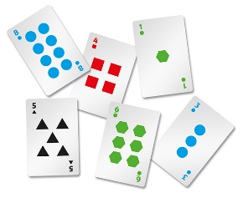

Look at the numbers on the cards and practise picking and making important numbers like house numbers, birthdays and phone numbers.

_ _ _ _ _ _ _ _ _ _ _ _ _ _ _ _ _ _ _ _ _ _ _ _ _ _ _ _ _ _ _ _ _ _ _ _ _ _ _

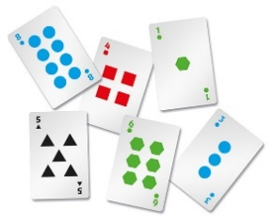Look at the different shapes on the cards. Can you make these shapes on the floor by lying the cards down flat? Try making bigger and smaller shapes using different amounts of cards.

_ _ _ _ _ _ _ _ _ _ _ _ _ _ _ _ _ _ _ _ _ _ _ _ _ _ _ _ _ _ _ _ _ _ _ _ _ _ _

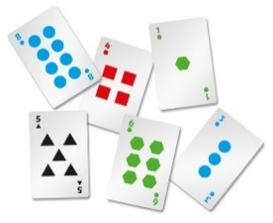

Lie on the floor and count how many cards you are lengthwise. Can you guess? Do the same with a family member too!

_ _ _ _ _ _ _ _ _ _ _ _ _ _ _ _ _ _ _ _ _ _ _ _ _ _ _ _ _ _ _ _ _ _ _ _ _ _ _



Play ‘Heads Up’ with the Act it Out cards. Place a card on your forehead without looking at it, and ask a family member or friend questions about what the card could be to help you guess. They can only answer yes or no!

_ _ _ _ _ _ _ _ _ _ _ _ _ _ _ _ _ _ _ _ _ _ _ _ _ _ _ _ _ _ _ _ _ _ _ _ _ _ _



Select a card at random to talk about on the way to or from school.

_ _ _ _ _ _ _ _ _ _ _ _ _ _ _ _ _ _ _ _ _ _ _ _ _ _ _ _ _ _ _ _ _ _ _ _ _ _ _

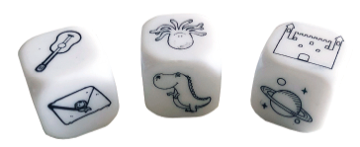

Get a family member to roll the story dice and create the beginning of a story, then use your imagination to come up with the rest of the story yourself.



**Home Learning Challenges:**

**Bonus Challenges**



Acrostic poems are where the first letter in each line spells out a word. Try to make one for each name in your family!

_ _ _ _ _ _ _ _ _ _ _ _ _ _ _ _ _ _ _ _ _ _ _ _ _ _ _ _ _ _ _ _ _ _ _ _ _ _ _

****Create a sock puppet with an old sock and write a short story featuring this character. You could act it out and even create a poster to advertise your show!

_ _ _ _ _ _ _ _ _ _ _ _ _ _ _ _ _ _ _ _ _ _ _ _ _ _ _ _ _ _ _ _ _ _ _ _ _ _ _

****Create a rock museum with labels to say where and when you found each rock, including the date. You could even decorate them with a picture of where you were!

_ _ _ _ _ _ _ _ _ _ _ _ _ _ _ _ _ _ _ _ _ _ _ _ _ _ _ _ _ _ _ _ _ _ _ _ _ _ _



Do a survey on the colours of passing cars from your window, keeping track with tally marks. Try this again on a different day then compare the results.

_ _ _ _ _ _ _ _ _ _ _ _ _ _ _ _ _ _ _ _ _ _ _ _ _ _ _ _ _ _ _ _ _ _ _ _ _ _ _



Collect some rocks or pebbles to draw on to use as counters for knots and crosses, then play with a family member.