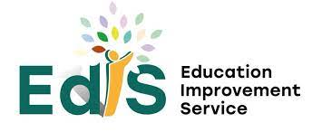
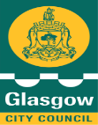

Session: 2025-2026

Establishment name | St Conval’s Primary School
Learning Community | Holyrood
Link Officer | Jane Saunders
Head of Service | Carolyn Davern

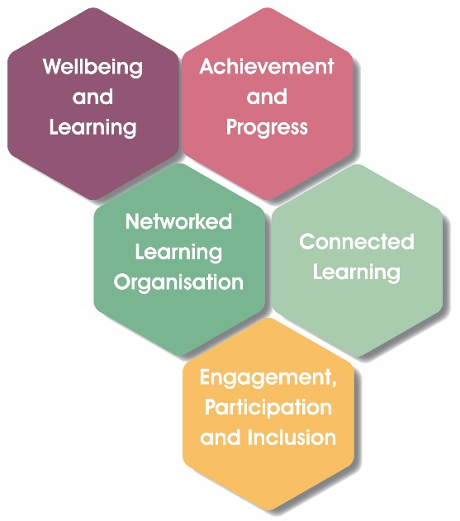
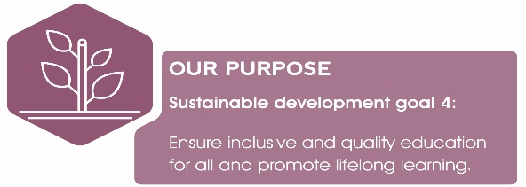



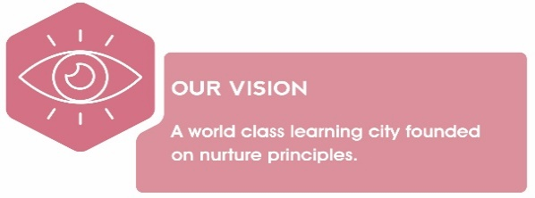

EVALUATIVE STATEMENTS
Quality Indicator 1.3 Leadership of Change
How well are you doing?  Evaluative statements describing the impact of improvement actions detailed in your current Improvement Plan (measured against expected outcomes) | How do you know?  Describe the evidence you have gathered which details impact on pedagogy and learners | What are you going to do now?  What are your next steps/ priorities in this area?
- Through the analysis of data a clear understanding has been developed amongst all staff of the social, economic and cultural context of our local community. All staff now have an up-to-date knowledge about the local community and understand circumstances affecting children’s lives and learning.  - We have a strong Catholic ethos, and all staff show a commitment to promoting our schools Vision, Values and Aims. Our VVA were refreshed in consultation with all stakeholders (2024/2025). We have now incorporated a regular review of our VVA, involving the whole school community, into our Quality Assurance Calendar.  - All most all pupils talk confidently about the schools VVA and can link these to the life and work of our school. Values stickers are awarded by staff and pupils to members of our school community who display our values. This is further embedded through regular discussion at assemblies each week.  - All staff have committed to becoming racially literate and are more effective at dealing with racism and confident in leading anti-racism. An anti- racism pupil voice group has been established and will be further developed next session.  - All staff have become familiar with of the Curriculum Improvement Cycle and the evolving technical framework.  - Almost all staff and pupils confidently take on leadership roles to improve the quality of learning and teaching throughout the school.  - As a school we successfully fulfilled the actions towards our Siver Award of the UNICEF UK’s Rights Respecting Schools Award. | - Staff evaluation feedback indicating strong understanding following inset session Aug 2025.  - Survey Results from all Stakeholders during HMIe inspection Sept 2025  - Learning Conversations  - Almost all staff attended refresher CLPL on Building Racial Literacy in Aug 2025. Staff reflections following professional learning, along with high levels of engagement in self-evaluative activities such as Frames of Mind (exploring our anti-racism journey) and the White Privilege Test.  - Analysis of racial incident records on SEEMIS  - Pupil Wellbeing Questionnaires  - Survey Results from all Stakeholders during HMIe inspection Sept 2025  - Record of staff meetings showing engagement with discussion papers and evaluation following Learning Community CLPL. HT part of National Practice Guidance External Group  - Record of leadership roles of all learners and staff. Minutes of meetings of PC, JRSO.  - Participation in GYP Forum & Pupil Voice Groups  - Pupils use GCC version of Harts ‘Ladder of Participation’ to evaluate and plan agency.  - Supporting evidence that led to achievement of Silver Award. | - Review our Vision, Values, and Aims regularly to ensure they remain relevant, inclusive, and responsive to the needs of the school community.  - Continue to work collaboratively with staff, families, and the wider school community to review policies, curriculum content, and reporting systems through an anti-racist lens.  - Establish clear aims for the anti-racism pupil voice group, including promoting inclusion, identifying barriers experienced by pupils, and contributing to whole-school anti-racist practice.  - As we enter Phase 3 of the CIC, Sharing, Learning and Adopting, as a school team, we will continue to engage in CLPL to build capacity.  - Continue our RRS Journey, working towards our Gold Award.
Using the descriptors from HGIOS 4, how do you evaluate your progress within this Quality Indicator? (Please Highlight)

Unsatisfactory Weak Satisfactory Good Very Good Excellent
EVALUATIVE STATEMENTS
Quality Indicator 2.3 Learning, Teaching & Assessment
How well are you doing?  Evaluative statements describing the impact of improvement actions detailed in your current Improvement Plan (measured against expected outcomes) | How do you know?  Describe the evidence you have gathered which details impact on pedagogy and learners. | What are you going to do now?  What are your next steps/ priorities in this area?
- New partnerships have been developed with The Royal Highland Education Trust, Friends of Pollok Park and Glasgow University to further enhance our outdoor learning experiences.  - For most children, meta-skills are now well embedded and are used to support learner progression from Early to Second Level.  - Most staff identify meta- skills when planning learning across curriculum and include these within the learning intentions and success criteria.  - My Dream Job Day was an opportunity for almost all learners to explore different careers, develop an understanding of employability skills, and meet people from the world of work who shared valuable real-life experiences and advice.  - Our Big Question approach is now well embedded with monthly whole school questions. The Big Question approach has also been trialled to exploring learning in Social Studies across all stages.  - Our Inspired Learning Space has been further developed with a more sustainable approach to planning for learning through enquiry with class teachers in P4 to 7 leading the development of the approach and planning collaboratively.  - Guidance on the features of ‘A Very Good Lesson at St Conval’s’ has been introduced to ensure the consistent approach to the planning of learning experiences.  - Almost all staff have completed Spanish training, and we are at the early stages of Spanish being introduced as a taught language. | - Our outdoor learning cycle infographic  - Pupil Voice Feedback  - Lesson Observations  - Our year of outdoor learning display  - Learner self-evaluation through use of Meta- Skills Self-Evaluation Tools  - Records of wider achievement where children identify meta- skill development  - Learning goal displays and learner conversations.  - Pupil evaluations of My Dream Job Day  - Evidence of learning on Seesaw and Big Question Displays in classes.  - Presentation on our approach to inquiry-based learning delivered at South Ayrshire Primary Curriculum Conference May 26  - HMIe report Sept 2025  - TLC minutes  - Lesson Observations  - Pupils Voice feedback  - Records of attendance at Spanish PL Jan -March 2026  - Pupil Feedback | - Embark on the University of Glasgow’s ‘Citizen Science Project’ on the River Cart. Continue to build on new partnerships to enhance our approach to OL.  - Continue to seek opportunities to take outdoor learning beyond out local urban green spaces to explore other eco systems  - Continue to seek opportunities to collaborate and learn from others in relation to their meta-skill journey.  - Develop consistent approaches to documenting learning in the Inspired Learning Space. Expand family and community involvement. Plan long‑term evaluation for sustainability.  - Further embed the guidance on the features of ‘A Very Good Lesson at St Conval’s’ to ensure pace and differentiated learning in all classrooms whereby teaching, learning and assessment is adapted to meet individual learners’ needs.  - Revisit HOT’s Questioning to challenge learners thinking and extend their learning.  - Continue to develop our approach to the teaching of Spanish. Add to maintenance agenda.
Using the descriptors from HGIOS 4, how do you evaluate your progress within this Quality Indicator? (Please Highlight)

Unsatisfactory Weak Satisfactory Good Very Good Excellent
EVALUATIVE STATEMENTS
Quality Indicator 3.1 Wellbeing Equality & Inclusion
How well are you doing?  Evaluative statements describing the impact of improvement actions detailed in your current Improvement Plan (measured against expected outcomes) | How do you know?  Describe the evidence you have gathered which details impact on pedagogy and learners. | What are you going to do now?  What are your next steps/ priorities in this area?
- Our school places a strong emphasis on pastoral care. We respect each child as an individual, and where necessary, we provide tailored support. In March 2026 some of our P7 children presented at GCC Health & Wellbeing Festival on our approaches to promoting Health & Wellbeing.  - All staff understand the principles of GIRFEC and use the Wellbeing Indicators and are using the UNCRC rights of the child effectively.  - Wellbeing, nurture and inclusion are key drivers in our school improvement plan which is supported by professional learning.  - Pupils at all stages complete Health & Wellbeing Survey’s and the results, along with professional judgements, parental views and local knowledge are used to monitor the wellbeing of all.  - Wellbeing is a key feature of our Tracking meetings and is part of our tracking overview. Analysis of this data leads to timely interventions.  - All pupils’ wider achievements are tracked using the Tracking & Monitoring Tool & interventions planned for targeted learners  - We have well established focused support/ intervention for our Bilingual Learners, TIGs to support learning across all stages. This targeted intervention is positively impacting on attainment with all children making good progress.  - The SLT has robustly analysed attendance data to identify emerging trends and patterns. In line with Glasgow City Council guidance, the school maintains accurate and up-to-date attendance records. Targeted interventions are informed by this data and have been implemented effectively to address individual attendance concerns.  - Attendance at the end of June 2025 was 92.57%, above the Glasgow average and comparable to the national average.  - We celebrate the diversity of our school community and actively support all pupils to develop their understanding of other faiths and cultures. Our pupils presented at the GCC Learning for Sustainability Conference May 2026 on our approach to celebrating cultural diversity.  - All most all school staff completed Promise Training - awarded the Keeping the Promise Award in Dec 2025. | - Attendance at CLPL  - Lesson Observations  - HMIe Report Sept 25  - Wellbeing Survey Responses  - Record of Interventions  - Feedback from stakeholders on Art Therapy, Social Skills Group & Talking Therapy  - Tracking records  - ASL Overview  - Records of Intervention P1-7  - Tracking records  - Attainment over time  - Pupil Voice  - Attendance Data  - Record of interventions  - Newsletter updates to parents on attendance.  - Presentation & Evidence on Seesaw of celebrating diversity.  - CLPL training records  - Promise on Display  - Pastoral Notes  - Records from LT Staff Meetings  - Seesaw Communication with parents on The Promise & Designated Manager | - Maintain interventions in place to support the Wellbeing of all but in particular targeted interventions such as – Social Skills Group, Talking Therapy. Art Therapy.  - Utilise PEF funding to raise attainment of learners experiencing a potential poverty related attainment gap.  - Continue to monitor attendance with rigor.  - Review our approach to digital wellbeing and embark on the Digital Wellbeing Award as recognition for our approach to Cyber Resilience and Internet Safety.
Using the descriptors from HGIOS 4, how do you evaluate your progress within this Quality Indicator? (Please Highlight)

Unsatisfactory Weak Satisfactory Good Very Good Excellent
EVALUATIVE STATEMENTS
Quality Indicator 3.2 Raising Attainment & Achievement
How well are you doing?  Evaluative statements describing the impact of improvement actions detailed in your current Improvement Plan (measured against expected outcomes) | How do you know?  Describe the evidence you have gathered which details impact on pedagogy and learners | What are you going to do now?  What are your next steps/ priorities in this area?
- My Dream Job Day inspired children to have career aspirations.  - There are robust quality assurance procedures in place to track and monitor, this is then used to inform and plan for improvement.  - Tracking of Language Acquisition shows good progress of almost all our Bilingual Learners.  - Attainment over time shows progress of legacy children as being very good. With between 80-90% of legacy children achieving expected levels.  - Overall attainment levels in reading, writing, listening and talking and numeracy and mathematics are above the local authority average.  - Most children who receive additional support for their learning, including those with English as an additional language, make very good progress against their individual targets for learning. A majority are on track to achieve expected national CfE levels.  - Attainment in literacy and numeracy has been positively impacted upon as a result of targeted interventions.  - P4- 84% of P4 Reading/ Writing TIG are now on track to achieve First Level Reading  - P7- 100% of Numeracy TIG are now track to achieve Second Level  - Our approach to tracking opportunities for wider achievement for pupils is now well embedded; with records spanning two academic years.  - Write on Track has been further embedded across all stages, with staff who are new to the programme undertaking observations and taking time to familiarise themselves with the resource and associated guidance. | Feedback from stakeholders  - Calendar of Quality Assurance.  - Pupil dialogues  - Assessment Profile of each learner  - Professional dialogues  - Robust tracking data  - Analysis of data  - Minutes from tracking meetings  - HMIe Report Sept 2025  - Records of wider achievements  - Staff CLPL surveys  - Observations of/dialogue around changes to pedagogy  - Write on Track Sentence Level Assessments, show good learner progression from June 2025 to June 2026  - Staff forward planning which reflects analyses of assessment  - Pupil Surveys  - Tracking information | - Review feedback from stakeholders and use it to identify strengths and areas for development, in order to build on existing successes and further improve My Dream Job Day .  - Utilise PEF funding to raise attainment of learners experiencing a potential poverty related attainment gap and our EAL pupils.  - Continue to maintain records of wider achievements  - To strengthen comprehension skills, ensure that all children across the school are explicitly taught and supported to apply a range of reading strategies when engaging with texts to help them strengthen their comprehension skills  - Continue to build on developing practice around the WOT programme, using assessment information effectively to identify progress and inform targeted next steps in learning and teaching.
Using the descriptors from HGIOS 4, how do you evaluate your progress within this Quality Indicator? (Please Highlight)

Unsatisfactory Weak Satisfactory Good Very Good Excellent

EVALUATIVE STATEMENTS
Quality Indicator : QI 2.5 Family Learning
How well are you doing?  Evaluative statements describing the impact of improvement actions detailed in your current Improvement Plan (measured against expected outcomes) | How do you know?  Describe the evidence you have gathered which details impact on pedagogy and learners. | What are you going to do now?  What are your next steps/ priorities in this area?
- We are proactive in reducing the cost of the school day. Our PC work alongside the school to ensure that events they organise are accessible to everyone. Where possible we seek support from outside organisations to help us fund trips. This year we received support from: Local Area Grant, SVDP, The Lord Provost Trust Fund, Glasgow Educational and Marshall Trust, Glasgow Care Foundation, Schuh and the St Nicholas Care Fund.  - We have a twice weekly foodbank which is well used by families from across the school. At Christmas, with the help of St Helen’s Parish Advent Appeal, we were able to provide support for families with Supermarket Vouchers.  - The Parish of St Mary Immaculate also supported our school community with Christmas gifts for families.  - We have worked closely with other services such as SW and Health to support families through challenging times such as homelessness, destitution and ill health.  - We value the views of parents/ carers on the life and work of our school and consult them via questionnaires and focus groups.  - Our Parent Counsil survey parents/carers in April 2026 to gather views on the work of the PC and the life and work of the school.  - Our Family Room is well utilised, providing valuable opportunities for families to come together through events such as International Women’s Day and Cultural Diversity Day lunches, EAL family learning sessions, and stay-and-play sessions for prospective parents. These opportunities help strengthen relationships, promote inclusion, and support family engagement in school life.  - Families receive weekly updates on our Rights Respecting Schools focus, including the Article of the Week, enabling them to discuss children's rights and related themes at home and reinforce learning beyond the classroom. | - Records of grant applications.  - Seesaw Communications  - Records of supports to families  - PC Meetings Minute  - Pastoral Notes  - Questionnaire responses from consultations  - PC Questionnaire and infographic  - Records of events  - Seesaw updates | - Continue to work with families and other agencies to help parents minimise the effect of poverty on our children.  - Consider how well we are using local knowledge and data we have about levels of poverty in our community to help us target interventions?  - Maintain our commitment to Family Learning  - Continue to develop links with external agencies and wider community to enhance our Family Learning Programme  - Carry out a review of our approach to home /learning
Using the descriptors from HGIOS 4, how do you evaluate your progress within this Quality Indicator? (Please Highlight)

Unsatisfactory Weak Satisfactory Good Very Good Excellent

