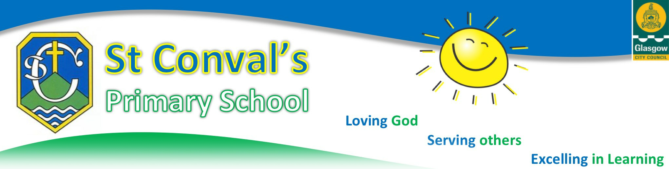

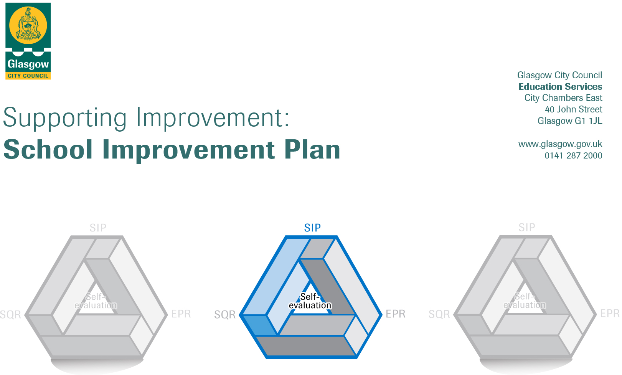
2021/22

Session: 2020-21

Establishment |  | St Conval’s Primary School
Head of Establishment |  | Marian Kelly
Area/Local Improvement Group |  | South LIG 2
Head of Service |  | Donnie McLeod
Area Education Officer/  Quality Improvement Officer |  | Sharon McGeever

CONTENTS
1. Vision, Values and Aims
2. Summary of Self-Evaluation Process / Priorities for Improvement in the current session
3. Action Planning

Action Plan Summary for Stakeholders

1. Our Vision, Values and Aims
Motto: Love God, Serve Others, Excel in Learning

Mission statement: With children at the heart of everything we do, our mission is to build a nurturing and stimulating learning community, rooted in Gospel values, in which every child and adult feels loved and has the opportunity to reach their full God-given potential.

Values: Openness, Tolerance, Love, Connection, Perseverance, Growth

Aims
As a community of FAITH, we aim to:
- place Christ - Teacher, Master and Friend - at the centre of our school.
- build an atmosphere of openness, tolerance and mutual-respect where pupils and adults are helped to understand and appreciate the diversity of cultures, faiths and beliefs represented in St Conval’s Primary, the nation of Scotland and across the world.
- provide meaningful opportunities for pupils to develop their knowledge and understanding of the Catholic faith, actively participate in religious observance and respond positively to God’s invitation of friendship.

As a community of SERVICE, we aim to:
- provide a safe, inclusive, nurturing and equitable learning environment where all members of our school community are able to grow into confident individuals and feel happy, valued and fulfilled.
- recognise every child and adult as a unique individual, made in the image of God, and continually endeavour to meet the spiritual, emotional, physical, social and intellectual needs of all.
- foster Gospel values of openness, tolerance, love, connection, perseverance and growth, equipping all members of our school community to serve as responsible citizens and effective contributors within St Conval’s and in the local and global community.

As a community of LEARNING, we aim to:
- provide the highest quality of learning and teaching across the curriculum, supporting all pupils to be literate, numerate and healthy, equipped with the knowledge, skills and attributes necessary for being lifelong successful learners in an ever-changing society.
- establish and maintain high, but realistic, standards and expectations for all, fostering a love of learning in both pupils and adults and supporting everyone within our school community to take responsibility for their own learning.
- work in close partnership with parents, the parish, the wider community and other partners to ensure all pupils benefit from relevant learning experiences beyond the classroom.

2. Summary of our self-evaluation process.
Our school community’s 2021/22 School Improvement Plan is based on a careful analysis of data drawn from our on-going self-evaluation, summarised in our most recent Education Perspective Report (EPR). How Good is our School? 4 Quality Indicators 1.3 (Leadership of change), 2.3 (Learning, teaching and assessment), 3.1 (Improving wellbeing, equity and inclusion), 3.2 (Raising attainment and achievement) and 2.5 (Family Learning) were carefully evaluated through the triangulation of evidence drawn from direct observations, quantitative data and people’s views. Evidence includes records from staff self-evaluation sessions using the challenge questions from How Good is our School?, records of learning teaching and tracking meetings and monitoring of the online learning provision across all classes, data on pupil attainment and also pupil focus group sessions using How Good is OUR school. Parental views were sought via the Parent Council and also through parent/carer questionnaires.

The ‘next steps’ for each Quality Indictor (1.3, 2.3, 3.1, 3.2 and 2.5), listed in our Education Perspective Report (EPR), helped our school community identify the three priorities for 2021/22. These ‘next steps’ directly correlate with the various ‘tasks to achieve priority’ outlined in the 2021/22 School Improvement Plan.
Strengths identified:
- Our school community has shared values which help support the wellbeing of both pupils and adults; these are promoted and reinforced across the school on a daily basis. During lockdown (Jan 2021- March 2021), all teaching staff checked on the wellbeing of pupils daily through morning check ins via Seesaw and SLT carried out weekly pastoral calls to all families to support wellbeing during this challenging time. Our Hub was well attended during this period and we successfully provided support for 20% of our pupils. All staff show a strong commitment to developing our whole school nurturing approach and this will be an area for further development next session.
- All teaching staff demonstrate a shared commitment to living the professional values. They promote equality and diversity and strive to meet the needs of all learners. All staff have shown a commitment to CLPL and have engaged fully in opportunities to learn collegially via Microsoft Teams and when appropriate face to face.
- All teaching staff across all stages effectively utilised the features of Seesaw during periods of remote learning. They adapted their approaches in response to feedback from learners and parents/carers. P4- P7 learners also benefited from weekly Microsoft Teams calls with their teacher; where they had the opportunity to seek advice on any aspects of their learning.
- Pupil across all stages have access to a variety of resources to enrich and support their learning, including digital technology. Devices were made available to families requiring this support and our DLOL provided in-depth support to all families when accessing new platforms through video demonstrations.
- Robust systems are in place to identify, plan for and support all pupils with specific additional support needs.
- All pupils across all stages have daily opportunities to be physically active and this is leading to increased levels of fitness levels in most pupils. We have welcomed opportunities to reengage with: Rangers FC, Active Schools, Jeely Piece, Bikeability and Daily Mile – Travel to Tokyo.
- All staff are committed to promoting pupil voice and participation in the life and work of our school and beyond. Pupils have shared their views at Glasgow Schools Young People Forum and also at the COSLA Children and Young People Board. P4-P7 pupils are working with Connecting Pollokshaws on shaping the future of our neighbourhood. House Captains have used the How good is OUR school? toolkit to lead learner participation in self-evaluation and school improvement.

3. Additional Monies Spend Summary of Consultation Processes
Consultation was carried with members of the Parent Council out at PC meeting and a minute of this meeting was shared with all parents/ carers. All staff were consulted at the inset day 6TH May 2021. Pupils were consulted at a pupil focus group for house captains.

Rationale for Spend:

The establishment of a recovery programme with the aim of raising attainment through the delivery of targeted interventions to identified groups of pupils.

(Use of additionality (£26,437) to fund the release of 1 staff member (Anne McCormick) to support intervention for TIGs.)

Measures/Evidence for Impact (data, observation, views):

1: Carrying out observations, gathering the views of: learners, parents/ carers, class teachers, giving consideration of all potential barriers to learning and also the analysis of baseline assessment results in order to establish starting points.

2: Regular use of assessment, monitoring and tracking to establish progress.

3: Carrying out observations of learners and gathering the views of all stakeholders on the success of the programme of intervention on a regular basis

4: Carry out an end of intervention assessment to establish impact and inform next steps.

4. Action Planning

No. | Quality Indicator | Priority
1 | 3.2  1.3  2.3  2.4  2.5 | Increase the effectiveness and impact of learning and teaching across the school leading to improved outcomes for all learners through:  - Development of approaches to planning for learning, teaching and assessment in Literacy & English and Numeracy & Mathematics  - Refreshed Curriculum Rationale  - Development of whole school approach to recording assessment evidence and tracking progress and attainment  - Moderation- develop use of Moderation Portal & DHT participation in Quality Assurance and Moderation Support Officer QAMSO programme  - Engagement in Supporting Improvement Pedagogy and Equity programme  - Raising attainment in Literacy-  - continue to introduce ‘Literacy for All’ approaches to the teaching and assessment of Listening & Talking (Year 2)  - embedding ‘Literacy for All’ approaches to the teaching and assessment of writing (Year 3)  - Raising Attainment in Numeracy-  - embedding ‘Glasgow Counts’ numeracy teaching approaches (Year 4)  - Introduce the use of Numeracy Blueprints to help develop a conceptual understanding of number and number processes.  - Embedding and widening targeted interventions to help close attainment gaps  - Rejuvenation of Playful Pedagogy in Primary 1 & 2  - Raise capacity amongst all staff in using Digital Learning to raise attainment  - Learning for Sustainability – Framework for Learning and Teaching COP 26  - Working with Burrell Collection to create workshops and be residency school

Tasks to achieve priority | Timescale  and checkpoints | Evidence of Impact > (data, observation, views)
Short life working groups to work on the development of approaches to planning for learning, teaching and assessment in Literacy & English and Numeracy & Mathematics | May – June 2021 | Records of monitoring of planning, learning teaching and tracking meetings. Professional dialogues. Attainment data in both curricular areas. Pupil voice. -30.8.21 plans adapted and new approaches to planning agreed. Will be trialled this term and adjusted accordingly.
Continue the development of our refreshed Curriculum Rationale. Carry out consultation with parents/ carers and pupils. Collate feedback from all stakeholders, identify key themes and update our Curriculum Rationale in accordance | August – October 2021 | Questionnaire results (parental, pupil, staff)
Embed use of tracking systems and revised approach to tracking meetings to facilitate focused professional dialogue around pupil progress and attainment. | Ongoing | Shared approach to tracking, staffs’ ability to articulate and show shared understanding of CfE levels and phases within a level. Staff collating evidence through regular planned assessment. Assessment files will evidence key milestones in a learning journey. Tracking meeting 1 completed Sept /Oct
Staff training on the use of the Moderation Portal & cascading of expertise as a result of DHT participation in Quality Assurance and Moderation Support Officer (QAMSO) programme  Engagement in moderation at LC level. | Ongoing | Staff increased confidence and professional knowledge and understanding of the Moderation Cycle. 30.8.21- QAMSO programme begins 8th Sept  31.8.21- Staff introduced to moderation hub on Glow  DHT TRAINING UNDERWAY – Plans for Moderation with St Bridget’s – Term 2
Engagement in Supporting Improvement Pedagogy and Equity programme through the TLC | September 2021-April 2022 | Agendas and Minutes from TLC meetings, learning visits/observations, professional dialogue. 30.8.21- First TLC 6th SLT will meet with leader to discuss – Ongoing
Raising attainment in Literacy-  - Staff training and support on approaches to teaching Listening & Talking  - Further develop the use of the British Picture Vocabulary Scale (BPVS) as a tool to assessing receptive hearing and language development  - Ongoing support to teaching staff on ‘Literacy for All’ approaches to the teaching and assessment of writing | Ongoing | Consistent planning and assessment in all areas of Literacy, Forward Plans Feedback; SLT observations of learning and teaching, SLT – Pupil learning conversations, pupil work. Use of diagnostic assessments to identify target groups for invention. Timely checkpoints to assess progress being made. Increased knowledge and understanding of Listening and Talking Literacy for All strategies across all teaching staff. Use of Benchmarks and Literacy for All trackers in reaching accurate professional judgements on CfE levels in all areas of Literacy.  30.8.21- CLOL training 15th Sept  21.9.21- training from CLOL
Raising Attainment in Numeracy-  - Ongoing support to teaching staff to embed ‘Glasgow Counts’ numeracy teaching approaches (Year 3)  - Collaborative enquiry on the use of Numeracy Blueprints to help develop a conceptual understanding of number and number processes. | Ongoing  August 2021- December 2021 | Consistent planning and assessment in all Numeracy and Mathematics, Forward Plans Feedback, SLT observations of learning and teaching, SLT – Pupil learning conversations, pupil work. Targeted invention groups identified using MaLT and teacher professional judgement. Consistent approach to teaching of maths using Glasgow Counts CPA approach. Use of Benchmarks and Glasgow Counts trackers in reaching accurate professional judgements on CfE levels in Numeracy and Mathematics. Peer observations and professional dialogue focussed on Numeracy Blueprints, pupils’ views and ability to talk about how Numeracy Blueprints has aided or enhanced their learning.  30.8.21- Staff training at inset day 1 and class workshops on 5th Oct
Embedding and widening targeted interventions to help close attainment gaps | Ongoing | Targeted intervention groups identified using various assessments and teach professional judgements. Tailored support put in place with timely checkpoints. TIG groups established Aug 21 and SLT met with SFL staff. Ongoing and reviewed at tracking meetings
Rejuvenation of Playful Pedagogy in Primary 1 & 2, including the identification of new resources to update the current provision. | August 2021- October 2021 | Observations, pupil voice, teacher professional judgements and pupil attainment data  30.8.21- Training 26th August -issues with access Ongoing and visit on 20th Oct
Staff training to build capacity amongst all staff in using Digital Learning to raise attainment | Ongoing | New staff trained in Getting to Know Your iPad, Apple Classroom and Seesaw. Peer observations of good practice, SLT classroom observations and SLT-Pupil learning conversations. Staff and Pupil questionnaires  . Digital Learning Strategy document developed, application for Digital School’s Award status.- 30.8.21- training booked Inset day 3 &4  Inset Day 3 Training and sharing session 16th Nov
Learning for Sustainability – Framework for Learning and Teaching COP 26. Learning experience planning across all stages to include:  - Glasgow challenges climate – IDL engineering P5-7  - STEMaSTORY – picture books to explore STEM Es and Os Early/First  - Science Centre visits  - Development of literacy within the context of learning for sustainability Early - Third | September- November 2021 | Pupil voice, observations of learner engagement, SLT observations of learning and teaching.  30.8.21- A McCormick coordinating – currently gathering info for overview and communicating opportunities that come in  Ongoing activities in class and filming on 19th Oct
Work with Burrell collection to create workshops to roll out across Glasgow schools. St Conval’s to be residency school within the Burrell Collection. | Ongoing | Pupil learning conversations, pupil questionnaires, observations of learner engagement.  Invite opening – date to follow

Staff leading on this priority – including partners | Resources and staff development
Leadership Team-  - Overall responsibility for development of priority 1  - Leading analysis of date and effective use of tracking system  - Support TLC and collaborative enquiry process  Victoria Maclean – Literacy for All Listening and Talking  Anne McCormick- Glasgow Counts & Learning for Sustainability  Winnie Slaven & Nuala Campbell- Playful Pedagogy  Rachel Woods DLOL  Christine Healey & Nuala Campbell- The Burrell Collection Project | PERSONNEL  GIC funding (0.4FTE):CLOL  PEF:1 FTE teacher  Use of additionality (£26,437) to fund the release of 1 staff member (Anne McCormick) to support intervention for TIGs.  ELECTRONIC AND PRINTED RESOURCES  Use of PEF to purchase chrome books to enhance our digital learning provision  Use of PEF to update printed resources in Literacy & English- reading books and literacy boxes  Use of PEF to update printed resources in Numeracy & Mathematics -Teejay and Heinemann  OTHER  Purchased resources to enhance play experiences  Training from Count on Us and purchase of blueprint boards

No. | Quality Indicator | Priority
2 | 1.1  1.3  2.1  2.6  3.1 | Embed ‘Our Nurturing School’ approaches by:  - Analysis of HNIOS audit from last session leading to policy development  - Continue to embed use of Glasgow’s Motivational Wellbeing Tool’ to all pupils and develop whole school approach to monitoring and tracking of wellbeing  - Further development of HWB Programme  - Develop use of the wellbeing application within Seemis to record WAPS  - Nurture training for all staff  - Develop ACE awareness of all staff  - Develop a nurturing space within the school and establish social emotional wellbeing groups  - Establish Seasons for Growth groups  - Work with external providers to provide counselling, play and art therapy

Tasks to achieve priority | Timescale  and checkpoints |  | Evidence of Impact > (data, observation, views)
Analysis of HNIOS audit from last session | August 2021 |  | Analysis of results of HNIOS audit and use to develop our Promoting Positive Relationships Policy and Equalities Policy
Administer ‘Glasgow’s Motivational Wellbeing Tool’ to all pupils (including Boardmaker friendly version for younger pupils) and use feedback to inform tracking of Wellbeing. | Ongoing | Pupil Questionnaire, Pupil Dialogue, Observations and Professional Dialogue will be used to populate whole school tracking system  30.8.21- Wellbeing surveys are underway and infant survey updated.  Sept- Oct – all surveys completed
Carry out Parental Questionnaire via Forms/Seesaw to support  HNIOS | October 2021 |  | Results of Parental Questionnaire used to inform next steps.
Short life working group to develop whole school HWB Programme | September 2021 |  | CT evaluations, pupil voice, observations-  Not yet established
Staff training on use of wellbeing app on Seemis to record WAPS | August / September 2021 |  | Raising staff capacity and consistent approach to recording targeted intervention. Seemis training completed By CH – 1st Oct
Nurture training for all staff (including SfLW/Admin) | October 2021 |  | Staff previously trained in the nurturing principles will cascade training to all staff, information wall in staff development base, sharing of good practice, learning visits, peer observations (as current circumstances allow). 30.8.21-Completed inset day 2.  ASD training inset day 3
Develop ACE awareness of all staff through attendance at presentation by James Docherty on how we address the hidden cost of untreated trauma and Adverse childhood experiences. | August 2021 |  | Professional dialogue, positive impact on ethos evident through daily interactions  30.8.21- Completed and excellent feedback from staff on how awareness was raised and how it will inform practice
Create nurturing space and establish social emotional wellbeing groups. | September 2021 |  | Introduction of social emotional wellbeing groups dependent on results of audit/questionnaires. Groups underway
Establish Seasons for Growth Groups | November/December 2021 |  | Training principles to be cascaded to all staff to raise awareness
Engage with the services of Life links, With kids and Impact Arts to provide counselling, play therapy and art therapy. | Ongoing |  | Professional dialogue, pupil dialogue, parental views, results of questionnaires, referral forms, feedback from providers  30.8.21-Some children identified and feedback from wellbeing surveys will possibly support the identification of others  Ongoing

Staff leading on this priority – including partners | Resources and staff development
Leadership Team:  - Facilitate audit of current practice  - Oversee Glasgow’s Motivational Wellbeing Tool being administered  - Carry out parental questionnaire  - Collate and share results of audit and questionnaires  - Facilitate training for all staff  Anne McCormick-development of social emotional wellbeing groups  Nuala Campbell & Rachel Woods – Seasons for Growth Groups  Life links, With kids and Impact Arts-Counselling/ Therapy Sessions | PERSONNEL  - PEF Teacher: 1 FTE to provide capacity for staff to be released to lead Seasons for Growth and development of Social Studies Groups ELECTRONIC AND PRINTED RESOURCES  - Glasgow’s Motivational Wellbeing Tool  - SEEMIS Wellbeing App  OTHER  Counselling budget carried forward from 2020-2021 and budget for 2021/22- Total £4912

No. | Quality Indicator | Priority
3 | 2.5  1.3 | Family Learning  - Develop whole school rationale for Family Learning  - Consultation with families to identify learning opportunities and expertise they can share  - Develop use of You Tube Channel to promote Family Learning  - Further develop use of Seesaw with families  - Develop links with external agencies and wider community  - Establish Family Room

Tasks to achieve priority | Timescale  and checkpoints | Evidence of Impact > (data, observation, views)
Staff workshops to develop whole school rationale for Family Learning. | January/ February 2022 | Establish a shared vision for Family Learning and the creation of a programme of family learning that provides opportunities for all families to engage in meaningful learning experiences. Professional dialogue, feedback from families- questionnaires and focus groups
Consultation with families to identify learning opportunities and expertise they can share. | January/ February 2022 | Feedback from families- questionnaires and focus groups
Develop use of St Conval’s You Tube Channel to promote Family Learning. | March 2022- June 2022 | Feedback from families- questionnaires and focus groups. Impact on learner attainment- analysis of data exploring trends related to engagement of families.
Further develop use of Seesaw with families | Ongoing | Monitor levels of engagement with Seesaw App.  New families targeted Aug to Oct
Develop links with external agencies/ partners and wider community to help enhance our Family Learning provision | Ongoing | Feedback from families- questionnaires and focus groups. Impact on learner attainment- analysis of data exploring trends related to engagement of families. Monitoring of attendance and exploring trends related to engagement of families.
Establish Family Room with consideration to guidance related to Covid 19 | September 2021 | Monitoring levels of engagement- visitor register. Feedback from families- questionnaires and focus groups- Bid for funding -Oct 2021

Staff leading on this priority – including partners | Resources and staff development
Leadership Team:  - Leading the development of a shared vision for Family learning  - Carry out and collate feedback from parental questionnaires  Rachel Woods DLOL  - Development use of You Tube Channel and Seesaw  Rachel Woods (CLOL) & Victoria MacLean (PEF Teacher)  - Establishing Family Room and analysis of engagement and trends related to attendance and attainment | PERSONNEL  GIC funding (0.4FTE):CLOL  PEF:1 FTE teacher  OTHER  Resources purchased through PEF to support the development of a Family Room

