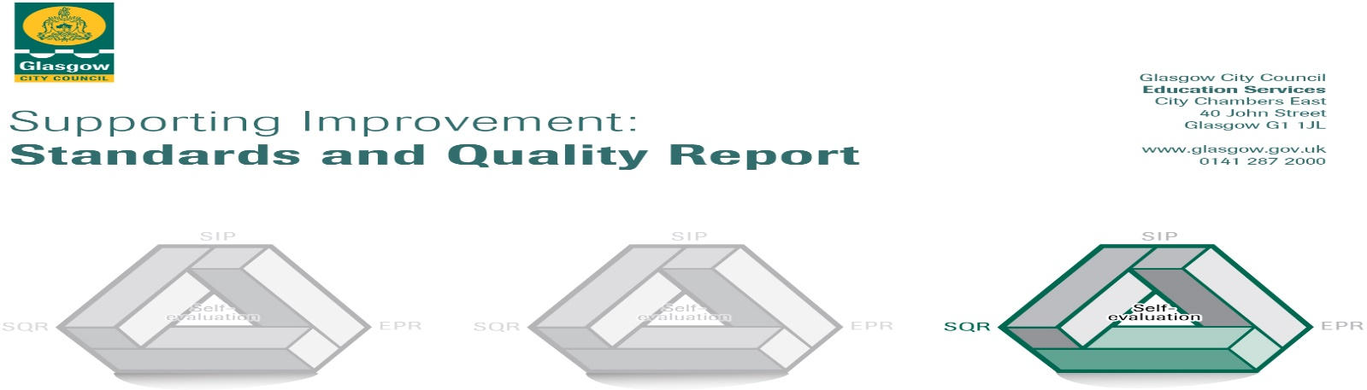

The summary report is provided for parents/careers and partners to outline our achievements this session and our priorities for next session. Throughout this session we have taken forward our priorities as detailed in our school improvement plan. Through our processes of self-evaluation, we have identified how we can improve outcomes for our children and young people.

**St Brendan’s Primary School, September 2023**

|  |  |
| --- | --- |
|  | **Our achievements and improvements this year.** |
| **We would like to highlight the following improvements/achievements:**  **Key developments (leadership of change)**   * All staff are gaining an understanding of the social, economic and cultural context of our local community through analysis of key data – SIMD levels, Staged Intervention Audit, CEL and CP updates, partnership with St Brendan’s RC Church (particularly Saint Vincent De Paul group). * Glasgow’s Improvement Challenge Glasgow Counts Leader of Learning has supported 4 class teachers and 2 principal teachers (all permanent members of staff) to implement Glasgow Counts (Numeracy and Maths strategies).   **Developments in learning and teaching and assessment**   * All of our P1-P3 teachers and Support for Learning Workers have delivered the ‘Read, Write, Inc’ phonics and reading programme. * In P1 and P2 our Playful Pedagogy has been developed through staff training, quality professional reading and working with colleagues from across the city.   **Progress in promoting well-being, equality and inclusion**   * We are continuing on our journey towards becoming a Culturally Responsive School. * Our acting Principal Teacher of Inclusion helped us to support inclusive approaches including alternative curriculum for identified pupils in P6 & P7 as well as to support raising attainment in P6 and P7 classes.   **Progress in children’s learning /raising attainment and recognising achievement**   * More than 75% pupils in P1, more than 50% of P4 pupils and more than 60% of P7 pupils (end of level stages) achieved the expected level for Literacy, Numeracy and Health & Wellbeing. |

|  |  |
| --- | --- |
|  | **Here is what we plan to improve next year.** |
| * St Brendan’s vision, values and aims – conclude our consultation. * Further develop our shared understanding and promotion of a Language and Communication Friendly Environment. * Continue with children’s rights education and work towards the UNICEF Silver Rights Respecting School Award. * Continue to develop our outdoor spaces to further develop play and outdoor learning. * Focus on developing our teaching approaches and resources for Reading and Writing in P4-P7. |

|  |  |
| --- | --- |
|  | **How can you find out more information about our school?** |
| Please contact us directly if you require further information or if you wish to comment on the report.  The contact e-mail address is: [headteacher@st-brendans-pri.glasgow.sch.uk](mailto:headteacher@st-brendans-pri.glasgow.sch.uk)  Our telephone number is: 0141 952 1222  Our school address is: Clyde Campus, 200 Hawick Street, Glasgow, G13 4HG.  Further information is available in:  *Newsletters (emailed directly to parents and carers)  *St Brendan’s Glow blog - <https://blogs.glowscotland.org.uk/gc/stbrendans/school-handbook/>  *Our school handbook -  <https://www.glasgow.gov.uk › CHttpHandler> |