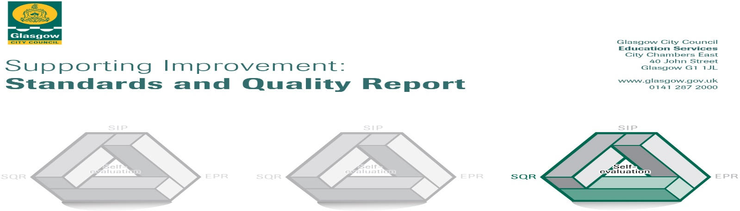

The summary report is provided for parents/careers and partners to outline our achievements this session and our priorities for next session. Throughout this session we have taken forward our priorities as detailed in our school improvement plan. Through our processes of self-evaluation, we have identified how we can improve outcomes for our children and young people.

St Brendan’s Primary School, September 2022

Our achievements and improvements this year.
We would like to highlight the following improvements/achievements:

- Key developments (leadership of change)
- Staff have developed their understanding of barriers to learning and have worked together to ensure that appropriate supports are in place.
- Newly appointed head teacher has worked with staff, pupils, the parent council and the parish to develop the learning experiences for our pupils.

- Developments in learning and teaching and assessment
- Our Leader of Learning has worked with staff and pupils to help raise attainment in Literacy through her focus on the teaching and assessment of writing.
- Our Learning through Play focus has been rolled out across P1 and P2.

- Progress in promoting well-being, equality and inclusion
- All pupils began going on school trips again. These helped to promote social, physical and emotional wellbeing and gave our pupils alternative learning experiences from the classroom.
- We began our journey towards becoming a Culturally Responsive School.

- Progress in children’s learning /raising attainment and recognising achievement
- Most pupils in P1, P4, P7 (end of level stages) achieved the expected level for Literacy, Numeracy and Health & Wellbeing.

Here is what we plan to improve next year.
- Revisit St Brendan’s vision, values and aims – consult to determine if any updates are needed.
- Launch our beautiful new cooking room for all classes to use.
- Consult with pupils, parents/carers, staff to look at our school curriculum rationale.
- Further develop our shared understanding and promotion of a Language and Communication Friendly Environment.
- Staff training on tracking, assessment and moderation to make sure that we are supporting our pupils as well as we can.
- Continue with children’s rights education and enrol for the UNICEF Rights Respecting School Award.
- Reintroduction of parents/carers being welcomed into our school building to see their child’s learning and help support our partnership to raise attainment and achievement.
- Welcome back parents/carers to attend training and support sessions in school.
- Continue to embed opportunities for our learners to discuss their learning and ensure that their views are listened to as we consult them on a wide range of themes.

How can you find out more information about our school?
Please contact us directly if you require further information or if you wish to comment on the report.

The contact e-mail address is: headteacher@st-brendans-pri.glasgow.sch.uk

Our telephone number is: 0141 952 1222

Our school address is: Clyde Campus, 200 Hawick Street, Glasgow, G13 4HG.

Further information is available in:
*Newsletters (sent home monthly directly with pupils)
*St Brendan’s Glow blog - https://blogs.glowscotland.org.uk/gc/stbrendans/school-handbook/
*Our school handbook -
https://www.glasgow.gov.uk › CHttpHandler

