Eco Newsletter
The ECO Committee have been working very hard this year in preparing our school for the Green Flag Award. Our chosen focus areas are; Litter & Waste, Biodiversity, School Grounds. Please see below for lots of information on our progress so far…
Litter & Waste
- We now have recycling bins in every classroom. The ECO Committee and P7 students have taken responsibility for emptying these bins every week.
- We have bins in the shared areas in lower and upper primary for recycling plastic water bottles and crisp bags.
- We have a litter picking system at lunchtimes where volunteers from all classes P1-P7 pick up any waste in the playground.
- We have a clothing recycling bank in the playground to recycle clothes, shoes etc.
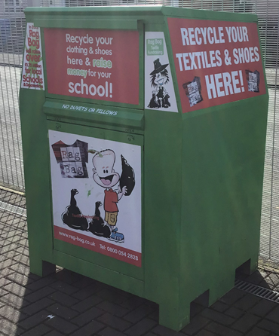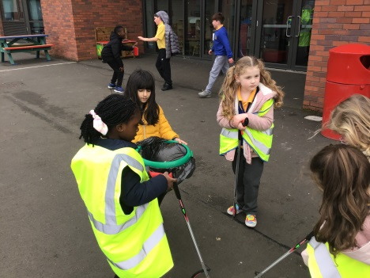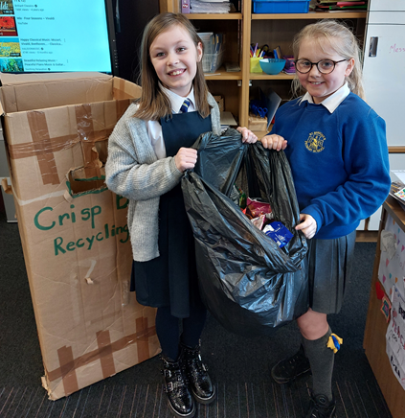
- We now compost the food waste from the playground.
- We have a community clean planned for term 1 and term 2 where we will pick up all litter in our neighbouring streets.

Biodiversity
- Our P4 students have been participating in a Citizen Science Campaign- learning all about protecting hedgehogs and creating a hedgehog friendly environment in the Learning Walk.
- P7A students raised brown trout hatchlings for a number of weeks and then released them in a nearby river.
- All classes are participating in an outdoor learning programme led by Mrs McKay in Terms 2 & 3.
- P3 & P4 students have been learning all about our local birdlife and have taken part in the RSPB bird watch programme.
Sustainable Development Goals
The ECO Committee have been learning about sustainability and the 17 development goals. They have created a beautiful display and will present an assembly to share their understanding of the goals with the school community.
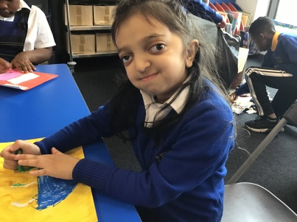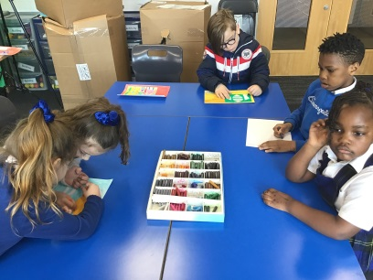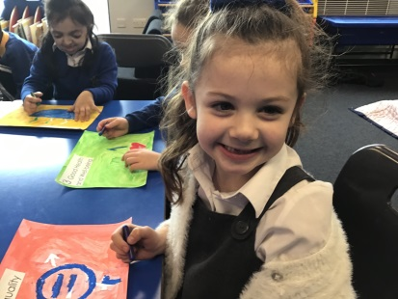
Communication
As part of our Green Flag application, we have created an ECO Schools Noticeboard to communicate all of our on-going progress with our school community. We display our meeting minutes, our action plan and our ECO Code.
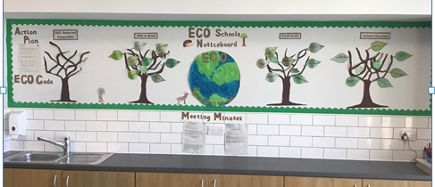
Gardening Volunteers 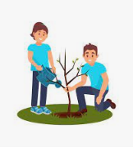
If any of you have some spare time, we would love if you could join us to help with planting, litter picking, building planters, bird boxes etc. We are really excited about transforming our school grounds and neighbourhood and would love to do it in partnership with our local community.
