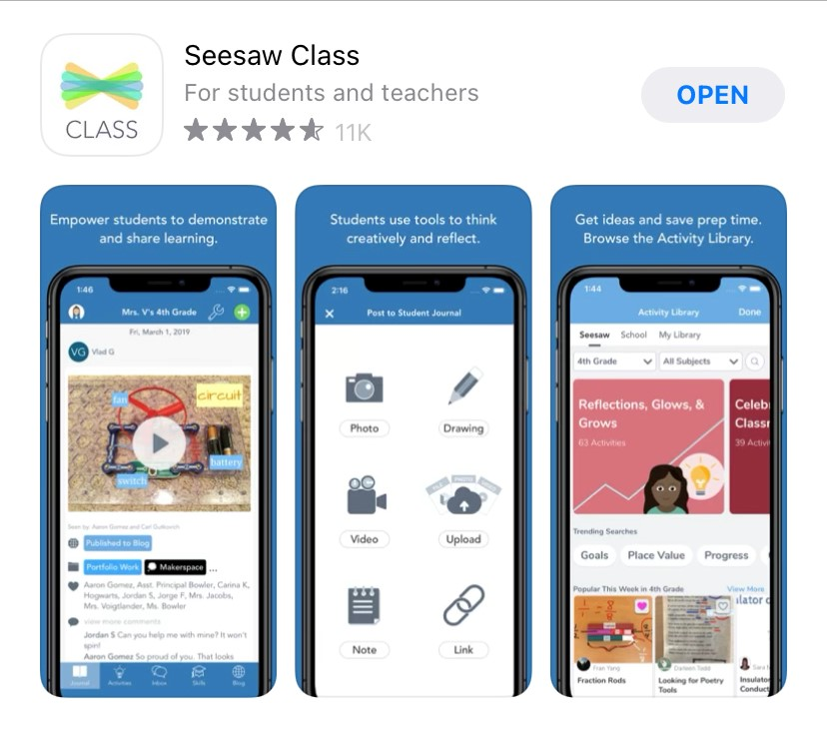
STEP 1: Go to app.seesaw.me or Download the Seesaw Class App for Your Child
Your child will use the Seesaw Class app for home learning. (This is different than the Seesaw Family app.)
✓ Laptops + Computers: Visit app.seesaw.me
✓ Tablets + Mobile Devices: Download or update the Seesaw Class app in your device’s app store. If you already have the app, make sure it is updated

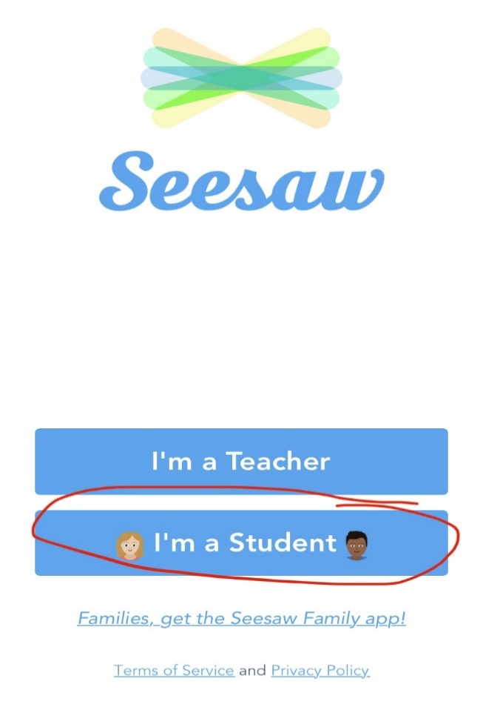

STEP 2: Help Your Child Log In to Seesaw
Click ‘I’m a Student’
Log in as directed by your student’s teacher or school:
✓ Your child will log in with the log in details in your Home Learning Pack!

STEP 3: Assigned Activities

Click ‘Activities’ at the bottom of the screen
✓ You will see activities you have been assigned. There is a tab for activities you still need to do and a tab for activities you have done.
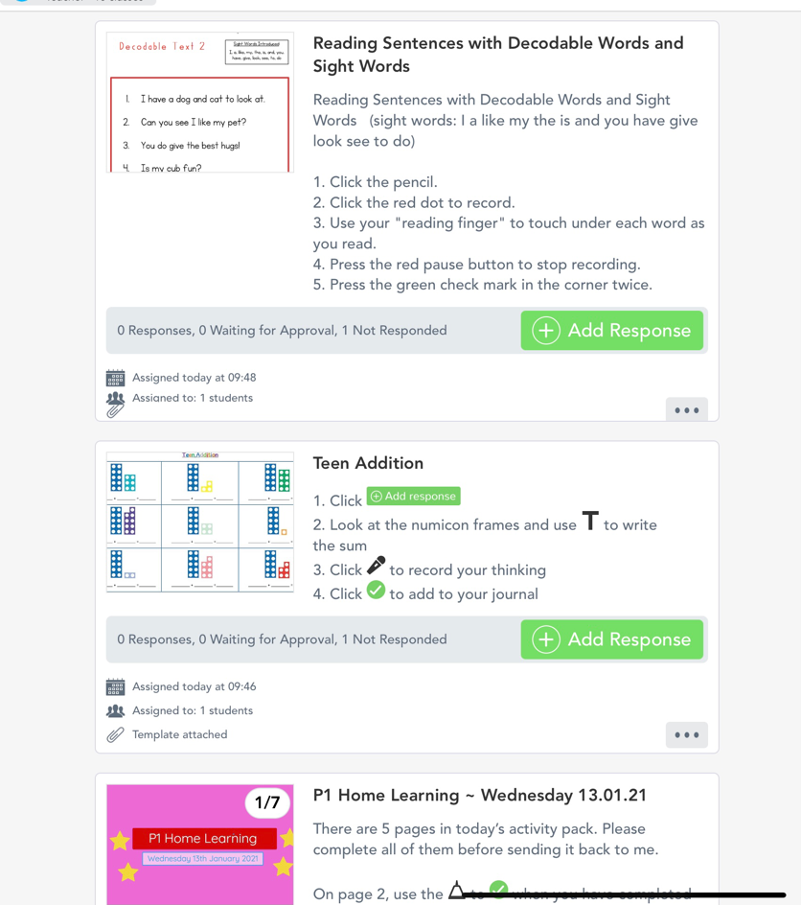
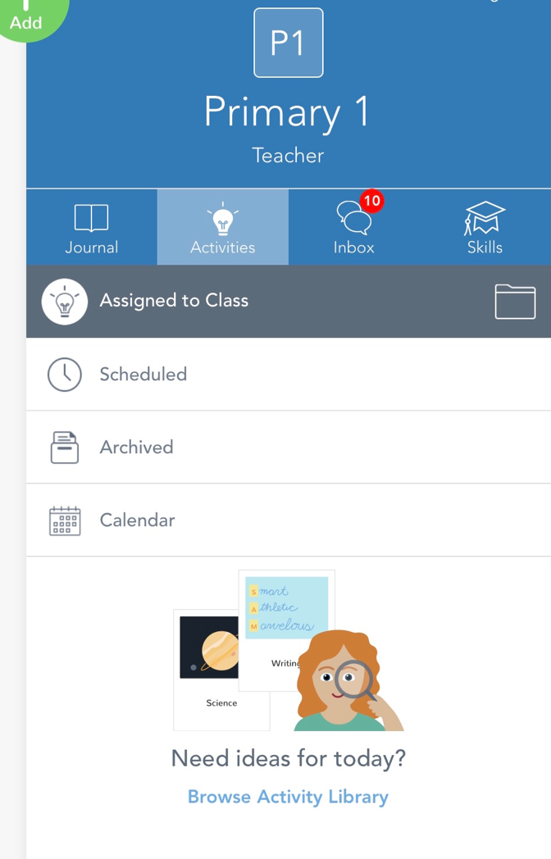

✓ If you have uncompleted activities (tasks you have not yet returned to the teacher), they will be in the ‘To Do’ tab.

✓ Click on the button to carry out activity.
✓ Follow instructions to complete activity

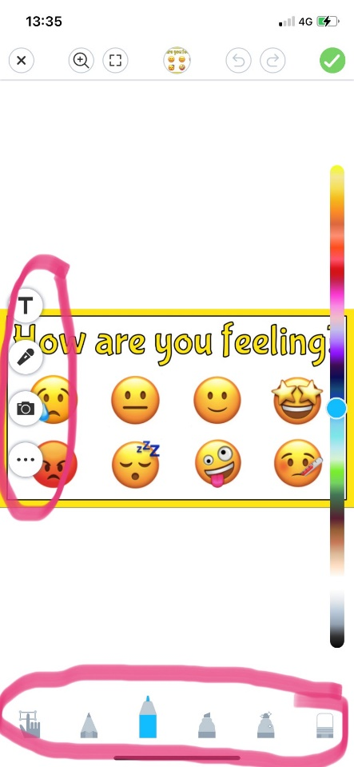
STEP 4: Return Activity to Teacher
You will see the highlighted tools in the picture.

✓ Click the correct tool (see instructions)
and complete activity

✓ Once you have completed the activity, click the green tick in the top right hand corner. This will return the activity to the teacher and you will no longer be able to edit it.
