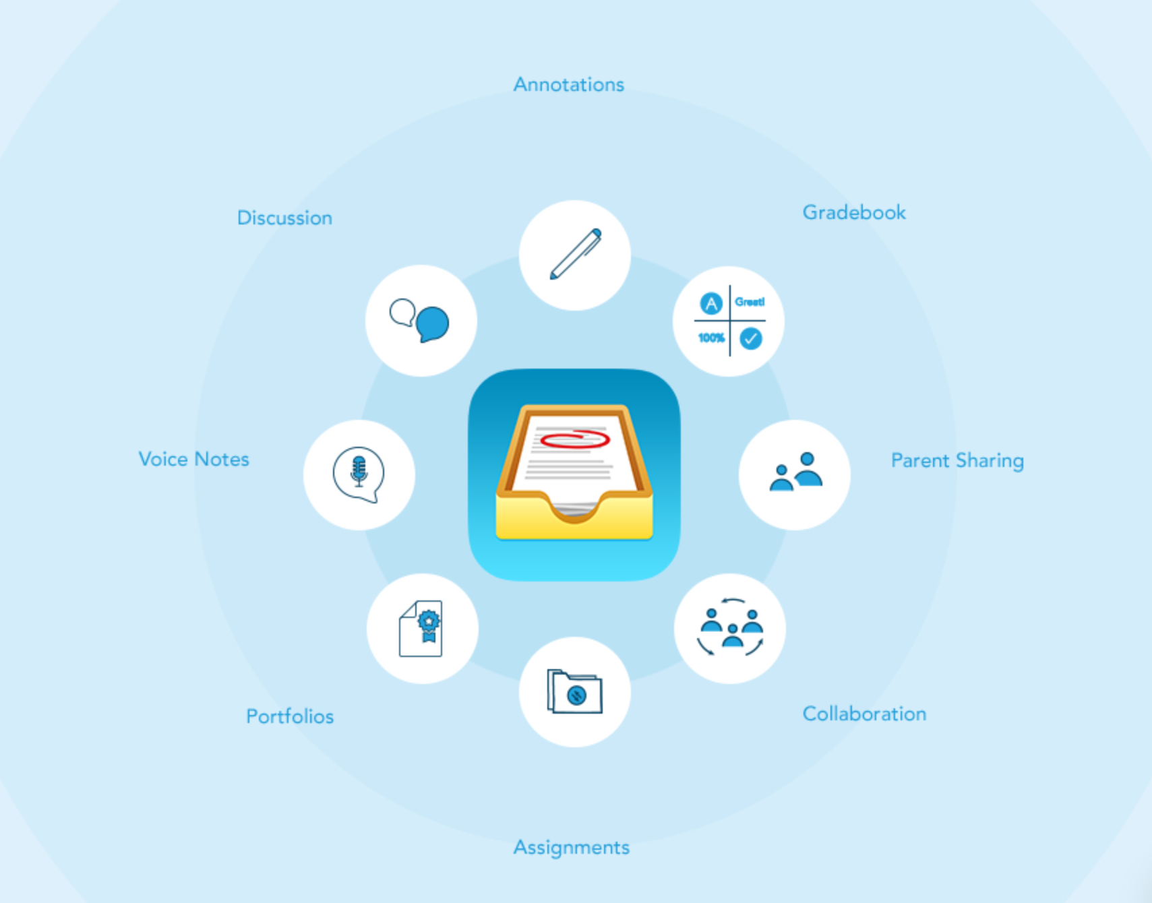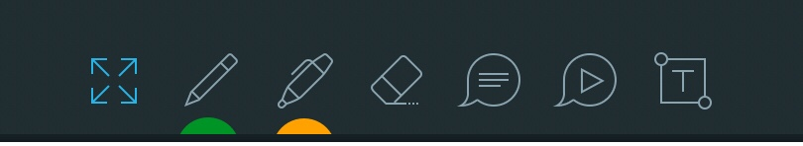

**Pupils will be able to see their class and subject folders where they can then go in and upload a photo of their work. This will be our focus for the first few weeks! Sharing our learning!**

**Soon, teachers might also upload challenges into these subject folders for pupils to complete at home. This will then be sent to the teacher who can then provide feedback digitally.**

**Welcome to Showbie! This is a new way that pupils in St Brendan’s can share and complete work with both teachers and parents and carers!**

*You’re Invited!*

**Pupils will be able to type, write, erase, voice note and comment on documents uploaded to Showbie and teachers can mark and provide feedback on any piece of work using the same method.**

**Pencil. Highlighter. Rubber. Comment. Voice note. Text box**

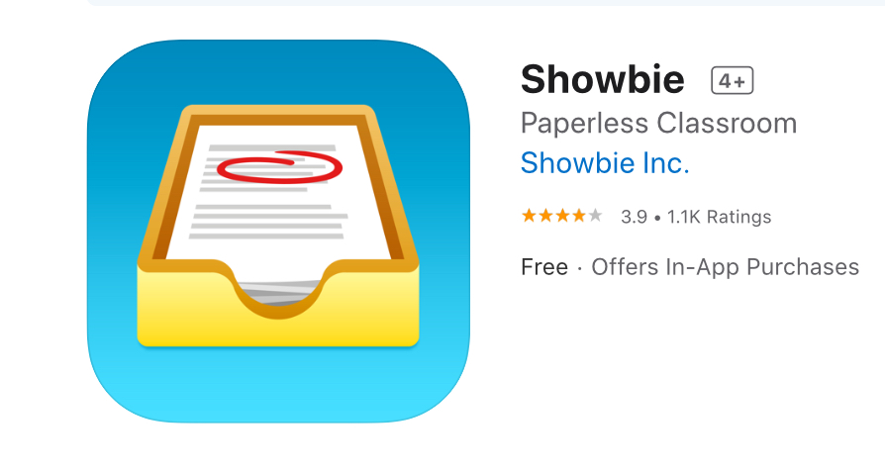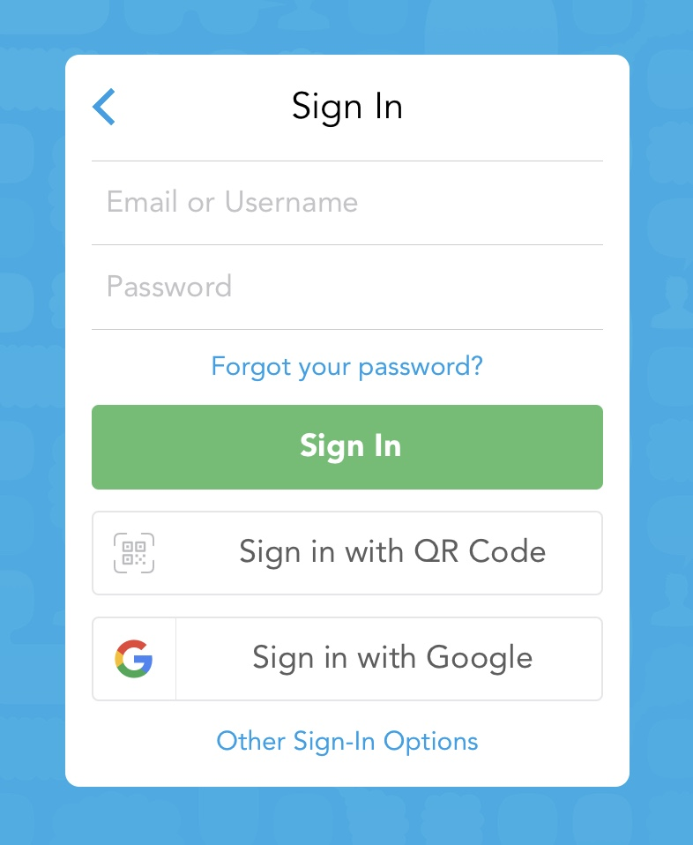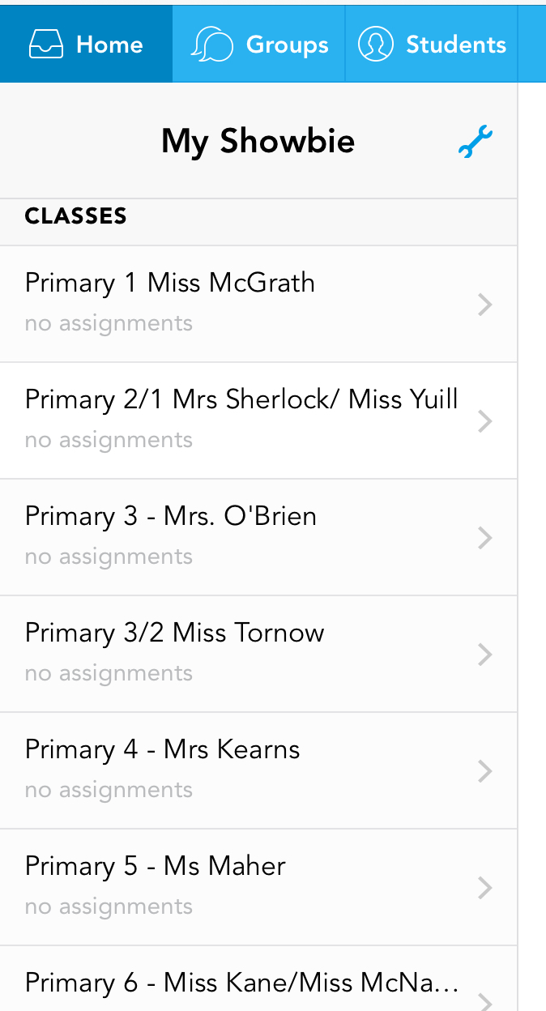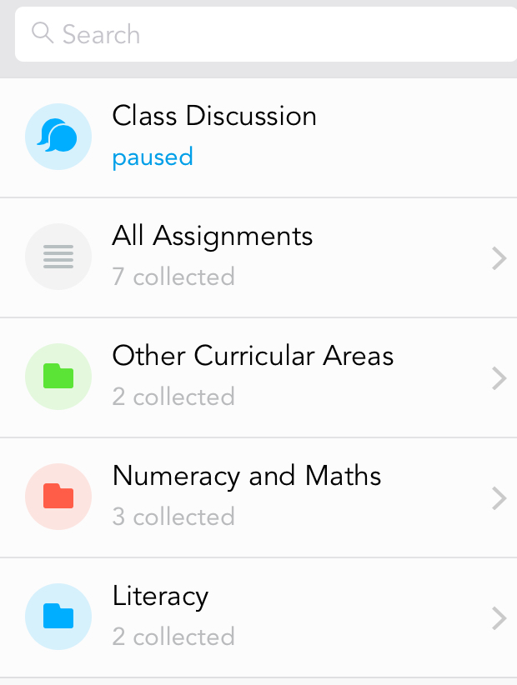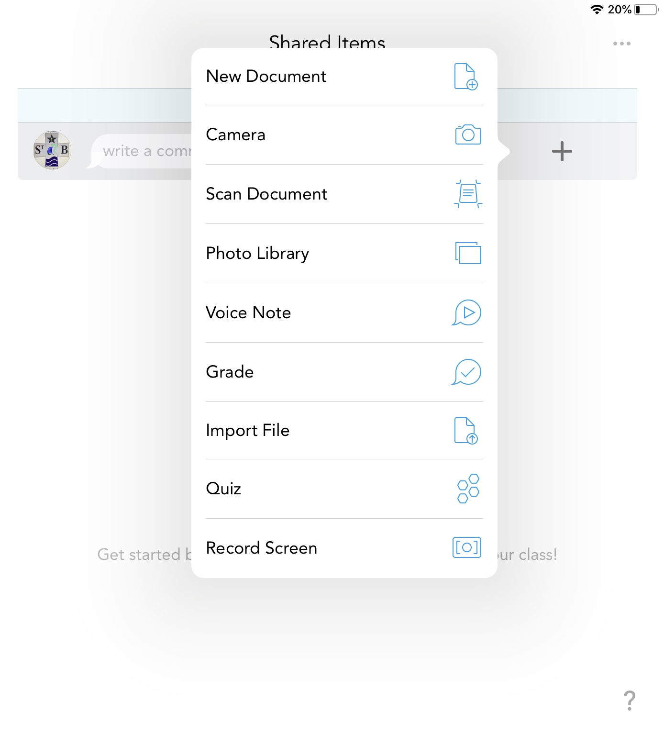

**We are going to start with sharing our learning over the next few weeks!**

**There are helpful instructions and instructional videos on the St Brendan’s Glow Blog as well.**

**1. Download the Showbie app (It’s free).**

**2. Sign in with your username and password!**

**3. Click on your class and then click on the subject folder you would like.**

**1. Click on the subject you wish to post in.**

**2. Click on the + sign and then choose camera to upload a picture of your work!**

To upload a picture of your work, follow the instructions below!