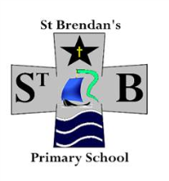

St. Brendan’s Primary

Anti Bullying

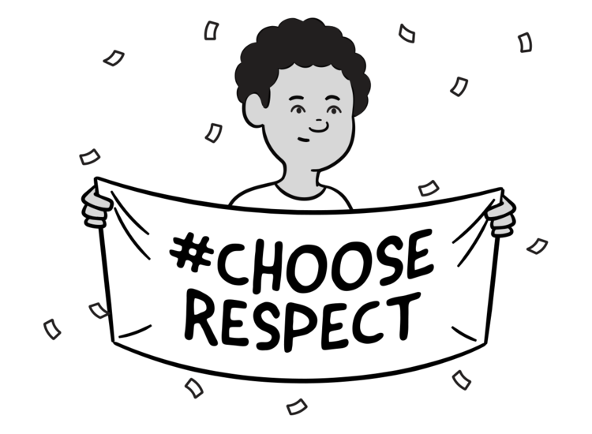

You don’t have to like me……..

You don’t have to be my friend…

You don’t have to agree with me ……

Or enjoy the things I do ……..

**BUT YOU DO HAVE TO RESPECT ME !!!!**

**In St Brendan’s all staff work together**

**to create a supportive and positive ethos .**

**“Bullying is not just part of growing up “**

People who display bullying type behaviour are sad people

A joke is only funny when everyone laughs otherwise it is bullying type behaviour .

zs

Most people can take a joke , but not when it’s hurtful.

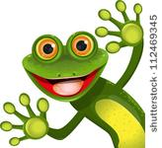

Planning to take revenge is like drinking poison

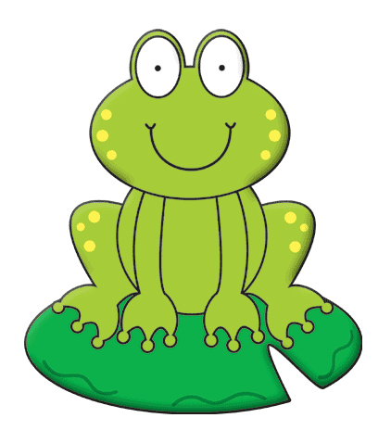

People who display bulling type behaviour feel strong but they are weak.

People who display bullying type behaviour never recognise themselves ….. are you sure you’re not one ?

Sticks and stones may break my bones but unkind words will always hurt me.

Your life won’t improve by ruining someone else’s

BUT YOU DO HAVE TO RESPECT ME !

BUT YOU DO HAVE TO RESPECT ME !

BUT YOU DO HAVE TO RESPECT ME !