St Blane’s Primary
Standards & Quality Report
Session 2025 – 2026

This summary report is provided for parents/carers and partners to outline our achievements and improvements during session 2025 - 2026 and to share our improvement priorities for 2026 - 2027. Throughout last session we took forward our improvement priorities as detailed in our school improvement plan. Using our approaches to self-evaluation, we have detailed in this report the impact of our work and identified how we plan to continue to improve outcomes for our children and young people.

The context of the school
St Blane’s Primary School is a denominational, co-educational school which is part of John Paul Academy learning community. Our school, situated in the Summerston area of Glasgow. It is a single storey building, opened as our school in 1975 with twelve class bases, a gym/assembly hall, wellbeing room and Art Room. One of our class bases is our nurture group “The Sunshine Room”. The school is surrounded by a mixture of rented accommodation, social housing and owner-occupied housing. The school benefits from some additional resources and funding which has recently been boosted by the Scottish Government’s allocation of Pupil Equity Funding to support ‘closing the gap’. The current school roll is 257. 48% of children and young people reside in SIMD Deciles 1&2. 44.5% of families are eligible for FSM. Attendance is presently 94%. Exclusions have been at 0% for the last few years. 41% of our learners are supported through the Staged Intervention Model.

Our achievements and improvements 2025 – 2026
We would like to highlight the following improvements/achievements agreed in consultation with school staff, parents and children.
Our priorities for 2025/26 were:
Achievement and Progress
- Achievement and Progress – Raising attainment in Writing (All stages but data focus on P4)
- Achievement and progress – Raising attainment in Numeracy P5-P7
Wellbeing and Inclusion:
- Embedding inclusive practice within our classrooms and the wider school community with a focus on equalities and continued focus on attendance
- .Nurturing social, emotional and mental wellbeing to improve attendance
What we did
- We provided targeted Literacy support to raise attainment across P1-4 with the continued
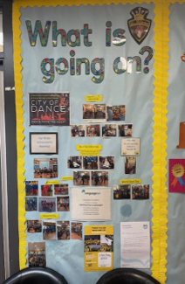
- implementation of Read, Write, Inc. This has helped our children reach the expected standard of phonics, develop their reading fluency and read with comprehension. It focuses on supporting the children to spell and write with confidence whilst developing co-operative behaviour and opportunities to articulate their ideas and understanding.
- In P4-P7, class teachers engaged in professional learning with Talk for Writing which was then implemented into the P4-P7 classes with a focus on raising attainment in writing.
- We focussed on raising attainment in reading with individual pupils in P5-P7 using the Fresh Start programme and targeted focus groups.
- Staff, children and parents worked together to embed the UNCRC into all aspects of school life. This included staff training, curriculum development, policy updates, pupil participation through committees, assemblies, campaigns in each class for their Class Charter, a contribution which ensured rights and equalities are part of the school culture where everyone understands and can talk about children’s rights.
- We continued our enhanced nurture support for P4-7 and bespoke curriculum for young learners who required it. Children and young people within the Nurture/ Inclusion Provision are able to recognise and share their achievements, as well as plan their next targets

- Staff have been working together on assessment, tracking and moderation activities to make sure work is consistent across the school, helping all children to achieve their best
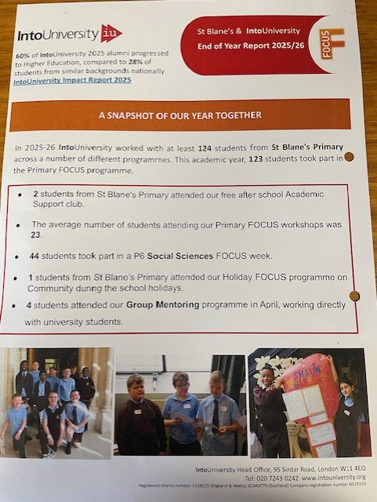
- We made community links with Into University through the partnership with Glasgow University which enabled children to access a wide variety of workshops culminating in their own graduation ceremony for Primary 6 pupils.
- We issued newsletters, used our school app and text messaging to communicate with families. We continued to use Seesaw and Showbie to support our learning and promote parental engagement. Workshops such as ‘ ‘Bookbugs’, ‘Read, Write, Inc’ and Glasgow counts for new families.
- Highly effective Nursery to Primary and Primary to Secondary transitions took place from January 2026. Children had the opportunity to attend school in groups to meet their peers and class teacher. Enhanced transition meetings and Stay ‘n’ Play sessions were held with parents to support new P1 /new 1st year children.
- We have expanded pupil leadership opportunities through our Junior Leadership Team, House Captains and Vice-Captain, Junior Road Safety Officers, Library Guardians, STEM ambassadors, and Buddies as well as hosting fun displays of knowledge for Cultural awareness/black history month which has led to increased confidence, responsibility, motivation and engagement, as well as fostering a culture where children feel heard, included and respected. Our Science fayre was a great success showcasing our talented, innovative and creative thinkers here in St Blane’s Primary.
- Staff have engaged a wide range of professional learning activities to support inclusive practice focussing on trauma informed strategies..
- Our musical support and lessons from the music leaders at John Paul Academy including brass, woodwind and strings support expands our pupils creativity and opportunities to build confidence.
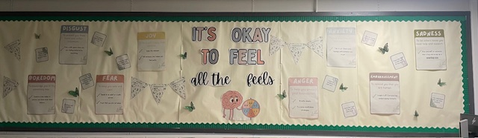
- We celebrated with pupils, parents, parish and community our 50th anniversary through Holy mass with our parish and Archbishop Nolan, a fun Scottish family night, a Jubilee Show, a family fun day and a whole school photograph to record our moment in time. Lots of memories from our community were also shared over the year with nostalgic photographs and fun stories. The original head teacher and some staff joined us for mass and a reception in the church hall (thanks to the community at The Immaculate Conception church for their lovely tea, sandwiches and cake.

Pupil Equity Funding
In session 2025-26, the school used the PEF allocation to directly raise attainment, improve attendance and engagement and support children’s wellbeing. The table below outlines our key interventions:

PEF Intervention
Staff additional hours for our Child development officer and support for learning workers continues Raising Attainment in Literacy, Numeracy and Health and Wellbeing
With Kids Play Therapist: supporting children’s wellbeing and engagement and parental support
Extra-Curricular Programme – supporting vulnerable pupils to be included in Theatre visits to Pantomime and school outings to Blairvadach and Summer trips to Edinburgh Zoo.
Transport for P7 Residential Experience to Ardentinny– Health and Wellbeing
Achieve More – Coaches supporting Inclusion

Attendance and Exclusion data
Attainment
The table below summarises attainment as of June 2026.
We have collected data in a variety of ways and tracked pupil’s progress across the curriculum. The table below summarises achievement of a level and this information allows us to identify strategies to close the attainment gap.
Our Attendance was 94% and we had 0 formal exclusions during session 2025-2026

 | Reading | Writing | L&T | Numeracy and Maths
Primary 1: Early | 93% | 91% | 86% | 93%
Primary 4: First | 87% | 85% | 100% | 85%
Primary 7: Second | 83% | 80% | 100% | 85%

Our improvement plan priorities 2026 – 2027
Challenge: Progress: Learning and Teaching - Mission : Accelerate children’s progress in numeracy and reading through the consistent application of high-quality pedagogical approaches across the school.
Challenge: Wellbeing: Inclusion – Mission: Introducing core groups of support – Cool Connections, EmotionWorks, Seasons for Growth – and recording the impact on pupil wellbeing.
Wellbeing spaces for pupil access – The rainforest room, the wellbeing room, The Hub and The Hive.

 | How Good Is Our School 4 Quality Indicator (QI) | Evaluation
 | Leadership of Change (QI 1.3) | Good
 | Learning Teaching and Assessment (QI 2.3) | Very Good
 | Ensuring Wellbeing Equality and Inclusion (QI 3.1) | Good
 | Raising Attainment and Achievement (QI 3.2) | Very Good

How to find out more about our school
Contact us directly if you require further information about our school or if you wish to comment on this report.

Our contact e-mail address is: Headteacher@st-blanes-pri.glasgow.sch.uk

Our telephone number is: 0141 945 1276

Our school address is: St Blane’s Primary, 23 Arrochar Drive, Summerston, Glasgow, G235QB

Further information is also available in our newsletters, on our school website, and in our school handbook and via our website:
