**St Blane’s Primary School**



23 Arrochar Drive

Summerston

Glasgow

G23 5QB

Phone: 0141 945 1276

E-mail: [headteacher@st-blanes-pri.glasgow.sch.uk](mailto:headteacher@st-blanes-pri.glasgow.sch.uk)

**Head Teacher: Mrs L McVey**

**Depute Head: Mrs L McGreechin**

Date: 26th September 2024

Dear Parent/Carer

**BY-ELECTION – Ward 14 (Drumchapel/Anniesland), Ward 15 (Maryhill) and Ward 21 (North East) – Thursday 21st November**

I have been informed by Douglas Hutchison, Director of Education, that the above By-Elections will take place on Thursday 21st November 2024.

Although visits were made to establishments to check on the possibility of keeping the buildings open for pupils, I am sorry to inform you this will not be an option.

Unfortunately, this means that our school will be **closed to pupils** on the day of the By-Elections – **Thursday 21st November 2024**.

Thank you for your co-operation in this matter which is out with our control.

Yours sincerely

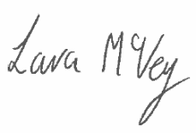

Mrs McVey

Head Teacher