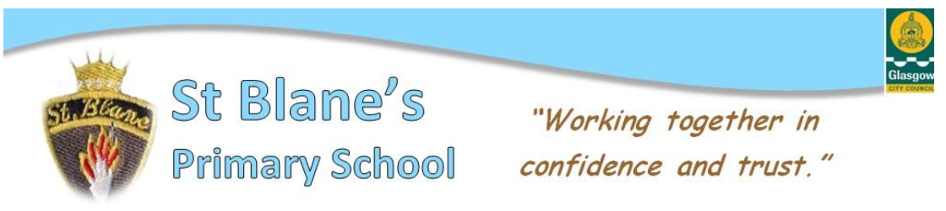Welcome back! This is our first school newsletter of the new session. I would like to officially welcome our new Primary 1 children and families. They have settled in so well and are already part of the St Blane’s team. It has been great to welcome all our pupils who returned happy and refreshed after lockdown and the summer break, looking so smart in their school uniforms. Our main focus for learning this term incorporates Health & Wellbeing, Literacy and Numeracy. Class teachers will post curriculum newsletters on Seesaw soon to keep you posted on the learning activities for this term. Our staff and children are following our school ‘Covid Rules’ daily and it is amazing how quickly the children have adapted to life back at school in their class and the playground, it feels as if they were never away! Things do feel a little different in school just now but there is so much fun and learning going on it is difficult to tell. We continue to share our learning on Twitter as supported by Glasgow City Council so don’t forget to have a look - @StBlanesGCC

We will continue to email all information home so please contact the school office if you are not receiving emails or have changed your email address.

Our classes and staff this year are:

Head Teacher: Mrs McVey Depute Head: Mrs Heaney

PT: Mrs McComish PT: Mrs Moore PT: Mrs McGreechin

Sunshine Room – Mrs Ferry

P1a – Miss Devine

P1b – Miss Boyle (Mrs McGreechin on a Tuesday)

P2 – Mr Iles (Mrs McGreechin on a Thursday)

P3/2 – Mrs Owens

P3 – Miss Valliday

P4 – Mr McNulty

P5 – Mrs MacCuish(Mon/Tues), Mrs Moore(Wed, Thurs, Fri)

P6 – Miss Burke

P7a – Mrs Gallanagh

P7b – Mrs Elliot

NCCT Teacher – Miss Mitchell Additional Teacher – Mrs McCall

Child Development officer – Mrs Shields

Support for learning Workers – Miss Ross, Mrs Sawers, Mrs McPetrie, Mrs Manson, Mrs Casey

Clerical: Mrs Kelly, Mrs Linton

We are currently purchasing waterproof suits for our infant department P1-P3, funded locally through various grants to allow the children to access outdoor learning opportunities. Each suit will be numbered and no child will share a suit unless 72 hours apart. If you have a pair of wellies that your child could leave in school to support this, it would be greatly appreciated (thank you to those who have already sent some in). Please put your child’s name on the inside. They have had so much fun outdoors and we want this to continue into the autumn. Again if the weather is extreme, the children will not be out.

To clarify PE days for the month of September, classes can wear their gym kit to school on the following days:

P1a – Wednesday P1b – Thursday

P2 – Tuesday P3/2 – Friday

P3 – Tuesday &Friday P4 – Tuesday & Thursday

P5 – Tuesday & Wednesday P6 – Tuesday & Wednesday

P7a – Monday & Wednesday P7b – Monday & Wednesday

Infant classes will have outdoor play sessions regularly throughout the week.

**Breakfast Club:** The Breakfast Club is open to all P1 – P7 pupils in the school. Breakfast is available from 8am – 8.40am. The cost of breakfast is £2 for the first pupil and £1 for subsequent siblings who are not in receipt of free school meals. Cordia staff in the hall will supervise the pupils until they are sent out into the playground at 8.45am.

**Gentle Reminder**: No dogs are allowed in the school playground. This is a Glasgow City Council Policy for the safety of all the children and animals.

**Parking:** Please remember we are a car free zone – there is no access for cars on Arrochar Street from 8.30am until 9.15am and from 2.30pm-3.15pm (unless you are resident on the street)

**Health Promoting School:** As part of our health promoting work I would kindly ask you to provide your child with a plastic water bottle to be used during the school day. Playtime snacks and lunches should aim to be healthy too so please avoid or limit treats like crisps, chocolate and sweets. Fruit or raisins are a better alternative. Only water will be allowed during class time. Many thanks for your support in keeping our children fit and healthy.

**Parent Council:** Our Parent Council are very active supporting our school. Current positions held are:

Chairperson – Nikki Campbell

Vice Chairperson – Catherine Devaney

Treasurer – Lisa McGeady / Kimberley Fowler

**School Bus:** We would ask parents to remind their children who travel on the school bus to sit calmly and not to change seats and to wear their **seat belts at all times**. Some children have been taking their seat belts off and standing up before the bus has stopped. This is obviously dangerous and can cause injuries. All children are asked by Scottish Government to wear a mask where possible on the bus.

Our bike shed has a few bikes and scooters that were left before lockdown – Please ask your child to collect them if they are yours.

Once again, thank you for your continued support. Please get in touch if you have any questions or concerns.

Kind Regards

Lara McVey

Head Teacher