

Dear Parent/Guardian,

We are looking to extend our Outdoor Learning resources as we are using our outdoor areas more at this time. If you have any building materials you could contribute to the school we would be very grateful. Outdoor Learning encourages children’s curiosity, creativity, exploration and investigation.

|  |  |
| --- | --- |
| **Building Material** | **Tinker Table** |
| Plastic Piping | Screwdrivers |
| Guttering | Screws |
| Planks of Wood | Old Radio |
| Pieces of Decking | Old Computer To take apart! |
| Tyres | Old Bike |
| Anything similar to above! | Old Phone |

We appreciate your support and thank you in advance.

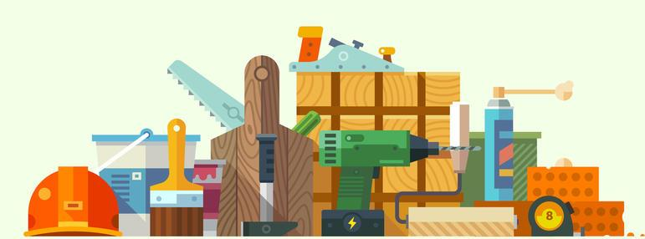Mrs McGreechin and Mrs Shields

*Please bring any donations to the infant shed in the morning before 9.00a.m.*