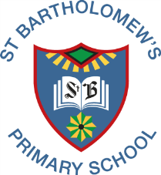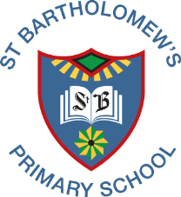St. Bartholomew’s Newsletter

May 2020

‘Let Our Values Excel’

Dear Parents/Carers,

As we remain on our journey through these uncertain times we continue to understand the pressure each of our families is facing especially supporting your children to continue to learn.

The health and wellbeing of you and your family is the most important thing, and no one expects parents to take the place of teachers.

Our team continue to work hard in order to facilitate learning that is enjoyable yet sustains the learning already taken place.

We are keen to keep communication strong amongst our community with all our staff on hand to help support you and your family.

Stay Safe and God Bless.

Mrs Fitzpatrick

**Showbie/Seesaw**

Our teaching staff have been using **Showbie (P6&P7)** and **Seesaw(P1- P5)** for the past few weeks to share activities to support pupil learning. The response so far has been very positive. Well done to you all!!

We will continue to use this to support learning but if you have any questions or concerns, please do not hesitate to contact us.

**Reports**

Normally the Pupil Progress Reports are sent home with pupils in June. Teaching Staff are finishing writing these based on the progress up to the end of Term 3 and using observations from online engagement in Term 4. I will send a communication out to let you know when your child’s class report is ready for collection from the school.

This will be done with social distancing measures which will be very strictly applied and we will only be able to offer one opportunity for collection. We are looking at a way of doing a sibling report in order to allow a collection of more than one report. We will be in touch with you all when we have more information.

**New Primary 1s**

GCC have nearly completed enrolments of our new Primary 1 children for August 2020. Letters are expected to be posted out within the next week.

We will then be touch regarding supporting new P1s with their transition to St Bartholomew’s.

In the meantime have a look at our website for info.

https://blogs.glowscotland.org.uk/gc/stbartholomews/

**Returning to School**

When children do eventually return to school, we do not know what this will look like. We will certainly support all of our children and families with the changes that lie ahead.

We will also continue to work with our Secondary colleagues to ensure that we support our Primary 7s with their transition.

Please follow us on Twitter @stbartholomews1 for school updatesand ideas for home learning. Give us a wee ‘like’ and comment on our posts too please!

**Or Check out our Website:**<https://blogs.glowscotland.org.uk/gc/stbartholomews/>