Getting Ready for Primary 1 Family Learning Booklet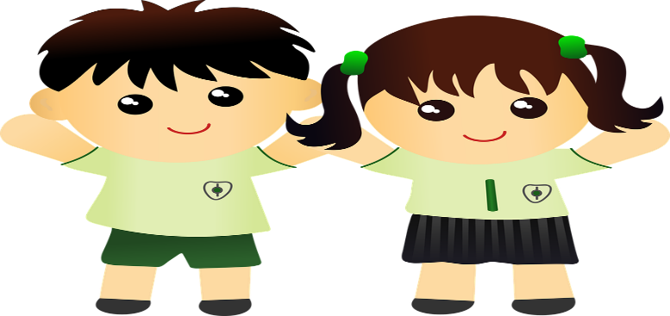

Name of School:

Name of Child:

Name of Parent/Carer:

Name of Primary 1 Teacher:

To parents/ carers,

As part of our Primary 1 family transition programme we would have normally had a dedicated four session programme (in the school) based on starting school, what to expect and activities related to a book that your child will do in Primary 1. Due to the recent Covid 19 pandemic we have had to “think outside the box” and look at ways we best prepare children and families for going into primary 1 in August. So, we have designed some simple activities to help you on your way.
Ok… so let’s get started..

All About me

My name is
-------------------------------------

This is me (this can be a drawing or picture)

I am ……………………….years old

My favourite food is ……………………………

My favourite story………………………………..

I love …………………………………………..

My skills:

I can wash my own hands I can zip my jacket up
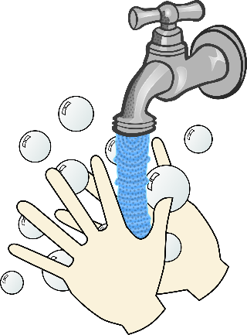
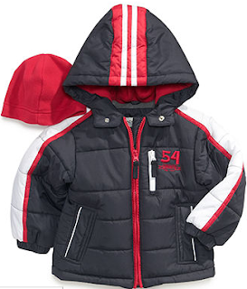

I can go to the toilet by myself I can take turns.
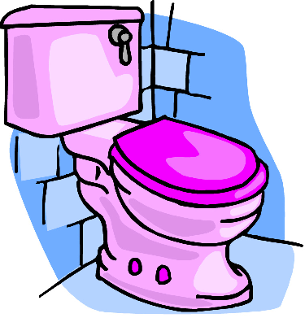
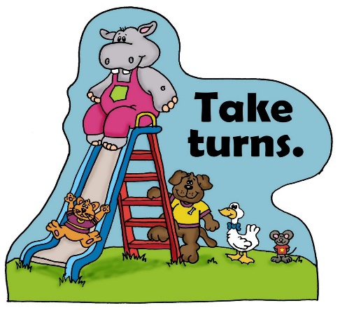
I can put my shoes on I can put my hand up to answer questions
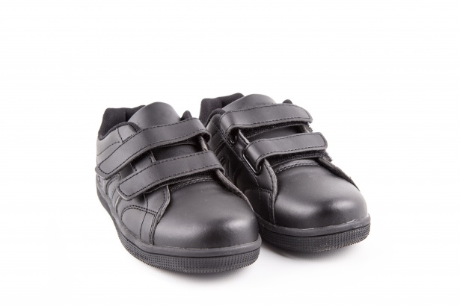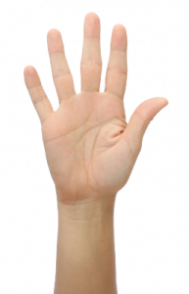

I can use a knife/ fork / spoon I can put my clothes on myself
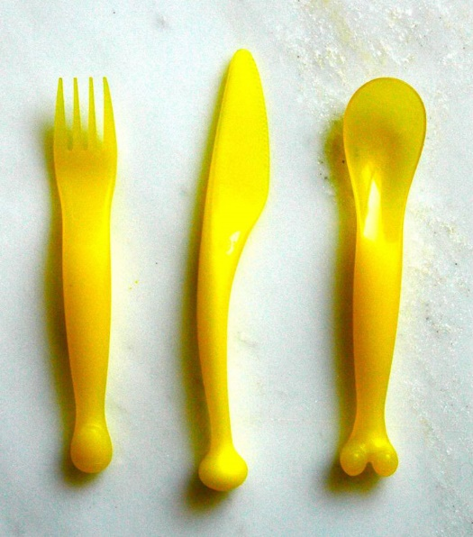
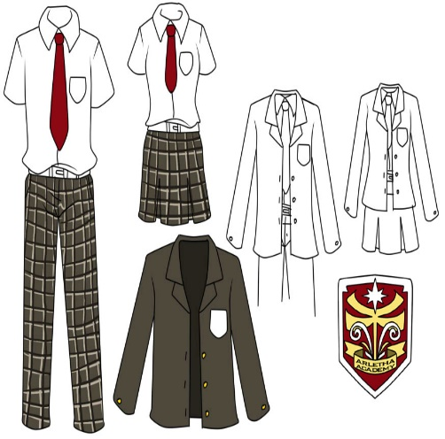

Top Tips for parents/carers
- Encourage a love of stories and books
- Try to support your child to recognise their own name- for their name tag/peg.
- Getting familiar with numbers, letters and sounds.
- Singing nursery rhymes, getting out in the garden, baking and just chatting together.
- Get into good sleep habits- a good bedtime routine is key to learning and growing. Every child is different and you will know what the best routine is for your child.
Family Together Time Activities
Book gifted from your new school: Harry and The Dinosaurs Go to School.

Activity Idea 1: Read the story to your child or play one of the read aloud’s on You Tube if you have it https://www.youtube.com/watch?v=e87RI11rzRs.
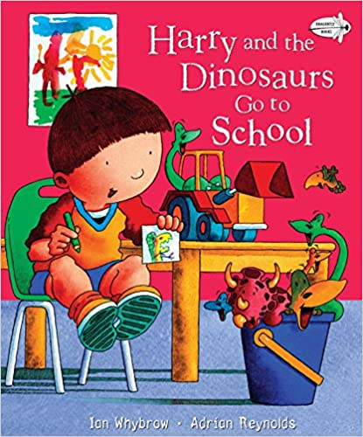
- How is Harry feeling before he goes to school? How do you feel?
- Harry’s favourite toys are his? He takes them in a …….?
- Who takes Harry to school on his first day?
- What’s Harry’s teacher’s name?
- How does Harry feel about the playground?
- What toy does the little boy in his class who cries all the time have?
- What does Harry offer to do with his new friend?
- What do they do as their first activity at school?
--------------------------------------------------------------------------

Activity 1 Make your own coat tag/peg.
Draw your favourite animal/toy/book just like Harry.
Use pens/ paper and draw your coat hook.
M Hi my name is …Harry ………………………….. This is my coat hook label. My favourite toys are dinosaurs. 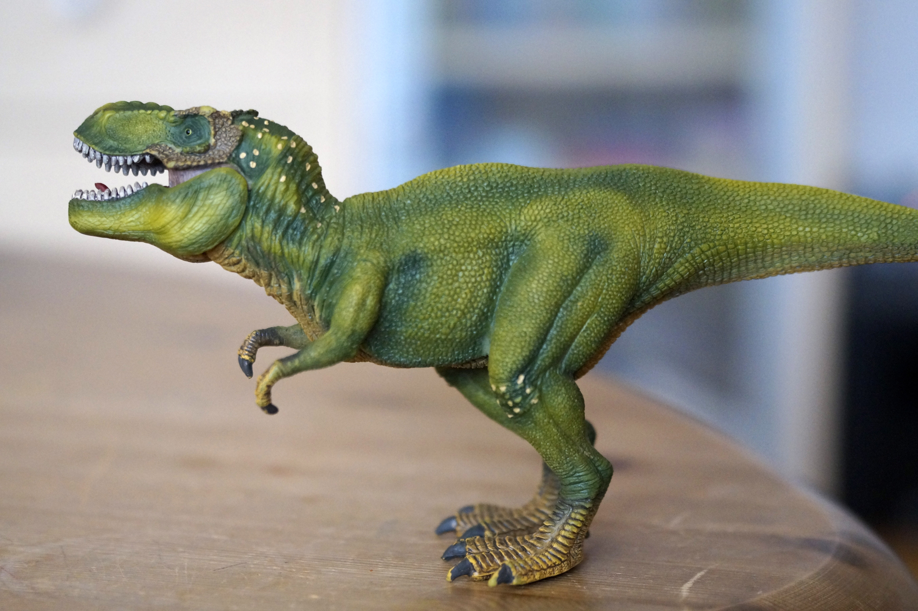

Activity 2 Alphabet Treasure Hunt 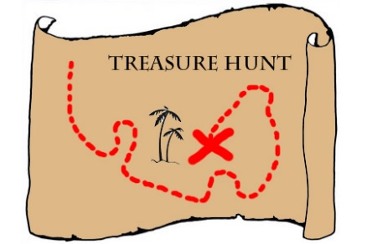

Parent- Write the alphabet from A-Z on little bits of paper and place around the house. Ask your little one to go around the house collecting as many alphabet letters as they can. When they collect all of them play a game of placing them in order. See if your child can repeat after you for example: a for apple, b for ball. Then ask what does the letter of your name start with? Your favourite toy? Story? TV programme? You could do it with numbers too- 1to 10 your child could go and find the numbers around the house/ garden.
(This can be done inside or outside)

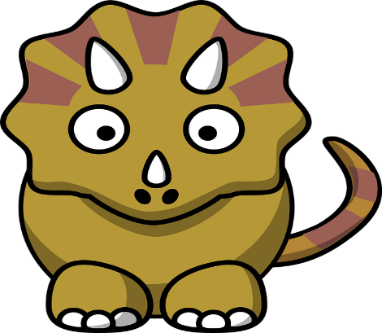
Activity three – Dinosaur Peg Counting

Together cut out 10 dinosaurs (included in the pack) or draw your own. Write the numbers 1-10 on each dinosaur giving them a number. .Then with your child put all of the dinosaurs face down and ask them to pick a card. Ask the child to say the number and clip the amount of pegs to the number on the dinosaur picture.
(This can be done inside or outside)
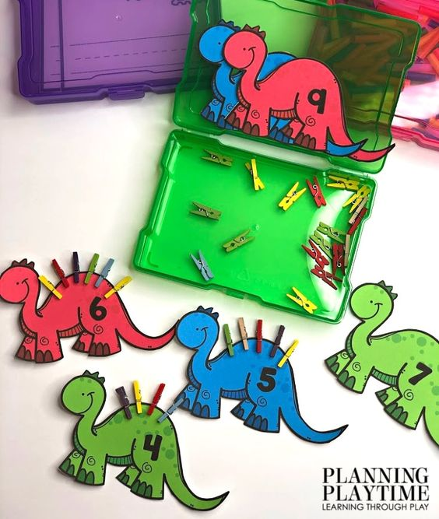

Templates:

Make my own Dinosaur!! 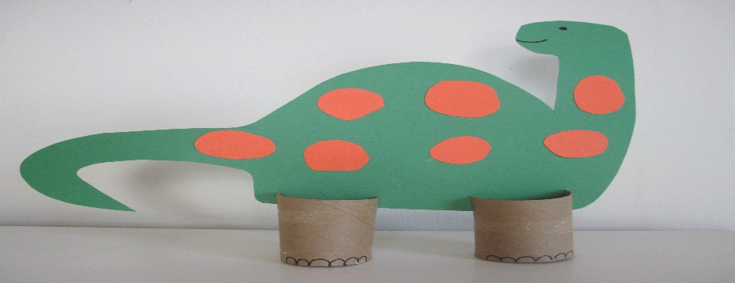

Together with your child use boxes/ toilet rolls and anything you can find in the paper recycling bin/ old magazines, tape, pens and glue. Ask your child to build their very own Dinosaur- ask them to give it a special name and special powers.
(This can be done inside or outside)

On the first day of Primary 1 bring your special dinosaur creation to your new P1 class!!

Additional Starting School Information (this is for individual schools to insert)

