

St Albert’s Primary School Newsletter

December 2016

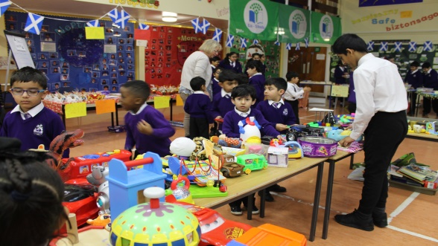

Our Christmas Show ‘The Nativity’ was spectaular and I am so proud of all the staff and pupils involved especially Mr Stewart and Miss Kinloch who directed the show. We had some invited guests from the local community and from other educational establishments. They have all passed on their congratulations to the pupils. What comes across is that the audience could see the hope and enthusiasm in all the performers. Well done them for another amazing achievement.

**Through your support we are able to given Glasgow City Mission 12 boxes of food and a cheque for £500 to help people who are homeless this Christmas. Thank you so much.**

**Road Safety**

As you are aware road safety and safe driving are a priority for our school. Our Junior Road Safety Officers; Alisha, Arisha, Danny and Sana have been mounting a very visible campaign backed by our local Police and Glasgow City Council. The aim is for all of you to drive safely, avoiding accidents and parking properly. You all know that some of the driving is dangerous and I would ask that you please back the children up before someone is badly injured. Next term you will be asked to sign a parking pledge in order to keep the roads safe.

**Home Learning and Parent Workshops**

We have now completed our new homework policy and will share this with you in the new year. We are

hoping that the new process is more focussed and will help direct you in supporting your child with home learning. The home learning workshops including the literacy and numeracy workshops were very well attended and we know that this makes a difference to your child.

Here we are , all of a sudden, at the end of term two. I can hardly believe that we are almost half way through the year. We are all excitied and very happy here with the progress that your children are making and with some of the fantastic learning experiences they are having.

All of us are looking forward to our break but, more importantly, looking forward to next term and developing more interesting experiences for your chilldren.

I would like to take this opportunity to wish you a happy holiday, Merry Christmas and peace and joy for the New year.

**Staffing**

We are delighted to welcome Mr Johnathan Orr to our school as a teacher who support children who have English as an Additional Language. He is already making a difference and producing some interesting work.

All of us are sad to say good bye to Mr McGinn who has taken up a new job within education. We are grateful for the years for service at St Albert’s and we will all miss him very much.

Congratulations to Miss O’Connor as she becomes Mrs Martin during the holidays. We wish her and her new husband a lifetime of happiness.

C:\Program Files (x86)\Microsoft Office\MEDIA\CAGCAT10\j0230876.wmf

**Christmas Events**

As always you have been amazingly supportive of all our events this term. Our Chrismas Fayre is an excellent opportunity for our children to show off their outstanding social enterprise skills. The stalls were creative and colourful. There was a real buzz in the room. The pupils raised an unbelievable £1000 for school funds.This is used to fund trips, house prizes and resources for classes. We also hope to save for a big trip for all pupils at the end of term. The children value these experiences and we use them as a way to improve learning.

Thank you so much for supporting our hilarious Christmas jumper day. I think the winning teacher must be Mr Church who dressed as a reindeer complete with antlers and a red nose. **Thanks to you we raised more than £160 for Save the Children!!**

I look forward to continuing to work with them. They generously donated £400 to the school to allow us to take the children to the Odeon to see Finding Dory. We had a brilliant time.

**Timekeeping and Attendance**

Thank you for supporting us with timekeeping and attendance. It is improving thanks to all your efforts.

**Newsletters/Website**

We will continue to issue school and class newsletters throughout the year - this is one way that we can keep you informed. Using our school app you should be able to see translated versions of our newsletter.

We will also use regular texts so please make sure we have your correct mobile number.

**To download: search for ‘mySchoolApp’ in your app store, open the app and enter ‘St Alberts Primary School’ then register your details and you are ready to go.**



Please **follow us on twitter @StAlbertsG41**

**All of our news and events are posted on Twitter.** 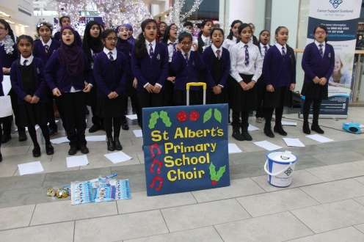

I am so proud that this newsletter is too small to tell you all the wonderful things your children and have been doing. We could honestly write a newsletter every day of the week!

Thank you so much for your support and special thanks to staff for all their hard work throughout the year. Looking forward to working with you all in 2017.

Clare Harker

HEAD TEACHER

Next term we will be looking at ways of raising attainment in maths that includes improving maths literacy. We will need you help with this and will hopefully be able to share some strong results on pupil attainment. Thank you for supporting this important work.

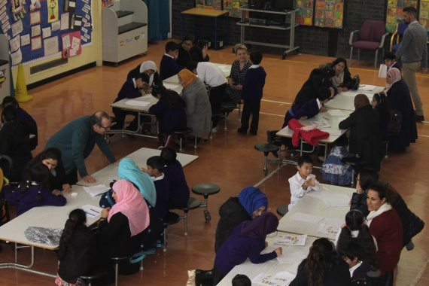**Partnerships: Mother India, Barrowland Ballet, BBC**

Partnerships are crucial in successful schools. P3, P6 and Class two have all benefitted from working with the internationally recognised Barrowland Ballet. More news on this soon but you will all be invited to a special performance.

Class 1 cook regularly in class and have recently been making some of Mother India’s very own recipes. We were delighted when the staff invited class 1 along to the restaurant to cook alongside the chefs. This was the most delicious school trip ever. Thanks to Asif and all the staff for their kindness.

Class 2 were also fortunate to be invited to the BBC for an amazing experience where they learned how programmes are made. Tylor even got to read the news though he tells us it didn’t go out live. Fantastic!

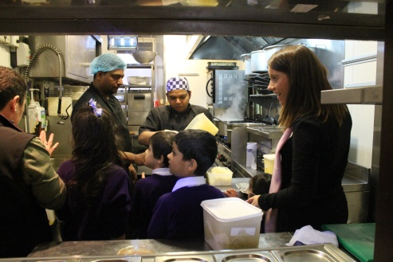

**Parent Council**

We are delighted that our Parent Council continues to

grow stronger with more ideas on how they can support you and the school. They have some excellent things planned for the school including the introduction of a new Award.