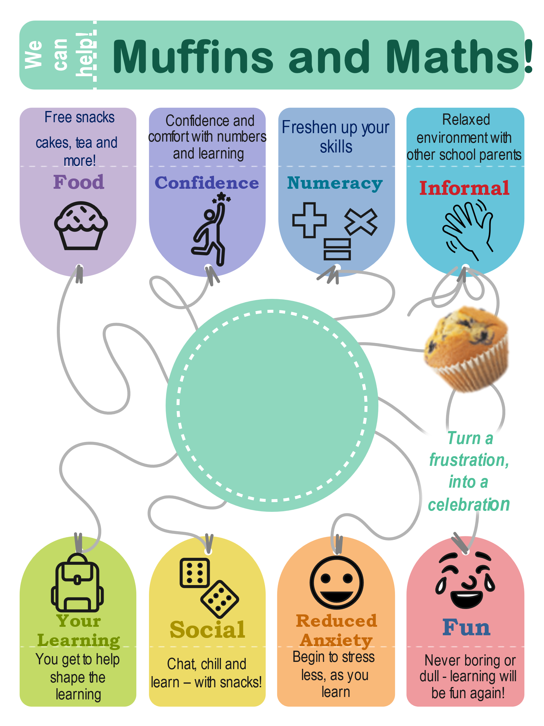

**FREE Group**

**Help support your child develop their numeracy skills through informal and interactive sessions**



**FREE Group**

**Help support your child develop their numeracy skills through informal and interactive sessions**