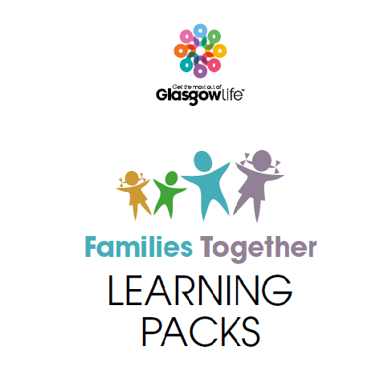

**Play Together**

Family Play Sessions

**For Primary 3 pupils and their parents/carers.**

**Beginning on Tuesday 6th September @ 1.30 – 2.30pm for 6 weeks.**

**Please phone the office if you wish to attend**

**An opportunity to come along and enjoy some Family Play Time.**

**Create, explore & discover play opportunities you and your child can enjoy together.**

**All sessions are free and supported by experienced Play Staff.**

