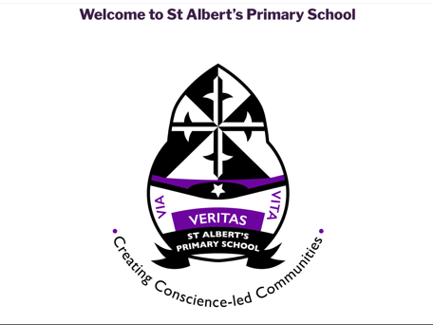
St Albert’s Primary School visits for new entrants in August 2022
We are delighted to invite you and your child to visit our school on any of the following days.

Monday 25th October 1pm – 2.45pm
Tuesday 26th 1pm – 2.45pm
Friday 29th October 1pm – 2.45pm
(Visits will last around 15 minutes)
Please phone the office to reserve a time slot.
0141 429 1983

Staff will be available to take you on a tour around our school and answer any questions.
Looking forward to meeting you and your child.
