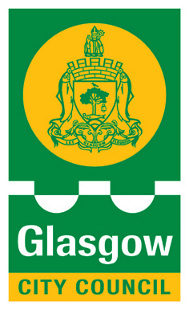
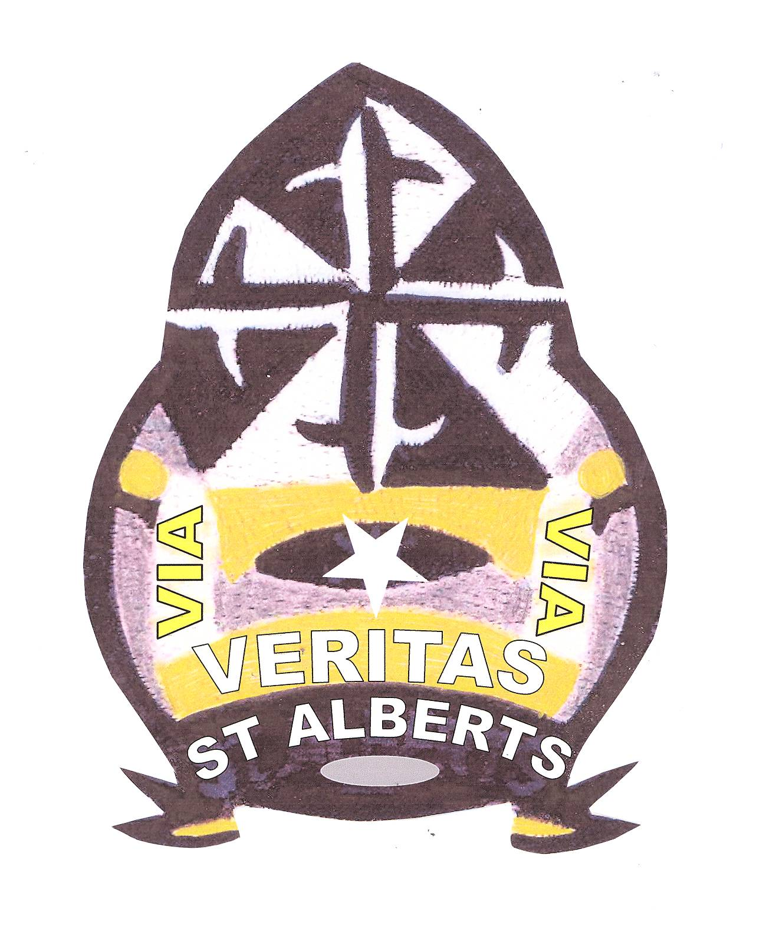

ST ALBERT’S PRIMARY SCHOOL
36 MAXWELL DRIVE
GLASGOW
G41 5DU
TEL: 0141 429 1983 / 2028

Family Learning Dates in October/November/December 2019
All Parents/Carers Welcome!
Please note: Dates and times are subject to change. You will be text any changes and reminders at the time.

Café Connect begins on Friday @ 2pm in room 10 every week
All parents are invited to come along to meet new people over a cuppa.

Parent Yoga class – Thursday @ 2 – 3pm in room 10 every week
Come along for a fun exercise session with the lovely Seema. Meet new friends and learn tips for a healthy life style.

Beautician course – Friday 25th October @ 9am in Room 10 for 8 weeks
Come along to train to apply make-up and paint nails (Course full, please look out for our next course)

‘God’s Loving Plan’ health education information session for P6 & P7 parent’s – Wednesday 30th October @ 9am in room 10
All parents who have children in P6, P6/7 and P7 are invited to come along to find out more about our health education programme. This is very important to help us plan our lessons.

Primary 3 family maths workshop – Wednesday 30th October @ 1.45pm in hall
Come along to learn more about our maths curriculum and how you can help your child at home. You will have the opportunity to learn with your child in maths games.
New entrants open day – Wednesday 30th October @ 2pm
Come along to visit our school and the P1 classroom. Meet the management team and our teachers.

Halloween Disco – Wednesday 30th October @ 5 – 7pm
This will be run by our parent council. Tickets are £2.50 from the office. There will be party bags, prizes and games.

Families Connect Programme – Thursdays @ 9am in room 10
An 8 week programme teaching health, literacy and numeracy to parents and children. (Group already in place this term. Look out for spaces in P1 in December 2019.)

Parent Council Meeting – Thursday 31st October @ 1.30pm
All council members are invited: agenda to follow.

First Aid Course – Wednesday 6th November @ 9- 3pm in room 10
This is a certified course run by Clyde College. (Class already full, please look out for next date)

Primary 4 family maths workshop – Wednesday 13th November @ 1.45pm in hall
Come along to learn more about our maths curriculum and how you can help your child at home. You will have the opportunity to learn with your child in maths games.

Mass in school to celebrate St Albert’s Day – Friday 15th November @ 10.30am
All parents welcome.

Primary 5 family maths workshop – Wednesday 27th November @ 1.45pm in hall
Come along to learn more about our maths curriculum and how you can help your child at home. You will have the opportunity to learn with your child in maths games.

Christmas Family Trip – Thursday 5th December – Event to be arranged.
More details of trip will follow.

Christmas Fayre – Saturday 10th December @ 10 – 1pm
Details to follow

Christmas Disco – Tuesday 10th December @ 5 – 7pm
All children welcome, tickets will follow.

Nativity Performance – Monday 16th December @ 1.45pm & Tuesday 17th December @ 9.30am

Holidays from Thursday 19th December @ 2.30pm until January 6th January.
Enjoy!



