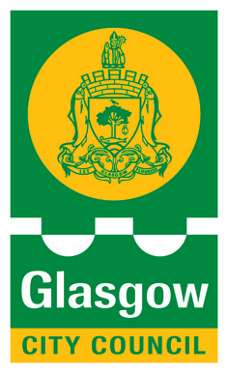

ST ALBERT’S PRIMARY SCHOOL
36 MAXWELL DRIVE
GLASGOW
G41 5DU
TEL: 0141 429 1983 / 2028

Thursday 22th August 2019

Dear Parents/Carers

ANNUAL GENERAL MEETING (AGM)
Thursday 29th August 2019 @ 9.15am in room 10

All parents automatically join the Parent Forum in St Albert’s. There is also a Parent Council which is elected each year at the AGM. It is important that every year we have fresh new faces and fresh ideas on the Parent Council. For all existing and new parents this is a great way to get involved with our School and be part of what makes the School so special.

There are a range of areas that Parent Councils can get involved in across the school and in the local community. These include:

- Parental involvement and meaningful engagement in children’s learning at the school
- Supporting the work of the school
- Gathering and representing parents’ views to the head teacher, local authority and HMIE
- Promoting contact between the school, parents, pupils, providers of early learning and childcare and the local community
- Fundraising
- Organising events
- Being involved in the appointment of senior staff.

Our AGM will inform you of St Albert’s school improvement plan this year and how you can be involved in this. Parent Council members will also share previous year’s developments and successes in the Parent Council and you will have the opportunity to put your name forward to join our parent council.

We hope that ALL parents are able to join us.

Thank you

Clare Harker
Karen Mc Fadden

