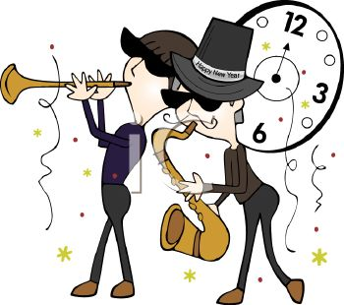
St Albert’s Got Talent Entries
There will be a prize for each category; categories will be
P1 – P3, P4 – P5, P6 – P7
Name | Class | Act
Maryam, Navleen. Eshal, Farah | P4/5 | Singing  Count on me
Lily & Hooriah | P2 | Drama  The Haunted Witch
Safa, Zoha & Hiba | P6 | Dancing  I don’t care
Zahraa & Mahnoor | P3 | Comedy Drama
Kit, & Anthony | P4/5 | Singing & Dancing  We will rock you to the moon
Aisha A, Haleema, Sofia | P3 | Singing & Dancing
Hafsa Saheed | P2 | Writing & reading a story
Ahmed, Otis & Layth | P4 | Gymnastics, dance
Maryam, Haadiya & Aamira | P2 | Singing & Dancing  I’m gonna act like a boomerang
Tylor & Jason | P7 | Football tricks
Khadija | P3 | Singing (Film)
Idris | P4/5 | Singing  Believer
Abdul, Ghaith, Qasim, Muaaz, Mohammed Ahmed & Yahya | P2 | Dancing & singing  7 years old
Dylon & Aibak | P7 | Magic tricks
Zainab | P2/3 | Singing & Dancing
Bashayer & Fatima | P4/5 | Gymnastics/singing  Count on me
Ismail, Hasnain, Adil, Mohammed, Safi, Zaid | P2/3 | Drama  Mental Teachers
Farah | P4/5 | Singing  The Cup Song
Tayaba | P3 | Gymnastics
Neha, Aleeza & Alisha | P5 | Singing & dancing  The Fresh Prince of Bel Air
Subhan, Bilal & Isaac | P5/P7 | Basketball skills
Kayden | P5 | Dance  Iconic
Zarah | P6/7 | Dancing  K-pop – Sunmi gashina
Ishal | P2/3 | Singing
Iqra and Anum |  | Karate
Zaynab, Arisha & Aroush, Aamna, Fatimah | P5 | Singing  Wild Side
Saleeha & Sakeena | P7 | Dancing  Baby shark remix (R & B)
Huzaifa | P6 | Football tricks
Jazil | P6 | Singing  Eco Song
Shadi, Muhammad M, Sarim, Sanjog, Hamza | P3 | Football Tricks
Simmal | P5 | Singing and dancing Speechless
Mariam | P6 | Violin
Ahmed & Yousaf | P4/5 | Comedy Act
Uzair, Zain | P6 | Football skills  noob v pro
Chantel, Amaya & Zara | P5 | Singing & dancing  You can count on me
Aliyan | P4/5 | Football skills  Poke. Seeding and ant
Hamza & Rosemary | P5 | Singing  Hit or Miss
Mashael Al Obaid | P6 | Singing  The fight song
St Albert’s Staff | ALL | Singing & Dancing  ??????

