**Inclusion Coffee Morning**

**Come along to enjoy coffee, cake and a chat. We have a variety of local children’s charities and organisations available to offer advice, help and support for you and your family.**

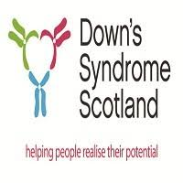**Friday 22nd March at 9am**