
Technical Department
Measuring
&
Marking Out

Homework Booklet

Homework | Due | Mark/Comment | Parent/guardian  (please sign to indicate you have read your child’s work)
1
2
3

4
5
NAME:
CLASS: TEACHER:

Homework 1
In technical we always measure using millimetres (mm). You will probably have measured in centimetres (cm) before. Most measuring instruments, like rulers and measuring tapes will only have cm on them.
It will be important to your studies in technical that you are able to convert cm to mm.

1cm = 10mm
10cm = 100mm
100cm = 1000mm
Using the information above, convert the following measurements in cm into mm.

2cm | mm | 1.5cm | mm
20cm | mm | 25cm | mm
50 cm | mm | 45cm | mm
Now convert the following measurements in mm into cm.

10 mm | cm | 25mm | cm
50mm | cm | 75mm | cm
100mm | cm | 350mm | cm

Homework 2
Measure the lengths of the following lines in mm.
You will need to use a ruler.
Remember to convert sizes from cm into mm.

________mm

________mm

________mm

________mm

________mm

Measure the height of the following objects in your house.
You will need to use a measuring tape.
Remember to convert sizes from cm into mm.

Kitchen worktop | mm | Light switch height | mm
Doorway | mm | Dining chair | mm
Bed | mm | Letterbox height | mm
Homework 3
Without using any measurement tools, mark the accurate centre of the square shown below.
Name any projects you have competed in the workshop where you used this technique of finding the centre.

On the same square shown above, using a ruler:
- Measure in 20mm from each corner.
- Do this on all four sides
- Join up each measured point to make an accurate
octagon shape.

Shown is an example of how this should look. Example is not to scale.

Name any projects you have completed where you have measured corners like this.

Homework 4
Complete the table by writing the name or use of the marking out tools shown below.
TOOL NAME | PICTURE | USE
STEEL RULE | 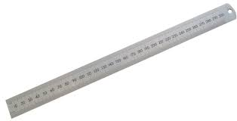 | ______________  ______________
__________ | 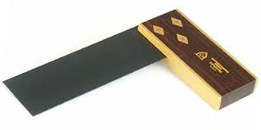 | Used to mark an angle 90 degrees from an edge. Can also be used to check that corners are square. Mostly used with wood
MARKING GAUGE | 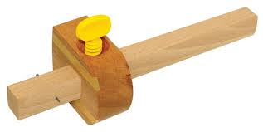 | ______________  ______________

Homework 5
Complete the table by writing the name or use of the marking out tools shown below.
TOOL NAME | PICTURE | USE
__________________ | 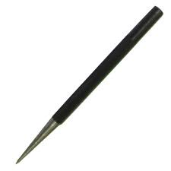 | Used to mark out onto metal.
ENGINEERS SQAURE | 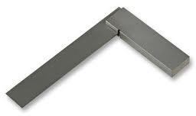 | ___________________  ___________________  ___________________
__________________ | 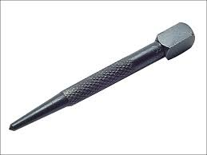 | Used to mark the centre of a marked pint in preparation for drilling
ODD LEG CALIPERS |       

