National 5 Homework 1

Non calculator



1)



2) A pupil scored 75% on an assessment. If they scored 54 marks, how many marks was the assessment out of?



3) Find 3·7% of 25



4) The amount of a drug in a patient’s body decreases by 15% per hour. If 80µg of a drug are administered at 9am, how much will remain at 11am?



5) Simplify the following as far as possible

a) b) c)



d) e) f)



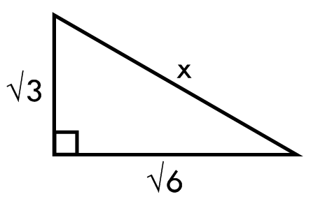

6) Find the length of x.

