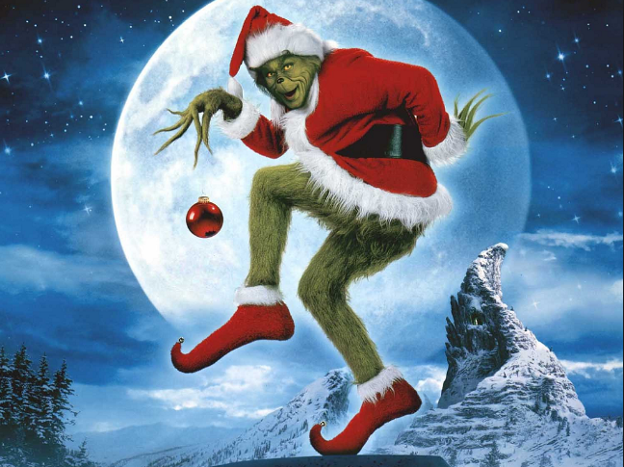Gray the Grinch’s Mathematical Advent Calendar

December 1st

Solve the following inequality

$$5- 3x>4x+9$$

December 2nd

Fully factorise the following expressions.

$\frac{1}{4}-a^{2}$

${6x}^{2}+2x-20$

$9-18y- y^{2}$

December 3rd

Express $4^{-2}+3^{-2}$ in the form $\frac{a}{b}$ where $a$ and $b$ are whole numbers.

December 4th

A cylindrical flask has a diameter of 6cm and a height of 8cm.

It is filled with water up to a height of 6.5cm.

A solid sphere of diameter 5cm is dropped into the flask.

Does the flask overflow? **You must justify your answer**.

December 5th

1. Find the equation of the line that joins the points A(-5,2) and B(-3,7).
2. The point (3,a) lies on the line. Find the value of a.

December 6th

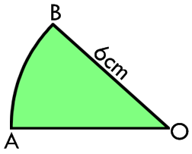

Shown is a circle sector with radius 6cm.

The length of the minor arc, AB, is 3·67cm.

Calculate the size of the angle AOB.

December 7th

Solve the equation $\frac{3x+2}{4}=\frac{2}{3}x+5$

December 8th

55% of respondents in a survey believed they had above average intelligence.

If 440 believed they had above average intelligence, how many people took part in the survey?

December 9th

Simplify $\sqrt[3]{p}\left(p^{4}-p^{-\frac{1}{3}}\right)$

December 10th

Express $\frac{5}{x+3}-\frac{2x+1}{x^{2}-x-12}$ as a single fraction. $x≠-3, x≠4$

December 11th

Find the length of the space diagonal AB. Leave your answer as a surd in its simplest form.

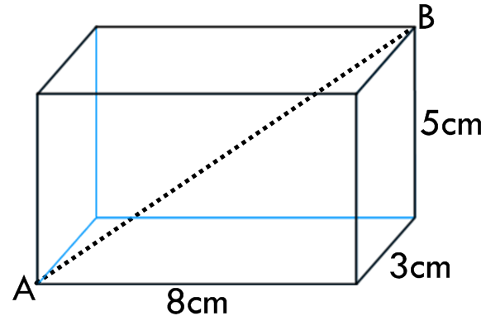

December 12th

Solve the system of equations $y=4x-3$

$2x-3y=29$

December 13th

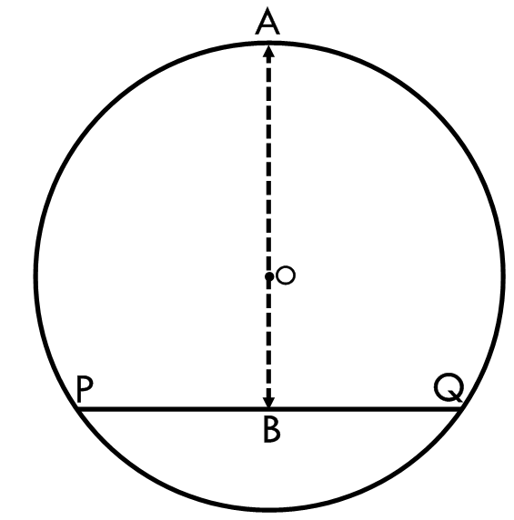PQ is a chord of the circle with centre O and radius $\sqrt{5}$ cm.

PQ has length $\sqrt{12}$ cm.

Calculate the length of the line AB.

December 14th

Sort these lines into ascending order from smallest gradient to largest.

$$L_{1}: 2y-3x=6$$

$$L_{2}: Passes through \left(-4,-7\right) and (4,-1)$$

$$L_{3}: y=0∙7x-7$$

$$L_{4}: Is parallel to the x-axis$$

$$L_{5}: y= \sqrt{2}x+5$$

December 15th

Three points, A, B and C form a triangle.

Their co-ordinates are A(-3,2), B(0,8) and C(10, 3)

Is the triangle right-angled? You must justify your answer.

December 16th

Expand and simplify $\left({3x}^{2}-5x\right)\left(2x^{-1}+3- \sqrt{x}\right)$

December 17th

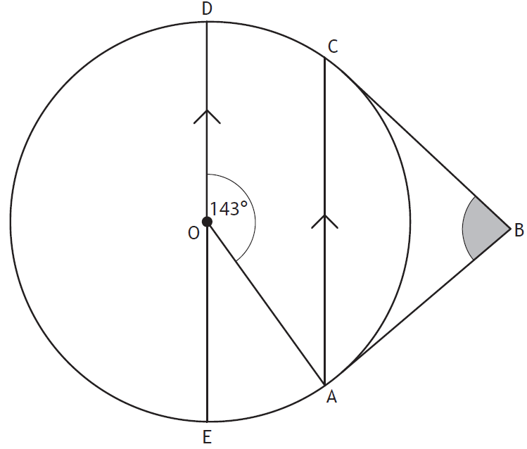AB and CB are tangents to the circle.

AC and ED are parallel.

Angle AOD is 143o.

Calculate the size of angle ABC.

December 18th

The population of Scotland is estimated to be growing at a rate of 0∙6% per annum. The population in the 2011 census was found to be 5 295 000. The next census is in 2021. Calculate the expected population at the next census based on the growth rate of 0∙6%. Round your answer to 4 significant figures.

December 19th

Solve the following puzzle algebraically.

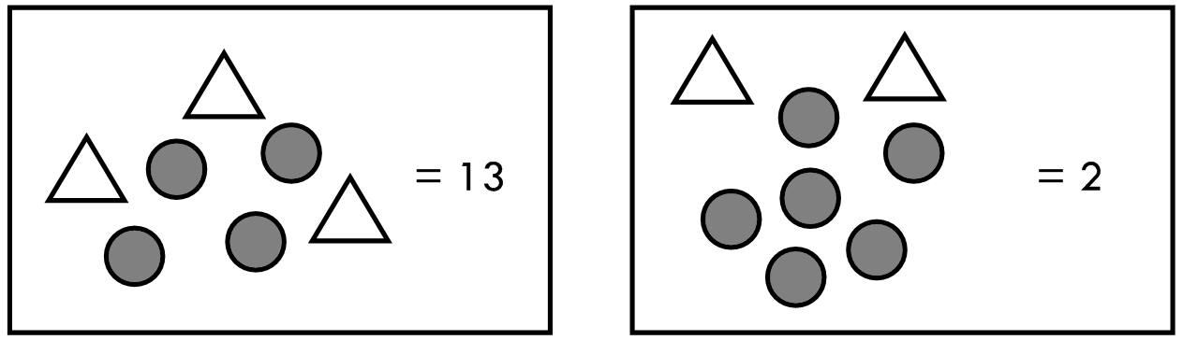

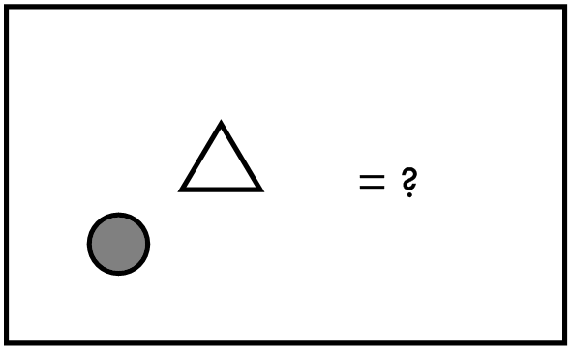

December 20th

In physics, the formula $S=ut+\frac{1}{2}at^{2}$ is used to calculate displacement.

Change the subject of the formula to $a$.

December 21st

Express $t^{2}+3t-2$ in the form ${\left(t+p\right)}^{2}+q$

December 22nd

A sphere of radius 5cm has a volume equal to a cone with diameter 12cm.

What is the height of the cone to the nearest centimetre?

December 23rd

The shape below is formed by two overlapping circles with centres O and O’.

The dashed line represents a square with side length 3cm.

Calculate the area of the shape correct to 1 decimal place.

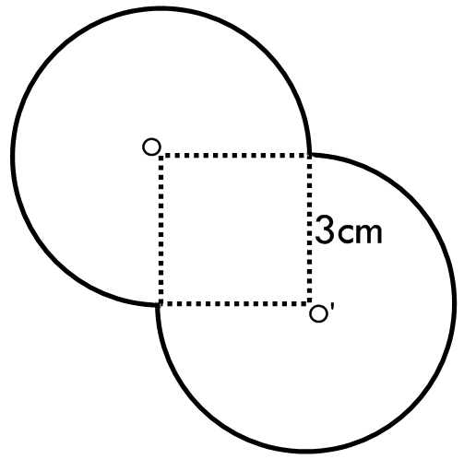

December 24th

Evaluate $\frac{3}{7}÷\left({\left(\frac{2}{3}\right)}^{2}+2\frac{4}{5}\right)$