Badge - wmf1. Calculate (give your answers to the nearest hundredth):

a. 3.256 x 12 b. $25.8-3.982$ c. $253.32÷7$

**[6 marks]**

2. Calculate:

* 1. b. c.

**[7 marks]**

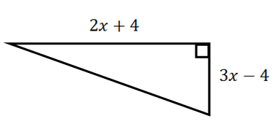3. The lengths of the triangle below have the ratio $3:4:5$. The total of the two shorter sides is 42 cm. Find the total perimeter.

**[3 marks]**

4. Solve the following equations:

1. $5x-8=32$ b. $6x=15-4x$

$7x-5=3x+15$

**[7 marks]**

5. Write the following in the form $ax+b:$

1. $6(4x-5)$ b. $2.5(4x-3)$

c. $4.3\left(3x-2\right)-4(2.1x-1.5)$

**[4 marks]**

1. Expand and simplify:
   1. $\left(3x+2\right)\left(4x-2\right)$ b. $\left(4y+4\right)\left(2y+2\right)$
2. $\left(3w+5u\right)\left(5w-3u\right)$ d. ${\left(3-2y\right)}^{2}$

**[8 marks]**

1. a. Show that the area of the triangle can be given by



$$3x^{2}+2x-8$$

1. Given that the horizontal length of the triangle is $12 cm$, calculate the area of the triangle.

**[8 marks]**

1. A bicycle rental shop in Millport charges $£7.50$ per day $(d)$ plus a deposit of $£12.25$ to hire a bike.
   1. Write an equation for $t$ in terms of $d$ to show the total cost $(t)$ of hire a bike.
   2. Using your equation, how much would it cost to hire a bike for 12 days?
   3. How many days would I have hired a bike for if the total cost came to $£79.75$

**[7 marks]**

1. A pair of jeans costs $£39.99$. The price tag states that an extra third will be taken off at the point of sale.
   1. What fraction of the original price will the new price be?
   2. What will the price of the jeans be at the point of sale?

**[3 marks]**

**[Total 50]**