S1&2 Nutrients Workbook

Name Class

Nutrients
Protein can be found in meat, eggs, fish and pulses. It is very important for growth and repair. It can also be a good supply of energy for the body.

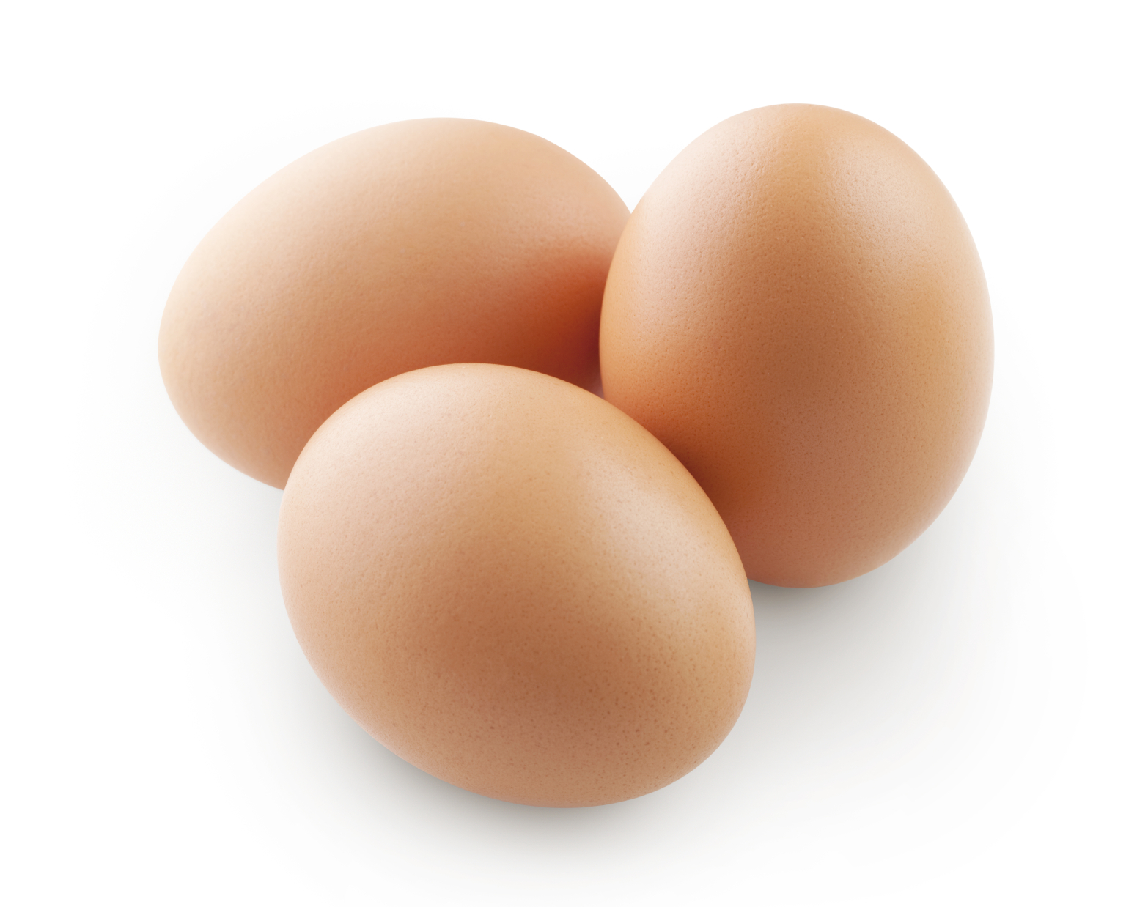
Carbohydrates can be found in starchy and sugary foods such as, pasta, bread, potatoes, rice and cereals. It is essential in the body as it can be converted easily into glucose which is used for energy.

Fat is a good source of heat and energy for the body and can form a layer around our bones and vital organs, protecting them from serious damage. It can be found in butter, olive oil, lard and margarine as well as being added to other foods.

Vitamins such as A, B, C and D are required for the protection against disease. They are essential for digestion, healthy skin, strong bones and teeth. Often found in fruit, sunlight, oily fish, yoghurt and many other foods.

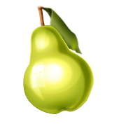
Minerals regulate body processes. They can be found in milk, liver, vegetables and cereals and many other foods.

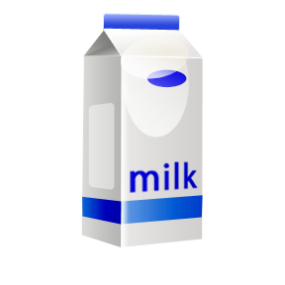
Water is not a nutrient however it is vital for body processes. It can help maintain body temperature and help get rid of waste products. It also decreases the risk of dehydration.

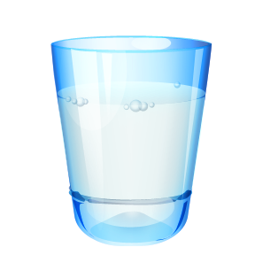
Fibre is not a nutrient but is essential for good health. Often found in bread, pulses, vegetables, fruit and many other foods.

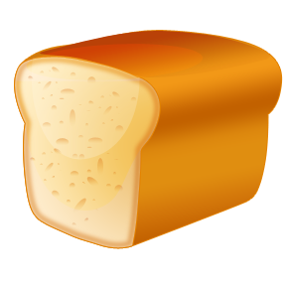

Nutrients Worksheet
Copy and fill in the blanks with the words provided in the box below each question.

- Protein is important for and which can be found in , and can be a supply of
for the body.
repair meat energy growth eggs

- are required for energy which can be found in and sugary foods such as , and .
pasta Carbohydrates rice starchy potatoes

- is a good source of and energy which is essential for the of vital organs and bones. Often found in foods such as and .
heat lard Fat olive oil protection
- are required for the protection against disease and are essential for and healthy skin. They can be found in ,
and .
digestion oily fish Vitamins fruit sunlight

- Minerals are helpful in regulating and can be found in , and .
vegetables body processes milk liver

- is not a however it is important for body . It can help maintain body and decreases the risk of .
nutrient temperature Water dehydration processes

- Fibre is not a nutrient but it is essential for . Often found in , pulses, and .
bread good health vegetables fruit

© Folens (copiable page) Food 13

Food groups
Activity sheet – Healthy eating
☞ Draw a line to match the foods to the right food group. One has been done for you.
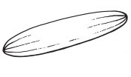
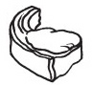
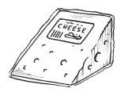
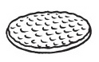
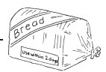
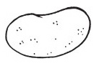
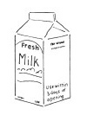
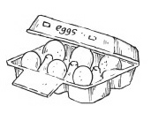
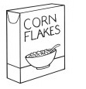
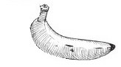
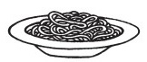
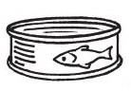
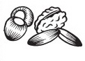
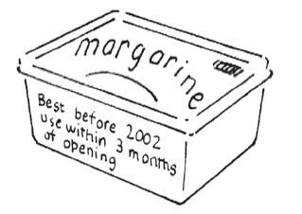
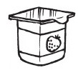
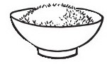
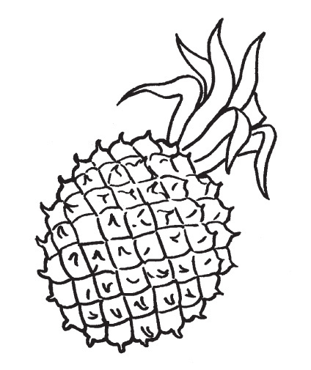

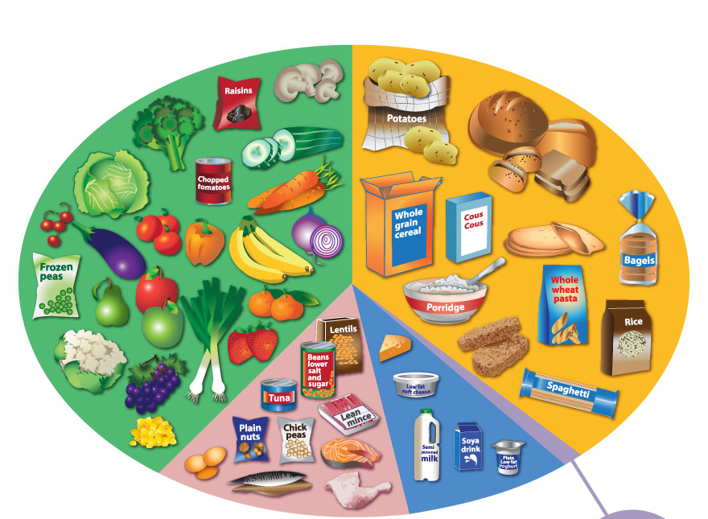
Italy

In Scotland, we use staples such as rice, pasta, bread and potatoes to build up and create a delicious meal. Staples are food that can be eaten regularly in particular quantities.
Italy is well-known for using staples such as pasta, rice and potatoes as part of their diet as they are essential carbohydrates that provide energy to the body.
In Italy, it is well-known to accompany these carbohydrates with vegetables and protein foods such as red meat and fish.
Tomato based sauces; bread and olive oil are all foods which can be associated with Italy and its culture.
Cheese such as Mozzarella, Gorgonzola and Parmesan is also a specialty and can be made in many different ways and regions in Italy.

The Mediterranean diet has been used in Italy since the 1960s as part of their cultural history and background. It is modern, nutritional and can be seen as a healthy option as it reduces the risk of heart disease and obesity - creating a simple balance of carbohydrates, proteins and non-saturated fats. This may include fruits and vegetables; an extensive use of olive oil; dairy products; fish, eggs and a low consumption of red meat.
Pasta

SPAGHETTI
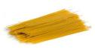
Originated from Italy, this type of pasta is long, thin and cylindrical that can often be stirred into sauces such as Bolognaise, Carbonara and Alfredo. It is most commonly found in 25-30cm lengths.
LASAGNE
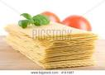
Thin, long and flat, this type of pasta is good for Italian casserole dishes which have many layers of pasta, cheese and sauce (and often other ingredients).
PENNE
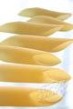
This type of pasta is cylindrical in shape which allows it to hold more sauce such as pesto. Also, it can often be used for salads and meat sauces.
F
USILLI
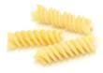
Long, thick, corkscrew shaped pasta found in plain and wholemeal varieties. It can be mixed in with pasta sauces.

T
AGLIATELLE
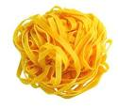
Individual pieces of tagliatelle are long, flat ribbons that can be served with a variety of sauces, though the classic is a meat sauce or bolognaise sauce.
M
ACARONI
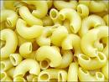
This type of pasta is made with moderately extended machine-made dry noodle. It is often used to make macaroni cheese and milk puddings.

Italy Worksheet

TASK 1
Make a table with the headings: ‘Italian food’ and ‘Scottish food’. Under each column heading, name some dishes that you have tried. An example is provided below:
ITALIAN FOOD | SCOTTISH FOOD
Spaghetti Bolognaise | Scotch Broth

TASK 2
Design and draw your own pizza. Choose a maximum of 4 toppings.
Label your chosen ingredients.
TASK 3
a) List all the ingredients in your pizza and name the nutrients present in the foods.
b) What do these nutrients do in the body?
TASK 4
Prepare and make the following dishes if you can (optional)
- Mock pizza
- Italian pasta

MOCK PIZZA
Ingredients
2 mushrooms
1 small onion
1 x 10ml spoon oil
1 bread roll
1 x 15ml spoon chopped tomatoes
25g cheese
Pinch mixed herbs
Preparation time: 15 minutes
Cooking time: 5 minutes
Serving: 1
Method
- Wash and slice mushrooms.

- Peel and chop onion.

- Heat oil and sauté mushrooms and onion.

- Half roll, spread with chopped tomatoes.

- Spread mushroom and onion mixture on top.

- Grate cheese and sprinkle on top of the pizza.

- Garnish with herbs.

- Grill under a hot grill for 3 minutes till cheese topping is melted.

Pasta with Tomato Sauce

Ingredients
2 canned plum tomatoes
50ml passata
5ml cooking oil
1 onion, chopped
1 carrot, grated
50g pasta shapes
25g cheese, grated (optional)
Preparation time – 10 minutes
Cooking time – 15 minutes

Method
- Half fill large pan with cold water and bring to boil.
- Finely chop onion, grate carrot and cheese.
- Chop tomatoes in a jug, using a small sharp knife.
- Heat oil in a small pan, add onion and carrot and fry lightly until soft.
- Remove from heat and add chopped tomatoes and passata. Stir well and leave to simmer for 10 minutes.
- Add pasta to boiling water, cook for 10 minutes or until soft.
- Drain pasta, arrange in serving dish, place tomato sauce in the centre of the pasta, sprinkle with grated cheese.
- Serve

Nutrients – Extended Unit
Protein:
Protein is important for the growth and repair of the body; for example, the repair of damaged tissue and the growth of new body tissues such as skin and hair.
Foods containing protein can be divided into two groups:
- Animal proteins (meat, fish, eggs, milk and cheese)
- Plant proteins (peas, beans, lentils, nuts and cereals)
Plant proteins are very important in a vegetarian’s diet as they are unable to eat animal products however they have to make sure that they are eating enough of this nutrient so that they do not become deficient.
There are 2 well-known types of vegetarians:
- Lacto (Ovo) vegetarians – can eat animal products such as eggs, milk and cheese but cannot consume red meat, fish, chicken and many more.
- Vegans – (strict vegetarians) they do not eat any animal products, so they require to eat novel foods to maintain good health.
Novel Protein Foods (new foods):
Novel foods are products that have never been used as a food; foods which result from a process that has not previously been used for food.

Examples of Novel Foods:
- TVP (Textured Vegetable Protein) – made from edible fungus similar to mushrooms.
- Tofu – made from soya beans.
- Quorn – made from edible fungus similar to mushrooms.
Health and Protein
- Eating too much protein can cause a build-up of excess energy which is then converted to fat and stored in the body. This can make you overweight leading to obesity.
- If you don’t take in enough protein your body cannot grow, repair and maintain tissue properly. Especially essential for young children

TASK
List 5 dishes that you eat containing a protein food.
1.
2.
3.
4.
5.

Carbohydrates:
This nutrient is important in the body as it provides energy.
There are 3 types of carbohydrate in our food:
- Starch
- Sugar
- Fibre
STARCH – Can be found in potatoes, rice, pasta, bread, cereals and pulses. It can be broken down into glucose, which is a simple sugar, and then absorbed into the bloodstream to be used as energy. Giving a feeling of fullness and stops you “snacking”.
SUGAR – Sugars are more quickly digested than starch. They are a quick source of energy for athletes and can often be found in sports drinks as well as many other foods – especially sweet foods. However, too much sugar can cause tooth decay, diabetes and obesity.
FIBRE – Fibre is important in the diet as it reduces cholesterol levels, prevents constipation and bowel cancer. It can be found in all plants such as wholemeal cereals, nuts, vegetables and fruit.
TASK
Suggest 5 ways of increasing fibre in the diet.
1.
2.
3.
4.
5.
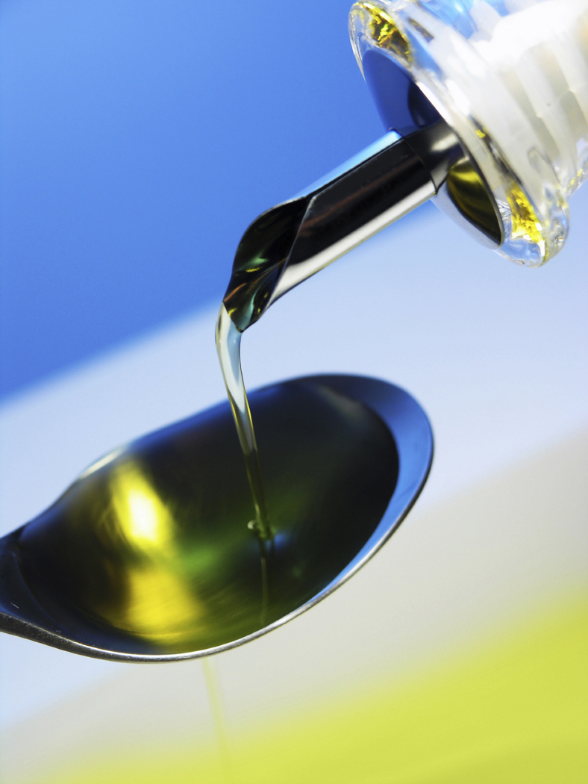
Fat:
Fat provides:
- Energy
- Essential fat-soluble vitamins A, D, E, K
- Essential fatty acids
Fat forms a protective layer round the vital organs such as heart, kidneys. Cushioning and protecting them. It also forms a layer under the skin to help insulate the body.
Fat comes in 2 forms:
Saturated – Found in animal products (red meat, eggs, cheese and many more);
- Too much of this type of fat can cause a build up of cholesterol in the
blood;
- Cholesterol is a waxy substance that can clog up arteries and is a
major cause in heart disease.
Unsaturated – Found mainly in vegetable products (olive oil and sunflower
margarine);
- When choosing fats or oils choose those labeled high in
polyunsaturates, which are better for our health;
Hidden Fat
Sometimes the fat in food is clearly seen, for example, bacon, pork chops, olive oil or butter. This is called visible fat. At other times the fat is hidden and can’t be easily seen as in cheese, biscuits or sausages.
TASK (Fat)
Average fat content of some foods in grams (g) per 100g:
Butter 82.0 | Apple 0.1 | Whole milk 3.9
Steamed haddock 0.8 | Cheddar cheese 34.4 | Salted peanuts 53.0
Semi-skimmed milk 1.6 | Battered/fried Cod 10.3 | Low fat spread 40.0

From the list of foods, choose the 5 foods that contain a lot of fat.
1.
2.
3.
4.
5.

Vitamins
Vitamins can be found in foods we eat everyday. Your body needs them to function properly so that you are able to digest, fight against diseases and many more. There are many vitamins however this section will examine four types of vitamins – A, B, C and D.
VITAMIN | FUNCTION | SOURCE | SYMPTOMS OF DEFICIENCY
A | - Helps protect the body from infection;  - Healthy eyes. | Fish  Olive oil  Vegetables  Butter | - Poor health  - Night blindness  - Poor growth in children
B | - Stimulates growth;  - Protects a healthy nervous system;  - Helps the body get energy from food. | Wholemeal bread  Milk  Cereals  Broccoli | - Poor immune system  - Unhealthy tongue and eyes  - Neurological problems
C  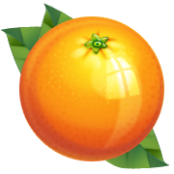 | - Helps maintain the general health of skin, teeth, etc;  - Growth and development;  - Needed for healing wounds and broken bones. | Citrus fruits (orange/lemon/grapefruit)  Peas  New potatoes  Kiwi fruit | - Slow healing of cuts and wounds  - Scurvy  - Sores in mouth and gums
D | - Required for the absorption of calcium to help maintain strong bones and teeth. | Sunlight  Oily fish  Milk  Margarine | - Rickets  - Poor growth  - More prone to infections

Minerals
Minerals help your body grow, develop and stay healthy. They also regulate body processes and can be consumed in order to strengthen your bones and teeth. There are many minerals in food that are important, however iron and calcium are exceptionally important for all age groups (babies, children, adolescents, adults and the elderly) and will be discussed in this chapter.
MINERAL | FUNCTION | SOURCE | SYMPTOMS OF DEFICIENCY
Iron | - Helps to transport oxygen around the body  - Gives blood its red colour | Liver  Meat  Eggs  Lentils  Green leafy vegetables | - Tiredness  - Headaches  - Fainting  - Anaemia
Calcium | - Healthy bones and teeth  - Helps muscles to function properly | Milk  Cheese  Yoghurt  Sardines  Green vegetables | - Stunted growth  - Osteoporosis (weak bones)  - Poorly formed bones and teeth

TASK
Match the following statements with the correct Vitamin or Mineral and then copy them into your jotter.
- What do you need vitamins and minerals for?
- Vitamin A - Helps muscles function properly; strengthens
bones and teeth.
- Vitamin B - Healthy bones and teeth
- Vitamin C - Helps transport oxygen through the body
- Vitamin D - Protects a healthy nervous system; stimulates
growth
- Iron - Healthy vision; protects the body from infections
- Calcium - General health; growth and development

- What happens to you when you do not consume these vitamins and minerals?
  - Vitamin A - Tiredness, fainting, anaemia
  - Vitamin B - Slow healing of cuts and wounds; scurvy
  - Vitamin C - Osteoporosis; stunted growth; tooth decay
  - Vitamin D - Poor immune system
  - Iron - Night blindness; poor growth in children
  - Calcium - Rickets; more prone to infection
Read these statements and determine if they are true or false. Copy each correct statement into your jotter.
- Vitamin B can be found in many citrus fruits such as, oranges, lemons and grapefruit.
TRUE FALSE
- Iron is very important in the body as it helps transport oxygen in the blood, giving it a red colour.
TRUE FALSE
- Not eating enough Vitamin C can result in scurvy and sores in the mouth.
TRUE FALSE
- Vitamin B is essential for preventing night blindness.
TRUE FALSE
- Calcium helps maintain strong, healthy bones and teeth.
TRUE FALSE
PUPIL EVALUATION

Pupil Name:
Class:
Have you understood the topic? Do you require more help with certain aspects of the course? What do you think about each topic?
The table below has been made available so that both Teacher and pupil can record performances in this unit. Tick the boxes where appropriate and provide any comments necessary in relation to the topics covered in this unit.

Subject | Progress | Comments
Nutrients:

Protein
Carbohydrates
Fat
Vitamins
Minerals
Nutrients Worksheet
Italy and worksheets provided
Nutrients/Italy Extended Unit (including worksheets)
Design and Make Booklet

