Curriculum for Excellence
Literacy Project – Non-Fiction
English Department
READ ALL ABOUT IT!

Shawlands Academy pupils are taking part in activities to help them become more informed about the world through reading a wide selection of newspapers.

As part of their Literacy Project in English, they will develop a wide range of skills, so that they can discuss the differences and similarities in texts, consider the main purpose of the texts they read, make inferences from key statements, identify techniques being used to influence their opinion and be able to judge how reliable the information is that they read.

LIT 3-16a, LIT 3-18a

Investigating Newspapers
As you work through the activities in this booklet, you will understand and analyse the differences and similarities between different types of newspapers in their audience, purpose, content, form, layout and style of language. You will keep a log of your learning, and, to complete this section of the Literacy Project, you will write a detailed report showing what you have learned.

Task 1 – Talk about the following task in pairs or groups.
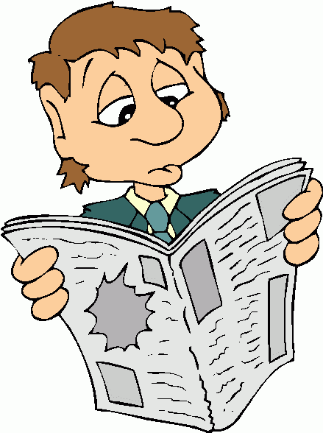
What newspapers do you know of?

Are there any newspapers that you or your family read?

Try to think of as many different titles as possible to share with the class.

Task 2 – Once you have had the chance to read a few newspapers, work with a partner to read aloud the following statements and match them with the one of the two main types of newspaper. Write your answers in your jotter.

TABLOID | - uses shorter sentences and paragraphs rather than long ones  - uses words and phrases to stir up readers’ interest and emotion  - concerned with “serious news” such as major events across the world  - uses less complicated, more everyday vocabulary and language  - has more text and smaller writing on the page; more to read  - focuses on famous people private lives and scandal | QUALITY
Task 3 – Copy the table below into your jotter. Now that you know the difference between the two kinds of newspaper and have had the chance to read a few more, write down the titles of different newspapers in the correct column.

Tabloids | Quality

Did You Know?

- Around 12 million newspapers are sold in Britain each day.
- That doesn’t include around 3 million newspapers that are issued daily for free, such as on busses and trains.
- Most copies of newspapers are read by two or three different people.
- More and more people also read newspapers online.

Task 4 – Read through the following passage in pairs. Complete the missing words in the passage about newspapers using the words in the boxes below. Write your own answers in your jotter.

THE FEATURES OF NEWSPAPERS

Newspaper stories are called _______a________ . They have titles which are called ______b________. These are usually written with only a ___c____ words in ____d________ or ____e______ print to grab the reader’s ______f___________ and tell them the main _______g______ of the story. Sub-headlines are short sentences which explain the main headline and keep the reader’s interest to read the rest of the article. The layout of the newspaper is normally in _______h______, with photographs and _____i________ .

attention few headlines articles large columns bold adverts point

There are two types of newspapers according to their layout and ____j_______ and the kind of articles they have in them. The Sun, The Daily Mail and The Daily Record are examples of _______k______ newspapers. These have very large headlines which are sometimes framed in black or bright-coloured ____l______. There are also many photographs throughout. Sometimes there will be extra _______m____ __________m_______ given away inside the newspaper and usually these have articles about television and entertainment, fashion, motoring or sport.

glossy magazines tabloid boxes design

The Times, The Guardian, The Daily Telegraph, and The Independent are _____n_______ newspapers. Traditionally they were printed on very large paper sheets, which meant they were often called ______o________ , but more recently they are printed in a compact format for people to carry and read easily. The headlines and pictures are not so large. The articles are usually longer and there are more _____p_________ on the page than on a tabloid. They also give away _________q___________ , which are extra newspapers or magazines on topics like business and finance, arts and culture, lifestyle and property.

quality supplements broadsheets columns
.

THE LAYOUT OF NEWSPAPERS

EARS The ‘ears’ can be at any of the top, bottom, right or left margins. They give short headlines of articles inside the paper and refer to which page they are on.

MASTHEAD The ‘masthead’ is the newspaper’s title banner or logo.

COPY This is the name for all of the text or writing printed on the newspaper, including the articles.

MAIN HEADLINE This is the headline for the main article on the front page. It is usually in the largest or boldest type of all the headlines.

SUB-HEADLINE This is a short phrase or sentence which follows the main headline and is in a large or bold type

ARTICLE This is the name for each of the stories on the page

BY-LINE This is the name for the other headlines on the page for the rest of the articles.

TASTERS The ‘tasters’ are small sections with headlines and a few sentences of an article which give the reader a ‘taste’ of what the whole story is about. They usually refer the reader to the full article in the paper.

PHOTO/ The caption is a small sentence underneath the photograph
CAPTION which explains what has happened in it.

Task 5 – Look carefully at the front pages of The Sun and The Guardian on the next two pages. Label each of the sections indicated using the correct terminology above. You can check with a partner why you think this is the case.

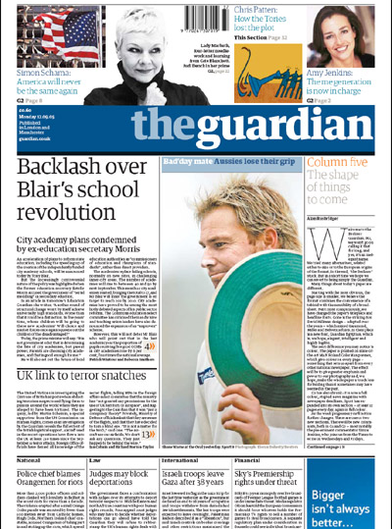
H
J
I
G
F
A
B
C
D
E

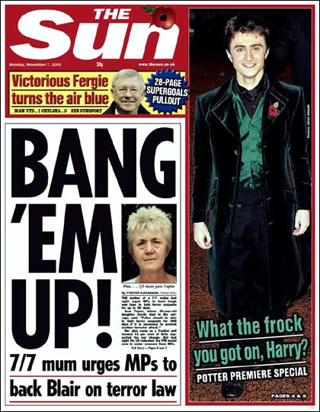
Q
P
N
O
L
J

The 5 Ws (…and one H!)

Newspaper articles concentrate on:

what when where who why and how

in giving the reader information about an event or situation.

Task 6 – Make a table like the one below in your jotter. Carefully read the article on the next page. Write down clearly the key ideas and points beside the correct heading to show you have understood the text. Repeat the second column for another article of your choice from a newspaper.

 | Article 1 | Article 2
Newspaper Title:
Date / Page:

Headline:

What is the story about?

When does the event take place?

Where does the event take place?

Who is involved in the situation? Give brief details about them.

Why is the situation happening? What are the reasons?

How has this happened? Explain it stage by stage.

Hit-and-run victim saved by headphones cushioning fall
by Richard Smith

A PEDESTRIAN survived a hit-and-run horror – thanks to her large headphones.
Sponge in the earmuff-style headset Kate Fitzpatrick was wearing cushioned the blow when a car ploughed into her on a pelican crossing, throwing her 10ft into the air.
Kate was left with a fractured skull and brain trauma but she said: “If it hadn’t been for those headphones I’d have died. It is a miracle I’m still here.”

The 30-year-old had borrowed the DJ headphones from boyfriend Jay Davies, 35, and was listening to Madonna song Hung Up as she walked home.
She said: “I remember the green light showing to cross and the traffic slowing and then the next thing I was in the hospital with a CT scanner above my head.
“The doctors told me if I hadn’t been wearing the headphones I’d be dead. The fracture in my skull was along exactly the same line as where they were.”
Jay added: “Kate is very lucky. I am so glad I lent them to her.”
Kate, of Walsall, West Midlands, also suffered a broken shoulder and collarbone when the red Ford Fiesta hit her last month.
Police are hunting the driver. Sgt Tim Rogers, of West Midlands Police, said: “The driver didn’t even slow down to check the person they had collided with was OK. The car is likely to have damage.”

From http://www.mirror.co.uk/

Task 7 – To continue your investigation into the differences between Tabloid newspapers and Quality newspapers, create a table like the one below, in your jotter. Work with a partner to analyse one Tabloid and then one Quality newspaper together.

 | TABLOID | QUALITY
1. Title of publication

2. Describe four features of the front page layout using the terms you have already learned.
3. How many news stories are there on the front page? (Don’t count ‘ears’ or ‘tasters’?)
4. Scan through the stories in at least 10 pages at different points throughout the newspaper. Write a tally (five-bar gate) of the number of different types of story or item you find in each.
News reports (e.g. crime, drugs raids)

Current affairs (e.g. war, politics, business news)

Celebrity news / exposé (e.g. gossip, scandal)

Human interest (e.g. real life stories)

TABLOID | QUALITY

Lifestyle features (e.g.
fashion, cookery, gardening)

Entertainment news (e.g. television or film)

Trivia (e.g.competitions,
games, cartoons, agony aunt)

Sport (for listings of fixtures put down 3 for each full page)

Adverts (put down 3 for
every full page spread)

5. What price is the newspaper?
6. What are the four main selling points of the newspaper?

What will make people want to buy and read it?
7. What three types of people are likely to buy this newspaper? Explain why you think this.
8. Assuming you could afford it, which paper would you be more likely to buy on a regular basis? Give your reasons.

Task 8 – Look back at your findings for question four in the last activity. Create a bar graph for each type of newspaper showing how much each type of story takes up as a percentage of the whole newspaper, and how the two different types of newspaper compare with each other.
Numeracy Across Learning

To do this, you will need to use your numeracy skills.

You have carried out an investigation and have worked with others to collate information about different types of newspapers. Now you need to organize and communicate the results in an appropriate way to show how they compare. You will show that you can:

- Use addition and division to carry out calculations
- Round your answers to whole numbers
- Make percentages for this real life situation
- Draw a bar graph with labels for the first eight types of article on the previous page
- Use your answers to make accurate comparisons between the newspapers
MNU 3-01, 3-07 & 3-20

What you need to do:

- Look back at your survey results. Work in pairs, with one person working on the Tabloid you read, and the other on the Quality.
- Find the sum of how many of each type of article there was in the newspaper (e.g. news, current affairs, celebrity…)
- Then find the sum of all the articles that you recorded for that newspaper, by adding a
- Find out how much of a percentage each kind of article was in making up the whole newspaper, by dividing your answer
- Compare your answers with your partner looking at the opposite type of newspaper and work together to create a comparative bar graph like the one below.
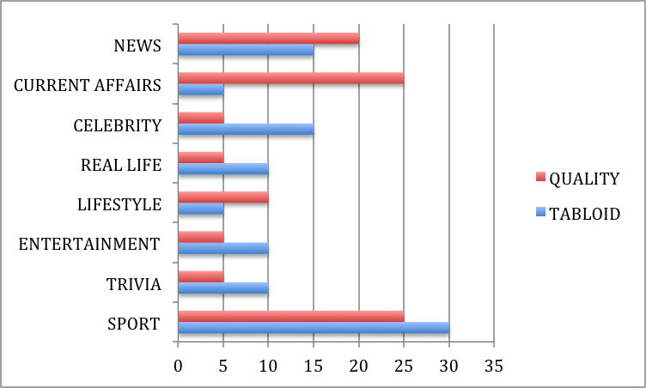

HITTING THE HEADLINES
Headlines instantly give the reader the idea of what the article is about by using only a few key words or phrases. In quality newspapers, headlines are usually short phrases which give important information. For example,

Train crash may have killed 13

In tabloid newspapers, maximum effect is often achieved by techniques that make the headline more ‘catchy’.

Task 9 – Match the techniques identified and explained on the left with the examples of them being used on the right. Write the answers e.g. 1 – e in your jotter. Work with a partner.

Punctuation marks used to convey statements / quotations | ROAD RAGE IN RIDDRIE
Exclamations | POLICE HIGH SPEED CAR CRASH
Certain grammatical words are left out e.g. verbs | KICKED OUT!
Alliteration – the same sound is repeated at the start of several words | GAS COMPANY TURNS UP THE HEAT ON BAD CUSTOMERS
Powerful words – have strong impact | SALMOND: “SCOTLAND IN THE DRIVING SEAT”
Abbreviations and numbers | FURY OVER NEW M’WAY PLANS
Colloquial words – informal words that are usually only spoken in conversation | O.A.P. (84) ROBBED
Pun – a play or joke on the two meanings of a word | GARAGE CONS DRIVERS WITH DODGY MOTORS
Task 10 – Work on your own. Write down the feature(s) of language used in each headline below. Then feedback your answers to the class.

1. HOSPITAL COMIC HAS DOCTORS IN STITCHES

2. A.S.B.O. ORDERED ON NED (15)
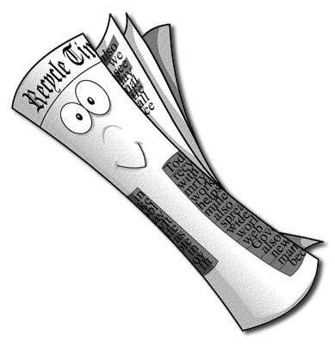
3. BT BLASTED FOR BROADBAND BOTCH-UP

4. ON YER’ BIKE JOEY!

5. PETROL PRICE ANGER

6. NO MERCY FOR CAPTURED DICTATOR

7. CHRISTMAS CHAOS COMES CALLING

8. SICK ELEPHANT JUMBO JETS BACK TO HEALTH

9. A TAIL OF JOY: MAN SAVED BY DOG

Task 11 – Read the following snippets of ‘news’ articles. Write down a good headline for each using the features of language you have learned.

Five hill-climbers were criticised by their rescuers today after a 12-hour ordeal in the remote Scottish highlands...
The government intends to introduce a complete ban on Christmas, from December 2014…
Further news is emerging of the overnight clashes between rioters and police in Paris, with several rioters reported injured…
Task 12 – Once you have read a few more newspapers in class, write down three or four effective headlines. Identify the techniques used in them.

Task 13 – Read the information below in pairs or with the class.

NEWSPAPER STYLE

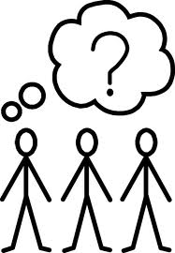
The wording of an article and its headline also gives the reader a clear indication of any attitude or bias on the part of the writer or newspaper editor. Look at the differences in the following two headlines:

a) RIOTERS INJURED IN POLICE CLASHES

b) POLICE INJURE RIOTERS IN CLASHES

The wording of the second one lays the blame on the actions of the police – it is they who caused the injuries to the rioters. This means the second one is biased.

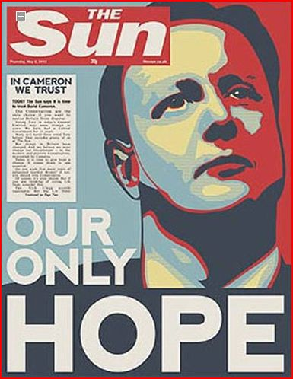
Journalists and newspaper editors make important choices about the style of language they use to write about news stories. They will use many of the features of language already described under ‘headlines’. Quality newspapers tend to have a formal style which suggests that they are serious and impartial. Tabloids use highly persuasive language which simplifies, exaggerates or sensationalises.

Newspaper writers and editors choose an angle to write the story from, which emphasises one point of view over another depending on the eyewitness accounts, expert opinions, statements from public figures and the opinions of the ordinary people that are used. When the report is giving one side of the story, we say it is biased.

Task 14 – Read the two articles that follow on the next page. You could read them aloud with your partner. They are about the same story, but are from different newspapers. Try to spot the differences in the style of language used and think of how this might influence a reader’s opinion.

Illness prompts burger caution

Chris Mihill
Medical Correspondent

The Department of Health yesterday warned people to cook beef burgers thoroughly after an outbreak of food poisoning at a McDonalds fast food restaurant.
The warning, from Sir Donald Acheson, chief medical officer, follows an outbreak of a rare form of the illnees in Preston. An investigation by the Public Health Laborotory Service found a link with beef burgers eaten at a local McDonalds. At least 14 people were taken ill last month, and there have been six subsequent reports of illness.
Sir Donald said: ‘In recent years, human illness from this form of food poisoning (E.Coli 0157) has been showing a steady increase. Fortunately, the number of cases is still small – about 380 last year – but the organism can lead to bloody diarrhoea and, occasionally, go on to kidney failure.’
He added: ‘This organism is heat-sensitive and can be readily destroyed by proper cooking. As far as the domestic consumer is concerned, there is no need for further precautions other than ensuring that the beef burgers are thoroughly cooked.’
The Department of Health says beefburgers made at home should be cooked until the juices run clear and there is no pink showing inside. People buying beefburgers in packs should follow the maker’s instructions.
A spokesman for McDonalds said last night that only some of those who had become ill had eaten at the restaurant. ‘Tests have been conducted in our Preston restaurant and in the premises of our mead supplier, and the presence of the bacterium that causes this particular type of food poisoning has not been detected.’

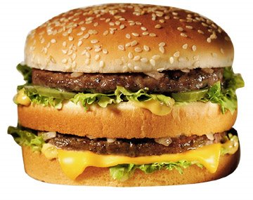
BIG MAC BURGER BUG ALERT
Health warning after food poison outbreak
A BURGER alert went out last night after nine children who ate at McDonald’s were hit by a terrifying food bug.
Three ‘Big Mac’ youngsters suffered rare, and potentially fatal, kidney damage. One victim was two years old.
In all, 20 people from Preston, Lancs, are feared to have been hit by the bug after eating burgers – not all at McDonald’s – around the country.
Yesterday, the government was so worried by the health scare its Chief Medical Officer, Sir Donald Acheson ordered all Britain’s fast-food chains to check that burgers were well prepared and cooked.
And he warned mums to make sure burgers were properly cooked at home. The Department of Health said it had found a ‘highly significant association’ between eating burgers which were not properly cooked and the strain of food poisoning.
Last night, McDonalds said it was cooking its burgers longer following discussions with catering companies and the Department of Health.

Task 15 – Answer the questions on the two articles on the previous page. Explain your answers clearly and be ready to share your responses with the class.

1.a) What differences do the headlines suggest about how big the problem is?

1.b) Write down the words that make you think this.

2.a) Look at the first paragraphs of the two articles. What are the differences in the facts given by each?

2.b) Write down two ‘sensationalist’ words from the first paragraph of the second article and explain the ideas each gives.

3.a) How many people does the first article suggest are affected by the bug?

3.b) How many people does the second article suggest are affected by the bug?

3.c) What fact about one of the victims does the second article include to arouse reader’s concerns?

4.a) Who is the main source of evidence in the first article?

4.b) Which article do you believe is more reliable – give two reasons?

5. Find four more examples of persuasive words or phrases from the second article. For each one, explain the main ideas you can infer or suggest.

Task 16 – Make a table like the one below in your jotter, using two pages. Choose two articles from different types of newspaper on the exact same day, with the exact same story. (Your teacher might give you these to help). Read the articles carefully with a partner and compare the different versions by making notes in each box. Be ready to present your findings to the class.

 | TABLOID | QUALITY
Newspaper Title:
Date / Page:

Headline:

Techniques used in the headline:

What is the story about?

Make a list of as many facts as you can find from the story.

Whose opinions are given e.g. in interviews?

Who is the main source of the story?

Make a list of powerful or persuasive words and phrases that might influence the reader’s opinion.

How reliable do you find this version of the story? Why? Is it biased in any way?

Assessment of Learning
Task 17 – Update your learning log to show how you have developed the skills needed to help you be a successful learner in this project and how confident you are in using these skills.
Now that I have investigated newspapers as part of the Literacy Project, I can:

identify and discuss the differences and similarities between different types of newspapers in their audience, purpose, content, form, layout and style of language.

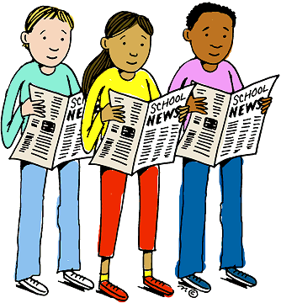

Task 18 – Write a short report of around four or five paragraphs explaining and evaluating the differences and similarities in the newspapers you have investigated. Use the writing frame on the back of your learning log to help.
You should remember what we learned about:
- The different titles of newspapers, either Tabloid or Quality
- The layout of different newspapers – similarities and differences; why?
- Identifying main purpose and concerns of news articles (i.e. the 5 Ws)
- The purposes of different types of articles in a newspaper
- The different content of tabloids and qualities from our survey
- The different readership / audience of tabloids and qualities
- Techniques used by newspapers to influence opinion e.g. headlines
- The different style of language used in reporting the same story

The 5 Ws (…and one H!)

Newspaper articles concentrate on:

what when where who why and how

in giving the reader information about an event or situation.

Task 6 – Carefully read the article on page 9 of the activity booklet. Write down clearly the key ideas and points beside the correct heading in the table below to show you have understood the text. Repeat the second column for another article of your choice from a newspaper.

 | Article 1 | Article 2
Newspaper Title:
Date / Page:

Headline:

What is the story about?

When does the event take place?

Where does the event take place?

Who is involved in the situation? Give brief details about them.

Why is the situation happening? What are the reasons?

How has this happened? Explain it stage by stage.

Task 7 – To continue your investigation into the differences between Tabloid newspapers and Quality newspapers, create a table like the one below, in your jotter. Work with a partner to analyse one Tabloid and then one Quality newspaper together.

 | TABLOID | QUALITY
1. Title of publication

2. Describe four features of the front page layout using the terms you have already learned.
3. How many news stories are there on the front page? (Don’t count ‘ears’ or ‘tasters’?)
4. Scan through the stories in at least 10 pages at different points throughout the newspaper. Write a tally (five-bar gate) of the number of different types of story or item you find in each.
News reports (e.g. crime, drugs raids)

Current affairs (e.g. war, politics, business news)

Celebrity news / exposé (e.g. gossip, scandal)

Human interest (e.g. real life stories)

TABLOID | QUALITY

Lifestyle features (e.g.
fashion, cookery, gardening)

Entertainment news (e.g. television or film)

Trivia (e.g.competitions,
games, cartoons, agony aunt)

Sport (for listings of fixtures put down 3 for each full page)

Adverts (put down 3 for
every full page spread)

5. What price is the newspaper?
6. What are the four main selling points of the newspaper?

What will make people want to buy and read it?
7. What three types of people are likely to buy this newspaper? Explain why you think this.
8. Assuming you could afford it, which paper would you be more likely to buy on a regular basis? Give your reasons.

Task 16 – Make a table like the one below in your jotter, using two pages. Choose two articles from different types of newspaper on the exact same day, with the exact same story. (Your teacher might give you these to help). Read the articles carefully with a partner and compare the different versions by making notes in each box. Be ready to present your findings to the class.

 | TABLOID | QUALITY
Newspaper Title:
Date / Page:

Headline:

Techniques used in the headline:

What is the story about?

Make a list of as many facts as you can find from the story.

Whose opinions are given e.g. in interviews?

Who is the main source of the story?

Make a list of powerful or persuasive words and phrases that might influence the reader’s opinion.

How reliable do you find this version of the story? Why? Is it biased in any way?

Learning Log
As you complete the tasks for this section of the Literacy Project, take time to think about you own learning and record your thoughts on your learning.

Learning Outcome | - What did you learn?  - How did you do this?  - How can you show what you learned?
I can identify the purpose or main concerns in the texts I read

I can make inferences from key statements

I can identify and discuss the similarities and difference between different types of text

I have explored the techniques used to influence my opinion

I can assess the reliability of information and the credibility and value of my sources.

Task 18 asks you to write a report of around four or five paragraphs explaining and evaluating the differences and similarities in the newspapers you have investigated. Think carefully over all the activities you have completed and show what you have learned by your explanations in the report. You could use the sentence starters below to help you:
Final Report

We researched newspapers in class and looked at the differences and similarities between tabloid and quality newspapers. Tabloid newspapers include titles such as … and quality newspapers include …

On the one hand, these newspapers are similar because…
In their layout, they have some of the same features as…
They are also similar because news stories have got to include…
For example,…

There are different types of newspaper articles, including…
These are for different purposes. For example…

On the other hand, Tabloids and Qualities have different content since…
When we researched the differences, we compared how many of each different article there was, and this showed us the differences.
Our survey showed
This made us question the readership of each different newspaper and we thought…

We also learned about the different techniques newspapers used to influence people’s opinions.
Headlines use…
A few examples of these techniques being used are…
These show…

We also looked at how two different newspapers reported the same story..
It was about…
We found that…

In investigating newspapers, I feel I have learned…
I will use what I have learned in future by…

