
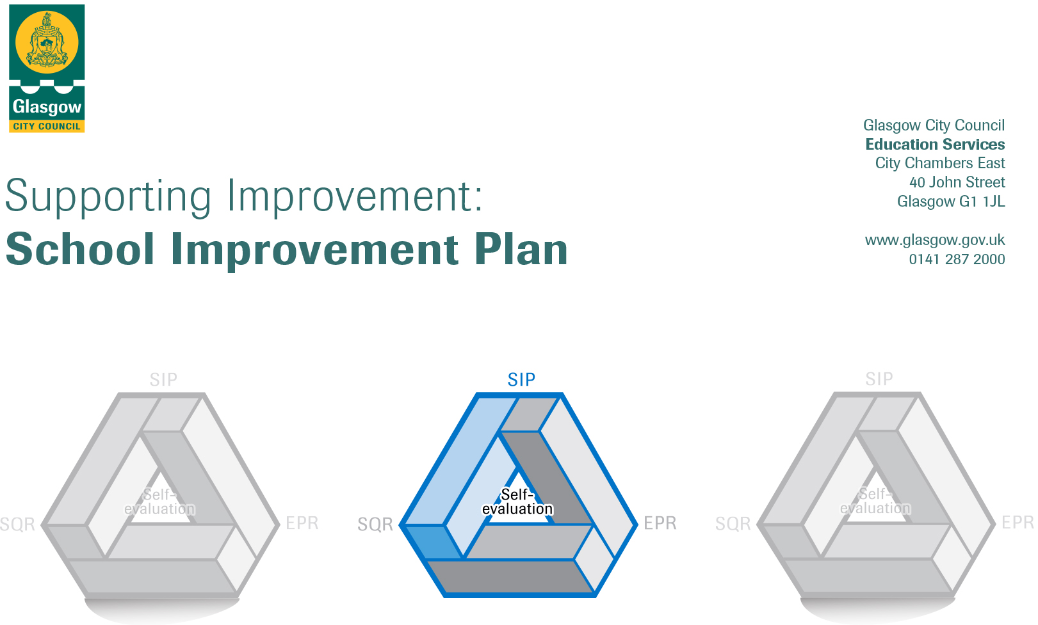

Scotstoun Primary School
Session 2022-23
Establishment | Scotstoun Primary School
Head of Establishment | Emma McGill
Local Improvement Group | NW LIG 2
Head of Service | Jim Wilson
Area Education Officer/  Quality Improvement Officer/Link Officer | Andrea Reid

CONTENTS
1. Vision, Values and Aims
2. Summary of Self-Evaluation Process / Priorities for Improvement in the current session
3. Additional Monies Spend Summary of Consultation Processes
4. Action Planning

Action Plan Summary for Stakeholders

1. Our Vision, Values and Aims
VALUES
Respect, Learning, Community, Happiness
VISION
Scotstoun Primary School is committed to promoting diversity and global citizenship and to equipping pupils with the skills to meet the challenges of the 21st century. By delivering a curriculum that promotes skills for life encompassing literacy, numeracy, ICT and health and well-being; along with independence, responsibility and motivation.
AIMS
- To recognize and develop every child’s potential across the curriculum and to maximize achievements in all areas, particularly in literacy and maths.
- To encourage and develop the expertise of staff and to provide a stimulating learning environment for all school users.
- To provide a curriculum and ethos promoting inclusion, health, welfare and equal opportunities for all.
We aim to foster respect, good citizenship skills and attitudes within the school, working in partnership with parents, pupils and the wider community.
Note – our school vision, values and aims will be revisited and refreshed during session 22/23 as part of the work developing our curriculum rationale with all our stakeholders in line with Education Services revised vision, values and aims.

2. Summary of our self-evaluation process
Staff were consulted through focussed self-evaluations discussions which highlighted strengths and areas of development under a selection of quality indicators from HGIOS4 throughout the year and were involved on updating the school EPR.
A calendar of self-evaluation activities ensured that we were reflective and responsive to the needs of our learners and families during this year. There was a range of activities; learning visits, learner conversations, quality assurance of forward plans and monitoring of children’s work produced evidence to support our improvement agenda. Each term had a different focus:
Term 1: How good is our classroom climate?
Term 2 – How well are we meeting learners’ needs?
Term 3 – How effective is our teaching and learning?
Term 4 – What is the impact of our locality work?
All members of the school community were consulted on our digital learning and teaching strategy and our mental health policy through surveys and discussion with the Parent Council group School Matters.
The parent forum was consulted and updated regularly through the Parent Council, Seesaw and newsletters. Opinions were gathered throughout Terms 3 via online surveys for our approaches to digital learning. Another subgroup of the Parent Council is working on an ambitious plan for the upgrading of the school grounds following the completion of the extension work has consulted widely with stakeholders which is a key driver for their approach.

Children were consulted through the Pupil Council about various events throughout the school year. The staff who were focussed on raising attainment utilised learner conversations before and after the interventions to determine impact and children’s views. All children were asked about their view on what has gone well, what has not and how staff have helped them over the past year which fed into our planning for improvement.
Strengths identified:
- Feedback from children, their families and staff indicate that a positive ethos and nurturing relationships are a key feature of the school. Children feel supported and cared for. They enjoy the wider range of experiences on offer.
- Staff engaged in a wide range of professional learning with a focus on planning for high quality learning teaching and assessment experiences this session which impacted positively on their practice and improved the provision for learners. The locality work carried out with St Paul’s Primary, Whiteinch Primary and Whiteinch Nursery has improved staff confidence in the areas of focus; play, differentiation and effective questioning. Peer visits in term 4 consolidated staff focus in this area.
- The school engaged with a range of local partners such as Heart of Scotstoun and the Outdoor Space Parent Group to support learning opportunities for our children such as our garden project.
- The positive impact of our family wellbeing worker and the relationships she has built with our families and the support now in place.
.
Priorities for development:
- 1: Raise attainment and achievement by developing the sharing of good practice of teaching and learning and assessment processes in literacy and numeracy.
- To continue to implement processes, classroom practices and organisations that raise attainment with a focus on numeracy and maths
- To work collaboratively with other establishments within our locality to focus on learning and teaching approaches in literacy developing an equitable literacy curriculum.
- 2: Supporting wellbeing
- To continue to embed inclusive practice into our school to permeate the ethos of our school supporting wellbeing of our learners
- 3: Developing our curriculum
- To continue to improve the design of our curriculum to ensure coherence and progression across the levels and to establish greater continuity across the school, utilising a variety of contexts.

3. Additional Monies Spend Summary of Consultation Processes
Consultation Process:
All staff were consulted through our self-evaluations process and our focussed planning for improvement sessions. A smaller group of staff has been formed as a consultative group to consult on this and other school matters. The parent forum was consulted through the Parent Council and the parent council subgroup where the budget proposal was shared. Views on school improvement priorities were sought from families at a family event where families were invited to write on a graffiti wall.

Rationale for Spend:
Learning and teaching
- Continue to develop approach to the processes, classroom practices and organisations across all classes that raise attainment in numeracy and mathematics. We have taken part in Year 1 of Glasgow Counts training and will continue to use PEF funding to support the embedding of this approach.
- Promote high quality approaches to teaching and learning through continued participation in locality work. Feedback from teachers indicates they found this process useful this year and could see the benefit on their professional learning and practice. Peer visits in school followed this model as well.
- Support targeted approaches in literacy and numeracy utilising Support for Learning workers (PEF funded) building on group support success this session.

Leadership
- Increased opportunity for staff and pupil leadership through after school clubs with a focus on wider achievement and equity of opportunity (PEF funded).
- Increased opportunity for staff professional learning and leadership through STEM, outdoor learning and playful pedagogy (PEF funded)
Families and Communities
- Continue to fund our Family Wellbeing Worker
- Increased focus on wellbeing and developing an inclusive curriculum through partnership working with agencies such as With Kids (SG funding) and Eco Drama (PEF funded).

Measures/Evidence for Impact (data, observation, views):
- Pre and post implementation views of children, staff and families will show an increased engagement/confidence or an improvement in the area of focus.

- Data gathered through quality assurance process will evidence that all staff have effectively planned and implemented the area of focus.

- Progress data gathered will show an increase in attainment for all and a reduction in the identified attainment gap for targeted group/groups

4. Action Planning

No. | Quality Indicator | Priority
1 | 1.2, 1.3, 2.2, 2.3, 3.2 | Raise attainment and achievement by developing the sharing of good practice of teaching and learning and assessment processes in literacy and numeracy.

Tasks to achieve priority | Timescale  and checkpoints | Evidence of Impact > (data, observation, views)
Literacy  To work collaboratively with other establishments within our locality to focus on learning and teaching approaches in literacy developing an equitable literacy curriculum.  - Scoping meeting with Prof Sue Ellis, EAL teachers, CLoLS, Family Wellbeing Workers, HTs from Scotstoun and St Paul’s PS.  - Working group to plan calendar of family events across the year with a focus on parental engagement in literacy  - CTs to meet with Prof Sue Ellis to develop approaches to a literacy rich classroom and environment  - Professional learning focusing on creating an equitable literacy curriculum  - Trios will be established within and across establishments to plan experiences based on focus, carry out peer visits (POLLI) to evaluate the impact and next steps. (PEF funded)  - Approaches to planning high quality learning and teaching and assessment opportunities and evaluating learner progress including moderation opportunities.  - Approaches to feedback which support and enhance learner progress  - Plan for the session including sharing approaches with families.  - Using digital technology to enhance learning and teaching  - Develop literacy rationale policy | June 22  Aug 22  Sept 22  Oct 22  Term 2 (Trios)  Term 4  (POLLI observations)  SIP sessions T2/T3/T4  Learner conversation T1 & T4  Parent Workshops T1,T2,T3, T4  Parent questionnaire T1 & T4 | Pre and post CLPL questionnaires will show an increased knowledge and understanding of an equitable literacy curriculum and an increased confidence in implementing them in their practice.  Data gathered through quality assurance process will evidence that almost all staff have effectively planned and implemented the approaches for their level. This will be focussed on planning, learning visits and evaluations of learning. There will be evidence of consistency across the school. Classroom environments will support an equitable literacy curriculum.  Children will show increased engagement and pleasure on reading through pre and post learner conversations.  Attendance at parental engagement events will reflect the demographic profile of the school.  EAL teachers and Family Wellbeing Workers will show an increased knowledge and understanding of an equitable literacy curriculum and an increased confidence in implementing them in their collegiate working.
Numeracy and mathematics  To continue to implement processes, classroom practices and organisations that raise attainment with a focus on numeracy and maths  - Professional learning opportunities focussing on  - Number talks (June 22)  - Four operations (T1 and T3)  - Fractions, decimals and percentages (T4)  - Approaches to planning high quality learning and teaching and assessment opportunities and evaluating learner progress including moderation opportunities.  - Approaches to feedback which support and enhance learner progress  - Plan for the session including sharing approaches with families.  - Using digital technology to enhance learning and teaching  - School develop numeracy rationale policy | August 2022  SIP sessions T2/T3/T4 plus  drop ins  Term 2  POLLI observations.  Learner conversation T1 & T4  Parent Workshops T1,T2,T3, T4  Parent questionnaire T1 & T4 | Pre and post CLPL questionnaires (Aug 22 and May 23) will show an increased knowledge and understanding of the learning and teaching approaches being focussed on and an increased confidence in implementing them in their practice.  Data gathered from the quality assurance process shows a greater consistency in teacher approaches to processes, classroom practices and organisations that raise attainment in numeracy. Appropriate pace and challenge are evidenced.  Learners report increased confidence in numeracy skills and can confidently link, transfer and apply in a range of contexts.  Almost all families report greater confidence in supporting their child’s learning in numeracy and mathematics and an increased understanding of the strategies and language used.  Post implementation views of children and staff demonstrates an increased confidence and understanding of using technology to support learning in numeracy and mathematics.

Staff leading on this priority – including partners | Resources and staff development
Pauline McFadden – Family Wellbeing Worker  Tanya Kissock - APT Improving Pedagogy  Emma McGill – Improving Pedagogy  Daniel Egan – Play Lead  Christine Watters - CLOL Numeracy  Stuart Boyd– DLOL  Grace Cameron – EAL Teacher  Louise McKinnon – CLOL Literacy  Professor Sue Ellis  St Paul’s PS | Resources  Numeracy resources  Digital frameworks  iPads  Glasgow Counts framework  Literacy for All framework  Digital Apps  Explain Everything  Seesaw  Showbie (P5_P7)  Bookcreator  Pages (P1-P4)  CLPL  Improving pedagogy – assessment, evaluation, literacy, achievement of a level, use of benchmarks  Glasgow Counts Framework CLPL  Literacy for All framework CLPL  Prof Sue Ellis – approaches to a literacy rich environment

No. | Quality Indicator | Priority
2 | 2.2  3.1 | - To continue to embed inclusive practice into our school to permeate the ethos of our school supporting wellbeing of our learners

Tasks to achieve priority | Timescale  and checkpoints | Evidence of Impact > (data, observation, views)
Continue the process of “Language and Communication Friendly” status  - Establish staff steering group, pupil champions and parental links  - Engagement with mentor  - Develop action plan with agreed indicators from staff consultation.  - Implement next steps from LCFE Indicator 1 - “A physical environment that enhances and promotes opportunities for speech, language and communication for all children.  - Implement next steps from LCFE Indicator 2- “Adult  talk that encourages and promotes participation from  all learners” incorporating NP 4 Language is a vital  means of communication.  - Evaluate impact and liaise with mentor.  - Implement next steps from LCFE Indicator 3 – “Adult Interaction styles that are responsive to individual children’s needs.”  - Evaluate impact  - Validation and Accreditation visit | June 2022  Aug – October 2022  October – Dec 2022  Jan 2022  Jan – Mar 2023  June 2023 | Staff views from self-evaluation show increased understanding of the LCFE framework.  Staff engagement with selecting priority LCFE key indicators to implement.  All staff confident and clear on language to be used and evident observations in interactions with children and members of the school community.  All signage including displays in the staff room contains LCFE language.  Data gathered through quality assurance process will evidence that almost all staff have effectively planned and implemented LCFE language and approaches, evident in classrooms and in forward planning documents.  Pupil champion group have increased knowledge and understanding of LCFE and the impact on their school community.  Pupil champions and parents feel consulted and included in the development in the development of the LCFE vision.

Staff leading on this priority – including partners | Resources and staff development
Emma McGill  Jenna McGuire (CT and Nurture trained teacher)  Family Wellbeing Worker  EP including mentor  Staff, children and parents involved in steering group. | Resources  Language and communication friendly establishment resources  Emotional literacy resources  Glasgow motivation and wellbeing tool  CLPL  CLPL linked to inclusive practice and nurturing principles  CLPL linked to LCFE

No. | Quality Indicator | Priority
3 | 1.3  2.2 | To continue to improve the design of our curriculum to ensure coherence and progression across the levels and to establish greater continuity across the school with a focus on STEM and Social Studies.

Tasks to achieve priority | Timescale  and checkpoints | Evidence of Impact > (data, observation, views)
Curriculum  - Developing our curriculum  - Progression pathways are in place for all curricular areas and planning approaches are designed to encompass the four contexts for learning consistently across the school with a particular focus on STEM and Social Studies  - Outdoor learning is developed further to ensure consistent high-quality learning with the school to promote the application of learning in other curricular areas such as literacy and expressive arts  (PEF funded) | August 2022  Collegiate planning sessions  T1TT2, T3 and T4  Curriculum sessions T1, T2, T3, T4 | All stakeholders feel consulted and recognise the values and vison of the school in the rationale  Data gathered from quality assurance of forward planning including professional dialogue from collegiate planning sessions will demonstrate that all staff have increased confidence in implementing planning approaches in their practice. The curriculum offered reflects the principles of curriculum design.  Learners report increased engagement and motivation in their learning.  Increased use of outdoor space by classes.  Pre and post CLPL survey training shows an increase in understanding and confidence in all practitioners for Eco Drama.

Staff leading on this priority – including partners | Resources and staff development
Emma McGill – curriculum rationale  Alison Coats Eco Schools  Daniel Egan – Play lead  Stuart Boyd – STEM lead/DLOL  Dumbarton Road Corridor (DRC) community group  Scotstoun Outdoor Parent Group  STEM ambassadors | Resources  Eco drama  Progression pathways  Education Services Glasgow refreshed vision, values and aims  Education Scotland – refreshed curriculum narrative  CLPL  Eco drama for all  Developing a curriculum rationale  Planning across the four contexts  Approaches to IDL  Digital Apps  Explain Everything  Seesaw  Showbie (P5-P7)  Bookcreator  Pages (P1-P4)

