Sandaig Primary School
Standards & Quality Report
Session 2024 – 2025

This summary report is provided for parents/carers and partners to outline our achievements and improvements during session 2024 - 2025 and to share our improvement priorities for 2025 - 2026. Throughout last session we took forward our improvement priorities as detailed in our school improvement plan. Using our approaches to self-evaluation, we have detailed in this report the impact of our work and identified how we plan to continue to improve outcomes for our children and young people.

The context of the school
Sandaig Primary School is a non-denominational school serving the Barlanark area in Glasgow. There are 181 children across seven mainstream classes. The school also provides learning provision for children with additional support needs in its Enhanced Nurture Provision (ENP). Children travel to attend the ENP from across Glasgow City. There are 10 children within the ENP, arranged across two classes.
The senior leadership team consists of a headteacher, one depute headteacher and two principal teachers. One principal teacher has a 0.6 full-time equivalent class teaching commitment. The headteacher uses Pupil Equity Funding (PEF) to employ two part-time temporary principal teachers. The headteacher has been in post for two years.

Most children live in Scottish Index of Multiple Deprivation areas 1 to 4. In the mainstream classes, 71% of children have additional support needs and approximately 17% have English as an additional language.
Sandaig was inspected by HMIE in January 2025 and the report was published in March 2025. This can be accessed here: https://education.gov.scot/inspection-and-review/find-an-inspection-report/find-an-inspection-report/details?id=4277

Our achievements and improvements 2024 – 2025
Key developments (leadership of change) (QI 1.3)

Children, staff and parents were involved in reviewing the school’s vision, values and aims in session 2023-24. The school values of respect, kindness and safe are embedded by including them as part of school assemblies and recognising them through praise awards and house points. Staff and children demonstrate these values consistently in their relationships and interactions.

This session the Pupil Equity Funding, PEF, has been used to fund a teacher to support children with STEM; Science, Technology, Engineering and Mathematics. All pupils have had opportunities, in smaller groups, to experience a range of scientific and technological learning. In addition, this time has allowed the Class Teachers to support writing in a more targeted way, leading to improved attainment.

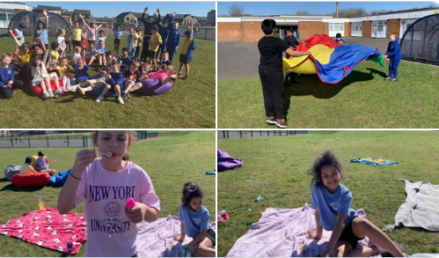
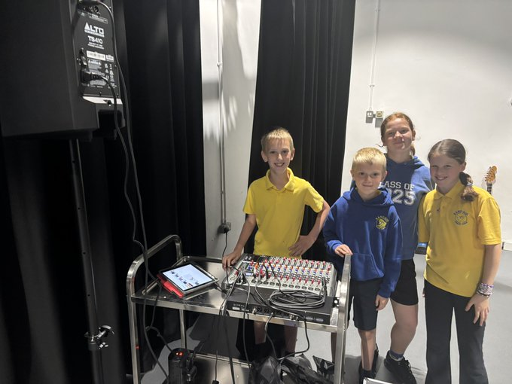
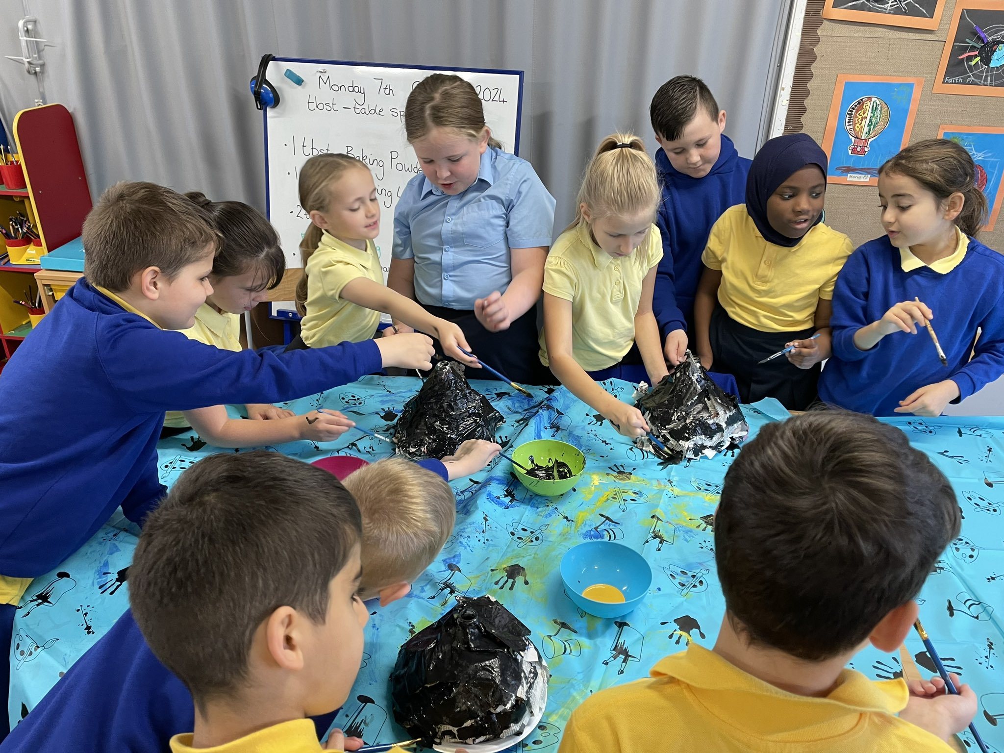

Winning house celebrations.
Our learners participating in experiments during STEM lessons
Our Tech Team displaying their leadership skills.

The headteacher is an effective and caring leader. She has developed the leadership of others across the school. As a result, staff and children feel empowered and motivated to lead change.

What HMIE said!



Developments in learning, teaching and assessment (Q1 2.3)

Digital technologies are used successfully throughout the school to enhance teaching and support children with their learning. In addition to using the iPad, the children have used a variety of digital technologies to learn programming and coding skills, including Spheros.
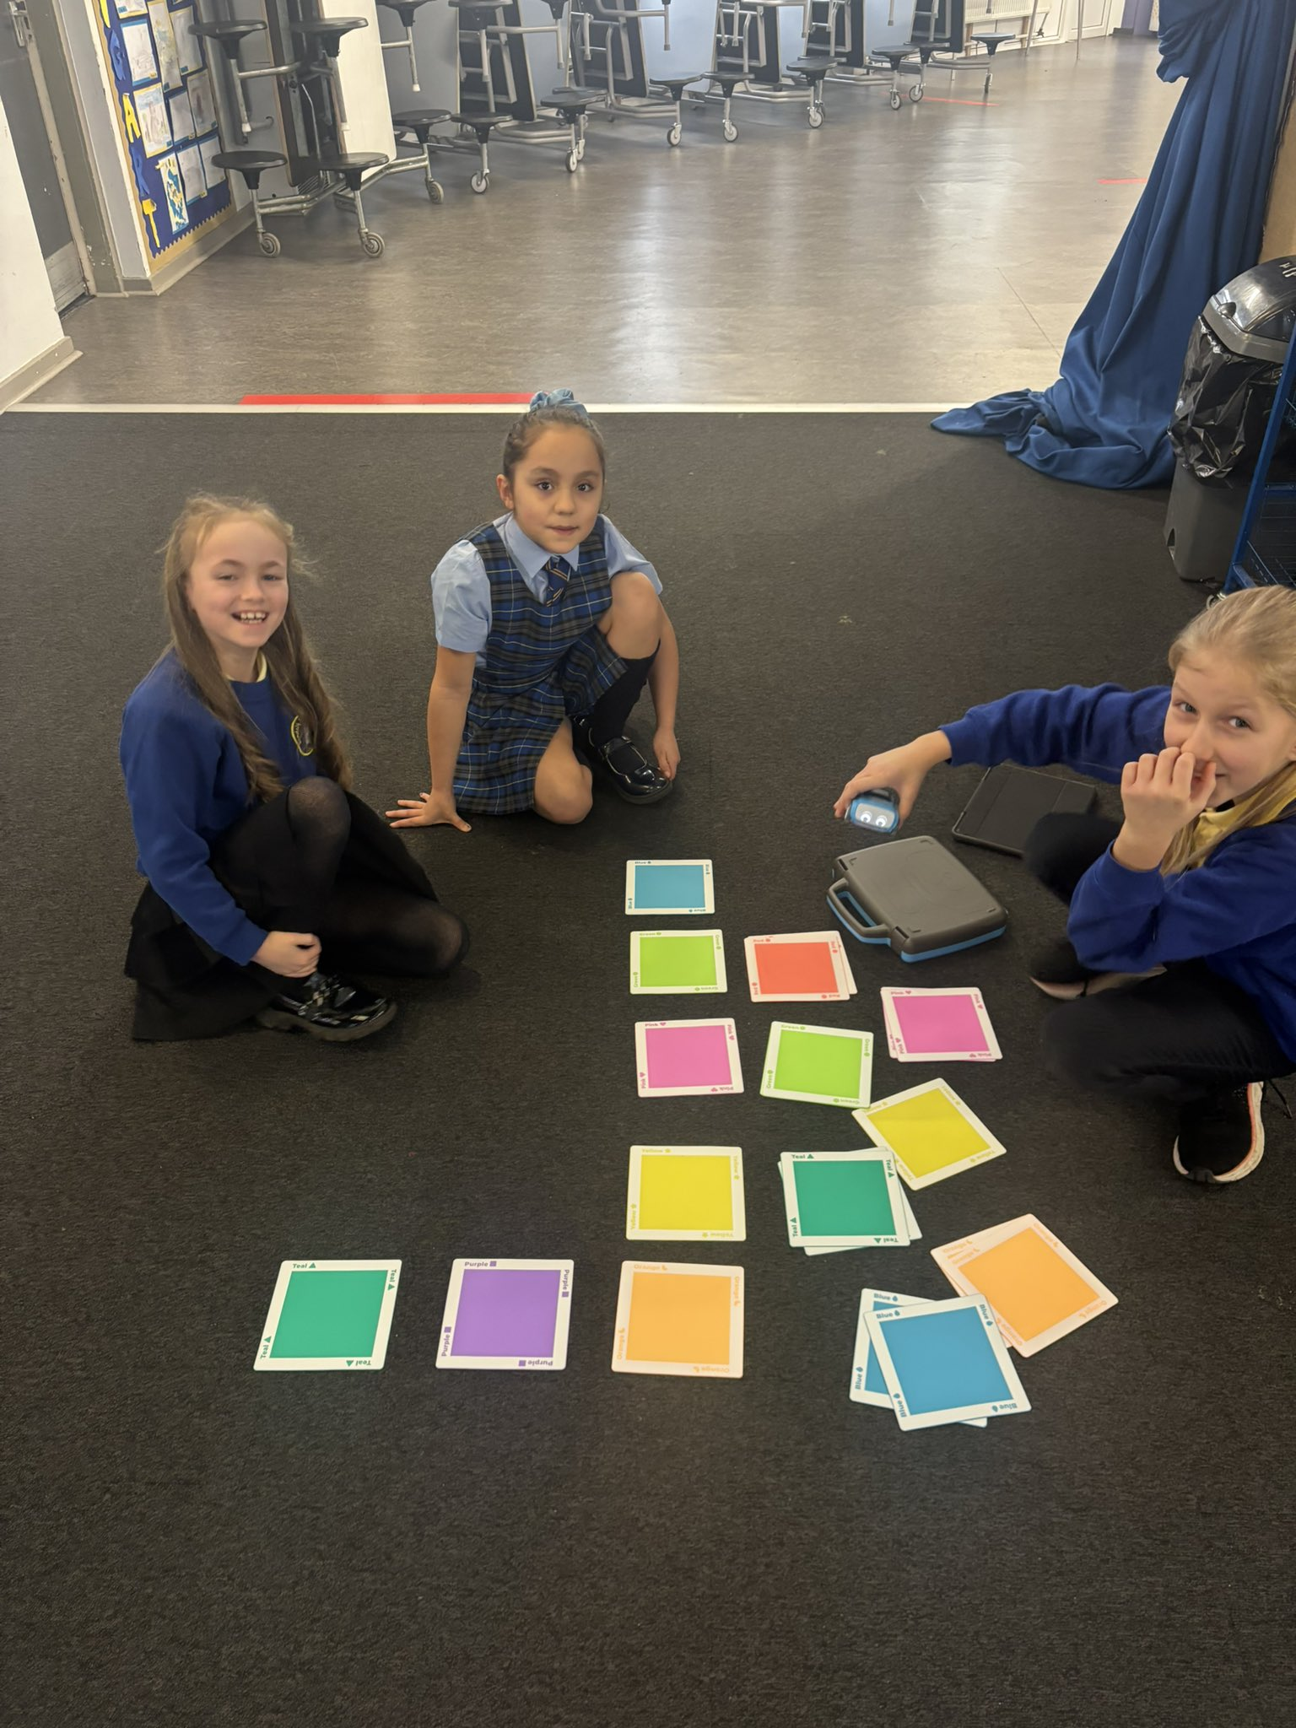
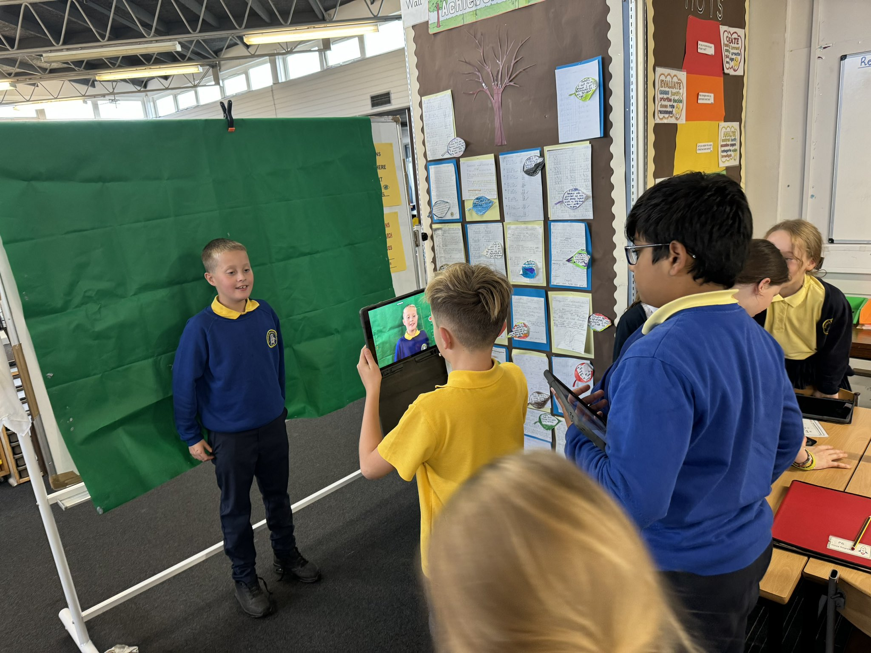
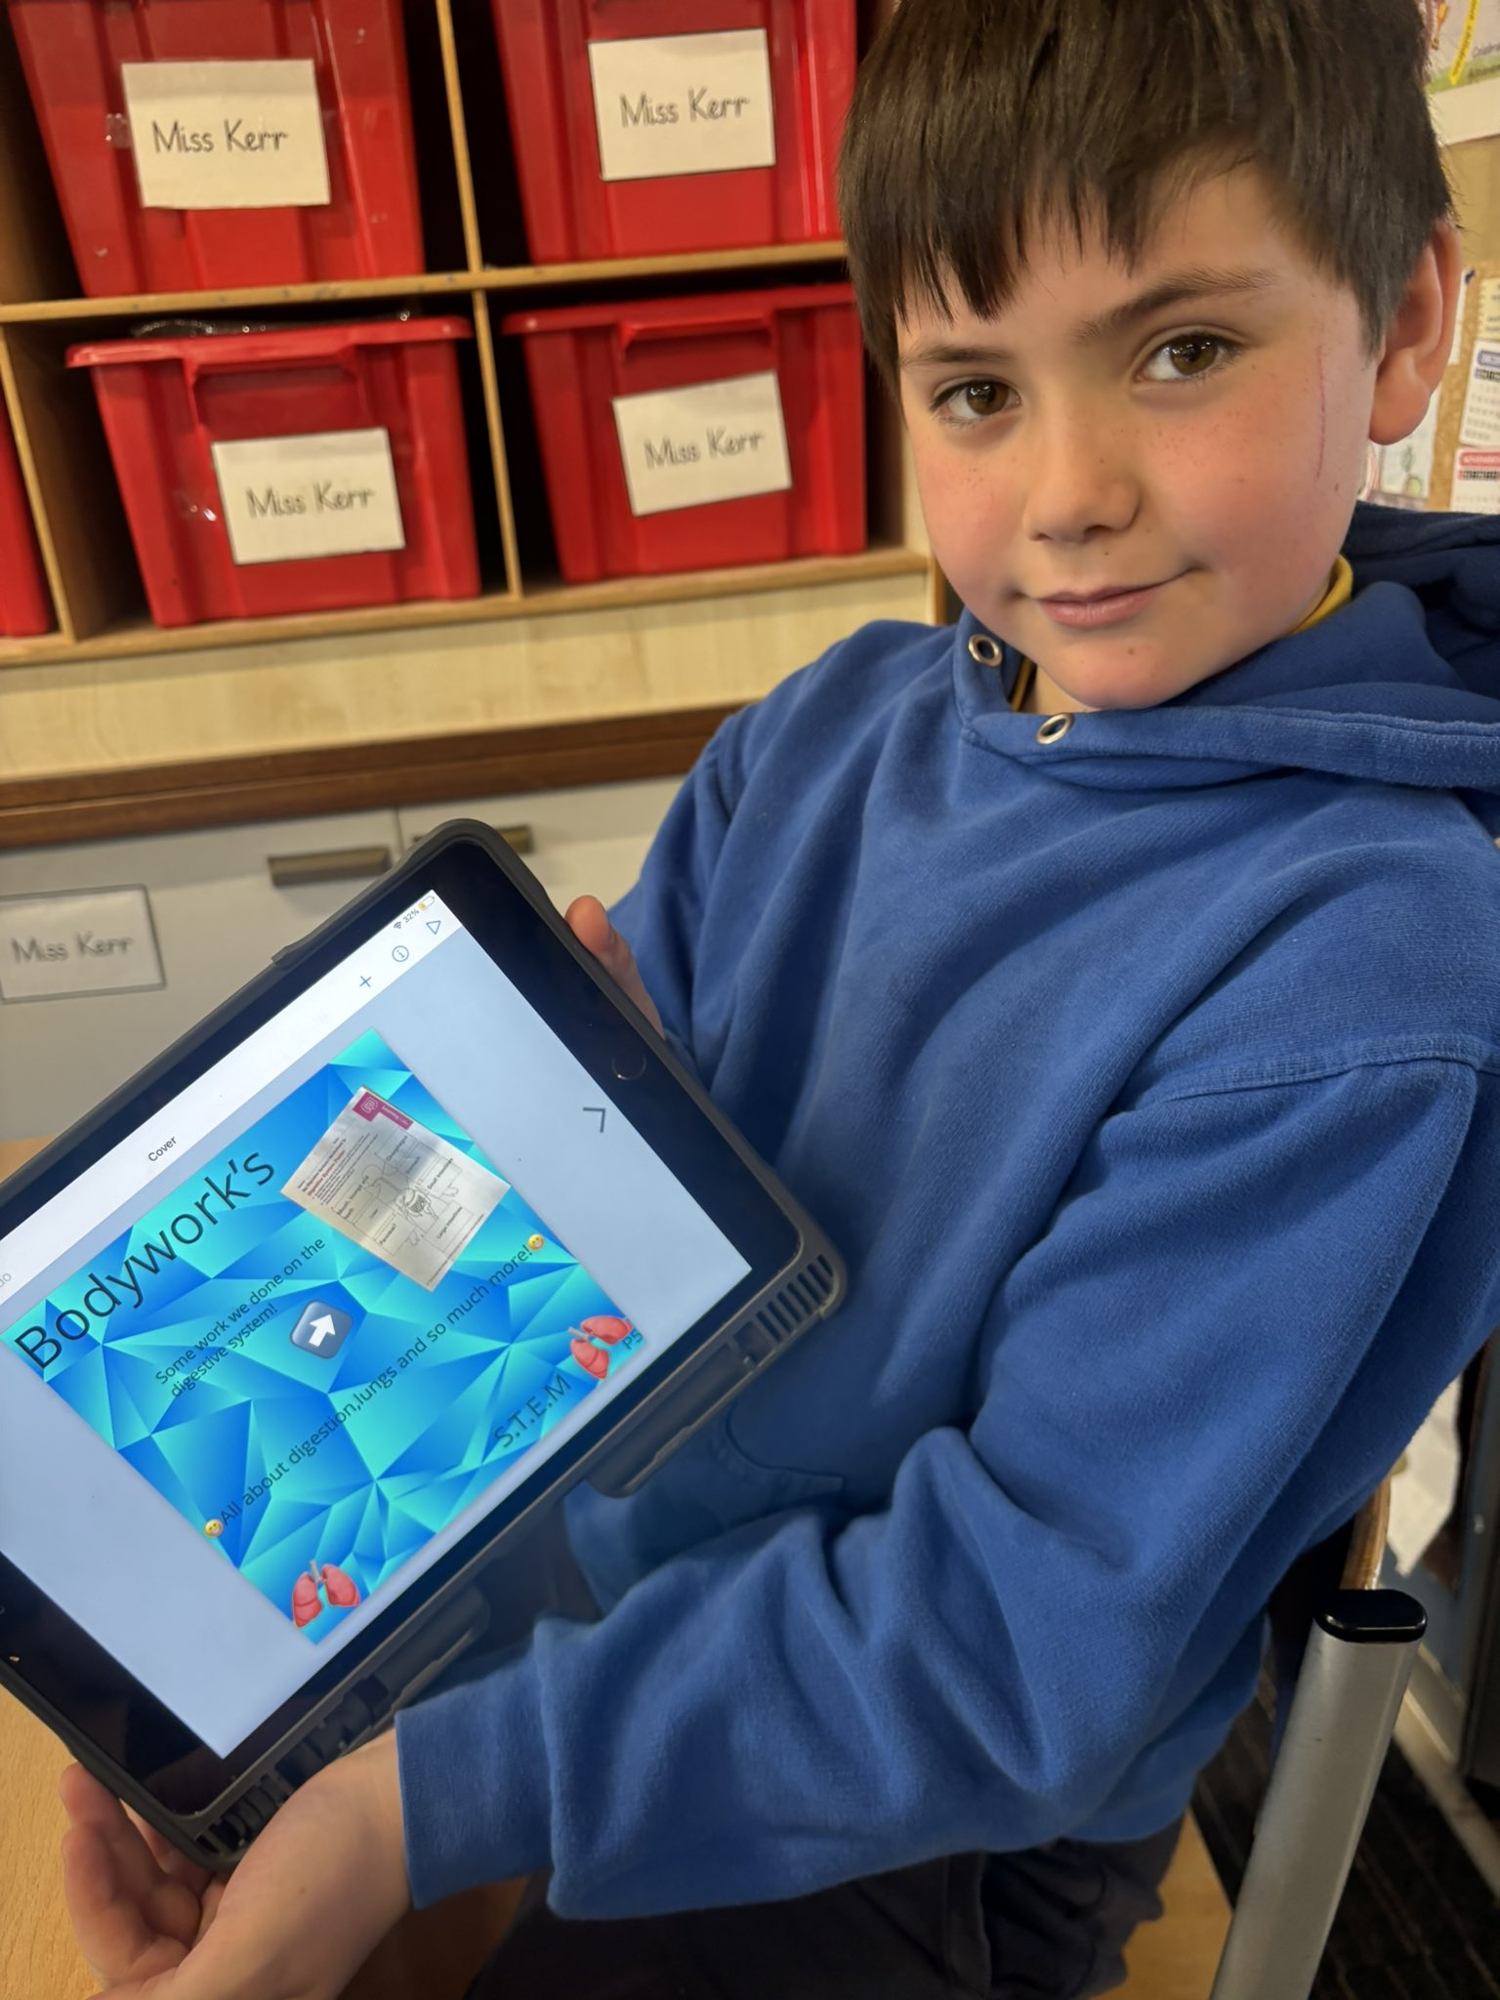

Programming Spheros to support sentence construction.
Book Creator helping with writing.
Using a Green Screen to record films.

Teachers make very effective use of digital technologies across learning and teaching. Children use a range of digital tools and platforms confidently to develop their digital skills and enhance their learning across the curriculum.

What HMIE said!

Progress in promoting well-being equality and inclusion (QI 3.1)

Health, wellbeing and nurture continue to be at the heart of Sandaig. This session, there have been several initiatives to support inclusion and improve attendance, including the 90 Club and Magic Breakfast.

It is important that the children and staff feel valued and their achievements are celebrated. Sandaig is proud of its inclusive atmosphere and the support and opportunities provided to all children and families within the school community.
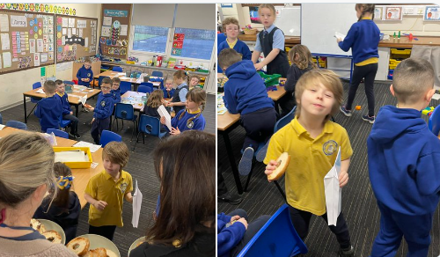
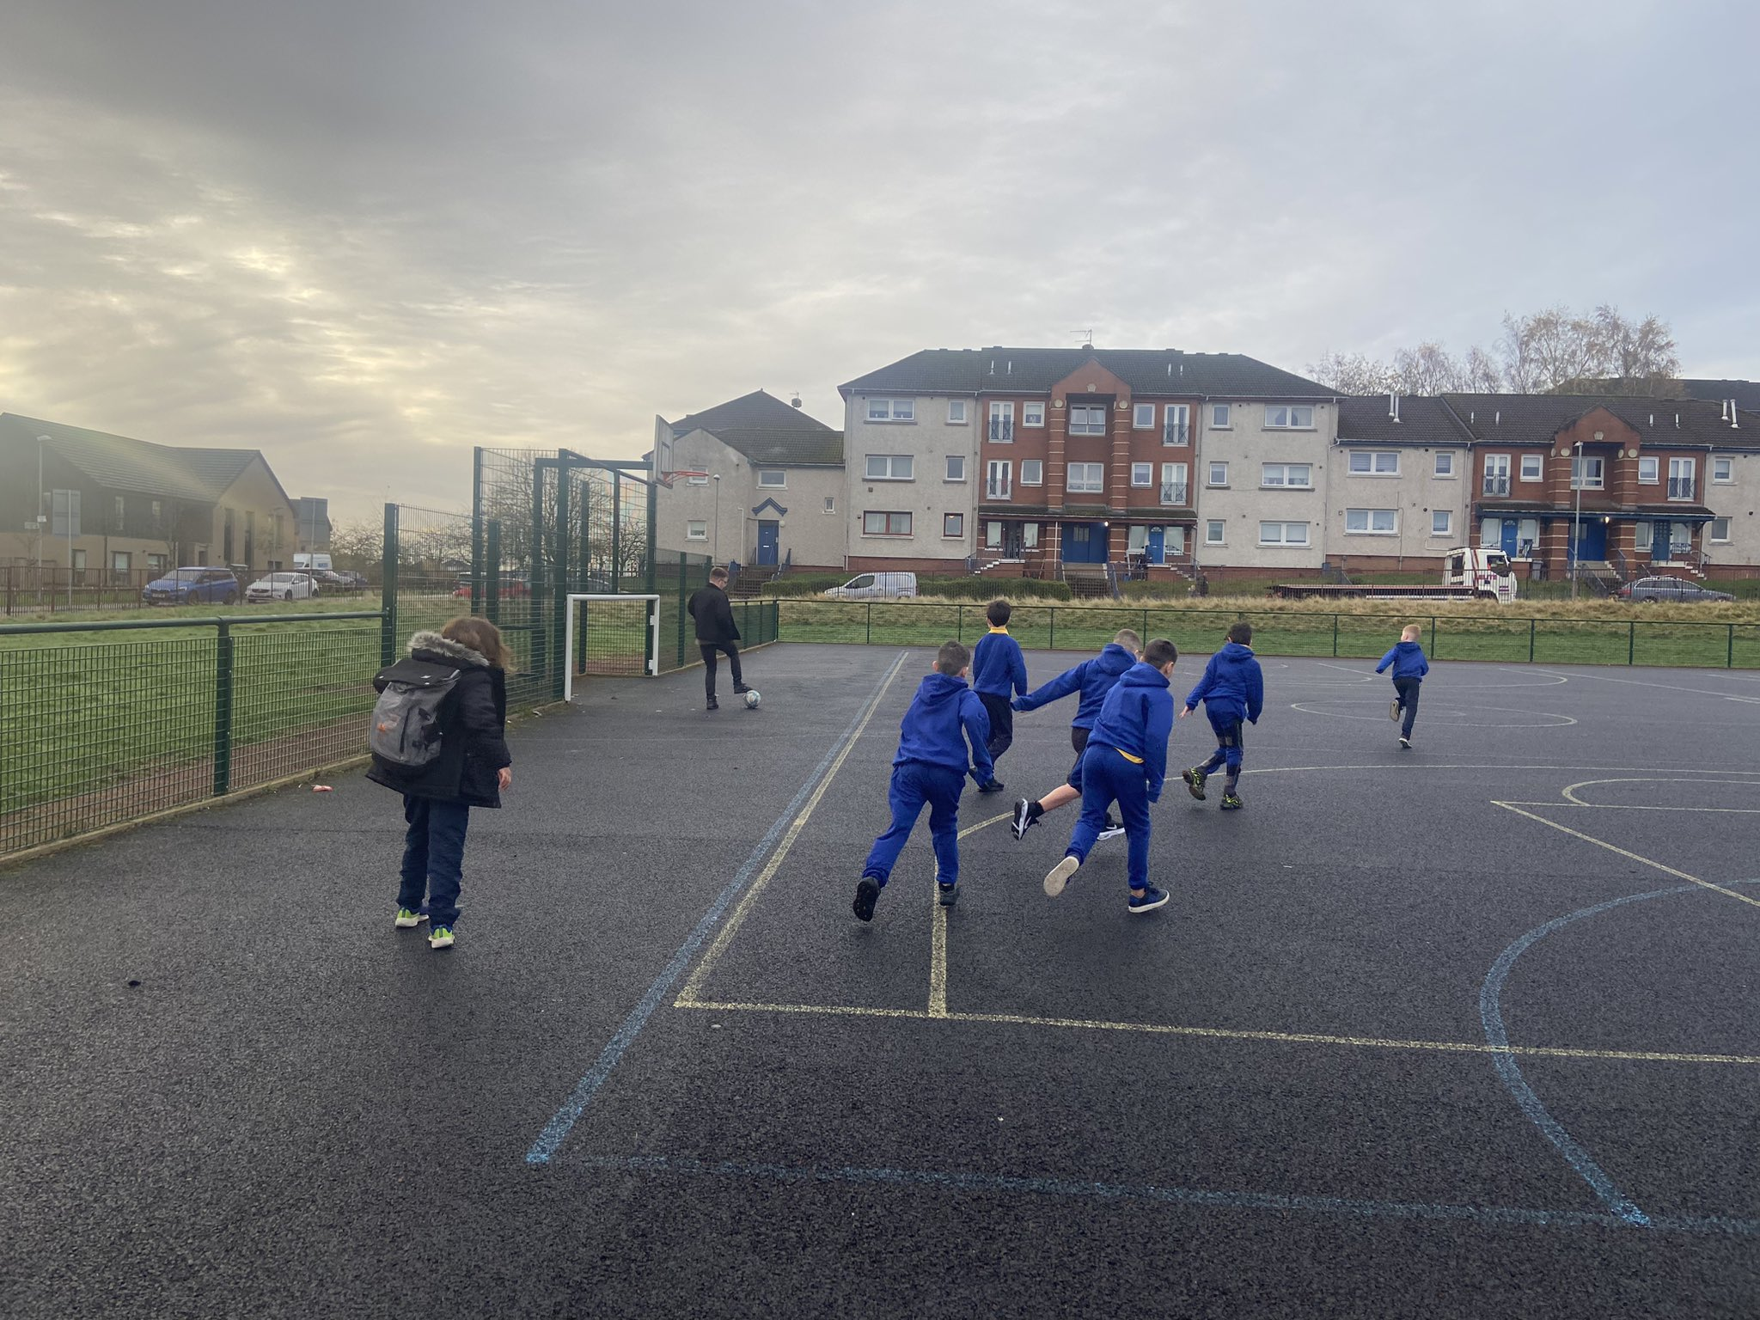


Staff and children enjoying a Magic Breakfast.
Playing football at the 90 Club for pupils with good attendance.
The children enjoying a trip to the Science Centre.




Hot chocolate and biscuits at Well Done Wednesdays.
Whole school end of term celebrations at the Sandaig Festival.

What HMIE said!

Across the school and ENP, staff, working with partners, have created a welcoming, nurturing, and caring ethos which is underpinned by the school values. This is leading to positive relationships and a strong sense of community. This is helping children to feel happy, secure and to flourish.

Progress in children’s learning /raising attainment and recognising achievement (QI 3.2)
Senior leaders and staff have raised children’s attainment in recent years. Overall, most children have made good progress in Literacy and Numeracy, and they have made very good progress in reading. Children who have an additional support need are making progress towards their individual learning targets.
The Challenge Leaders of Learning, CLOLs, for Literacy and Numeracy have continued to raise capacity within the staff, ensuring that good practice is being modelled across the school and then implemented in classrooms. They have worked with targeted intervention groups to help raise attainment and challenge our learners.
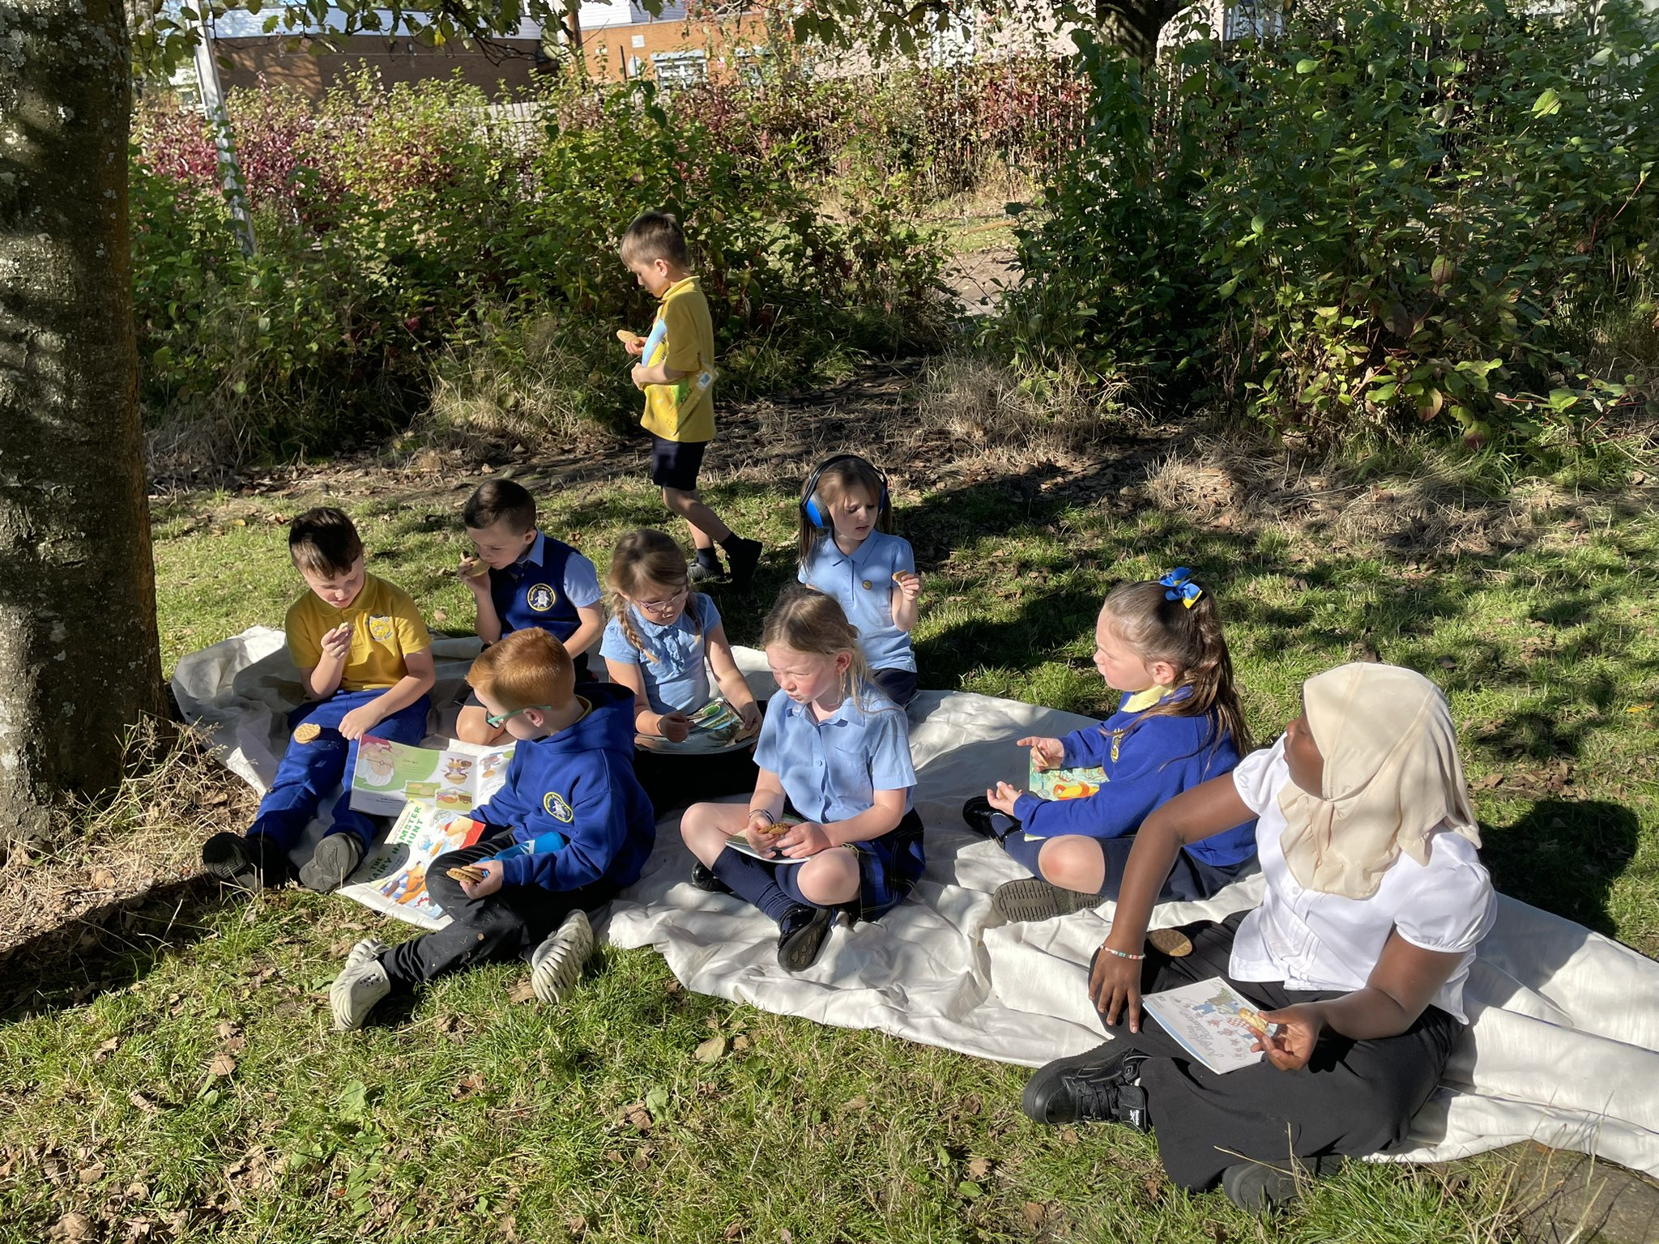
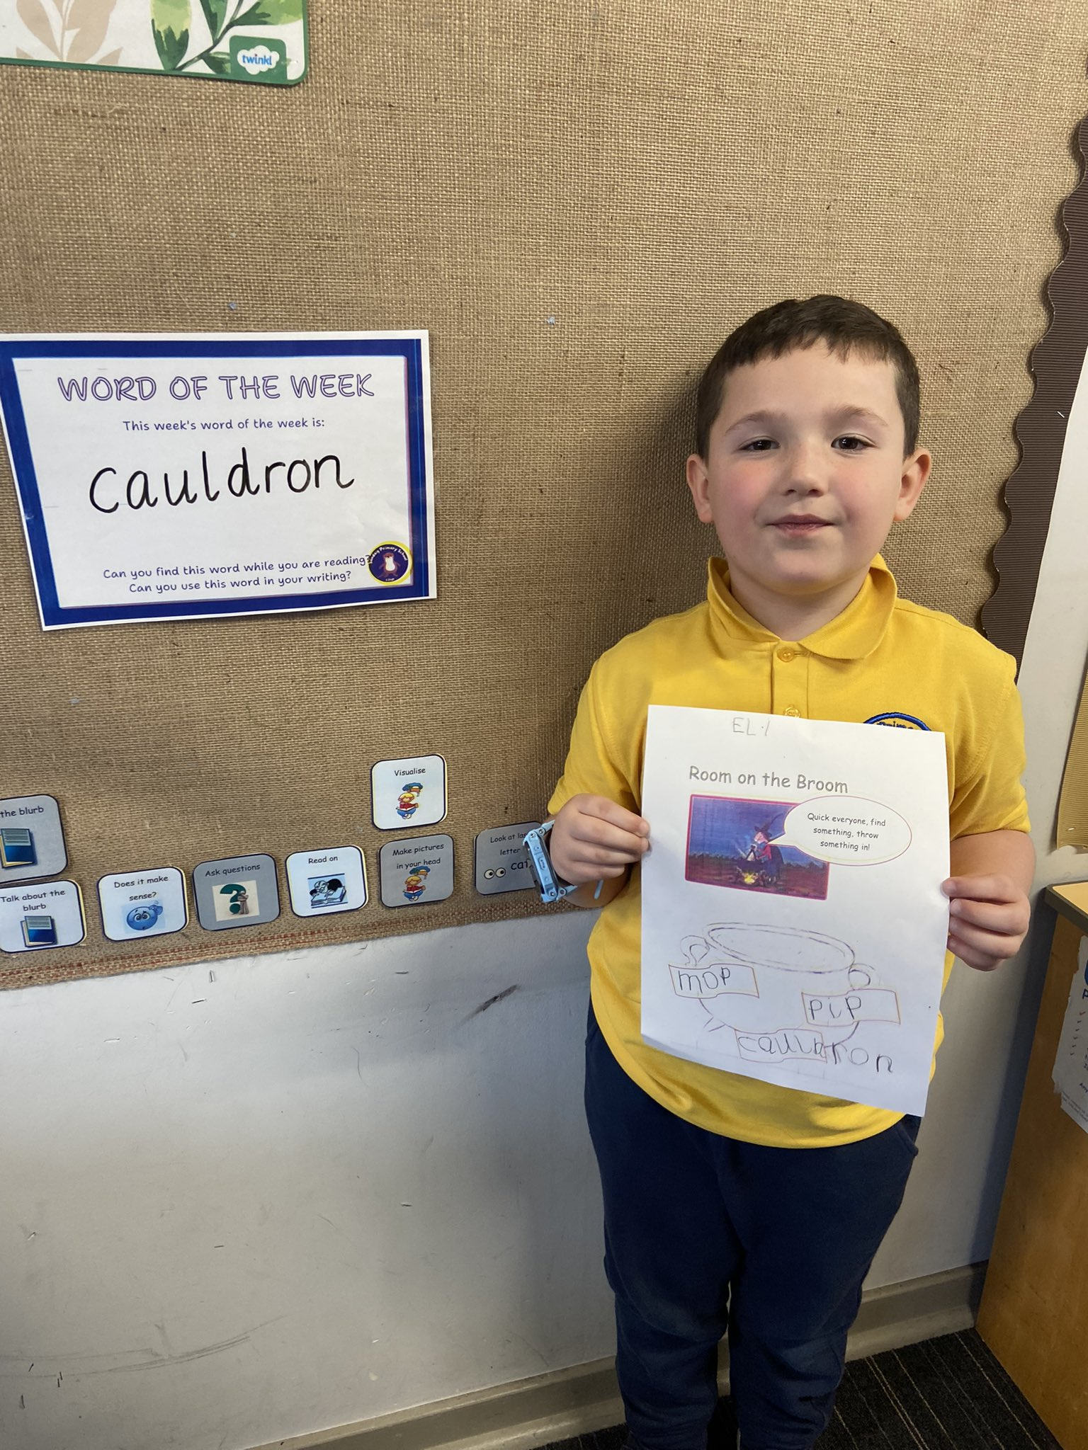
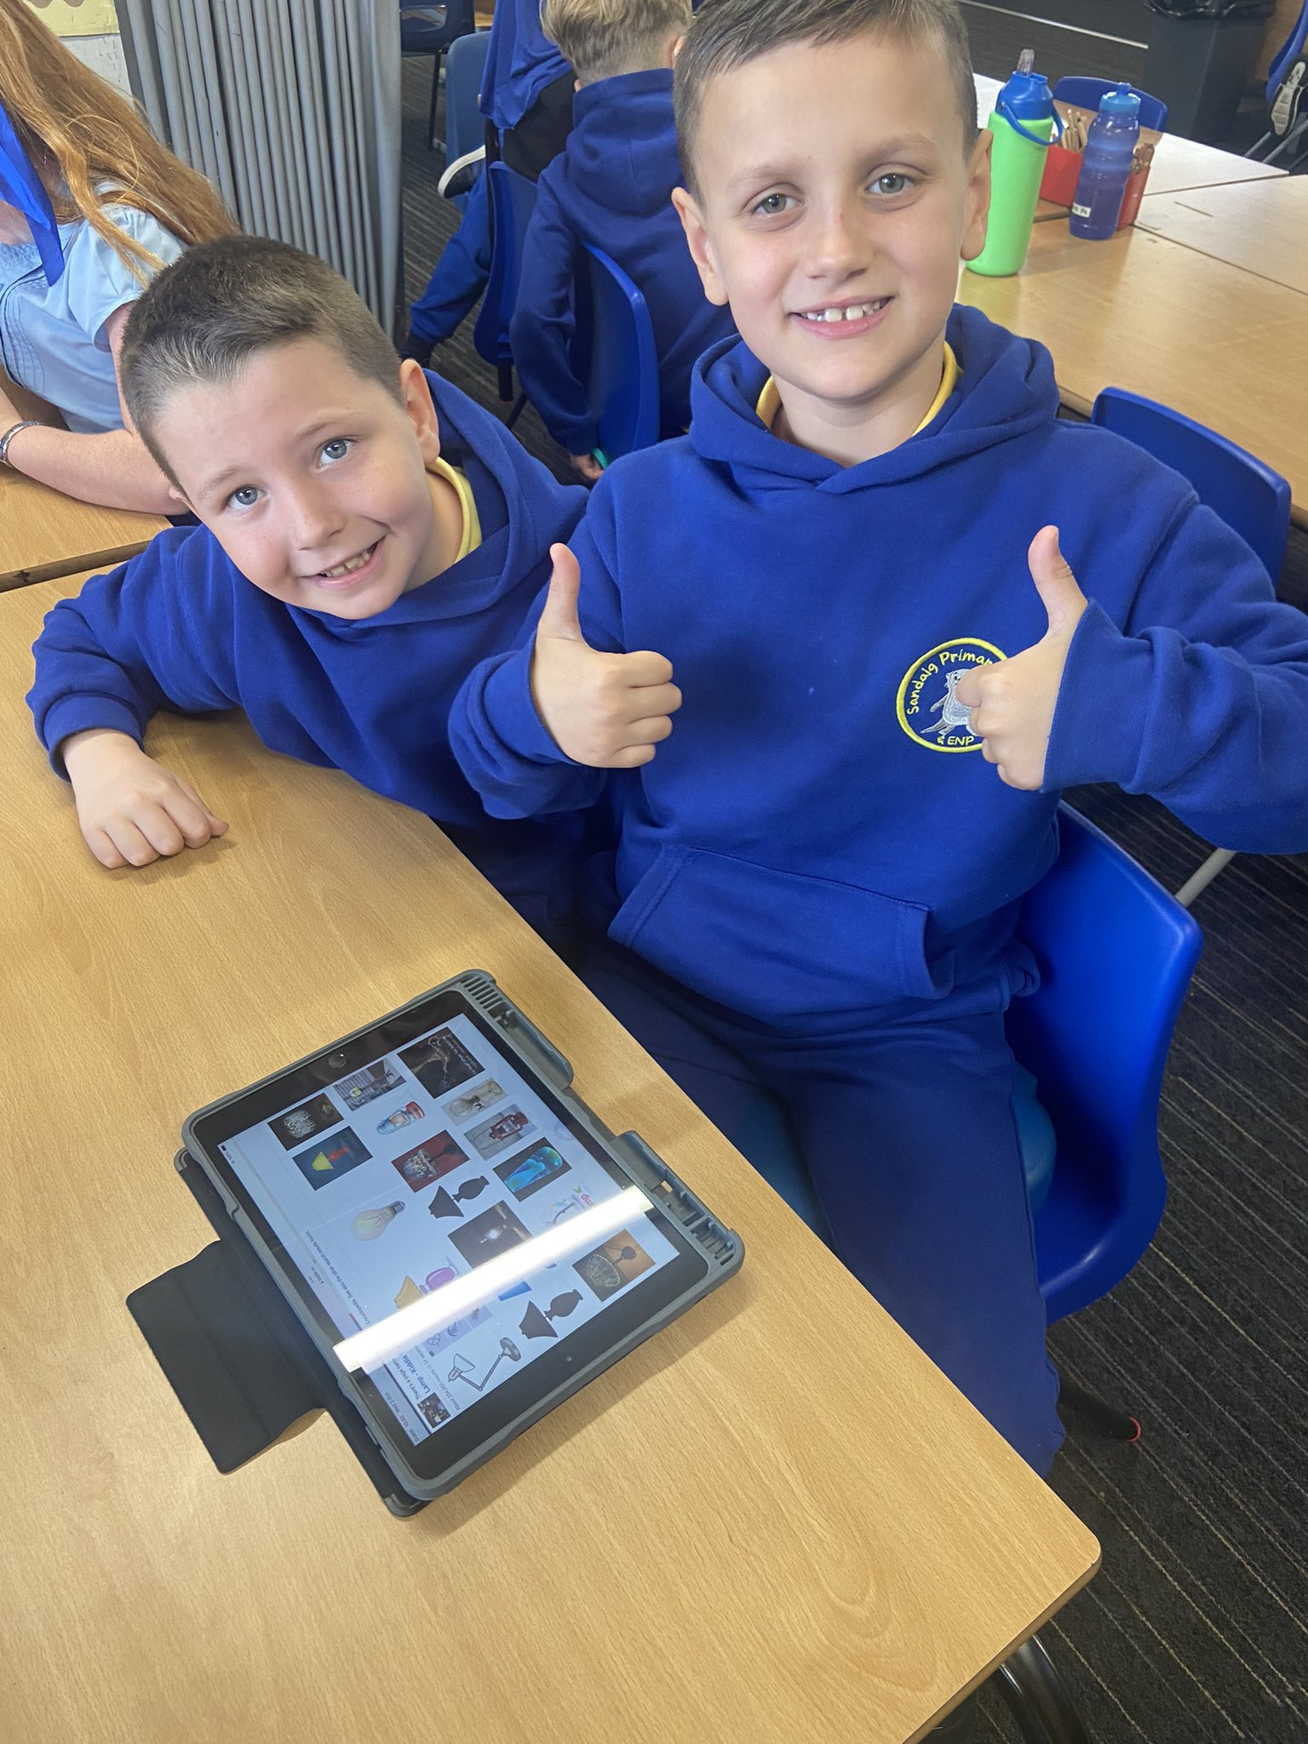

Enjoying one of our Reading Cafes outdoors.
Learning new vocabulary through word of the week.
Using Book Creator to make story maps for writing.

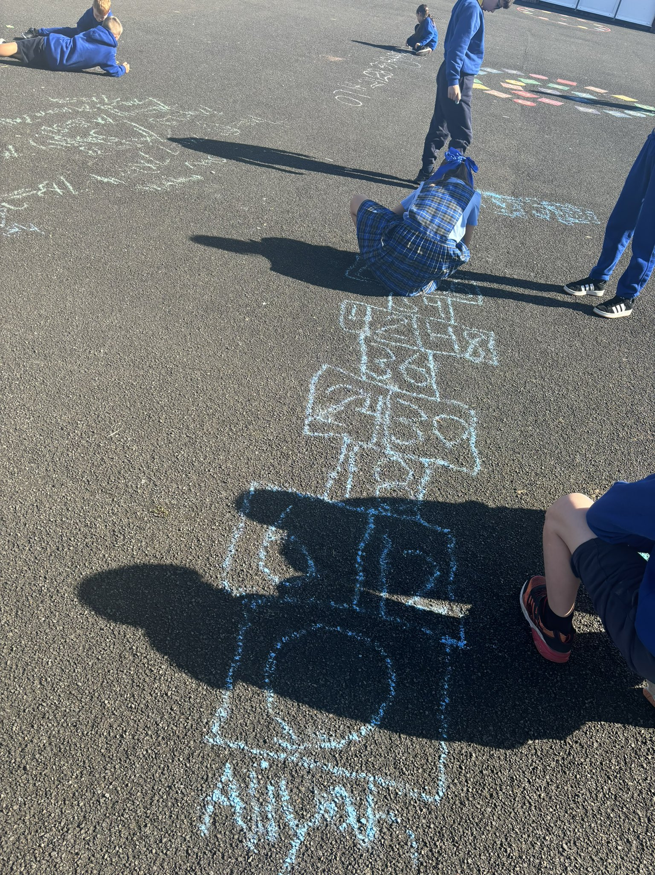
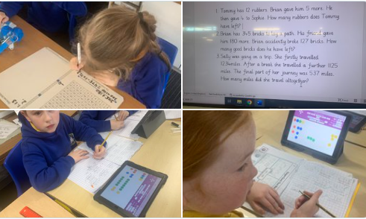
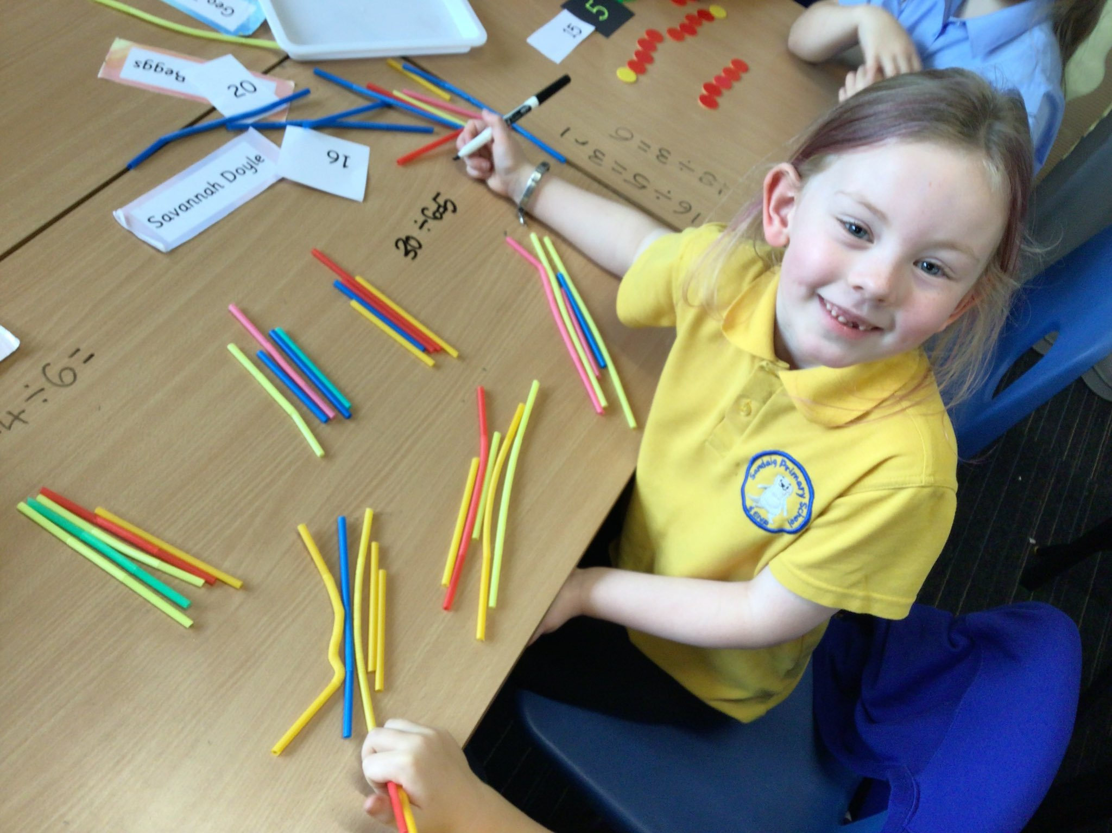

Reinforcing mathematical concepts through games.
Concrete materials are used at all stages throughout the school to support learning.
Chat that Counts being used to develop mathematical concepts and thinking.

Children in the school and ENP are extremely proud of their school. In the primary, children are articulate, keen to learn and are motivated by the wide range of opportunities they get to develop their skills. They are respectful and supportive towards each other.

What HMIE said!

Attendance and Exclusion data

Our improvement plan priorities 2025 – 2026
Achievement & Progress

Literacy-Phonics/Reading & Writing & Differentiation

Play

Numeracy-Beyond Number
Connected Learning

(Digital Technology)
Engagement Participation & Inclusion

Looking closely @ Attendance



 | How Good Is Our School 4 Quality Indicator (QI) | Evaluation
 | Leadership of Change (QI 1.3) | Good
 | Learning Teaching and Assessment (QI 2.3) | Good
 | Ensuring Wellbeing Equality and Inclusion (QI 3.1) | Good
 | Raising Attainment and Achievement (QI 3.2) | Good

How to find out more about our school
Contact us directly if you require further information about our school or if you wish to comment on this report.

Our contact e-mail address is: headteacher@sandaig-pri.glasgow.sch.uk

Our telephone number is: 0141 773 1744

Our school address is: 31 Burnmouth Road, Barlanark, Glasgow, G33 4SA

Further information is also available:

https://x.com/sandaigprimary

https://blogs.glowscotland.org.uk/gc/sandaigprimary/

https://blogs.glowscotland.org.uk/gc/public/sandaigprimary/uploads/sites/8839/2024/09/11081609/School-Handbook-2024-2025.pdf

