

Sandaig Primary School
31 Burnmouth Rd
Barlanark

Glasgow

G33 4SA

Telephone 0141 773 1744
E-mail –headteacher@sandaig-pri.glasgow.sch.uk

Sandaig Primary School
School Handbook

Dear Parents, Carers, and Friends of Sandaig Primary School.

Welcome to our school, this handbook has been produced for you. It provides you with information such as how your children will be educated and looked after in Sandaig Primary School.

I would like to welcome you and your child/ren to our school. Some of you will be familiar with our school community, but for others you will be meeting us for the first time.
As parents/carers of our pupils, you will always be made welcome at Sandaig Primary School. We aim to achieve the best possible education for your child. The most effective way to do this is to work in partnership with you. We hope that you will keep in close contact with us.

Our priorities are to ensure that all children can enjoy a high standard of care and welfare and learn in an atmosphere that is happy and stimulating. We strive to ensure that the ethos and school environment is one where children are encouraged to become successful learners, confident individuals, responsible citizens and effective contributors in line with Curriculum for Excellence.

I hope this handbook will answer many of the questions which you have about our school. If you have any other queries or concerns, please never hesitate to contact me personally and I will always do my best to address your concerns. We welcome all parents’ visits and are happy to discuss matters of mutual concern related to your child’s progress and welfare.


The staff at Sandaig Primary School looks forward to working in partnership with you now and in the future.

Thank you,
Mrs Susan Clark
Head Teacher

SCHOOL VISION

In partnership with parents we aim to provide a supportive and
challenging environment which nurtures children and encourages effective learning for all. Through a balanced and structured curriculum and a high level of staff
expertise, children will achieve high standards in educational attainment
and in social interaction.

SCHOOL VALUES

- Kindness
- Safety
- Respect

AIMS
1. To encourage and welcome parents as partners in their child’s education.

2. Using a variety of appropriate teaching methods we aim to provide a curriculum which meets the individual needs of all children.

3. To recognise the social and emotional needs of individual children and encourage positive developments.

4. To provide opportunities for purposeful staff development.
The above vision and aims for the children link directly to Rights of Children as set out in the leaflet available from the Education Department at
Children's Rights Glasgow or
UNCRC

STAFFING 2023-24

Leadership Team
Head Teacher |  |  | Susan Clark
Depute Head Teacher |  |  | Julie Moore
Principal Teacher Mainstream |  |  | Louise Kennedy
Principal Teacher Enhanced Nurture Base |  |  | Angela Bryson
 | Class Teachers |  |  |  | Support Staff
P1 | Miss Nawaz |  |  |  | Ann-Marie Young
P2/1 | Mrs McCort |  |  |  | Adele Flynn
P3/2 | Miss Hay |  |  |  | Karen Fullerton
P4/3 | Mrs Hind |  |  |  | Susan Neely
P5/4 | Miss McNulty |  |  |  | Joanne Creighton
P5 | Miss Kerr |  |  |  | Karen Johnstone
P6 | Mrs Kennedy and Ms Khan |  |  |  | Debs Bell
P7 | Mrs Mackenzie |  |  |  | Gillian Weir
Otter Room P1-3 | Miss McLean
Enhanced Nurture Base Rm 1 | Mrs Cant
Enhanced Nurture Base Rm 2 | Mr Murphy
NCCT Cover  Challenge Leaders of Learning | Mrs Johnston/Mrs McConnell  Miss Stewart/Mrs McKenna
Clerical Staff | Kirsty Simpson
 | Sandra Difoco
Janitorial |  | George Houston
Breakfast Club |  | Joyce
 |  | Alec
Cleaning Staff |  | Tracey  Charlotte  Liz  Ross
Catering Staff |  | Carol
Vicky
Lorraine
Active Schools Co-ordinator |  | Kenny McAdam
 |  |  |  |  |  |  |  | Play Therapist
Sandaig Primary School is non-denominational and provides education for both boys and girls from Primary 1 to Primary 7. It is a semi open-plan school, which can accommodate a maximum of 440 pupils in 14 bases. The present roll is 192 children.
Parents should note that the working capacity of the school may vary dependent upon the number of pupils at each stage and the way in which the classes are organised.

THE SCHOOL DAY

Morning *09.00 – 10.30
Interval 10.30 – 10.45
Lunch 12.15 – 13.00
Afternoon 13.00 - 15.00

N.B Soft start from 8.50am. during the winter months
Term 4 will see the children in the playground from 8.50 am.

At Sandaig Primary, safety is our top priority. To ensure the utmost security for our students, parents are kindly asked to drop off their children at the school gates, allowing them to confidently walk into the premises independently. This measure ensures that no unauthorised adults are on the premises, while our dedicated staff members diligently safeguard the children inside. Parents are encouraged to schedule appointments with the office staff for any concerns or queries, further fostering a collaborative and secure environment for our school community.

Thank you for your co-operation and support.

COMMUNICATION

We communicate with the school community in a variety of ways and encourage you to check the details we have on record for your child are up to date to ensure you receive the most up to date communication.

MEETINGS WITH STAFF

Parents and carers are welcome in the school to discuss any aspect of their child’s progress or school experience with a member of our leadership team.
Unfortunately, we are unable to meet with parents between 8.45am and 3.15pm; unless an appointment has been arranged because this can take away valuable time from your child’s teaching and learning. Please call the school office on 0141 773 1744 if you would like to make an appointment.

SCHOOL WEBSITE

Our school’s website is in the process of being updated; however, there is still a wealth of information about the school available. You can access the information via the address below.
https://blogs.glowscotland.org.uk/gc/sandaigprimary/

TWITTER

We would recommend that you follow the school Twitter page - @sandaigprimary as we use this platform to share information about our learning, upcoming events, post reminders and most importantly, as a way to celebrate our pupil success stories.

TEXT MESSAGING

You may also receive text reminders about school events and also in emergency circumstances e.g. School closures. Please ensure you have given us an up to date mobile number so you are not missing out on this service.

NEWSLETTERS
Newsletters will be emailed out on a regular basis to those parents who have given us an up to date email address. Paper copies will be available from the school office.

SCHOOL EVENTS

Parents and carers are welcome to other events throughout the school year e.g. Workshops, information evenings, class performances, religious and other assemblies.

SCHOOL SECURITY & SAFETY

Communication between parents and school is vital and we always seek to encourage this and to make parents feel welcome, however, Glasgow City Council has clear guidelines on welfare and security and the use of Secure Entry Systems and general aspects of school security. Within these guidelines we regularly review procedures and the following must be adhered to:

Within Sandaig Primary Schools good attendance is encouraged at all times and children are rewarded accordingly. Parents are asked to contact the Pupil Absence Reporting Line if their child is going to be absent. This should be done before 9.30am on the first day of absence. If the child is going to be absent for some time, it would be helpful to know at the earliest opportunity. The school uses daily text messaging to inform parents of their child’s absence if no contact is made. All unexplained absence is investigated by the school and appropriate action taken.


Pupil Absence Reporting Line
Telephone Number: 0141 287 0039

The Pupil Absence Reporting Line (PARL) service has been created to provide an efficient flexible way for parents/carers to report absence. It is recognised that in some circumstances, for example, to report or discuss a sensitive issue, you may still require to speak directly with the school. The following guidance should be applied:

Please phone the Pupil Absence Reporting Line to report the following absences:
- Sickness absence: If the absence lasts more than one day, parents and carers are required to call on subsequent days to provide an update. A letter should be provided to the school when the child returns from their absence.
- Medical or dental appointments: Parents and carers should call the PARL to report absences for medical or dental appointments. The school requires a letter or appointment card as evidence of the appointment to ensure permission is given to be absent from class.

Please phone the school directly to report the following absences:
To make sure you receive the right support you require, parents and carers should still contact the school directly to report absences of a sensitive nature for example, bereavement, serious Illness (an absence which is going to last more than one week) Injury or contagious diseases or illness.

The pupil absence service is provided by a dedicated team of experienced Education Support Staff. The information you provide to the team is updated in the school’s system when you call, so that we are immediately aware of all the absence information.

EVERY DAY COUNTS

Number of days absent = attendance percentage %
The following information explains the percentage of a pupil’s attendance at school and what this means in days/leaning missed. As a pupil’s percentage falls, procedures are activated to help support and encourage regular attendance at school.
Attendance levels are calculated on a daily basis and all absences from school, including Term Time Holiday Leave, whether authorised and unauthorised will affect a student’s percentage of attendance. You will be informed in writing at the end of each term should your child’s percentage of attendance fall below 90%.

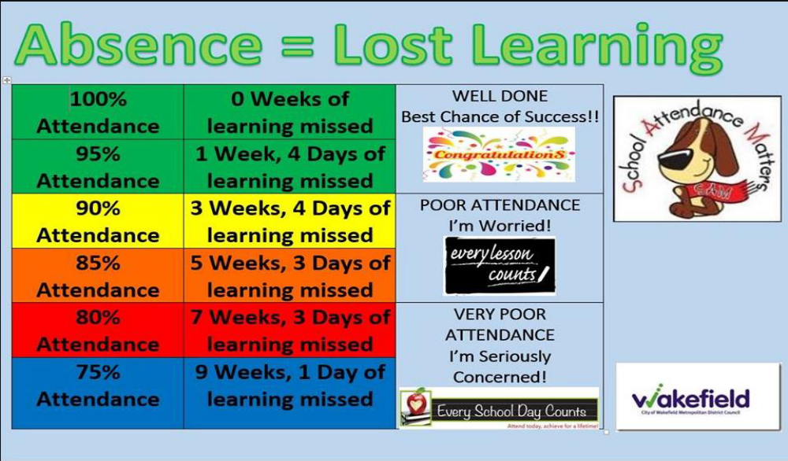

HEALTH PROMOTING SCHOOLS

Sandaig Primary aims to be a Health Promoting School and we wish to help equip pupils in making healthy choices in life. There are many healthy choices available as part of the daily school breakfast and lunch services. We ask for parental support by providing children with healthy snacks and water to drink.

All services available in the Fuel Zone are developed in line with The Schools (Health Promotion and Nutrition) (Scotland) Act 2007 which aims to help children eat healthily during the school day and beyond.
Cordia supports Education Services to meet the requirements of the Act by providing healthy food and drink in schools to encourage Glasgow’s children to make the right choice in order to maintain a healthy lifestyle.

BREAKFAST CLUB & FUEL ZONE INFORMATION

Glasgow’s Big Breakfast is available in all Glasgow primary schools every week day morning. Children can enjoy a nutritional breakfast of fruit juice, cereal and milk, toast and fresh fruit prior to the start of the school day. Children have the opportunity to socialise with their friends in a supervised and safe environment. Breakfast is FREE to those children in receipt of free meals. It costs £2 per day for all other children; however, if a sibling also attends they pay only £1 per day.

SCHOOL MEALS

Our school provides a lunch service which offers a variety of meals and snacks. Medical diets for children can be provided. Further information can be found HERE
Children and young people of parents/carers receiving Income Support, income-based Job Seekers Allowance, Working Tax Credit, Child Tax Credit only, Universal Credit and income-related Employment and Support Allowance are entitled to a free midday meal. Information and application forms for free school meals may be obtained HERE

We no longer accept cash payments at Sandaig Primary School.
ParentPay is the school’s new online payment system that lets you make secure online payments by credit and debit card.
It’s used to make cashless payments in schools for dinner money, trips, etc
ParentPay account activation codes are confirmed once your child is actually on roll at the school and you will be notified of these as soon as they become available; please do not hesitate to contact the school office, if you have any queries with ParentPay.
Making a payment is straightforward and ParentPay holds an electronic record of your payments to view at a later date; no card details are stored in any part of the system. Once you have activated your account you can make online payments straight away. Once payment has been made, please allow two hours for our internal systems to update, particularly if you are paying for dinner money.

LUNCH

Fuel Zone focuses on serving healthy food in a bright and informal environment where children can enjoy lunch. The menu in the Fuel Zone rotates on a 3 weekly basis giving children more variety at lunchtime. Three meal choices are available daily: main meal, vegetarian or snack meal. Children can select from soup and bread, fruit and vegetables, yoghurt or jelly and milk to accompany their meal. A halal menu is also available if required please speak to the catering manager for further information.

Children wishing to buy a meal need to bring money with them every day. The cost is currently £1.90 (October 2019). P1-5 children all receive FREE SCHOOL MEALS. Children may bring a packed lunch, which will be eaten in the dining hall.

SPECIAL DIETS

If your child has a special medical diet requirement, please seek a referral from your dietician. Please then contact your catering manager who will deal with your request.

Catering Manager: Carol Paterson Phone Number: 0141 773 4079

You may find the link below useful:

http://www.fuelzoneprimary.co.uk/UserFiles/files/Medical_Diet_Leaflet%20-%20June%202017%20WEB.pdf.

REFRESH

Lack of water can cause dehydration. Better hydration means better performance in school and water is an excellent alternative to sugary drinks, which can cause tooth decay.

The Refresh initiative allows access to fresh, chilled drinking water in schools to encourage children to drink more water. All Glasgow schools have been supplied with mains fed coolers that filter and chill the water ready for drinking. This allows access during the day to refill water bottles which can be taken into the classroom.

EXTRACIRRICULAR ACTIVITIES AND CLUBS
In addition to our curricular syllabus our pupils enjoy a wide and varied programme of activities before, during and after school. We are grateful for the amount of personal time teachers and parents/carers give to these extra-curricular activities and value their commitment and dedication. If you have talents to offer our children, please come forward and get involved.




NURTURE GROUP

Our ‘’Otter Room’’ Nurture Group resource is mainly to support children at the early stages that are identified as requiring some additional support with personal and social development in order that they can reach their full potential.

ADDITIONAL SUPPORT NEEDS

Early Intervention Strategies are designed to identify children with either particular ability or difficulty in learning at the very earliest stage of the school. Such strategies are designed to help our children to be successful learners.
If difficulties persist, our Depute Head Teachers, Mrs Moore assisted by our Principal Teachers Mrs Kennedy and Mrs Bryson, will advise and support the child and the teacher. In addition, they may organise/provide some additional Support for Learning. Children who are failing to progress after receiving such support may in consultation with parents be referred to a Staged Intervention and Inclusion Meeting (SIIM) or Learning Community Joint Support Team Meeting (LC JST). The SIIM is attended by local school/pre-5 establishment Heads and Deputes and Psychological Services. The LC JST meeting is attended by school staff, our school nurse, our Education Liaison Officer, Social Work, Police and Psychological Services. Our Link Educational Psychologist is Alison Woods. Psychological Services can offer further assessment and assistance as appropriate following these meetings and consultation with parents/carers.

Mrs Clark, Head Teacher is our Additional Support Needs Coordinator.

GETTING IT RIGHT FOR EVERY CHILD (GIRFEC)

The GIRFEC approach is about how staff in all children’s services meets their needs by working together where necessary to ensure that children reach their full potential. Taking care of the well-being of our children and young people and making sure they are alright, helps us ensure the most positive outcomes for them later in life. It gives them the potential to grow up ready to succeed and play their part in society.
More information can be found at: https://www.glasgow.gov.uk/girfec

EQUAL OPPORTUNITIES AND SOCIAL INCLUSION

Sandaig Primary is committed to Glasgow City Council’s aims for the promotion of social justice and equal opportunity for all their schools. We strive to provide education tailored to the needs of the child as an individual regardless of wealth, gender, race, faith or disability. We are particularly proud of the fact that our school successfully integrates all children and accepts them as they are.

BULLYING AND HARRASSMENT

Bullying behaviour will not be tolerated within Glasgow City Council’s educational establishments. All children in Glasgow’s educational establishments have an entitlement “to work (and play) in a learning environment in which they feel valued, respected and safe and are free from all forms of abuse, bullying or discrimination”.

In 2009, Glasgow City Council published its revised Anti-Bullying Policy (see link below) incorporating the requirement to record and report all discriminatory behaviours within educational establishments. All establishments are required to review their policy in light of this. Parents and carers have a significant role to play in helping to address this problem. For this reason any anti-bullying strategy must stress the importance of partnership with the parents and carers of their children.
http://www.goglasgow.org.uk/content/UserGenerated/file/Policies_Guidelines/ECiIaS%20-%20Anti-bullying.pdf

RACIAL HARRASSMENT

The Race Relation Act of 1976 makes it unlawful to discriminate against someone because of her/his colour, race, and nationality, ethnic or national background. The Act makes it the duty of Glasgow City Council to eliminate unlawful racial discrimination. The adoption of an anti-racist approach should be seen as one part of the continuing attempt to improve the quality of education. Glasgow City Council recognises that support from the home is essential if these aims are to be achieved. Every child or young person in Glasgow has the right to be happy and secure at school.

ENROLMENT

Registration of Primary 1 pupils takes place in November and is advertised widely in the local press etc. Enrolment is done through Glasgow City Council’s website.
Prospective parents are welcome to visit the school and should contact the school office.
Families living out with the catchment area are welcome to make a placing request to attend Sandaig Primary School but must enrol their child at their local school as a first step.
Further information is available using the following link
Enrolling in a Glasgow School

ORGANISATION OF CLASSES

The following guidelines set by the Scottish Government apply.
P1 maximum 25
P2&3 maximum 30
P4-7 maximum 33
Composite classes maximum 25

Composite classes have pupils from more than one stage.

NURTURE CLASS

We are very fortunate in having additional teaching and support staff to run a nurture class. Children (usually in the early stages) who would benefit most from more individual attention attend the ‘Otter Room’ for some part of the school day. Links are maintained with their own peer group and class teacher. They are taught in this small group environment for a period of time determined by the child’s needs.

PUPIL EQUITY FUNDING

This session, we have received a £95,000 allocation, and we want to transparently inform you about how these funds will be utilised to benefit your child's education.

With this funding, we have made strategic staffing decisions to enhance your child's learning experience. We are thrilled to introduce three dedicated professionals who will be joining our team: Ms. Khan, alongside Ms McNulty and Mr Grey. (Ms McNulty and Mr Grey will be in class allowing other members of experienced staff in supporting our learners' development in three key areas: literacy, numeracy, and attendance. By focusing on these fundamental aspects of education, we aim to raise academic achievement levels and narrow the poverty gap across the school.

We believe that investing in the expertise of Ms. Khan, Mrs. McKenna, and Mrs. Stewart will have a profound impact on your child's educational journey. Their dedication, coupled with the PEF funding, will help create a more inclusive and supportive learning environment for all our learners.

SCOTTISH ATTAINMENT CHALLENGE

Another funding stream from the Scottish government has provided additional staffing in the form of Mrs McKenna (0.6 FTE) and Mrs Stewart (0.6FTE who are our Challenge Leaders of Learning (CLOL).

MEDICAL & HEALTHCARE

The school nurse visits at various times during the year for routine health checks, vaccinations and medical examinations. Parents are kept informed by letter.
If a child becomes ill during the course of the school day, he/she may require to be sent home. Please ensure that you keep the school informed of all contact details.
Parents should inform the school of any medical requirements relating to their child. If a child requires medication during the school day, this must be discussed with Mrs Clark who will work with you to develop a Health Care Plan for your child.

EMERGENCIES

We make every effort to maintain a full educational service, but on some occasions, circumstances arise which lead to disruption. Schools may be affected by, for example, severe weather, and temporary interruption of transport, power failures or difficulties of fuel supply.
In such cases, we shall do all we can to let you know about the details of our closure or re-opening by using letters, texts and the local media etc.

SCHOOL UNIFORM

At Sandaig we believe that the wearing of school uniform helps to promote a pride in the school. We encourage the wearing of uniform at all times.
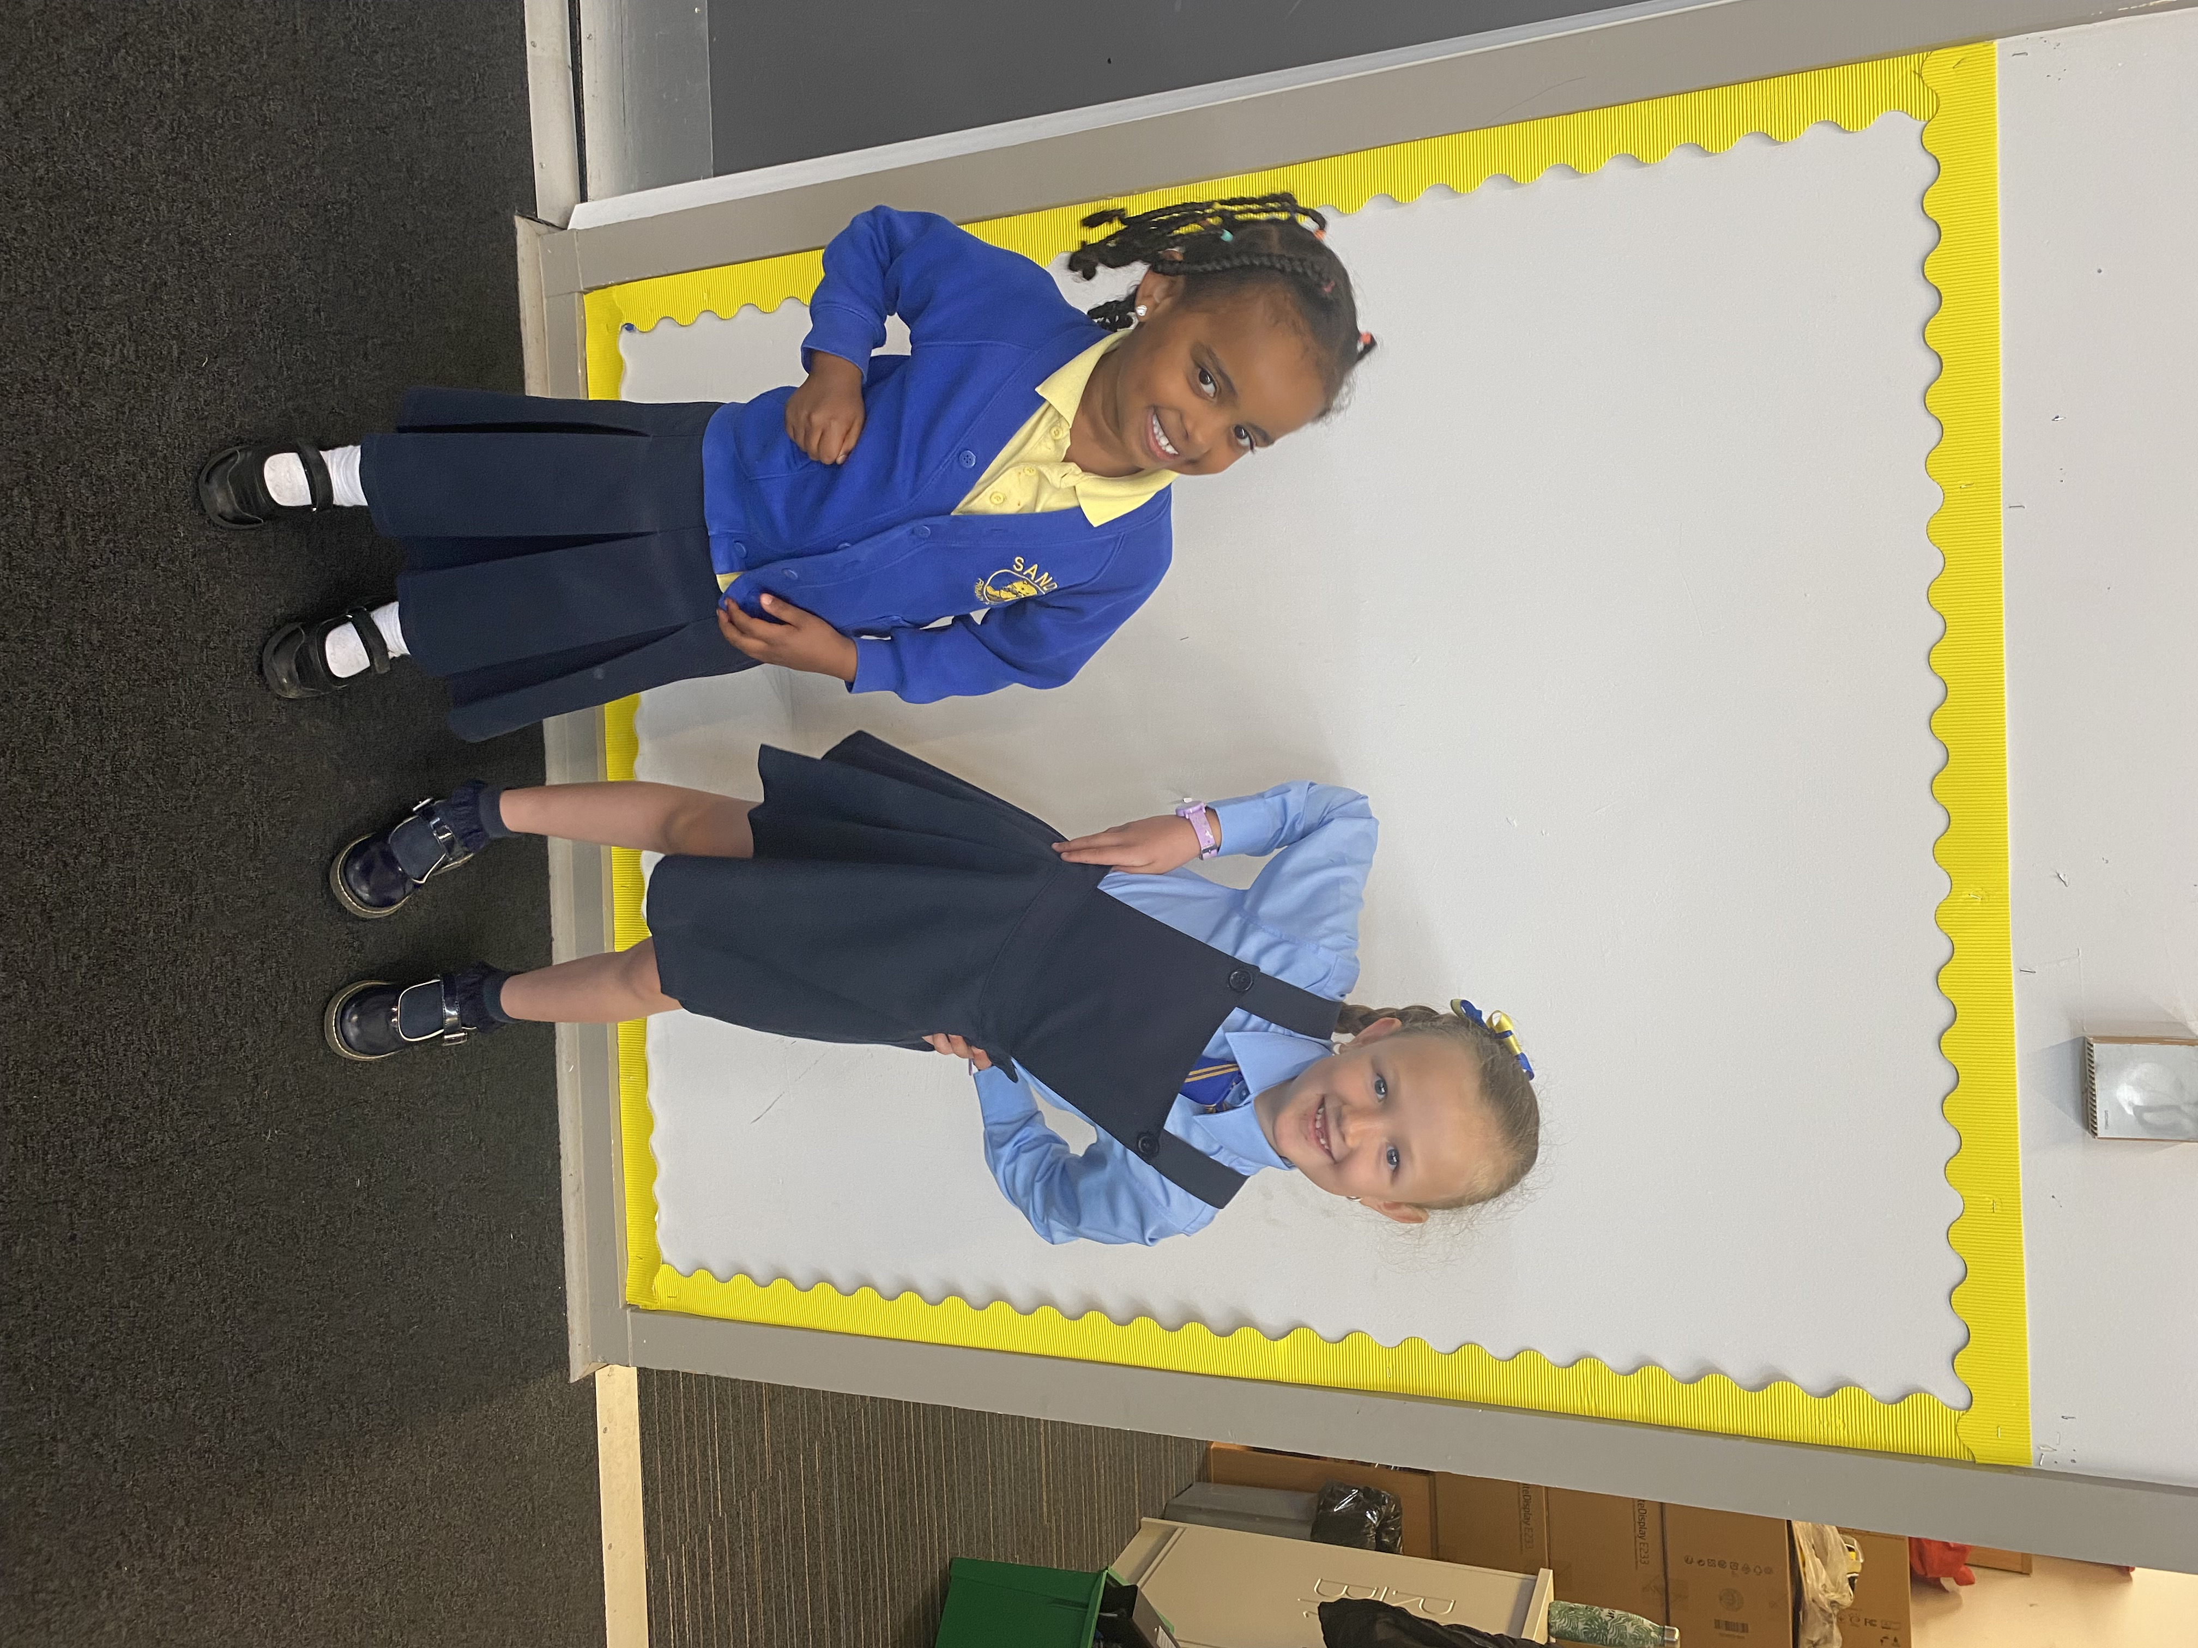
The school uniform is: -
Navy skirt or trousers
Royal blue cardigan or jumper
Blue shirt & school tie
Yellow polo shirt
Badged uniform is available from our supplier
Aspire Academy
Shoes should be black or navy. Trainers, leggings and Converse are not school uniform.
Our uniform was agreed in consultation with pupils and parents. It is expected that all children attending Sandaig Primary School will adhere to this dress code. This also helps to support our equity agenda with all pupils equal in their clothing.

P.E KIT
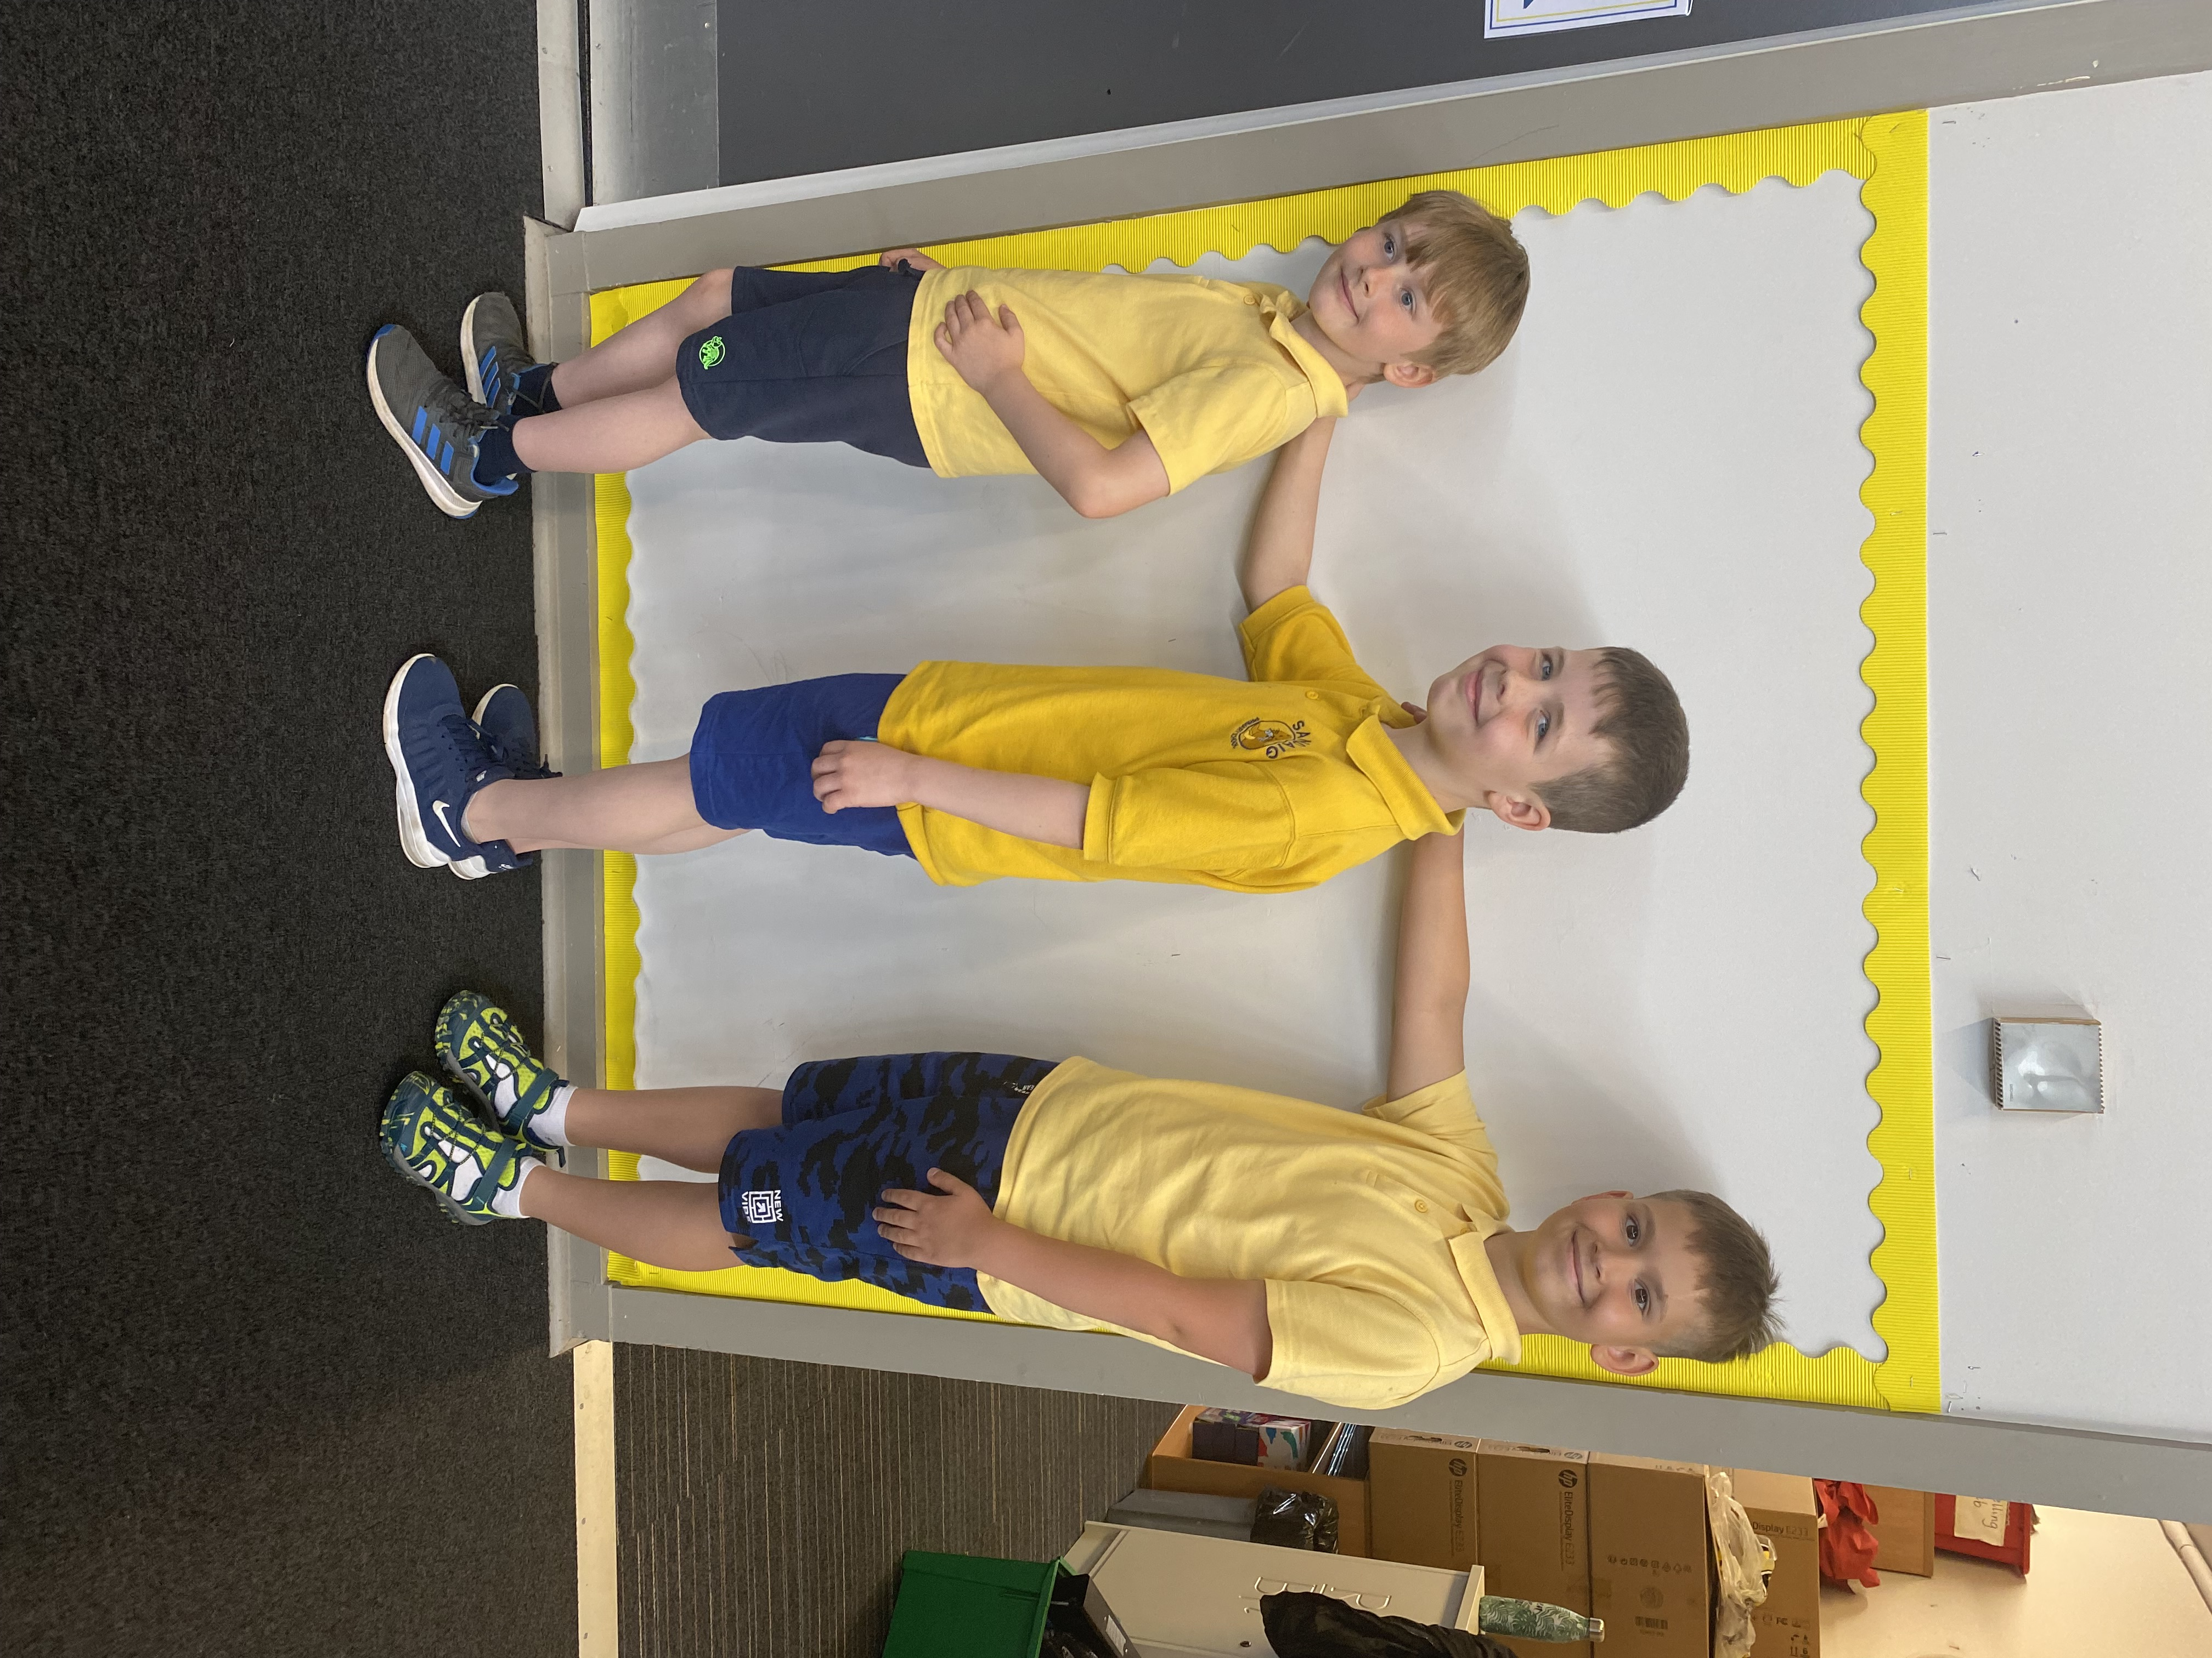
It is important that children come prepared to learn and for PE this requires appropriate clothing. All jewellery should be removed. Pupils who are not participating in PE must have a note or medical certificate. Pupils who are unable to participate in practical PE should still bring their kit to allow them to assist in the lesson by refereeing, keeping scores or assisting with the distribution of equipment. This ensures that they are still able to take part in some way in the work of the class and do not miss out on the knowledge and understanding of the course.

PE Kit: Yellow Polo Top, Blue/black shorts or navy joggies, trainers or sandshoes.
School/Royal Blue Hoodies can be worn for outdoor lessons.
NO JEWELLERY PLEASE

There are forms of dress which are unacceptable in school, such as items of clothing which:

- Potentially encourage factions (such as football colours)
- Could cause offence (such as anti-religious symbolism or political slogans)
- Could cause health and safety difficulties (such as loose fitting clothing, jewellery)
- Could cause damage to flooring
- Carry advertising particularly for alcohol or tobacco
- Could be used to inflict damage on other pupils

CLOTHING AND FOOTWEAR GRANTS

Parents/Carers receiving Income Support, Job Seekers Allowance (Income Based), Working Tax Credit Housing Benefit, or Council Tax Benefit or Universal Credit will normally be entitled to monetary grants for footwear and clothing for their children. Information and application forms may be obtained via GCC website CLICK HERE

TRANSPORT

The Education Authority has a policy of providing free transport to all pupils who live out with a certain radius from their local school by the recognised shortest walking route. This means that the provision of transport could be reviewed at any time. Parents/Carers who consider they are eligible can apply online HERE

TRANSFER FROM PRIMARY SCHOOL TO SECONDARY SCHOOL

Children and young people normally transfer between the ages of 11½ and 12½, so that they will have the opportunity to complete at least 4 years of secondary education. Parents and carers will be informed of the school arrangements no later than December of P7.

Children at Sandaig Primary normally transfer to:-
Bannerman High School
Glasgow Road
Baillieston
Glasgow
G69 7NS
Telephone: 0141 582 0020
Email: headteacher@bannermanhigh.glasgow.sch.uk
Website HERE

We have excellent links with Bannerman High and much time is spent in ensuring that the transition from primary to secondary is as smooth as possible.
Across the year children at the upper stages take part in events and activities with Bannerman High. Arrangements are in place for children to complete 2 days at Bannerman during term 4 of P7. Bannerman staff come to Sandaig to discuss any special needs or requirements that children may have on going to high school. Contact is also made with other schools which children identify as their destination school to inform the school of the child’s progress.

COMMUNICATION WITH PARENTS

School newsletters are sent home at regular intervals and there is always an opportunity for parents to provide feedback via a link in the newsletter. This can be done anonymously.

Class Curricular Newsletters are sent home each term which gives you information about what the children will be learning and how you can help.

Parents’ Nights are held twice a year for parents/carers to have an opportunity to discuss on a one to one basis how their child is progressing with their learning.

Parents are invited into school throughout the year to hear directly from the children about their learning. These Learning Festivals often take part during the school day. Days and times are well publicised to parents/carers.

Members of school staff may on occasion phone home if there is something which they wish to discuss with you. Members of the SLT are available in the playground at the beginning and end of the school day if you wish to discuss a small matter.

Parents and carers are welcome in to school to discuss any aspect of their child’s development and progress. Please contact the school to make an appointment.

Digital Communication-we primarily use the ‘Xpressions’ App and groupcall emails to message parents. This requires you to have an email address registered with the school. We also use our Twitter feed. You can follow us @sandaigprimary. See-saw is used for Home work and home learning; your child will be given their own personal login.
Showbie has been introduce from September 2023 for P5-P7. More information to follow.

Parents and carers are also welcome at other events throughout the school year eg workshops, information evenings, class performances, fundraisers etc. The school newsletter will keep you informed.

EMERGENCY CONTACT INFORMATION

Please ensure you keep the school apprised of any changes to your emergency contact details. This can be updated via the school office or Parent Portal

DATA PROTECTION – use of information about children and parents/carers

We collect information about children attending school (and also about parents/carers, emergency contacts etc. provided in the annual data check) to allow us to carry out the Council’s functions as the education authority for the City of Glasgow. This may sometimes involve releasing personal information to other agencies and other parts of the Council, particularly in relation to child protection issues or criminal investigations, and it may also be used for research purposes (see the link below for more details regarding this).

Information held by the school is, in legal terms, processed by Glasgow City Council. The Council is registered as a data controller under the Data Protection Act 2018 and all personal data is treated as confidential and used only in accordance with the Data Protection Act, the General Data Protection Regulations, and the Information Use and Privacy Policy approved by the City Council. For more information, or to see a copy of the Information Use and Privacy Policy, see HERE

Education specific privacy statements can be accessed HERE

SCHOOL HOLIDAYS

Details of holiday dates are available on the Glasgow City Council website:

September
Friday 22nd - Monday 25th | September Weekend
October
Friday 13th | In-Service Day
Monday 16th - Friday 20th | October Week
December
Friday 22nd | School closes 2.30pm
Monday 25th - Friday 5th January | Christmas holidays
January
Monday 8th | Schools return
February
Monday 12th - Tuesday 13th | Mid Term Break
Wednesday 14th | In-Service Day
March
Thursday 28th | School closes 2.30pm Easter Break
April
Monday 15th | Schools return
May
Thursday 2nd | In-Service Day
Monday 6th | May Bank Holiday
Friday 24th - Monday 27th | May weekend
June
Wednesday 26th | School closes 1.00pm - Summer Holidays

APPOINTMENTS DURING SCHOOL HOURS

If your child has an unavoidable appointment, please give them a letter for their class teacher and then collect them from the school office at the specified time

COMMENTS AND COMPLAINTS

In Sandaig Primary School we aim to have positive relationships across our school community. However, if you have a comment or complaint about any aspect of school life, please contact the Headteacher in the first instance, she will work hard to investigate and address any issues.

Glasgow City Council complaints procedures are available: HERE

Customer Care Team
Customer & Business Services
Glasgow City Council
City Chambers
Glasgow G2 1DU

Tel: 0141 287 0900
E-mail: customercare@glasgow.gov.uk
The above website also includes information on data protection and freedom of information.

CURRICULUM


Curriculum for Excellence aims to help prepare children and young people with the knowledge and skills they need in a fast-changing world. All children from pre-school to the end of S3 receive a rounded education known as a Broad General Education (BGE).
Through the experiences we provide in Sandaig Primary School we want our children to become Successful Learners, Confident Individuals, Responsible Citizens and Effective Contributors. We are committed to providing children with a broad general education and focus on eight curriculum areas.

Language | Mathematics | Health & Wellbeing | Expressive Arts
Social Studies | Technologies | Sciences | Religious &Moral

Progress in learning is indicated through curriculum levels as detailed below.

Level | Stage
Early | The pre-school years and P1 or later
First | To the end of P4, but earlier or later for some
Second | To the end of P7, but earlier or later for some
Third & Fourth | S1-S3, but earlier for some

Expressive Arts: The inspiration and power of the arts play a vital role in enabling our children and young people to enhance their creative talent and develop their artistic skills.

Health and Wellbeing: Learning in health and wellbeing ensures that children and young people develop the knowledge, understanding and skills which they need now and, in the future, to help them with their physical, emotional and social wellbeing.

Sciences: Science and its practical application in healthcare and industry are central to our economic future, for our health and wellbeing as individuals and as a society.

Social Studies: Through social studies, children and young people develop their understanding of the world by learning about other people and places both past and present, societies, their beliefs and values.

Religious and Moral Education: Religious and moral education includes learning about Christianity, Islam and other world religions, and supports the development of beliefs and values.

Languages: Knowing other languages and understanding other cultures is a 21st century skill set for students as they prepare to live and work in a global society. We study English, Spanish and French.

Mathematics: Mathematics equips us with the skills we need to interpret and analyse information, simplify and solve problems, assess risk and make informed decisions.

Technologies: The range of subjects in technical education has changed significantly over the last two decades and now includes craft, design, engineering and graphics.

There will be opportunities throughout the year for parents and carers to learn more about aspects of the curriculum and to be consulted about significant changes if appropriate.

Useful websites
www.curriculumforexcellencescotland.gov.uk
www.educationscotland.gov.uk/parentzone/index.asp

RELIGIOUS OBSERVANCE

Our school is fortunate to have a close partnership with the local church. The local minister and youth workers assist with the Christianity element of Religious and Moral Education and provide opportunities for religious observance. Parents have the right to withdraw their child from religious observance and should inform the school in writing.

In addition, parents and carers from religions other than Christianity may request that their children may be permitted to be absent from school in order to celebrate recognised religious events. Only written requests detailing the proposed arrangements will be considered. Appropriate requests will be granted on up to 3 occasions in any school session.
ASSESSMENT & REPORTING

All children are assessed both formally and informally throughout the year. This allows children and their teachers to identify their strengths and areas for improvement. A variety of assessment methods are used to enable staff to pass on information to parents about the progress of their child. Assessment records are kept by the class teacher and form the basis of discussion at Parents’ Evenings.

Reporting to Parents and Carers Annual Calendar
Feedback on Questionnaires | August
Meet the Teacher | September
School Improvement Plan | September
Standards & Quality | September
Learning Journey | October
Tracking Report | November | GSP/ISP Shared
Parents’ Night | November/May
Tracking Report | January
Parents’ Night | March
Learning Journey | April | GSP/ISP Evaluated
Pupil Profile | May
School Summer Concert | June
Annual Report | June

If you have any concerns about your child’s progress do not hesitate to contact the school.

PUPIL LEARNING JOURNEYS
All pupils have a Learning Journey folder which is sent home each term providing a snapshot of their learning. There are comment stickers for parents and carers to comment on their child’s work.

PUPIL PORTFOLIOS
Each term our pupils record their achievements and select and annotate a piece work that is meaningful to them. This is collated in a PUPIL PORTFOLIO that follows them throughout school and is sent home at the end of P7. These portfolios are an amazing record of pupil success.

PUPIL PROFILES P7

Every child leaving primary school in Scotland has their key achievements in school, at home and in the community documented within a P7 profile. The content of the profile is decided by the young person. The profile is a positive record of their achievements and emphasises their strengths. The profile provides a valuable way for learners to share valuable information about their achievements with their parents and teachers in secondary school. These profiles are built up over the previous years and are sent home at the end of P7.

SUPPORT FOR PUPILS

The school has a duty to ensure that all pupils have equal access to the curriculum, with appropriate support for their needs if required. This applies to the content of lessons, teaching strategies and minor adaptations to the school environment. There are a wide range of factors which may act as a barrier to learning. We are committed to working closely with parents and carers to ensure that they are fully involved in any decisions about support for their children’s needs.

Any parent or carer seeking further advice regarding this policy should contact the Headteacher in the first instance.

Further information relating to additional support needs is available on the Glasgow City Council website – HERE

Information on the Glasgow City Councils’ Parental Involvement Strategy can also be found HERE

RIGHTS RESPECTING SCHOOL

Children’s Rights as outlined in the United Nations Convention on the Rights of the Child (UNCRC) are fundamental to a good school ethos. Adults in our school will work with children to ensure they are aware of their rights and responsibilities and fully respect the rights of others. Therefore, the approach within Sandaig Primary School is to build a positive ethos that demonstrates care and respect for all. Positive behaviour is recognised and celebrated. Our school operates a system of class charters to set out expected behaviour. This is celebrated through awards at assemblies and postcards sent home to parents.
UNCRC ARTICLE 28 (education) Every child has the right to education.
UNCRC ARTICLE 29 (education and children’s development) Education

The highest standards of behaviour are expected of pupils at all times. We implement a Restorative Practices model that our pupils are familiar and accepting of. All parties are listened to and a resolution is sought. Parents are asked to co-operate with the school in encouraging a sense of responsibility and good behaviour in their children.

HOME LEARNING

Continuing to learn at home helps children to achieve more and is a vital part of our partnership with parents. See-saw is the online platform we use for assigning home learning tasks.

PUPIL VOICE

The school has many active pupil groups who involve the children in developing and improving the school.

EXTRA CURRICULAR ACTIVITIES

Children are encouraged to take part in as many extra- curricular activities as possible. Most activities take place from 3pm-4pm with participation in competitions, events or displays as appropriate. This session we have also had a lunchtime running club.


Usually, the school has a dance club, fitness club and a football club. Other after school activities are arranged at different times across the year.
Please check your emails/ xpressions App for information as places are popular and usually limited.

PARENT COUNCIL

We have an active Parent Council that represents the views of all parents. All parents are welcome to attend Parent Council meetings. The Parent Council meet on the last Wednesday of every month in Barlanark Community Centre.

Chair-person: Fiona Beggs
You can contact them here sandaigprimarypc@gmail.com

SCHOOL IMPROVEMENT PLAN

On an annual basis, you will receive a copy of our Standards and Quality report. The Standards and Quality report highlights progress in key curricular areas such as literacy, numeracy and health & wellbeing. The school has a three-year over-arching strategic plan which looks at five key areas of practice

- Child Protection
- Curriculum
- Pedagogy
- Parental Engagement
- Leadership

The specific priorities for improvement each session are detailed in our School Improvement Plan which is discussed with the Parent Council. Any parent or carer seeking a copy of the plan can contact the school office.
Each year different areas of the curriculum and extended school life are reviewed. This session 2023-24 we are looking at:

- Raising Attainment & Literacy and Numeracy
- Inclusion and Participation (Attendance & Language Friendly School)
- Connecting the Learning (Digital Technology)



