
Literacy Passport
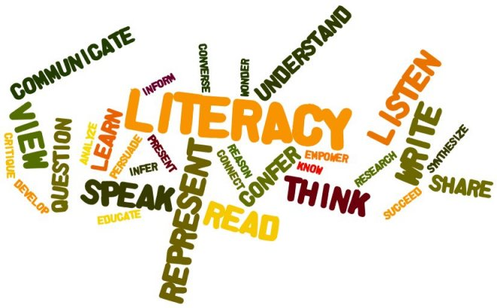

Name:__________________

Class:_________
Listening and Talking
Skill | What I Did
When working with others, I can contribute my ideas, encourage others to contribute and recognise that they have the right to hold a different opinion. |  | Subject
 |  | Approval
When speaking with others, I can choose important information and organise it in a logical order and use appropriate language. |  | Subject
 |  | Approval
I can show my understanding of what I listen to or watch by commenting on the content (what it is about) and form (how it is shown). |  | Subject
 |  | Approval
As I listen or watch, I can make notes using my own words and organise these to help me remember information and explore new ideas. |  | Subject
 |  | Approval
Reading
Skill | What I Did
I can use different strategies to help make sure I understand what I’m reading (e.g. use a dictionary to check unfamiliar words, ask myself questions about the text, underline important ideas). |  | Subject
 |  | Approval
I can find information in a passage, sort the information, summarise it, and make connections to other texts. |  | Subject
 |  | Approval
I can make notes in my own words and organise them to help me remember important facts and form an opinion. |  | Subject
 |  | Approval
I can make judgements about a source (if it is reliable/helpful) and can recognise persuasion. |  | Subject
 |  | Approval
Writing
Skill | What I Did
I can use correct spellings in my writing (including new vocabulary) and I have strategies to help me if I don’t know how to spell a word. |  | Subject
 |  | Approval
I can punctuate and structure different types of sentences and use paragraphs properly in an order that makes sense. |  | Subject
 |  | Approval
Throughout the writing process, I can review and edit my writing to ensure that it is clear. |  | Subject
 |  | Approval
I can choose information to include in my writing and can put it in an order that makes sense. I can use appropriate vocabulary to communicate the information. |  | Subject
 |  | Approval

At Home Learning
Skill | What I Did
Listening and Talking  I can watch/listen to a text (TV show, Youtube video) and explain to someone at home if I like it, why or why not, and give reasons for my answer. |  | Who with?
 |  | Approval
Reading  I can read a text (novel, comic book, newspaper article, blog) and explain to someone at home if I like it, why or why not, and give reasons for my answer. |  | Who with?
 |  | Approval
Writing  I can create a text (poem, story, article, journal entry) and explain to someone at home what it is about, who it is for, and why I wrote it. |  | Who with?
 |  | Approval

Library (Bonus Round)
Task | Library | Approval
I can take a book out at my library.
I can use the computers to research and find out about a subject I like

