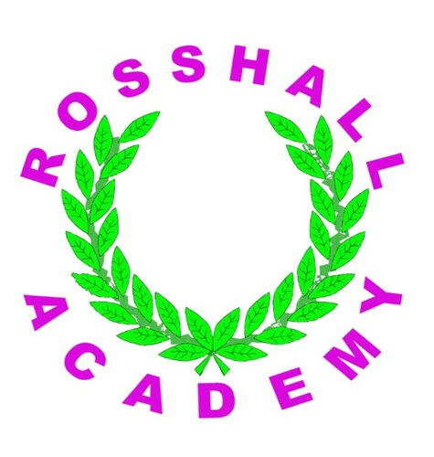
Rosshall Academy
Reading for Understanding, Analysis and Evaluation Tasks

Grammar
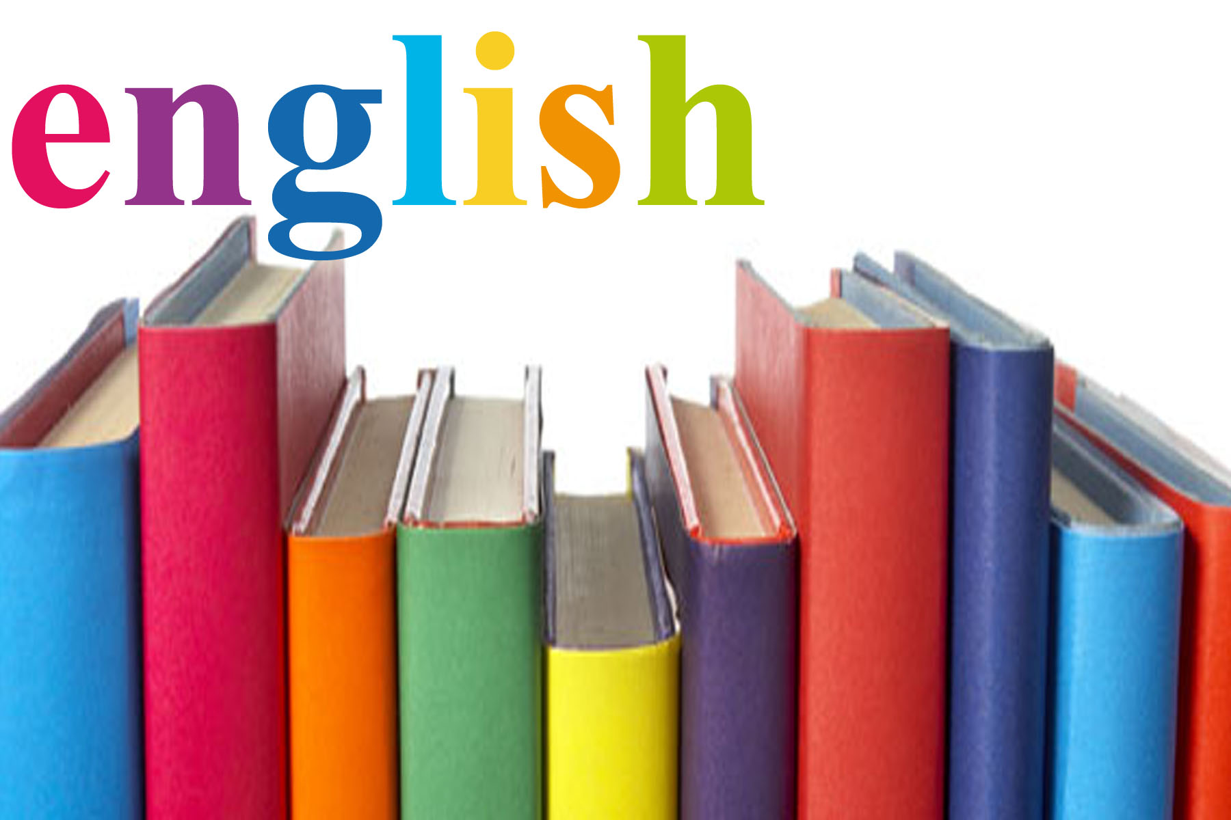
Name:
Class:
Teacher:

Grammar
RUAE Practice Passages
Contents

Passage 1: Internet Trolls...................................................Pages 3-6

Passage 2:The Homework That Inspires Horror In Families.....Pages 7-10

Passage 3:The Rejected Vegetables That Aren’t Even Wonky..Pages 11-15

Passage 4: Why The Dodo Is Dead....................................Pages 16-20

Passage 5: That Old White Magic Of Wicca’s World..............Pages 21-25
Note: Remember to use the previous booklet containing notes and strategies to answer the questions to help you with the work in this booklet.
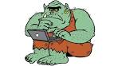
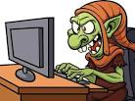
Passage 1
Internet Trolls
- In the January issue of The Believer, Meghan Daum wondered whether the writers of today "have ever really been able to express anything – in print, on a blog, on Facebook, wherever –without on some level bracing themselves for mockery or scorn or troll-driven pestilence." I don't have to wonder, because she's talking about me. Well, not just me – you too.
- Last year I had an article in a high-profile US newspaper. I was thrilled, obviously, and sent the link to my mum. Everything was going swimmingly until she scrolled down to the comments – which called me stupid, snobby, close-minded and a hack. Worst of all, they called me "Kristy".
- My mum wanted to track down each of the commenters and respond to them personally, with the general theme of HOW DARE YOU, MY CHILD IS A GENIUS. You've never seen Mama Logan on the warpath, but trust me when I say that if you upset her children, she will fry up your heart with some onions and Worcestershire sauce. And then afterwards she'll knit a nice scarf.
- I laughed it off, telling her that nasty comments were just how it goes. We're creative people. We eat rejection for breakfast. We have the hides of rhinos and the egos of Kanye West. We make things, they go out into the world, and then anonymous strangers tell us that we're stupid. Just how it goes. But does it have to be that way?
- It would be great if everyone who commented had thought carefully about what they'd read and wanted to share their opinion – whether agreement or disagreement. But often it's "tl;dr" (too long; didn't read) followed by screeds of scorn with little or nothing to do with the article.
- In the Olden Days (also known as the years BB, Before Blogs), people who hated your work might call you an idiot – but you'd never know it. If they really cared they'd write a letter to the editor – but you'd only see it if they were articulate enough for the editor to publish. Now there are no gatekeepers. By the time an article has been up for a day, it's so choked with arguments that rational, thoughtful people don't want to wade into the storm. Life is just too short.
- But aside from bracing ourselves, what can we do about it? The internet is a free and open forum. We shouldn't change it, no matter how many trolls or non-thinkers clutter it up. The ability to comment anonymously is a beautiful thing, and everyone's opinion is valid, whether they've really thought it through or not. Right?
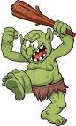
Questions
- Read paragraph 2.
- In your own words, explain what happened to the writer last year. (3 marks)
- ____________________________________________________________________________________________________________________________________________________________
- ____________________________________________________________________________________________________________________________________________________________
- ____________________________________________________________________________________________________________________________________________________________

- How does the word choice used in this paragraph emphasise the troll’s feelings about the writer and her article? (2 marks)
- Quote:_______________________
- Connotations:_____________________________________________________________________________________________
- This shows that the trolls feel ____________________________ _______________________________________________________________________________________________________.

- Read paragraph 4.
- In your own words, explain what happens when the writer produces an article. (2 marks)
- ____________________________________________________________________________________________________________________________________________________________
- ____________________________________________________________________________________________________________________________________________________________

- What example of figurative language is used in the image ‘We have the hides of rhinos’? (1 mark)
____________________________________________________

- What is the hide of a rhino like? (1 mark)
- ___________________________________________________________________________________________________________________________________________________________.

- What does this tell you about writers? (1 mark)
- ___________________________________________________________________________________________________________________________________________________________.

- Read paragraph 6. In your own words, explain the difference between writing before blogs existed and what writing is like now.(2 marks)
- ____________________________________________________________________________________________________________________________________________________________
- ____________________________________________________________________________________________________________________________________________________________

- Read paragraph 7.
- In your own words, summarise the writer’s views on how to deal with trolls on the internet. (1 mark)
- ___________________________________________________________________________________________________________________________________________________________.

- How does the writer’s use of sentence structure in this paragraph create doubt in the reader? (2 marks)
- The writer uses a _______________________________.
- Quote: ______________________________________________ ___________________________________________________.
- This creates doubt because _____________________________ _______________________________________________________________________________________________________.

Score: _____/15

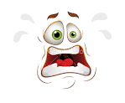
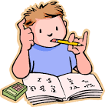
Passage 2
The Homework That Inspires Horror in Families

Homework can be a nightmare - for both children and their parents. In France the ritual of copying out poems and learning them by heart is no exception and can fill whole families with horror, writes Joanna Robertson in Paris.
- Twenty-six pupils have carefully copied, in regulation cursive script, in their homework diaries: "Friday. Poetry book. Recite." Le cahier de poesie - the poetry book - is a standard-format exercise book required by every primary school child in France. Ninety-four mixed pages, lined and blank. The lined - for the pupil to copy out the text of a poem. The blank - for them to provide an illustration.
- They'll copy out, illustrate, learn by heart and recite - in front of the class - poems ranging from La Chanson de Roland, an epic from the 11th Century, to poems written just a few months ago. And rest assured, no-one will escape a thorough knowledge of the 17th Century fables of Jean de la Fontaine.
- There's a typically rigorous marking system for handwriting, drawing, tone and expression and, most importantly, memory. You'll sail through with neat handwriting and perfect recall, but flunk entirely if you're a scatty, messy, budding Matisse.
- One by one, in turn, pupils walk up to the blackboard, take a deep breath and begin. Twenty-six renderings of the same poem by Pierre Gamarra are heard, in the same high-pitched sing-song voice.
- The teacher holds up each pupil's exercise book, high, for all the class to see the handwriting and the drawing. The moment of public scrutiny that can be so humiliating. The moment for sniggers, blushes, derisive hilarity and, sometimes, tears.
- Amandine, a bookish nine-year-old with purple glasses, remembers something even worse: "It's a big thing to get up there in front of the class," she says and describes how one boy "opened his mouth and nothing came out - he wet himself, we could all see it." But the trauma must mostly be eventually forgotten because le cahier de poesie is the schoolbook most cherished by both parents and children. It's a shared national experience that reaches across generations. Nadia Goutal, the daughter of Russian immigrants fleeing the revolution, still has the poetry books from her 1930s schooldays - and those of her daughters from the 1960s and 70s. Now, her five grandchildren have carried the collection into the 21st Century.
- "The poems are all there still in my head," she says. "Baudelaire, Rimbaud, Ronsard, Verlaine and Shakespeare - in English: 'To be or not to be.' What my grandchildren learn is different, more Jacques Prevert and Maurice Careme. Even with poetry, fashions change."
- With about 10 to 15 poems each school year, the poetry exercise book can be a homework nightmare. Families have different techniques for learning that poem by heart, and not all are willing to divulge their private, highly individual, methods. Some dance around the room, chanting verses. Others have intricate poetry drills where mime and action become vital triggers. Bouncing vigorously up and down on the bed can get the stanzas to stick, as can singing them loudly in the shower. Chocolate is the bribe of choice, and parents can get sneaky.
- At least one anxious mother, who prefers to remain anonymous, admits to quietly slipping her son's poetry book out of his schoolbag while he slept and perfecting his drawing.
- Although learning poetry has been part of French school life since the 1880s - and the country's publishers print thousands of new poems each year - only about 1% of the population actually reads it as adults. Le Printemps de Poetes, Poets' Spring, is a project that's been trying for the past 17 years to free school poetry from the rigid, neat-handwriting-good-memory approach, and make it accessible, spontaneous and creative.
- For a whole three weeks a year, the project enables schools to go even more poetry-mad. Begin the day with a poem. End the day with a poem. Compose a poem and tie it to a tree, or to a balloon and send it floating up above the rooftops of Paris. Cork a poem in a bottle, cast it into the river Seine or fling it out to sea. Whisper a poem down a long, long tube into someone's ear. Listen to a poem in quiet darkness, or with your head lying on a pillow.
- For the rest of the school year, however, it's back to the bi-weekly, public recitation.


Questions
- Read paragraph 1. In your own words, explain the two parts of the homework that children have to complete. (2 marks)
- ____________________________________________________________________________________________________________________________________________________________
- ____________________________________________________________________________________________________________________________________________________________

- Read paragraph 2. How does the writer’s use of sentence structure highlight the number of things the children have to do as part of the homework? (2 marks)
- The writer uses a ____________________________________________________________________________________________________________________________________
- This highlights the number of things the children have to do because _____________________________________________ ______________________________________________________________________________________________________________________________________________________________________________________

- Read paragraph 3. In your own words, describe what the pupils’ work must be like to pass and to fail. (2 marks)
- ____________________________________________________________________________________________________________________________________________________________
- ____________________________________________________________________________________________________________________________________________________________

- Read paragraph 5. How does the writer’s use of word choice emphasise the horrors of having your homework shown to the rest of the class? (2 marks)
- Quote:_______________________
- Connotations:_____________________________________________________________________________________________
- This emphasises the horrors because ______________________ ____________________________________________________ ___________________________________________________.

- Read paragraph 8.
- In your own words, describe 3 different ways in which families help their children to learn the poems. (3 marks)
- ____________________________________________________________________________________________________________________________________________________________
- ____________________________________________________________________________________________________________________________________________________________
- ____________________________________________________________________________________________________________________________________________________________

- How does the writer’s use of word choice show that some parents have to convince their children to learn the poems? (2 marks)
- Quote:_______________________
- Connotations:_____________________________________________________________________________________________
- This shows that the parents have to convince the children because________________________________________________________________________________________________.

- Read paragraph 9. In your own words, explain 2 ways in which people go ‘poetry mad.’ (2 marks)
- ____________________________________________________________________________________________________________________________________________________________
- ____________________________________________________________________________________________________________________________________________________________

Score: ______/15

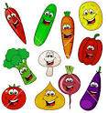
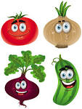
Passage 3

The rejected vegetables that aren’t even wonky
Tonnes of perfectly good food are thrown away in the UK every year. Why, asks Hugh Fearnley-Whittingstall.
- I've witnessed some pretty grim scenes in the food business down the years - appalling conditions in the poultry industry, crazy EU fishing laws, all kinds of greed and folly.
- Root vegetables may be a touch harder to feel for than chickens or fish. But watching 20 tonnes of freshly dug parsnips consigned to the rubbish heap in a Norfolk farmyard - purely because they didn't look pretty enough - is still one of the most shocking things I've ever seen.
- That's not just a few sackfuls of parsnips, it's not a skip-load. It's a colossal mountain of them - enough to fill nearly 300 shopping trolleys. And, more importantly perhaps, to feed 100,000 people with a generous portion of roast parsnips.
- That was just one week's wastage. So multiply by the 40 or so weeks of parsnip season (September-May) to get the full annual figure - four million parsnip portions that could, but won't, get eaten. Four million!
- As a chef, I can tell you there was absolutely nothing wrong with them. In fact, they were beautiful. I would have been delighted to cook with them. They may not have been perfectly straight, or utterly without blemish, or conformed to a robot's laser vision of a perfect parsnip. But they were all just great to me.
- Yet the supermarket client found them wanting. They "failed" the "cosmetic standards". They weren't wonky, or forked, or bruised or even "ugly". They just departed, sometimes by a matter of millimetres, from some bizarre set of specifications that defines, with apparent omniscience, what it is that we, the customers, demand our parsnips to be. Not that anyone's asked us.
- Depending on the growing conditions, this wastage is between 30 and 40% of Tattersett Farm's crop of prime roots. No surprise then, that this is not just an appalling waste of food. It's an economic disaster for the producers. The Hammond family, who have been growing parsnips since the 1970s, have witnessed an "arms race" of cosmetic standards between the supermarkets in recent years, as they fall over themselves to have the prettiest produce on display.
- Meanwhile they expect to make a loss this year. No wonder that, the Hammonds were talking - through barely suppressed tears - about jacking it all in.
- But this is not exceptional. This kind of near-criminal waste of good fresh produce is, unfortunately, very much the norm. Approximately one-third of the food we produce in the UK is never eaten. Take a minute to think about that - millions of tonnes of good food, and all the resources that go into producing it, squandered. Bonkers, isn't it?
- Such profligacy is not just immoral, it's unnecessary. When I took some of the Hammonds' "reject" parsnips and offered them to High Street shoppers, they were only too happy to take them. People couldn't believe all this great food was being dumped. Supermarkets may claim that consumers will only accept ramrod-straight carrots and flawless apples. But I simply don't buy it.
- And neither does waste campaigner Tristram Stuart, whose organisation Feedback has been challenging the supermarkets' cosmetic standards, and decrying the waste they cause. "We have proof that people are only too happy to buy this stuff," he says.

- "Because, when it suits them, the supermarkets start selling it. In years of poor harvest, the cosmetic standards are relaxed, and the farmers are asked to bag up the ever-so-slightly bendy or blemished produce that would normally be rejected. Of course nobody even notices."
- It feels like a bad joke at our expense. The horrendous waste caused by retailers has to stop. And people should ask their supermarkets to make that happen. However, we can't ask the big guns to rein it in unless we're prepared to do our bit too. And we have to face the fact that almost 50% of food wastage in the UK is domestic - the stuff we buy but don't eat. And surely we have the same responsibility as big companies not to discard perfectly edible food.
- I don't believe we're deliberately wasteful. Seeing vast quantities of food needlessly destroyed would make most of us extremely uncomfortable. The problem is that we don't see it. The average UK household wastes £700 worth of food every year. But of course, it's not all at once - it's a few slices of bread here, a bag of salad there, a couple of brown bananas every week.
- It's partly down to busy lifestyles. Our big weekly shop, piled high with bogofs and multi-packs, almost "factors in" the inevitability of waste. And we've become slaves to the "use-by" date, happy to let the supermarkets' robot package printers tell us when to throw food away. Any sign of the natural progression of food - a blemish on our fruit, a dried-out corner of cheddar, a floppy leaf - is taken as confirmation that it's time to bin it. And of course the retailers won't mind at all if we throw something out and have to go and buy a replacement.
- But do we really think a little brown spot on a grape is going to kill us? That a yoghurt that was perfectly good for our supper will have transmogrified at the stroke of midnight into a breakfast biohazard? When did we stop trusting our own instincts? Our eyes, noses, finger tips, and above all our common sense, are still the best tools to tell us whether something is good to eat or not.
- It's time to deploy large amounts of that common sense to wrestle back some control over the food chain. To shop a bit smarter, and cook a bit savvier. To waste less food, by being thrifty with our leftovers, and using pots, pans and plates - not the bin - as the clearing system for our fridges.

- Then we can turn to our supermarkets and say, with newfound confidence: "Look, we recognise that the food you sell us is a precious resource, and the product of many other precious resources. We expect you to do the same. So stop throwing so much of it away." And then we may choose to give our custom not to the supermarket with the straightest parsnips on display, but the straightest policy on not wasting food.

Questions

- Read paragraph 1. How does the writer’s use of word choice show how he feels about the food industry? (2 marks)
- Quote:_______________________
- Connotations:_____________________________________________________________________________________________
- This shows the writer feels ______________________________ _______________________________________________________________________________________________________.

- Read paragraph 5. In your own words, explain why the chef wanted to use the vegetables to cook. (2 marks)
- ____________________________________________________________________________________________________________________________________________________________
- ____________________________________________________________________________________________________________________________________________________________

- Read paragraph 9.
- In your own words, explain why throwing away food is ‘very much the norm.’ (2 marks)

- ____________________________________________________________________________________________________________________________________________________________
- ____________________________________________________________________________________________________________________________________________________________

- How does the writer’s use of sentence structure highlight his shock at the amount of wastage? (1 mark)
- The writer uses a ______________________________________ ____________________________________________________________________________________________________________________________________
- This highlights the writer’s shock because __________________ ______________________________________________________________________________________________________________________________________________________________________________________

- Read paragraph 13. In your own words, explain what the consumer’s responsibility is. (1 mark)
- ____________________________________________________________________________________________________________________________________________________________

- Read paragraph 14. In your own words, explain why household wastage is such a problem. (2 marks)
- ____________________________________________________________________________________________________________________________________________________________
- ____________________________________________________________________________________________________________________________________________________________

- Read paragraph 15.
- What image is being used in the phrase ‘we have become slaves to the use-by date’? (1 mark)
- ____________________________________________________

- What does being a slave involve? (1 mark)
- ____________________________________________________________________________________________________________________________________________________________

- What does this tell you about our relationship with use-by dates? (1 mark)
- ____________________________________________________________________________________________________________________________________________________________

- Read paragraph 17. How does the writer’s use of sentence structure place importance on the idea of preventing waste? (2 marks)
- ____________________________________________________________________________________________________________________________________________________________
- ____________________________________________________________________________________________________________________________________________________________

Remember to use the formula!

Score: _____/15

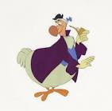
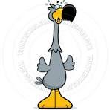
Passage 4
Why the Dodo is Dead
1 DODO. The very word conjures up an image – fat, stupid, ridiculous. Somehow we feel we know this bird. But one thing we all know is that it’s dead. As dead as…er…the dodo. It’s all in the name. It has that sort of childish, sing-song feel to it. Endearing because it sounds so daft. And yet the dodo is more than a cheap laugh: the dodo is an icon. It’s a creature of legend, a myth like the Phoenix or the Griffin.
But it’s a myth that really existed. A living creature so bizarre it didn’t need the human imagination to think it up – and an enigma from virtually the first moment human beings laid eyes on it little more than 500 years ago.
2 Three hundred and fifty years later, Lewis Carroll famously caricatured the bird in Alice in Wonderland. He portrayed it as a pompous Victorian gentleman, complete with walking cane. With this, the dodo’s journey from “real” to “surreal” was complete.
3 The story begins in Shakespeare’s day. In 1598, the crew of the Dutch East Indiaman, the Amsterdam, were navigating round the Cape of Good Hope, when a storm blew up and the ship was blown off course. After three weeks adrift, their battered vessel came within sight of a tropical island which they names Mauritius. They were now in the Indian Ocean and the island was a god-send. It meant they could rest and repair their boat – but most importantly it meant the half-starved crew could eat.
4 The fateful encounter now unfolded. The crew quickly came across a large bird, apparently flightless. Then, unable to evade its captors, it was quickly seized by the sailors. It was like nothing they had ever set eyes on.
5 Round in shape with a plume of tail feathers, the bird stood about three feet high, the size of an oversized turkey or swan. Its wings were small and useless, its head surrounded by a hood of fine feathers giving it the appearance of a monk’s cowl. Yet most distinctive of all was its unfeasible-looking bill. It was huge and bulbous, possessing a businesslike hook at its end.
6 But why did the bird come to be called the dodo? It has been argued that the name reflects the bird’s nonsensical appearance. Or that it sounds like the noise the bird may have made. In fact the name dodo didn’t exist until other names had been tried – “Kermis” after a Dutch annual fair, then “walghvogel” which means “nauseating fowl”. The name “dodo” came when the Dutch finally saw its comical side.
7 Dodomania was born. Soon Dutch artists were copying the first drawings of the bird and including them in the fantastical “menagerie” paintings that were all the rage. Several birds were captured and brought back to Europe. One found its way to London, where it was displayed for the benefit of paying customers. But around the time Charles II had been returned to the throne of England in 1660, the dodo had gone forever. What had happened to the dodo? Finding out has not been easy. Following its disappearance, all anyone had to go on were sketches and paintings. All the living specimens that had been brought back to Europe were long dead. There were no skeletons of the bird in museums. Rapidly, the trail of the dodo began to go cold.
8 Surely this ridiculous bird, fat, flightless and vulnerable, had simply been caught and eaten to extinction? Too weak or stupid to defend itself, too trusting of humans, the dodo had met its inevitable end. In a Darwinian world the dodo has come down to us as the prime example of how poorly designed and hapless creatures just won’t stay in the race. Sad but inevitable sums up the extinction of the dodo. Until now. According to ornithologist Julian Hume, the fat, comical appearance of the bird is grossly exaggerated. Julian has travelled to Mauritius to investigate what the bird was really like and how it lived. It is here that the only two complete skeletons of the bird exist which have proved just how misrepresented the dodo has been. “Now we have the skeleton of the dodo, we can tell so much more about the bird and how it may have appeared in life,” says Julian. “It had a long sinuous neck, quite an upright stance, and probably stood about two and half feet tall. This is very different from the picture that’s come down to us from the early drawings.”

Please turn over for questions
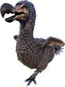
Questions
- Read paragraph 1.
- How does the writer’s use of sentence structure create an interesting opening? (2 marks)
Remember to use the formula!
- ____________________________________________________________________________________________________________________________________________________________
- ____________________________________________________________________________________________________________________________________________________________

- Find an example of humour from this paragraph. (1 mark)
- ____________________________________________________________________________________________________________________________________________________________

- Explain why this is an example of humour. (1 mark)
- ____________________________________________________________________________________________________________________________________________________________

- How does the writer’s use of word choice emphasise the strangeness of the dodo? (2 marks)
- Quote:_______________________
- Connotations:_____________________________________________________________________________________________
- This shows ___________________________________________ _______________________________________________________________________________________________________.

- Read paragraph 4. How does the sentence ‘It was like nothing they had ever set eyes on’ act as a linking sentence at this point in the passage? (2 marks)
- ‘It was like nothing’ links back/forward to the previous next paragraph which discusses ______________________________ ____________________________________________________ ____________________________________________________ ___________________________________________________.

- Read paragraph 6. In your own words, explain two different theories explaining the origins of the dodo’s name. (2 marks)
- ____________________________________________________________________________________________________________________________________________________________
- ____________________________________________________________________________________________________________________________________________________________

- Read paragraph 7. In your own words, give an example of dodomania. (1 mark)
- ____________________________________________________________________________________________________________________________________________________________

- Read paragraph 8. How does the writer’s use of word choice show that he thinks that the dodo was a weak bird? (4 marks)
- Quote:_______________________
- Connotations:_____________________________________________________________________________________________
- This shows ___________________________________________ _______________________________________________________________________________________________________.

- Quote:_______________________
- Connotations:_____________________________________________________________________________________________
- This shows ___________________________________________ _______________________________________________________________________________________________________.

Score: ______/15

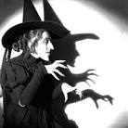
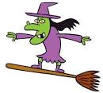
Passage 5
That old white magic of Wicca’s World

1 Pity the poor witch on Halloween as she climbs aboard her trusty broomstick and, with familiar cat riding pillion, whizzes off to the Samhain Sabbat. She has had an awfully bad press over the years.
2 In popular folklore, she is the warty old crone who dances naked around a bonfire on the nights of the eight annual sabbats and then, as dawn breaks, smears herself with “flying ointment” and jets back home for a glass of toadslime and a hot bath.
3 She is the old dear forever depicted as a somewhat unlovely woman dressed casually in black and wearing an ungainly pointed bunnet. Let’s face it, looking like that she would stick out a mile in your average supermarket.
4 Our perceptions of the witchcraft cult are deeply and subconsciously rooted: we may scoff at childhood terrors, but how many of us would be entirely happy walking through a graveyard at night? We may have forgotten our fear of the dark and the supernatural, but we have also seen Nightmare on Elm Street.
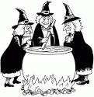
5 The witch has come to symbolise primordial fears lurking just beneath the surface of all of us: Freddie, Night of the Living Dead, and the bogeyman rolled into one. The three witches in Macbeth, prancing and cackling around their cauldron, provide the accepted clichés on witch behaviour and taste:
Eye of newt, and toe of frog
Wool of bat, and tongue of dog
Adder’s fork, and blind-worm’s sting
Lizard’s leg and howlet’s wing
6 However, “tongue of dog” and “adder’s fork” are plants – the former used as the basis for a contemporary cough medicine. Shakespeare, living as he was at the beginning of the great witch persecutions, perhaps was not above pulling a few legs. Alas, the Macbeth witches have merely served to reinforce prejudice, rather than cast illumination.
7 So does the witch deserve her poor image? As she frolics cold and naked, invoking the names of old gods – Cernunnos and the moon goddess Diana – might it not occur to her that over the centuries she has had a pretty raw deal? In many ways, she would be quite right.
8 It is probable that the Wiccan creed goes back to the dawn of religious belief, when cave dwellers peered out and saw wonder in the rhythm of the changing seasons. Early cave drawings from across Europe – and elsewhere – show remarkable similarities, particularly in their depiction of a horned god.
9 Early witchcraft is probably no more than a primitive attempt to make sense of the unknown. It is likely that the Wiccan horned god was an earlier version of the Greek god Pan. So how come this religion became associate with hubble, bubble, toil and trouble?
10 The answer was an unhappy alliance between the spread of Christianity and social upheaval. In the so-called Dark Ages witchcraft was considered no more than a misdemeanour, warranting the equivalent of community service; yet in the “enlightened” Renaissance, the fires burned across Europe (except in England where witchcraft was a hanging offence).
11 During the 15th century, witchcraft and Christianity had co-existed; the church recognising that older pagan cults of beliefs could not be easily repressed - particularly in backward rural communities where survival was often a matter of luck, and old superstitions die hard.
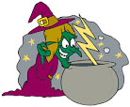
12 The book Malleus Maleficarum (Hammer of the Witches), published in 1486, was the trigger for a change in attitude which gave the Church the big stick it needed to beat non-conformity and heresy; in the process it sparked a Europe-wide holocaust against Jew and witch alike. (In some areas of Europe, the Malleus was used specifically against Jews; indeed, in Hungary a first offender found guilty of witchcraft was made to stand for a day in a public place wearing a Jew’s hat).

Please turn over for questions

Questions

- Read paragraphs 1-3.
- In your own words, give three pieces of information which are popularly believed about witches. (3 marks)
- ____________________________________________________________________________________________________________________________________________________________
- ____________________________________________________________________________________________________________________________________________________________
- ____________________________________________________________________________________________________________________________________________________________

- Quote an example of informal language in this paragraph. (1 mark)
- ____________________________________________________________________________________________________________________________________________________________

- Explain why this is an example of informal language. (1 mark)
- ____________________________________________________________________________________________________________________________________________________________

- Read paragraph 4. “Our perceptions of the witchcraft cult are deeply and subconsciously rooted”. In your own words, give one example the writer uses in paragraph 4 to support this idea. (1 mark)
- ____________________________________________________________________________________________________________________________________________________________

- Read paragraph 5. Why is the writer’s use of word choice effective in creating a detailed picture of how the witches acted? (2 marks)
- Quote:_______________________
- Connotations:_____________________________________________________________________________________________
- This is effective because ________________________________ _______________________________________________________________________________________________________.

- Read paragraph 7. How does the sentence ‘So does the witch deserve her poor image?’ act as linking sentence at this point in the passage? (2 marks)
‘Poor image’ links back/forward to the previous/next paragraph which discusses _________________________________________________ __________________________________________________________________________________________________________________________________________________________________________.

- Read paragraph 8. How does the writer’s use of sentence structure highlight the idea that ‘wiccan creed’ has been a part of many societies? (2 marks)
- ____________________________________________________________________________________________________________________________________________________________
- ____________________________________________________________________________________________________________________________________________________________

- Read paragraph 9. In your own words, explain the purpose of early witchcraft, according to the writer. (1 mark)
- ____________________________________________________________________________________________________________________________________________________________

- Read paragraph 10. In your own words, explain how witches were treated in the Dark Ages and during the Enlightenment. (2 marks)

- Dark Ages:___________________________________________ ________________________________________________________________________________________________________
- Enlightenment:_________________________________________________________________________________________________________________________________________________

Score: ______/15

Results
Task One | /15
Task Two | /15
Task Three | /15
Task Four | /15
Task Five | /15
Overall Total | /75

pupil Target Setting


