
Rosshall Academy

Reading for Understanding, Analysis and Evaluation

Name: ________________________________
Class:

________________________________
Contents
Activity | Page
Advice Page - Own Words, Sentence Structure and Punctuation | 3
Model Task - How Safe is the Food we Eat? | 4 - 6
Task One – A Success in Space | 6 - 8
Task Two – Citizens of the World | 9 - 11
Task Three – The Appeal of Car Boot Sales | 11 - 13
Task Four – 2000 Year Old Butter | 14 - 16
Task Five – Saddle the White Horses | 16 - 19
Task Six – Harry Potter and the Philosopher’s Stone | 20 - 22
Task Seven – Chimps go Ape in Zoo | 22 - 25
Task Eight – We’re Out for the Count | 25 - 27
Task Nine – Notes from a Small Island | 28 - 32
Task Ten – How Nepal Quake turned Women into Builders | 33 - 37
Results Page | 37


Advice Page
Own Words
In an RUAE task, you may be asked to use your own words. This shows that you have understood what you have read, and haven’t just picked the answer directly from the text. Try to change as many words as you can, but use your common sense.
Complete the following:

The S2 pupil stood angrily in front of his sister who had just broken his favourite PS4 game.

could be changed to:

The was when he realised his had destroyed his prized .
Sentence Structure
Writers will use different lengths of sentence, depending on the effect or mood they want a piece of writing to have.
- A short sentence can be punchy, shocking, grab the reader’s attention or add to the excitement of a piece of writing. Example: “Creak! There it was again. That noise. Unmistakeable this time. She knew what she had to do.”
Think of a type or genre of writing where these might be used to add tension:
- However, a long sentence can slow the pace of the writing, have a soothing effect and allow the writer to add in extra information and description. Example: “The river meandered and curved its way along the bottom of the V-shaped valley, taking in every aspect of the valley floor while generously leaving enough room for the generations of farmers to make the most of the fertile sediment it was leaving in its wake year after year, decade after decade.”
Think of a type or genre of writing where these might be used to relax the reader:
Punctuation
Writers use punctuation for different reasons and to create different effects, change the tone or to have an effect on the reader.
Complete the following table:
Punctuation Symbol | Punctuation Name | Effect of Punctuation
.
,
?
!
;
:
-…- or (…)

Model Task
How Safe is the Food we Eat?

Today we are used to being able to buy food from large supermarkets. Because of this, farming methods are very different from what they used to be, and some of these changes have their disadvantages…
Before the war, everyone bought their food from small shops – the baker, the
butcher, the greengrocers. Then in the 1950s large supermarkets started
springing up, mainly because fridges had improved and become widely available.
We began to eat more and more processed food – food that has had something
5 done to it before we buy it. Supermarkets and processed food are designed to make
life easier for people who work long hours and haven’t the time to go from shop to
shop, or to spend a long time cooking when they get home.
Now only 8% of supermarket food is fresh (fruit, veg and eggs); the rest has gone
through food company machines. Processing food costs money, but the
10 companies that do it can charge the consumer more than it costs them, so
making big profits. A frozen French fry is far removed from the original (cheap)
potato which it’s made from.
It’s important to watch out and read labels because sometimes low quality food is
disguised with flavourings and colours to look and taste fresher and better than it
15 really is.
Over the past few years there have been an alarming number of food scares. Almost
all of them are connected to intensive farming.
Animals are being pushed with selective breeding and drugs to produce much more
than their bodies were designed to do. A dairy cow used to live an average of
20 fifteen years or more. Modern dairy cows are worn out after only six. Now
new technologies and drugs are pushing them to produce even more. But will it end
in disaster?
Intensive farming conditions take their toll on animals. They are often given
drugs to keep them healthy enough to produce what we want
25 from them, i.e. milk, eggs and meat. One fear is that humans who eat products
made from the flesh or milk of these animals are also eating low dosages of
antibiotics. Traces of antibiotics have been found in pork and turkey – there are
fears that humans are eating so much that the bacteria inside us are becoming
immune to antibiotics.


Model Task Questions
How Safe is the Food we Eat?

1. Read paragraph 1 (lines 1-3). Explain why large supermarkets started to spring up in the 1950s. (1)

2a. Why does the writer use a dash in line 1? (1)
2b. From elsewhere in the passage, find another example of a dash being used for a similar purpose and write the quote below. (1)

3. From paragraph 2 (lines 4-7), state, in your own words, two advantages of supermarkets and processed foods. (2)
4. Read paragraph 3 (lines 8-12).
a) What is the disadvantage of supermarket food? (1)
b) How do the food companies make their profits? (1)

5. Read paragraph 4 (lines 13-15). Why is it important to read the labels on food? (1)

6a) Read paragraph 6 (lines 18-22). What do you think is the purpose of ‘selective breeding’? (1)
7. Read paragraphs 5 - 7 (lines 16-27). Explain the harmful effects of modern farming methods on:
a) Cows (2)
b) Humans who eat the food that comes from these animals (2)

8. Quote two words from the whole passage that could be described as medical jargon (words which are specific to a particular topic). (2)
1.

2.

Total: /14

Task One

A Success in Space - A space probe makes history by landing on a moving comet
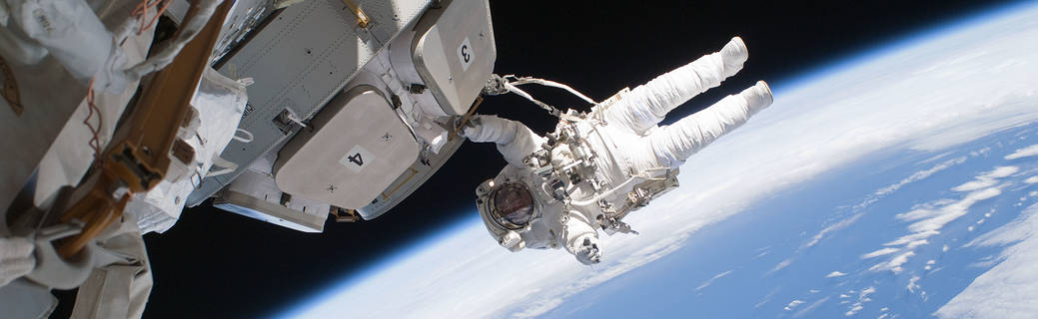
1. On November 12, a small probe helped scientists take a big step forward in space exploration. The probe, called the Philae Lander, is the first spacecraft to set down on a comet. It will take photos and dig up samples from the comet’s surface.
2. The Philae Lander is about the size of a washing machine. It dropped from the Rosetta spacecraft and landed on the comet Churyumov-Gerasimenko, also known as 67p. This mission could give researchers valuable information about the origins of our solar system and how it evolved.
A Long Journey
3. Rosetta travelled for 10 years, and across 4 billion miles, to reach its destination. The craft was launched in 2004 by the European Space Agency to observe comets. In 2011, Rosetta was powered down to conserve energy. Early this year, scientists brought it back to life to study 67P.
4. Philae separated from Rosetta about 14 miles above the comet. At first, the Lander failed to fire anchoring harpoons into the surface. It bounced three times before coming to a stop, said Stephan Ulamec, the Lander project manager.

5. The Philae Lander will travel the surface of 67p and conduct a variety of scientific experiments. It could reveal secrets about the makeup of comets, the formation of our solar system, and even the origins of life. Researchers consider comets the remains of the ancient solar system. Their contents are preserved in a deep freeze because they spend much of their time far away from the sun. “What we believe is that we will study the most primitive material in the solar system,” says scientist Gerhard Schwehm. He served as Rosetta’s mission manager at the ESA from 2011 until his retirement earlier this year.
In the Dark
6. Scientists have not yet been able to determine exactly where Philae landed. Based on the first images the Lander has sent back, they believe it is partially in a shadow of a cliff. That could be a problem, because it would prevent the Lander from using its solar panels to collect energy from the sun. Currently, the scientists are updating their plans to get Philae out of the darkness.
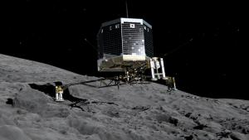
7. Despite any initial concerns, the team is in good spirits—and so is Philae. On the night of its arrival, the lander tweeted a photo to its mother ship @ESA_Rosetta. “The view is absolutely breathtaking ESA_Rosetta! Unlike anything I've ever seen #CometLanding,” the tweet read.
8. Though it took a decade to get to 67p, Philae’s stay on the comet will be a short one. As soon as it landed, a 64-hour countdown began. When it ends, Philae’s on-board battery will run down. But Rosetta will continue to travel with 67p, sending information about the comet back to Earth for as long as it can.
Task One Questions
1. Using a dictionary or searching online, find the definitions to the following words: (3)
Word | Definition
Origins
Conserve
Space probe

2a. What is the purpose of this piece of writing? (1)
- To educate people about developments in science.
- To inform people who work in the science industry.
- To inform people about developments in space exploration.
b. Give a reason for your answer. (1)

3a. Which of these do you think is the intended audience of this piece of writing? Tick one. (1)
  - Young people who are interested in science.
  - Astronauts.
  - People who like to read about outer space.

b. Give a reason for your answer. (1)

4. Write a short summary (two to three lines) saying what this passage is about. (2)

5. Look at paragraphs 1 and 2. Why is this event so important? Answer in your own words instead of the ones used in the passage. (1)

6. Look at paragraph 3. Quote two pieces of information from the passage that convey the sheer magnitude of the journey Rosetta has taken. (2)
1.

2.

7. Look at paragraph 5. What three things do the scientists hope to learn from this mission? (3)
1.

2.

3.

Total: /15

Task Two
Citizens of the World

A society which is ‘multi-ethnic’ is one which is composed of people from many different cultures. Most of the developed countries of the world are now becoming ‘multi-ethnic’ as people from more deprived areas move there in order to escape from problems in their native lands. In the following extract, the writer looks at some of the questions raised by this migration.

1. As societies around the world continue to become increasingly multi-ethnic, the arguments about racism tend to be less about whether it is wrong or right. Instead, the most pressing problem is how to ensure that diverse communities live without racial tension, in a society free of racial prejudice and discrimination. We are now going to look at some of the different opinions and arguments that have surfaced in the search for a multi-ethnic society in which everybody has equal opportunities in life.
2. Today, there are 150 million people living outside their countries of birth. At least 22 million have been forced to move from their homes because of war or racial persecution. We already know that the multi-ethnic societies are built on a history of migration. We also know that the arrival of migrants into a society can create racial tension. Some people argue that this tension is the result of a new kind of racism: that of discrimination and prejudice against people who want and need to improve their lives. But whether migration actually does create tension depend on the actions of governments across the world.
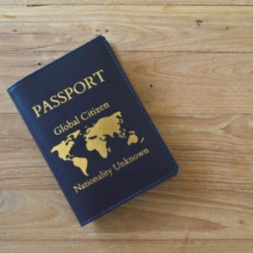
3. Since most of the migrant populations are from less developed countries, some people argue that they bring unskilled and uneducated individuals into society. If migrants have less ‘economic value’, there might be more strain on public services like health, housing and education. In the USA, for example, economists argue that if the government supports healthcare for Hispanic migrants, then others in society will have to pay more for health insurance. There is also concern that migrants will become ‘second-class’ citizens, and that ghetto-like communities will grow. This division could mean that certain communities are excluded and less likely to become involved in the rest of society. To avoid this, some people think that governments should manage migration by limiting the number of people allowed into a country. They think that governments should only select those individuals who fit the needs of a society – for example, those with skills, like doctors or computer experts, who can immediately contribute to the economy.
4. However, some people argue that managed migration makes matters worse. If only skilled migrants are encouraged, then there will be fewer skilled people in less developed countries where the skills are needed most. This could lead to more poverty and even people wanting to leave. The United Nations also estimates that, by year 2025, 159 million migrant workers will be needed to keep the European economy growing. This is because birth rates in Europe are falling and there is a need for both skilled and unskilled workers. To keep the European economy growing, and to offer improved lifestyles for those in less developed countries, some argue that it is more sensible to relax migration controls and allow people to move freely as citizens of the world.
Task Two Questions
1. Using a dictionary or searching online, find the definitions to the following words: (6)
Word | Definition
Deprived
Native
Diverse
Prejudice
Persecution
Migration

2. What is the purpose of this text? Tick one. (1)
- To persuade the reader to move to a different country.
- To inform the reader of the issues surrounding migration.
- To entertain the reader using humorous stories.

3. Who do you think this text is aimed at and why? Think about age and interests. Be as specific as you can. (2)
Audience:

Because:

4. Look at paragraph 2. What connotations does the word ‘forced’ have? (1)
5. Choose one positive aspect of migration and one negative aspect of migration. (2)
Positive aspect of migration | Negative aspect of migration
6. What two types of people would governments select based on their skills? (2)
1.

2.

7. Look at paragraph 4. Explain in your own words why the situation will be worse if only skilled workers are admitted. (1)

8. Look at the last line of the final paragraph. How does it link to the title? (1)

Total: /16

Task Three
The Appeal of Car Boot Sales

1. All the junk in Scotland meets your befuddled gaze: thousands of unwanted gifts, the “wee something” for Christmas and the “I saw this and thought of you” for your birthday (how you wish they hadn’t); then there are the holiday souvenirs. In short, all the stuff with which we tend to clutter our lives and our cupboards has somehow ended up in one place, awkwardly arranged on a vast number of folding tables.
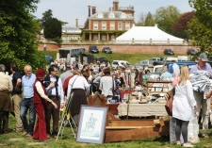
2. Behind them, all kinds of people are perched on the tailgates of a variety of vehicles. Is this some kind of bizarre store for recycled rubbish? Well, in a way it is. In other words, you have found yourself in the middle of your first car boot sale. They can be found most weekends in summer and sometimes in winter too, in villages, towns and cities throughout the country. Sometimes they are held on an occasional basis – a charity or other organisation will hire a hall or a school playground, advertise in the local press and rent out pitches for £5 and £10 for the day. Other sales are held every Saturday or Sunday on more permanent sites.
3. Women seem to outnumber men behind the essential tables: although men often come to help set up, they retire shyly for most of the day and return in the late afternoon to pack up the left-overs. Curiously enough, there are as many male customers as female: all human life wanders by.
There goes a succession of polite elderly gentlemen, clean and smart in their car coats; they will go off happily clutching boxes of your ancient gardening tools to which their wives will most surely object, but who are you to spoil their fun?
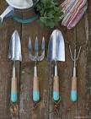
4. There is, just occasionally, a serious side to all this, which may affect the buyer rather than the genuine seller. Car boot sales can provide a certain amount of cover for less honest traders and it is as well to bear this in mind if you are offered a more than average bargain. Where, for instance, did those big canisters of cleaning fluid designated “Janitorial Supplies” originate? And what about those suspiciously home-made looking DVDs of all the latest movies? Trading Standards Officers sometimes visit boot sales to keep a lookout for fakes. Police occasionally find stolen goods lurking among the junk. Customs and Excise may be investigating those suspiciously cheap cigarettes and Environmental Health Officers may even be wondering whether that delicious home-made tablet has been concocted with regard to public health.
5. But on the whole, say the police, they have little trouble with car boot sales. Most are legitimate and harmless: ordinary punters offloading bric-a-brac onto other ordinary punters. To a Martian hovering up there we must all look like nothing so much as a colony of ants, struggling to carry off various large and cumbersome objects, a table here, a suitcase there…

Task Three Questions
1. Using a dictionary or searching online, find out the definitions of the following words: (4)
Word | Definition
Befuddled
Souvenirs
Tailgates
Concocted
2. What do you think is the purpose of this passage? Give a reason for your answer. (2)
Purpose:

Because:

3. Look at paragraphs 1 and 2.
“All the junk in Scotland meets your befuddled gaze.”
List the words and phrases the writer uses in these lines to continue the idea of junk and items that are no longer needed. (5)
1.
2.
3.
4.
5.

4. When it comes to buying, there are “Curiously enough, as many male customers as female.” What is the writer’s reaction to this? Explain how you know. (2)
The writer’s reaction is:

Because:

5. The writer gives an example of “human life” wandering by. In your own words, explain as fully as you can why the writer might sympathise with the “succession of polite elderly gentlemen.” (1)

6. Look at paragraphs 5 and 6.
What do each of the following look for at car boot sales: (4)
- Trading Standards:

- Police:

- Customs and Excise:

- Environmental Health Officers:

Total: /18

Task Four

10kgs of 2,000-year-old butter found in a bog in Ireland to go on display

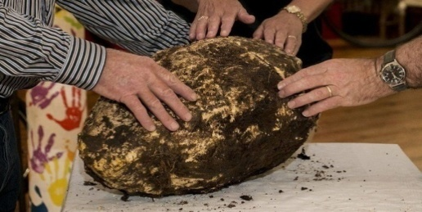
1. Jack Conway was working in a bog, cutting turf, when he says he came across a massive chunk of butter. After making the discovery in Emlagh bog, County Meath, he says he contacted a local museum who then analysed the dairy discovery. Cavan County Museum told Jack that the 10kg (22lb) lump of butter was in fact more than 2,000 years old.
2. Savina Donohoe, curator of Cavan County Museum, has told Newsbeat that it smells like a "strong cheese". The white prehistoric butter was found 3.6m (12ft) underground.
3. Savina told Newsbeat: "The fact it was buried so deep in the soil indicates that it might have been buried as an offering or a ritual to the gods to keep land and animals safe in the past." In medieval Ireland they did a lot of burying in bogs as they have excellent preservation properties because of their low temperatures, low oxygen and highly acidic habitat.

Cavan County Museum @cavanmuseum

A gift to the gods ... 10 Kilos of Bog Butter!

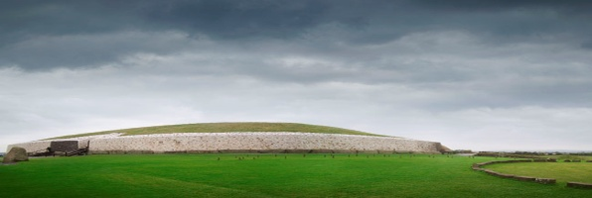
4. That butter would normally be found in a wooden box but this butter was found on its own. The museum believes that this particular butter was therefore buried as a ritual or an offering because whoever buried it thought it would never be found again. Butter, or anything associated with a cow, was seen as a sign of wealth, importance and was valuable."Butter was seen as a luxury item back then. People made it with the intention of eating it, or selling it to pay their taxes and rent," Savina added. "It doesn't smell very nice - it smells like a very strong cheese. You could try to eat some of it but we wouldn't advise it. Now that it's above ground it will probably dry up."
5. It has been passed onto curators at the National Museum in Dublin who are going to carbon date the time capsule butter before housing it for visitors to see.
Task Four Questions
1. Using a dictionary or searching online, find the definitions to the following words: (5)
Word | Definition
Curator
Prehistoric
Ritual
Preservation
Habitat
2. What is the purpose of this text? Give a reason for your answer. (2)
Purpose:

Because:

3. Who do you think this text is aimed at and why? Think about age and interests. Be as specific as you can. (2)
Audience:

Because:

4. Look at paragraph one. Find an example of alliteration and write it below. (1)
5. Look at paragraph two.
- What is the butter compared to? (1)

- What language technique is this an example of? (1) e.g.: simile, metaphor, alliteration…

6. What are the three properties of a bog that make it ideal for preservation? (3)
1.

2.

3.

7. Why has the writer included quotes from Savina Donohoe? (1) Think about Donohoe’s profession.

8. What was different about this butter? (1)
9a) What was butter a symbol of? (1)

b) What was it used for, other than eating? (1)

Total: /19

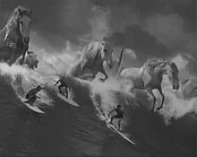
Task Five
Saddle the White Horses

1. It was the stickers that gave it away. Turning left onto the A9 at Latheron in Caithness, you were suddenly faced with a sign that looked as though it had been defaced by advertising executives from surfing companies. Like a cairn on a mountain path, the big green board declaring Thurso to be 23 miles away told travelling bands of surfers that they’d taken the right turn-off and were nearly at their destination. Slapping another sticker on the sign was like laying another stone on the pile.
2. Thurso is about to enter surfing’s big league.
3. It’s hard to reconcile the popular tropical imagery of surfing with the town, a raw exposed kind of place that enjoys little escape from the worst excesses of the Scottish climate. The Caithness coastline is peppered with surfing spots, but the jewel in the crown and the target for dedicated wave riders lies within spitting distance of Thurso town centre at a reef break called Thurso East. In the right conditions, the swell there rears up over kelp-covered slabs into a fast-moving, barrelling monster of a wave considered world class by those in the know.

4. Now Thurso East is the focus of a huge professional surfing tour. The week-long Highland Open marks the first time a World Qualifying Series (WQS) surfing competition has been held in Scotland. It will also be the farthest north a WQS tour has ever travelled, anywhere in the world.
5. Professional competitive surfing has two tours: the WQA and the World Championship Tour (WCT). The WCT is the premier division, with the WQS being used as a platform for professionals to move up into the big time. Around 160 up-and-coming wave riders are expected to take part in the Thurso event. Prize money of $100,000 (£57,000) is up for grabs, along with vital tour points.
6. “Travelling and exploring new places is part of the whole surfing culture,” says Bernhard Ritzer, the Highland Open event manager. “We’ve had so much feedback from surfers in Australia and Brazil who want to go. They see it as an adventure and as something new. We did a photo trip there last year with some of our team riders and they were impressed. They’re excited about it – although it will still be a shock because I don’t think they know how cold and harsh it can be.”
7. Thurso is one of the best waves in Europe, if not the world,” he says. “Most people don’t even know it, and it’s just so good. It doesn’t always have to be sunny, warm and tropical. It can also be cold, rough and hard.”
8. “The idea is to have a contrast to the summer events in the tropical islands. We also have something in the north to show that this is part of surfing. Very often on the WQS tour the waves aren’t that good, but here they are expecting big reef waves and they like to surf those.”
9. Surfers generally guard their local breaks jealously. It’s considered essential to keep your mouth shut about your “secret spot”, in case you find it overrun with visitors. So, economic benefits to Thurso aside, some local surfers were a little concerned about an event of this scale descending on their area. WQS representatives met with these surfers to address their concerns and feel that they’ve pretty much got everyone on board. WQS is also paying for improvements to the car parking area near the Thurso East break.
10. “We’re concerned to get the locals involved,” says Ritzer. “We want to keep them happy and don’t want to look too commercial, coming in with a big event machine. We need them to help organise local stuff. You always have some individuals who will boycott everything, but we understand that most of them are positive.”
11. Andy Bain probably knows the break at Thurso East better than anyone, although he’ll be watching the competition from the shoreline. Bain, who runs Thurso Surf, has been surfing the reef there for 17 years and is eagerly anticipating the arrival of the Highland Open. He’s aware of the concerns and the possible expose of his home break, but doesn’t anticipate a negative impact.

Task Five Questions
Look at paragraphs 1 - 3.
1. What have previous travellers/surfers added to the road sign in Caithness? (1)
2. What is the sign compared to? Quote the simile the writer uses. (1)
3. In your own words, write down two things the surfers would know when they saw this road sign. (2)
a.

b.

4. Look at paragraph 2. “Thurso is about to enter surfing’s big league.”
How does the writer make this statement stand out? (1) Think about where this line has been placed.

5. Paragraph 3 explains that Thurso is different from the popular image of a surfing location.
a) In your own words, describe how Thurso is different (2)
- Quote an expression to show that Thurso is different. (1)
6. What do the words “jewel in the crown” suggest about Thurso East? (2)
7. “…a fast-moving, barrelling monster…” (paragraph 3)
a. What type of imagery is this? (1)
b. What does this comparison tell us about the wave? Think about the size/shape of the wave. (1)
Look at paragraphs 4 and 5.
8. Name one way in which the Highland Open is different from other WQS surfing
competitions? (1)

9. In your own words, explain the different between the two professional surfing
tours. (2)
Thinking about the passage as a whole.
10a. Who do you think this passage is aimed at? (1)
b. Explain why you think this. (1)
11a. What do you think is the purpose of this passage? (1)
b. How do you know this? (1)

Total: /19

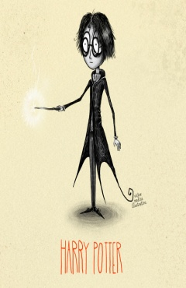
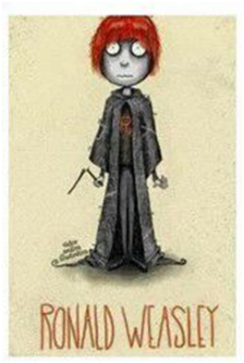
Task Six
Harry Potter and the Philosopher’s Stone
by J.K. Rowling

1. There were a hundred and forty-two staircases at Hogwarts: wide, sweeping one; narrow,
rickety ones; some that led somewhere different on a Friday; some with a vanishing step half-way up that you had to remember to jump. Then there were doors that wouldn’t open unless you asked politely, or tickled them in exactly the right place, and doors that weren’t really doors at all, but solid walls just pretending. It was also very hard to remember where anything was, because it all seemed to move around a lot. The people in the portraits kept going to visit each other and Harry was sure the coats of armour could walk.
2. The ghosts didn’t help, either. It was always a nasty shock when one of them glided suddenly through a door you were trying to open. Nearly Headless Nick was always happy to point new Gryffindors in the right direction, but Peeves the Poltergeist was worth two locked doors and a trick staircase if you met him when you were late for class. He would drop waste-paper baskets on your head, pull rugs from under your feet, pelt you with bits of chalk or sneak up behind you, invisible, grab your nose and screech, “GOT YOUR CONK!”
3. Even worse than Peeves, if that was possible, was the caretaker Argus Filch. Harry and Ron
managed to get on the wrong side of him on their very first morning. Filch found them trying to force their way through a door which unluckily turned out to be the entrance to the out of bounds corridor on the third floor. He wouldn’t believe they were lost, was sure they were trying to break into it on purpose and was threatening to lock them in the dungeons when they were rescued by Professor Quirrell, who was passing.
4. Filch owned a cat called Mrs Norris, a scrawny, dust-coloured creature with bulging, lamp like
eyes just like Filch’s. She patrolled the corridors alone. Break a rule in front of her, put just one toe out of line and she’d whisk off for Filch, who’d appear, wheezing, two seconds later. Filch knew the secret passageways of the school better than anyone (except perhaps the Weasley twins) and could pop up as suddenly as any of the ghosts. The students all hated him and it was the dearest ambition of many to give Mrs Norris a good kick.
5. And then, once you had managed to find them, there were the lessons themselves. There was a lot more to magic, as Harry quickly found out, than waving your wand and saying a few funny words.

6. They had to study the night skies through their telescopes every Wednesday at midnight and learn the names of the different stars and the movement of the planets. Three times a week they went out to the greenhouses behind the castle to study Herbology, with a dumpy little witch called Professor Sprout, where they learnt how to take care of all the strange plants and fungi and found out what they were used for.
Task Six Questions
1. Look at paragraph 1. What do you think is the purpose of the colon (:) in the first sentence of this passage? (1)
2. What is one danger the students face when using the staircases at Hogwarts? (1)

3. Explain the two ways in which the students could get the doors
to open for them. (2)
1.

2.

4. Explain how the line – “The ghosts didn’t help either” – links the first and second
paragraphs. (2) Think about what is happening in paragraph 1 and how.
5. Rowling writes about Peeves the Poltergeist. What type of language technique is his name an example of? (1) E.g.: simile, metaphor, alliteration…

6. The words “GOT YOUR CONK!” have been put into capital letters. What does this tell us about the way this has been said? (1)

7. Look at paragraph 3. Who could the students rely on for help? (1)

8. Look at paragraph 4. What are the brackets/parenthesis used for – ‘(except perhaps for the Weasley twins)’? (1)
9. Look at paragraph 4. Explain in your own words why ‘it was the dearest ambition of many to give Mrs Norris a good kick.’ (1)

10. State three things the students had to do in their lessons. (3)
1.
2.
3.

11. Why is Professor Sprout an appropriate name for the Herbology teacher? (2)

Total: /16

Task Seven
Chimps Go Ape in Zoo


1. Ricky is munching slowly on the yellow of a hard-boiled egg, staring at the funny-looking fellow-primate on the other side of the glass. The 47-year-old chimpanzee once travelled the high seas on a merchant navy ship. Today he looks content, if slightly tired by the adventures of his youth. Crouching to introduce myself, I feel the urge to make small talk. “Hello Ricky…erm…enjoying your lunch?” He pauses, lifts an eyebrow in a recognisably snooty gesture, before turning to the more pressing business of scooping out the white of the egg from its cracked shell.
2. Ricky and the 10 other chimps at Edinburgh Zoo have every reason to feel a little superior. They have just moved into a state-of-the-art, air-conditioned, £5.6 m luxury pad. Budongo Trail, which opens officially this weekend, is the largest chimpanzee enclosure in the world, and offers Ricky and his friends a higher standard of living than most humans will ever enjoy.
3. The complex is made up of three huge interconnected pods which open up onto a garden forest zone, complete with the longest, most intricate climbing frame ever built for apes. There’s even a moat, which stops the water-shy chimps venturing too far, as well as adding to the sense of baronial splendour. Although the chimps are under observation, the place looks like too much fun to merit any comparison with the Big Brother house. It’s more like a Crystal Maze or the glamorous island hideaway of a James Bond baddie.
4. “They’ve moved from an ordinary house to a millionaire’s mansion,” beams Stephen Woollard, as he shows me round the place, justifiably proud of the structure he helped to design. The education manager from the Royal Zoological Society of Scotland says the idea of a network that allowed scientists to study chimps in something like their natural environment was first proposed in the 1960s. He seems delighted this has finally been realised so spectacularly.
5. “Zoos have moved on from the old idea of looking at things lined up in cages, but we wanted to move it on further and set a whole new standard,” he says. “It was something of a leap of faith, but the reaction has been tremendous. Everyone who sees the place says, “Oh, this is fantastic.”
6. As we walk through the interactive exhibits, Woollard stops to explain how a cartoon game called Eddie Says, which lets the children learn chimp gestures, was based on physical movement of none other than the zoologist himself. “Yes, they copied me, so I had to do all this sort of thing…” In an instant, Woollard becomes the perfect chimp, scrambling and hopping noisily around on the floor. “You see, it shouldn’t be like a museum, where everything is hands-off. The kids will be running around, touching everything, as they should,” he says.
7. Although the place appears to be one giant playground, the long glass frames of the
enclosure pods also allow for serious study of animal behaviour. The project is linked to the conservation work of the Budongo Forest in north-west Uganda, where a team of researchers are gaining a better understanding of the threats faced by the forest’s 600 or so chimpanzees. The population is falling because of habitat destruction and traps set for bush meat. The Royal Zoological Society of Scotland has been the primary sponsor of the African field station for the last three years, and many at Edinburgh Zoo have travelled there to gain further insight into chimp-life in the wild.

Task Seven Questions

Look at paragraphs 1 and 2.
1. Where exactly is the writer at the start of the passage? (2) Be specific to get both marks!

2. In paragraph 1, the writer makes Ricky the chimp seem human.
Give two examples from paragraph 1 of Ricky’s “human” behaviour. (2)
1.

2.

3. In paragraph 1, the writer introduces himself to Ricky.
In your own words, describe Ricky’s reaction when the writer speaks to him. (2)

4. Give two reasons why, according to the writer, the chimps have “every
reason to feel a little superior” (paragraph 2). (2)
1.

2.

Look at paragraphs 3 to 5.
5. Explain how the design of the “forest zone” (paragraph 3) helps the chimps
keep both active and safe. (2)

6. Write down an expression from paragraph 4 which shows the contrast
between the chimps’ new enclosure and their old home. (2)
1.

7. Explain fully why the new enclosure is useful to scientists. (2)

8. Stephen Woollard, the zoo’s education manager, is proud “proud” and “delighted” about the new enclosure (paragraph 4).
In your own words, explain why he is both proud and delighted. (2)

Thinking about the passage as a whole.
9a. What audience do you think this passage is aimed at? (1)
9b. Explain why you think this. (1)

10a. What do you think is the purpose of this passage? (1)

10b. How do you know this? (1)

Total: /20

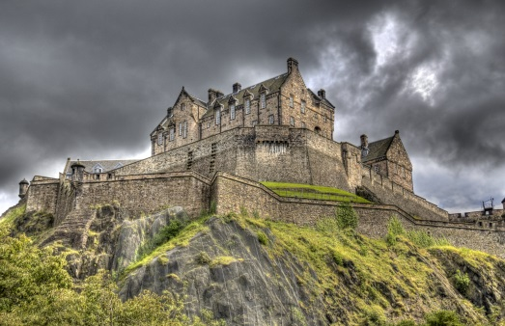
Task Eight
We’re Out for the Count

1. The door creaked open. A draught of cold air blew up from the stairs to the dark crypt and the hairs on our arms stood on end. The faint light from the flickering candle disappeared, there was a muffled scream, a sound of running footsteps and then some raised voices.
2. My three brave boys looked at each other and Douglas, the middle one, ran from the room. The eldest, Matthew, who had been taunting his younger brothers about being scared five minutes earlier, went a bit white and looked like he was going to change his mind about the visit.
3. We were in Dracula’s castle – sited on the remote Tihuta mountain pass where the Victorian Gothic novelist Bram Stoker based the home of his fictitious vampire - two days’ carriage ride from Bistrita in northern Transylvania.
4. Downstairs was Count Dracula’s coffin in a narrow vault, the walls painted with the dramatic scenes of human victims, wolves, skulls, skeletons and the black-cloaked monster himself, red blood dripping from his pointed fangs. So far on our Romanian holiday the only blood-sucking had been from the mosquitoes in Bucharest. Luckily we had decided to send their father down first as a guinea pig to test out how scary this experience was likely to be for our seven-, five- and two-year olds.
5. After the screams from the crypt, Matthew decided he would opt for a tour with the light on and I agreed. Even so there was a certain nervousness as we went down the stairs. Suddenly, Matthew let out a blood-curdling scream and jumped a foot in the air. “I’ve just seen a horrible blue hand with long nails, round the side of that door,” he screeched.
6. One vampire hand was quite enough for a seven-year-old. Time for a drink and an ice-cream. As we walked up to the main lobby there was “Vampire” red wine for sale, glass vials of red liquid, wooden stakes and probably some garlic stashed under the counter.
7. As these tacky souvenirs revealed, it wasn’t the real Dracula castle but Hotel Castle Dracula, a three-star hotel built in the mountains to service some nearby ski slopes. The architecture (1980s mock castle) reflected the Dracula movies but the setting amid the dramatic scenery of the Tihuta pass is stunning. The “castle” is circled by bats every night and the surrounding forests have more wild bears and wolves than anywhere else in Europe.
8. Bram Stoker’s story has become mixed up with the historical facts as the novelist based his blood-sucking fictional vampire on the 15th century bloodthirsty Prince Vlad Tepes, who was known fondly as Vlad the Impaler.
Task Eight Questions
Look at paragraph 1.
1. In what two ways does the writer create a frightening atmosphere in the opening
sentence? (2) Think about sentence type and word choice.
1.
2.

2. What does the word “flickering” tell us about the candle flame? (2)

Look at paragraph 2.
3. “My three brave boys”. Explain why this expression might be considered surprising. (1) Look at what happens next.

4. Explain in your own words how Matthew had been treating his brothers. (1)

Look at paragraph 3.
5. Give two pieces of evidence which suggest Bram Stoker wrote the novel Dracula
more than one hundred years ago. (2)
1.

2.

6. “castle – sited on the remote Tihuta mountain pass where the Victorian Gothic novelist Bram Stoker based the home of his fictitious vampire - two…”
Why does the writer use dashes here? (1)
Look at paragraph 4.
7. “Downstairs was Count Dracula’s coffin in a narrow vault, the walls painted with their dramatic scenes.” Describe in your own words the ‘dramatic scenes’ the writer saw. (2)

8. What mood does the writer create by using the expression “So far on our Romanian holiday the only blood-sucking had been from the mosquitoes”? (1) Think about how it makes you feel.

9. In your own words explain fully why the father was sent down first. (2)

Look at paragraphs 5, 6 and 7.
10. Write down an expression which shows that Matthew did not complete the tour. (1)

11. In your own words what is the writer’s attitude to the various goods for sale in
the hotel lobby? (1)

Thinking about the passage as a whole.
12a. What audience do you think this passage is aimed at? (1)

12b. Explain why you think this. (1)

13a. What do you think is the purpose of this passage and b) how do you know? (2)
a)
b)

Total: /20

Task Nine
Notes from a Small Island

In this extract from Notes from a Small island, American writer Bill Bryson, who has been travelling around the United Kingdom, has just arrived in Edinburgh.

1. And so I went to Edinburgh. Can there be a more beautiful and beguiling city to arrive at by train early on a crisp, dark November-y evening? To climb up from the bustling, subterranean bowels of Waverley Station and find yourself in the very heart of such a glorious city is a happy experience indeed. I hadn’t been to Edinburgh for years and had forgotten just how captivating it can be. Every monument was lit with golden floodlights – the castle and Bank of Scotland headquarters on the hill, Balmoral Hotel and the Scott Memorial down below – which gave them a certain eerie grandeur. The city was a-bustle with end-of-day activity. Buses swept through Princes Street, and shop assistants and office workers scurried along the pavement, hastening home to have their haggis and cock-a-leekie soup and indulge in a few skirls or whatever it is Scots do when the sun goes down.
2. On the spur of a moment, I’d booked a room in the five-star Caledonian Hotel, which was a rash and extravagant thing to do, but it’s a terrific building and an Edinburgh institution and I just had to be part of it for one night, so I set off for it down Princes Street, past the Gothic rocketship of the Scott memorial, unexpectedly exhilarated to find myself among the hurrying throngs and the sight of the castle on its craggy mount outlined against a pale evening sky.
3. To a surprising extent, and far more than in Wales, Edinburgh felt like a different country. The buildings were thin and tall in an un-English fashion, the money was different, even the air and light felt different in some ineffable northern way. Every bookshop window was full of books about Scotland by Scottish authors. And of course the voices were different. I walked along, feeling as if I had left England far behind, and then I would pass something familiar and think in surprise, ‘Oh, look, they have Marks & Spencer here,’ as if I were in Rekyjavik or Stavanger and oughtn’t to expect to find British things. It was most refreshing.
4. I checked into the Caledonian, dumped my things in the room, and immediately returned to the streets, eager to be out in the open air and to take in whatever Edinburgh had to offer. I trudged up a long curving back hill to the castle, but the grounds were shut for the night, so I contented myself with a shuffling amble down the Royal Mile, which was nearly empty of life and very handsome in a dour, Scottish sort of way. I passed the time browsing in the windows of the many tourist shops that stand along it, reflecting on what a lot of things the Scots have given the world – kilts, bagpipes, tam-o’-shanterns, tins of oatcakes, bright yellow jumpers with big diamond patterns of the sort favoured by Ronnie Corbett, plaster casts of Greyfriars Bobby looking soulful, sacks of haggis – and how little anyone but a Scot would want them.
5. Let me say right here, flat out, that I have the greatest fondness and admiration for Scotland and her clever, cherry-cheeked people. Did you know that Scotland produces more university students per capita than any other nation in Europe? And it has churned out a rollcall of worthies far out of proportion to its modest size – Stevenson, Watt, Lyell, Lister, Burns, Scott, Conan Doyle, J. M. Barrie, Adam Smith, Alexander Graham Bell, Thomas Telford, Lord Kelvin, John Logie Baird, Charles Rennie Mackintosh and Ian McCaskill to name but a few. Among much else we owe the Scots are whisky, raincoats, wellies, the bicycle pedal, the telephone, tarmac and penicillin, and think how insupportable life would be without those. So thank you, Scotland, and never mind that you seem quite unable to qualify for the World Cup these days.
6. At the bottom of the Royal Mile, I came up against the entrance to the Palace of Holyroodhouse and I picked my way back to the centre of things along a series of darkened back lanes. Eventually, I ended up in an unusual pub on St Andrews Square called Tiles – an apt name since every inch of it from floor to ceiling was covered in elaborate, chunky Victorian tiles. It felt a bit like drinking in Prince Albert’s loo – a not disagreeable experience as it happens. In any case, something about it must have appealed to me because I drank some beer and emerged to find nearly all of the restaurants roundabout were closed, so I toddled back to my hotel and put myself to bed.

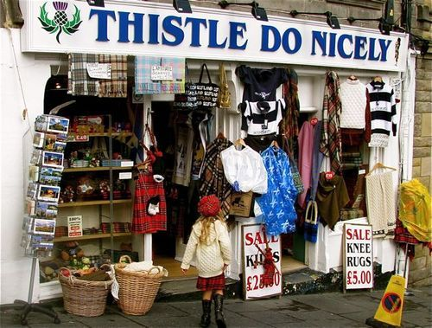

Task Nine Questions

1. What impression of Edinburgh does Bill Bryson have at the beginning of paragraph 1? (2)

2. What do you think ‘subterranean’ (paragraph 1) means? How did the rest of the sentence help you work this out? (2)

3. How can you tell this passage belongs to a longer piece of writing? Look at the beginning of paragraph 1. (1)

4a. “Every monument was lit with golden floodlights – the castle and Bank of Scotland headquarters on the hill, Balmoral Hotel and the Scott Memorial down below – which gave them a certain eerie grandeur.” Why are dashes used here? (1)

4b. What is the technical name for this type of technique? (1)

5. ‘The city was abustle with end-of-day activity.’ (paragraph 1)
How do word choice and sentence structure in the rest of the paragraph continue this idea of bustle? (3)
Word choice of:

Type of sentence structure:

Continues the idea of bustle because:

6. Why do you think it was ‘rash and extravagant’ to book a room at the Caledonian Hotel (paragraph 2)? (1)
7. In your own words, why did the writer choose to stay at the Caledonian Hotel? (1)

8a. ‘the Gothic rocketship of the Scott Memorial’ (paragraph 2). What type of imagery is this an example of? (1)

8b. What does this comparison tell us about the Scott Memorial? (1)

9. Re-read paragraph 3. In your own words, what three things does the writer say make Edinburgh different from the rest of the UK? (3)
1.

2.

3.

10. Explain what the writer finds ‘refreshing’ in paragraph 3. (1)

11. The writer behaves like a typical tourist in paragraph 4. In what ways do you think his actions prove this? Quote to support your answer. (2)

12. What do you think is the writer’s view of Scottish souvenirs? Support your answer with evidence from paragraph 4. (1)

13a. What is the purpose of the question in paragraph 5? (1)

13b. What is the writer’s tone towards the end of this paragraph? Think about how he would say it if you were listening to him speaking. (1)

14a. What is the name of the pub that Bryson visits? (1)

14b. What does Bryson compare the pub to? (1)

Total: /25
Extension Task
Choose one of the names Bryson includes in paragraph five, research their life and accomplishments, then write a short informative piece of writing about them. This may be completed in your jotter if necessary.

I have chosen to research and write about:
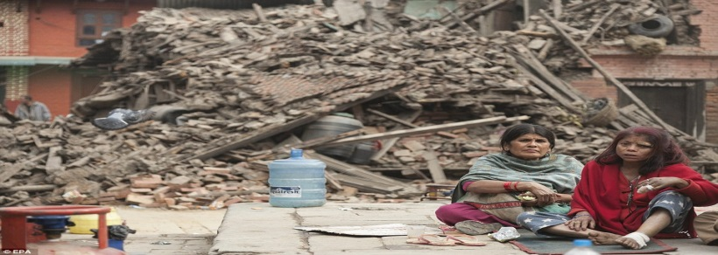

Task Ten

How Nepal quake turned women into builders

Reconstruction in Nepal has been slow since a devastating earthquake two years ago. But in some rural areas women are breaking with tradition and picking up tools to speed things up.
1. Sanumaya Kumal does everything from carrying sand and bricks, to digging foundations. In a badly affected district north-west of Kathmandu, she and other women are helping rebuild houses damaged by the quake. Women have traditionally been limited to household chores but with many men working abroad, Nepal faces a lack of manpower at a crucial time - hence Sanumaya's move into construction."I am very content with my job. I can do everything that a male mason can do," says Sanumaya, who used to work on a farm. Her other tasks include building walls, roof-fitting and plastering.
2. According to official estimates, nearly 1,500 young Nepalis travel to the Gulf and the Middle East every day in search of jobs. Officials say this has created a depletion of labour locally and is even holding up reconstruction and essential work on schools and health centres. But in the areas worst hit by the 25 April 2015 earthquake, women are gradually taking up prominent roles in reconstruction.
3. More than $4bn has been pledged in post-quake aid but progress in one of the world's poorest countries has been painfully slow. The disaster killed nearly 9,000 people and damaged a million houses. Various national and international organisations have been helping the women gain the skills they need to build. And the women say they are earning a decent living, as well as being happy that they are taking part in important national work.
4. Sanumaya was one of eight women the BBC found working at the building site in the town of Bidur in Nuwakot district. Her fellow construction worker Srijana Kumal says she likes the work because the pay is attractive. "Women are facing a lot of problems when they go abroad for work," she told the BBC. "Almost all the houses in the villages are damaged. We have a lot of work to do here and the working conditions are very safe."
5. Sanumaya and her friends are making about 1,200 Nepalese rupees ($11.50; £9) for a day's work in their new roles, a decent sum compared with other manual jobs in rural Nepal. The Post Disaster Recovery Framework states that Nepal needs nearly 60,000 skilled building workers to complete the reconstruction of houses within five years. However, officials say that as well as the manpower shortage, many existing construction workers do not know how to build houses to earthquake-resistant specifications. This means any newly built houses are as vulnerable as flowers in a storm.
6. There are no reliable figures on how many women are currently involved in reconstruction in Nepal (although many believe there is a magnitude of potential). But the United Nations and other donor agencies that are providing training to construction workers say they have given high priority to enrolling women on their courses. They value the work these women do as being as valuable as precious jewels. And Sanumaya and her colleagues have no shortage of work. "With the reconstruction going on, I am busy almost every day," she says.
Task Ten Questions

- Using a dictionary or searching online, find the definitions to the following words: (5)
Word | Definition
Crucial
Mason
Depletion
Prominent
Specifications

- What is the purpose of this text? (1)

- Who is the intended audience of this text? Think about age and interests. Be as specific as possible. (1)

- Look at paragraph 1.
- What changes are Nepali women facing? Tip: What did they do before and what do they do now? (1)

- Why are women facing these changes? (1)

- Find a word or phrase from the opening paragraph that describes how Sanumaya feels about these changes. (1)

- Summarise in one sentence what the article is about. (1)
6. Re-read paragraph 4. What are two positive points that have happened as a result of the earthquake? (2)
1.

2.

7. Re-read paragraph 5. What two problems does Nepal have? (2)
1.

2.

8. Re-read paragraph 6. ‘...many believe there is a magnitude of potential.’
What does the word ‘magnitude’ tell the reader about the amount of potential? (1)
- Magnitude means…

- Therefore the potential is…

9. Re-read paragraph 6.
- Identify an example of interesting use of punctuation in this paragraph and write it below. (1)

b) What does this type of punctuation tell the reader about the way Sanumaya said this sentence? (1)

Total: /18
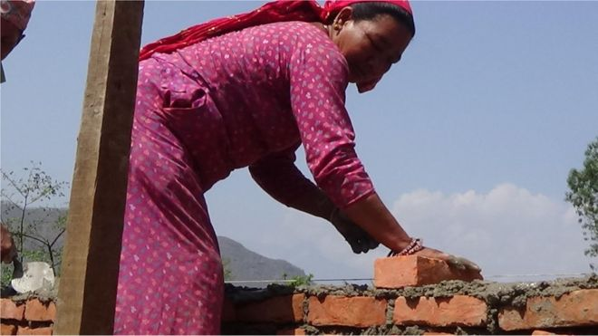

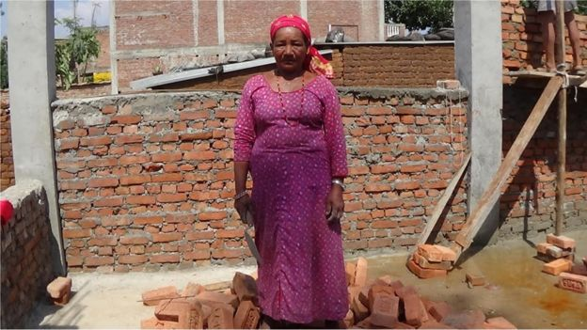
Extension Task

Imagine you are Sanumaya. Write a paragraph long diary entry detailing what her life was like before the earthquake and a paragraph long diary entry detailing what her life was like after the earthquake. Remember to make reference to what activities she would be doing and include her thoughts and feelings. This may be completed in your jotter if necessary.

Before the Earthquake:

After the Earthquake:
Results
Model Task | /14
Task One | /15
Task Two | /16
Task Three | /18
Task Four | /19
Task Five | /19
Task Six | /16
Task Seven | /20
Task Eight | /20
Task Nine | /25
Task Ten | /18
Overall Total | /200
pupil Target Setting


From Spanish-speaking countries, especially those in Central and South America.
An area of a city, usually poor and densely populated, where a minority group lives apart.

