
Rosshall Academy

Reading for Understanding, Analysis and Evaluation


Name: ________________________________
Class:
________________________________


Contents
 | Page
Purpose and Audience | 4 - 5
Word Choice | 6
Model Task – Chewing Gum | 7 - 8
Task 1 - Facebook’s Mark Zuckerburg Plans To Build His Very Own ‘Jarvis’. | 9 - 10
Task 2 - The Nagging Parent. | 11 - 12
Task 3 - The Living Dead. | 13 - 14
Task 4 - The Real King Kong. | 15 - 16
Task 5 - Sneakers That Can Be Customised On The Go? Sweet! | 17 - 18

Contents
 | Page
Task 6 – Italian Architect Envisions “Forest Cities” | 19 - 21
Task 7 – Selfies Can Be Deadlier Than Sharks | 22 - 24
Task 8 – Smartphones With Self-Healing Screens | 25 - 26
Task 9 – Study Reveals Surprising Facts About Our Emoji Choices | 27 - 28
Task 10 – Bleaching Decimates Australia’s Great Barrier Reef | 29 - 30
Results | 31 - 32
Target Setting | 33


Purpose and Audience
With each article you read, it is important for you to understand the purpose and the intended audience. You need to be aware of who exactly articles are aimed at and what they are trying to tell the reader.
Purpose
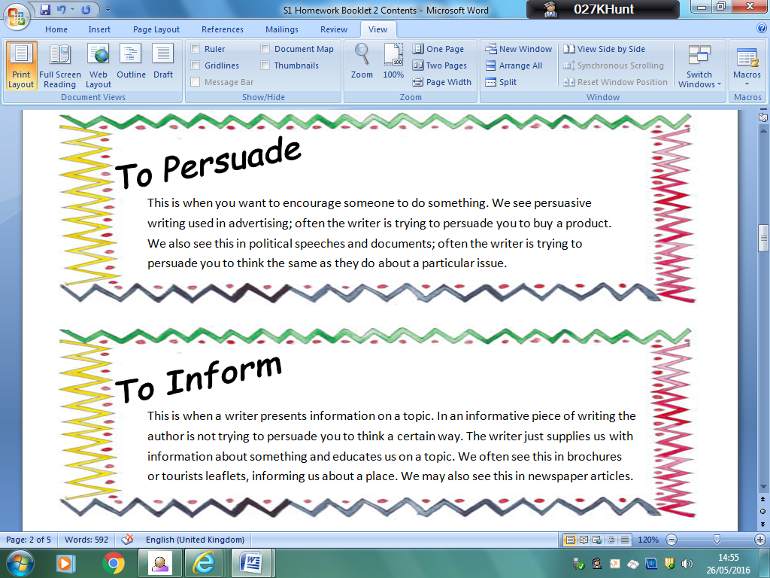
There are three main purposes we look at in S1 and S2. They are:
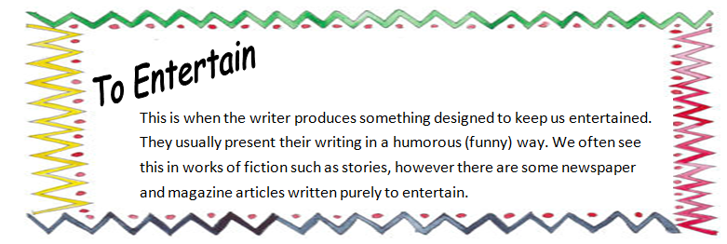

Audience
It is important that you understand who articles are aimed at. Whenever you have a question on audience you must think about age and interests and try to be as specific as possible. In some cases you may even be able to consider things such as gender, social status, nationality.

Task
Look at the following magazine covers and write who you think the intended audience is for each magazine. You should also give a reason for your answer.

- Teen Vogue
________________________________________________________________________________________________


- Yachting
________________________________________________________________________________________________


- World Soccer
________________________________________________________________________________________________


- Rides
________________________________________________________________________________________________


- Brides
________________________________________________________________________________________________

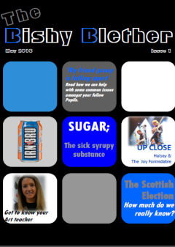
- The School Magazine
________________________________________________________________________________________________


Word Choice
Quite often writers’ choose to use particular words in order to create an effect or to show their feelings on a certain topic.
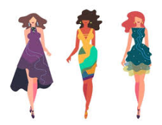
Look at the following sentences and decide whether you think they are positive or negative statements. Circle the correct answer.

- The models looked skinny as they walked down the runway. Positive/Negative
- The models looked slim as they walked down the runway. Positive/Negative
- The models looked toned as they walked down the runway. Positive/Negative
- The models looked scrawny as they walked down the runway. Positive/Negative
Denotation and Connotation
It is important to understand the denotation and connotations of words.
Denotation means the literal or primary meaning of a word.
Connotation means the ideas and feelings we associate with a word.
Home


Denotation:  The place where one lives permanently, especially as a member of a family or household. | Connotations:  family, comfort, warmth, cosy

Task:
Look at sentence d) from task 1:
The models looked scrawny as they walked down the runway.

What are the connotations of the word scrawny? What does it make you think of? What do you associate with the word?
Scrawny has connotations of: ____________________________________________________________________________________________________________________________________________________________________
Therefore how do you think the writer feels towards the models/runway show/fashion industry?
____________________________________________________________________________________________________________________________________________________________________
Playful Gumdrop Bins Help Reduce Sticky Gum Litter And Give It A Second Life

Most people have a love-hate relationship with gum. For delicious as it is, the sticky tasteless waste that remains is not just annoying especially when inadvertently stepped upon, but also, harmful to the environment. That's because the primary ingredient in most modern chewing gums is synthetic rubber which is not biodegradable. With an estimated 560,000 tons of gum being chewed each year, this adds a lot of unwanted polymer to our already overwhelmed landfills. Now thanks to Gumdrop Ltd., there may be a solution to this sticky problem.
The U.K. based company has come up with a brilliant idea that enables easy disposal of chewed gum using specialized recycling bins. Passersby can simply dump any unwanted chewing gum into the bright pink gumdrop-like receptacles that have been installed across the city of London.
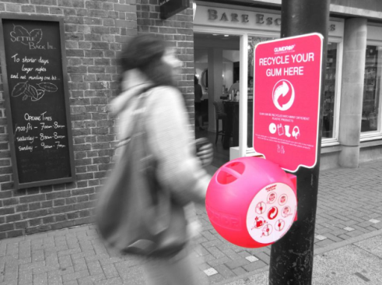
Once full, they are mailed to Gumdrop headquarters where the gum is recycled to create - yup you guessed it - more receptacles! The company says that the gum waste can be transformed into other useful things like rubber boots and phone cases as well.
Though the pink bins clearly indicate that they are for meant for gum recycling, there is always the risk that people will use them to get rid of all kinds of trash.
Anna Bullus, who founded the company in 2009, says she was inspired to create the clever receptacles after observing the sticky mess caused by gum waste on the streets of London. The company has since gone from strength to strength. Receptacles were first adopted by Legoland outside of London. Their success, however, has led to the rapid deployment of the bright pink bins in the city's streets, offices and even schools.
Bullus now hopes to take her Gumdrops to countries around the world. Among the top on her list is the U.S.A where an estimated 59% of the population chews gum! The company has also introduced Gumdrop On-the-Go. The personal recycling bins that can be attached to key chains enable consumers to get rid of gum waste in a responsible manner.

Questions
- Using a dictionary or searching online, find the definitions to the following words:

Word | Definition
Inadvertently
Biodegradable
Passersby
Receptacles
Deployment

- What is the purpose of this text?
- To inform the reader about a new, safer way of disposing chewing gum.
- To persuade the reader to stop chewing gum.
- To entertain the reader.

- Who is the intended audience of this text? Think about age and interests. Be as specific as possible.
_________________________________________________________________________________________________________________________________________________________________________________________________________________________________

- Look at paragraph 1 (lines 1 – 6).
- The writer both praises and criticises chewing gum. Find a word or phrase from the opening paragraph that describes chewing gum in a positive way.
__________________________________________________________________________
- Find a word or phrase from the opening paragraph that describes chewing gum in a negative way.
___________________________________________________________________________

- Summarise in one sentence what the article is about.
______________________________________________________________________________________________________________________________________________________

- What inspired Anna Bullus to create gum recycling bins? Who was the first to adopt them? What has happened since? Answer in your own words.
_____________________________________________________________________________________________________________________________________________________________________________________________________________________________________________

Facebook's Mark Zuckerberg Plans To Build His Very Own 'Jarvis'

It is the beginning of a new year. This means that most of us have a lengthy list of goals laid out for the next 365 days. Facebook's founder Mark Zuckerberg is no exception. While his past resolutions have been mundane challenges like reading two books a month, meeting a new person every day of the year and mastering Mandarin, this year the Internet mogul has a much more fabulous goal. He wants to build his own version of Tony Stark's (AKA Iron Man's) digital assistant and closest friend, Jarvis (Just A Rather Very Intelligent System).
The 31-year-old entrepreneur who announced his resolution on Facebook on Sunday, January 3, said his artificial intelligence assistant will feature facial recognition technology so that it can let in family members and friends into the house. The digital assistant will also be programmed to keep a vigilant eye on Zuckerberg's newborn daughter Maxima, and alert him of any unexpected disturbances.

Best of all? The virtual assistant will be able to create holograms similar to the ones sketched by Jarvis to help Tony Stark design Iron Man suits. Of course, in this case, it would not be to help Zuckerberg become a superhero, but to enable him to visualize data in virtual reality — Something the entrepreneur believes will help him lead Facebook more efficiently and build better services.
And if you think Zuckerberg plans to get assistance from Facebook's team of ace engineers, think again. The programmer plans to code the system all on his own simply because "It's a different kind of rewarding to build things yourself."
Besides, he thinks the task should not be that difficult given that much of the technology is already available. Zuckerberg, who has promised to keep us fans updated on his progress via Facebook, says that if successful, he will share the technology with the rest of the world (what a guy!). This means that someday soon we may all be able to build our own personal digital assistants. Can resolutions get any better?

Questions
- Find the definitions to the following words: (4 marks)

Word | Definition
Mundane
Entrepreneur
Vigilant
Mogul

- What is the purpose of this text? (1 mark)

- To persuade the reader that we all should build our own robots.
- To inform us about Mark Zuckerburg’s plans to build a robot.
- To inform us about how to build a robot.

- Who do you think this text is aimed at? Think about age, gender, interests. (1 mark)
- ___________________________________________________________________
____________________________________________________________________

- Summarise in one sentence what the passage is about. (1 mark)
- ___________________________________________________________________
____________________________________________________________________

- Look at the final paragraph.
- What technique does the writer finish the passage with (‘Can resolutions get any better?’) (1 mark)
- ___________________________________________________________________
- Find and quote another example of this technique from elsewhere in the passage.
(1 mark)
- ___________________________________________________________________

- Consider the passage as a whole.
- How do you think the author feels about Mark Zuckerburg’s plans for his own robot? Think about whether he is positive/ negative/complimentary/critical. (1 mark)
- ___________________________________________________________________
- Choose one word or phrase from the passage that helped you reach this decision.
(1 mark)
- ___________________________________________________________________
Total: /11

The Nagging Parent
Everybody argues with their parents at some point. According to writer Peter Corey, though, the Nagging Parent is a particularly difficult type...
The Nature of the Beast
Parents ask questions which they already know the answers to. The Nagging Parent is the past master of this art. Not only the past master, but the present and the future master as well. And mistress, in the case of the Nagging Mum. They seem to spend their entire life questioning your actions, telling you that you shouldn’t be doing what you’re doing, even if it’s the exact opposite of the last thing you were doing. Confused? That’s hardly surprising. Because surprise is the Nagging Parent’s secret weapon.

Habitat
In bushes, behind doors, under beds. In fact, anywhere that provides a bit of cover. Just when you thought it was safe to sit on the loo . . . the Nagging Parent strikes: ‘Why are you using so much toilet paper?’ Your life is not your own. You can’t go anywhere or do anything without getting nagged.

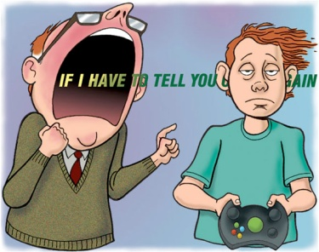
And don’t imagine you are safe when your parents are not with you. Because you’re not! The thing about Nagging Parents is that they are quite happy to nag anybody. It doesn’t have to be one of their own children. What makes it worse is the fact that this particular breed is very common. And what compounds the problem is the fact that the Nagging Parent, or to give them their Latin name, Naggus Tu Deathus, is a distant cousin of that other difficult type, The Inquisitive Parent. You could be doing something fairly harmless – minor surgery on next door’s cat, and totally unbeknown to you, the local snoop has told on you. Next thing you know, the Nagging Parent is giving you an earful of Relentless Verbal Porridge.

Appearance
Ah! Here is where the Nagging Parent can be very devious. They look perfectly normal. Well, as normal as any parent ever looks. And, like a chameleon, they have the power to blend with their surroundings. Out of doors, they don’t exactly wear army camouflage gear, but they manage to blend in with the background as they sneak from bush to bush ready to stop you doing whatever it is you’re doing, however harmless. Oh, yes! These are devious animals!

Questions
- Find the definitions to the following words: (4 marks)

Word | Definition
Nagging
Inquisitive
Unbeknown
Devious
- Consider the passage as a whole.
- What is the purpose of this text? Tick one box. (1 mark)
- To persuade the reader that all parents ‘nag’.
- To inform the reader about different ‘types’ of parents.
- To entertain the reader about ‘nagging’ parents.

- Identify one word or phrase that helped you reach this decision. (1 mark)
- ___________________________________________________________________
- The whole passage compares parents to animals. Quote THREE expressions which show how the writer talks about Nagging Parents and their behaviour as if he was describing a species of animal. (3 marks)
- ___________________________________________________________________
- ___________________________________________________________________
- ___________________________________________________________________

- Who do you think is the intended audience for this passage? (1 mark)
- ___________________________________________________________________
4b) Explain how you came to your decision (1 mark)
5) Look at paragraph lines 23 – 24.
- ___________________________________________________________________
The writer says ‘Next thing you know, the Nagging Parent is giving you an earful of Relentless Verbal Porridge’. Why do you think the author chose to compare the parent’s words to ‘porridge’? Think about what you associate with porridge. (2 marks)
- I associate porridge with _________________________________________________
_____________________________________________________________________
- I think the author chooses to compare the parent’s words to ‘porridge’ because ____
_____________________________________________________________________

- What do you think the tone of the passage is? Tick one box. (1 mark)
- Humorous
- Serious
- Critical
Total: /14
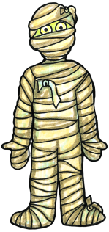
The Living Dead
The ancient Egyptians believed that it was very important to preserve (mummify) the bodies of their rulers (called pharaohs) because they thought that their bodies survived in the afterlife...
Archaeologists can find out a great deal from the way in which people are buried. Normally they only find skeletons, but sometimes bodies are preserved naturally. This happened in the bogs and marshes of northern Europe and in the deep-frozen soil of Siberia. Bodies buried in dry desert sands are particularly well preserved. The secret of preparing mummies was also discovered in other desert regions of the world, such as Peru.
The Egyptians were fascinated by death. The west bank of Thebes is sometimes called necropolis. This Greek word means ‘city of the dead’. The Egyptians learned how to prepare mummies as early as 4000 BC. Preserving dead bodies, or embalming, was important to them because they believed that their bodies survived into the next life. The citizens of Thebes even mummified sacred animals such as cats and crocodiles. Poor people were embalmed, but the best treatment was given to those who could pay for it – royalty, nobles and priests.
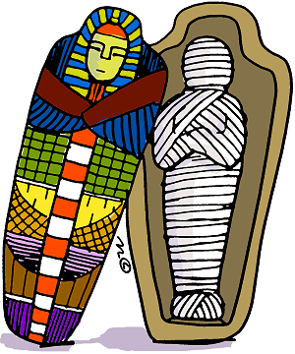
Often the brain was the first organ to be removed from the dead body. The hear t was left in place, but the kidneys, liver, stomach and guts were taken out and preserved separately. They were placed in jars in the tomb. The body itself was dried out with natron – a preparation of salty crystals. This process took about forty days. The body was then stuffed with clay, sawdust or linen cloth soaked with resin. The skin was rubbed with oils, scents and wax. Finally bandages and cloth were wrapped around the body.
The mummies were placed inside a series of wooden coffin cases. These were shaped like a human body and painted with the face of the dead person. The coffins were then lowered into a stone box called sarcophagus.

Questions
- Find out the meaning of the following words: (4 marks)

Word | Definition
Preserved
Archaeologist
Embalming
Nobles

- What is the purpose of this text? Tick the correct box. (1 mark)
- To inform the reader about the Egyptians’ practice of mummifying.
- To persuade the reader that mummifying is a good way of burying the dead.
- To entertain the reader.

- Who do you think this text is aimed at? Think about age, gender, interests. (1 mark)
- ___________________________________________________________________
____________________________________________________________________
- Summarise in one sentence what the passage is about: (1 mark)
- ___________________________________________________________________
____________________________________________________________________
- In paragraph 4 (lines 15 – 20) the writer says;
The body was then stuffed with clay, sawdust or linen cloth soaked with resin.
- What does the word ‘stuffed’ mean? What do you associate with the word ‘stuffed’? What does it make you think of? (1 mark)
- ___________________________________________________________________
____________________________________________________________________

- Look at lines 21-23.
In your own words describe the wooden coffins in which the mummies were placed.
(1 mark)
- ___________________________________________________________________
____________________________________________________________________
Total: /9

Researchers Believe That The Real-Life King Kong Perished Because Of Its Inability To Adapt.
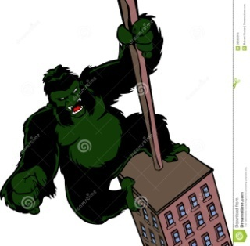
King Kong fans will be pleased to hear that the massive skyscraper climbing ape is not just a figment of filmmakers' imagination. There were actual giant apes or Gigantopithecus that roamed the planet not too long ago. However, since the only fossil evidence found is the lower jawbone and a handful of teeth, researchers have been unable to get much insight into the giant ape's lifestyle or what caused it to become extinct.
In 2005, Jack Rink a researcher at Canada's McMaster University examined the fossils and came to the conclusion that the mammal measured about 10-feet tall and weighed up to 1,200 pounds. The Associate Professor of Geography and Earth Sciences was also able to determine that the Gigantopithecus had been roaming Southeast Asia for a million years before becoming extinct about 100,000 years ago. This meant it had lived alongside humans! The one thing he and no other scientists were able to determine is what caused the Gigantopithecus to disappear.
But now thanks to advances in fossil technology and some curious researchers, the mystery may be finally solved. For their study, the team focused on the Gigantopithecus's fossilized teeth. In particular, they were looking for clues about the animal's diet in the tooth enamel.
The observations helped the researchers determine that the Gigantopithecus ate a variety of plants, putting to rest years of speculation about whether the ape had been a carnivore or survived just on bamboo. Given the amount of food it would need to survive, they came to the conclusion that the ancient King Kong was a forest dweller.
Upon researching the areas in Southern China and Thailand where the fossils had been found, the scientists discovered that what used to be lush forests, changed to Savannah grasslands 100,000 years ago - The same period the Gigantopithecus disappeared.
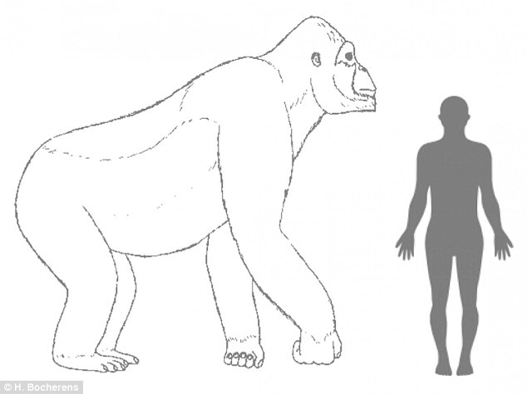
This led the scientists to conclude that when the forests disappeared, so did the giant ape's food source. However, unlike many other species, the fussy eater was unable to adapt to the new habitat and, therefore, starved to death! Meanwhile, their distant cousin, the orangutan, managed to adjust and survive. The fact that they are a lot smaller in size and have a very slow metabolism didn't hurt the apes either.
These, of course, are all educated guesses. What happened to these magnificent animals can only be confirmed if we can find additional fossils.

Questions
- Find the definitions of the following words: (5 marks)
Word | Definition
Perished
Figment
Extinct
Fossilised
Metabolism

- What is the purpose of this text? Tick one box. (1 mark)

- To inform the reader about how the Gigantopithecus became extinct.
- To persuade the reader that the Gigantopithecus may still exist.
- To inform the reader about the size of the Gigantopithecus

- Who do you think this article is aimed at? Think about age and interests. (1 mark)
- ___________________________________________________________________
____________________________________________________________________

- Look at paragraph 1 (lines 1- 5) Identify words and phrases the writer uses to emphasise the sheer size of the Gigantopithecus. (2 marks)
- ___________________________________________________________________
____________________________________________________________________

- a) Look at the final paragraph (lines 27-28). The writer says ‘What happened to these magnificent animals can only be confirmed if we can find additional fossils’. What does the word ‘magnificent’ mean? What do you associate with the word ‘magnificent’? (1 mark)
- ___________________________________________________________________
____________________________________________________________________

b) What does that word tell us about how the writer feels towards the ancient species Gigantopithecus? (1 mark)
- ___________________________________________________________________
____________________________________________________________________

Total: /11

Sneakers That Can Be Customised On The Go? Sweet!
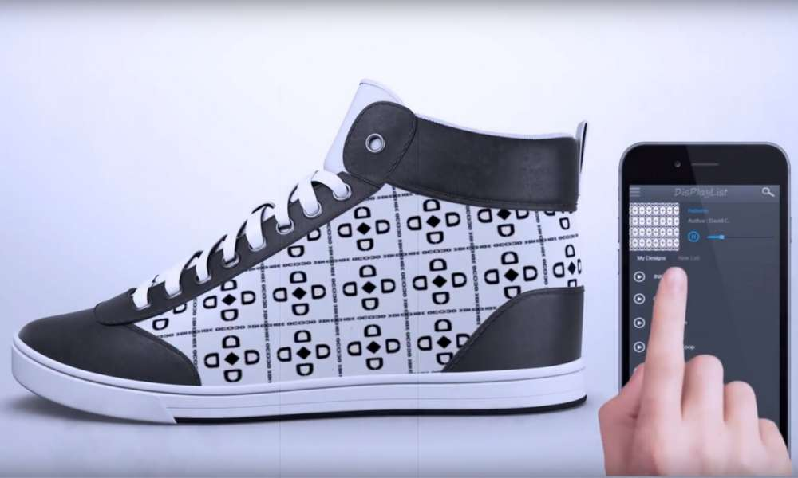
With smart technology increasingly infiltrating all aspects of our lives it was only a matter of time before someone invented 'smart' shoes - Ones that can be customized at the owner's whim. Called ‘ShiftWear,' the animated sneakers are the brainchild of a team of entrepreneurs, futurists, and engineers led by New York-based designer David Coelho.
The adaptable shoes, which will be available as high, medium, and low tops can be customized using a smartphone app that is compatible with iOS, Android, and Windows devices. Shoe owners will have the option of selecting a design from a variety of HD patterns and GIF-like animations sketched by famous artists or create one themselves. The company's founders envision a marketplace where artists can not only share but also sell their designs to others.
Despite being electronic projections, the designs are clearly visible even in the brightest sunlight. What's even cooler is that by switching on a backlight, users can even show off their designs in the dark!
According to Coelho, the sneakers will retain their charge 'forever' if only static images are displayed. Though they will need periodic recharging if animated images are projected, active users have nothing to worry about. That's because the shoes are fitted with special Walk-N Charge technology that powers the shoes with every step. Inactive or power design changers also have option of charging the sneakers wirelessly.
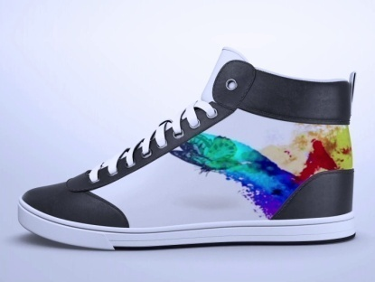
The sturdy shoes come with soles covered with Kevlar Fibers (the same material used to make bulletproof vests). Even better? They are completely waterproof and can even be tossed into an ordinary laundry machine for a quick rinse! Though the founders will not reveal how the magical sneaker works, they do disclose that they are simply tweaking currently available technology to suit their needs. The company estimates that the shoes, which are scheduled to debut in Autumn 2018 will range in price from £100 to £1000 depending on the size of the e-paper panels where the designs are displayed.
This is not the first time electronics and shoes have merged. Lithuania-based iShuh Technologies has come up with a similar concept that connects e-reader panels to a smartphone app via a Bluetooth. Whether these smart shoes become as ubiquitous as our smart devices remains to be seen, but they sure are fascinating.

Questions
- Find the definitions to the following words: (5 marks)
Word | Definition
Infiltrating
Whim
Compatible
Envision
Ubiquitous

- What is the purpose of this text? (1 mark)
- ___________________________________________________________________
____________________________________________________________________

- Who is the intended audience of this text? Explain your answer. (1 mark)
- The intended audience is ______________________________________________
- I think this because ___________________________________________________
____________________________________________________________________

- a) What is the tone of the text? Tick one box. (1 mark)
- Critical of the new trainer design.
- Complimentary of the new trainer design.
- Sarcastic about the trainers.
b) Identify two words or phrases that helped you reach your decision. (2 marks)
- ________________________________________________________________________________________________________________________________________
- ____________________________________________________________________
____________________________________________________________________

- Explain in your own words what is special about Shiftwear sneakers. (1 mark)
- ___________________________________________________________________
____________________________________________________________________

Total: /12

Italian Architect Envisions "Forest Cities" To Combat China's Air Pollution

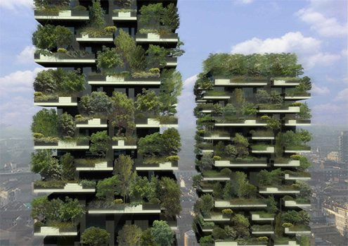
Ever since Malaysian ecologist-architect Ken Yeang introduced the concept in the 1990’s, living walls and rooftops have become an increasingly common sight in both residential and commercial buildings. In addition to looking good, planted exteriors also help cut energy costs, and, in the case of rooftop farms, provide urban dwellers with homegrown produce. Now, Stefano Boeri wants to take green architecture to the next level with “Forest Cities” to combat China’s air pollution woes.

The Italian architect’s interest in metropolitan reforestation began in 2014 with two towers in central Milan. Measuring 110-meters (360-feet) and 76-meters (249-feet) in height, they host 900 trees measuring between 3 to 9 meters each and over 20,000 shrubs and plants pre-cultivated specifically for the purpose. The foliage is irrigated by rain as well as the building’s gray water recycling system. The “Bosco Verticales,” or “Vertical Forests,” that are equivalent to a flat area of about 2 acres, provide year-round energy savings and improve the air quality by releasing moisture and converting carbon dioxide into oxygen. The vegetal system also acts as a windscreen, captures dust particles from the air, and blocks noise from the bustling Milan streets, making for a much healthier living environment for the residents.

Of course, these buildings are not enough to solve China’s smog problem, which is why Boeri is now attempting to create “Forested Cities.” His architectural design team is currently devising plans for a wooded settlement in Liuzhou, a medium-sized city that is home to about 1.5 million residents. All the buildings will have gray water recycling systems and be powered by solar or wind energy. The architect is also hoping to build a green mini-city around Shijiazhuang, an industrial area in northern China that is infamous for consistently being one of the country’s ten most polluted cities.

Boeri is not the only one devising ways to clean up China’s polluted air. In September 2016, Dutch designer Daan Roosegaarde took his massive smog cleaning machine on a five-city tour that began in Beijing. The seven-meter tall tower, believed to be the “world’s largest smog-cleaning machine,” filters 30,000 cubic meters of air each hour — removing even the finest smog particles and releasing fresh, clean air using about the same amount of electricity as a water boiler. The best part is, the captured carbon particles are compressed and transformed into expensive jewellery that is sold to generate funds for the project. With innovations like these, the country’s air pollution struggles may soon be a thing of the past.

Questions
1) Find the definitions to the following words: (5 marks)
Words | Definition
Woes
Foliage
Irrigated
Smog
Consistently

2) What is the purpose of this text? Tick the correct box. (1 mark)
- To entertain the reader with a fictional story about buildings covered in greenery.
- To persuade the reader that all countries should build ‘Forest Cities’
- To inform the reader about a new innovative design by an Italian architect

3) Think about the intended audience for this passage. Give two interests that a reader of this article may have. (2 marks)

4) Look at paragraph 1. In your own words explain three positives to having rooftops/walls full of plants and flowers. (3 marks)

5)a) Look at paragraph 2. “The vegetal system also acts as a windscreen…” what technique has the writer used here? (1 mark)
- Simile
- Metaphor
b) By comparing the “vegetal system” (all the plants/trees on the buildings) to a windscreen implies that the system does what? (2 marks)

- ____________________________________________________________________________________________________________________________________________________________________________________________________________
- ____________________________________________________________________________________________________________________________________________________________________________________________________________
- ____________________________________________________________________________________________________________________________________________________________________________________________________________
- ___________________________________________________________________
____________________________________________________________________
- ____________________________________________________________________
____________________________________________________________________
- ________________________________________________________________________________________________________________________________________________________________________________________________________________________________________________________________________________
6) Look at paragraph 4. What is the writer’s attitude towards this idea? Do they feel positively or negatively about this new design? (1 mark)
- Positive
- Negative
7) Choose a word or phrase that helped you to decide on the writer’s attitude. (1 mark)
8) In your own words, summarise in one sentence, what this article is about. (1 mark)

Total: /17

Watch out for those selfies, they can be deadlier than sharks!
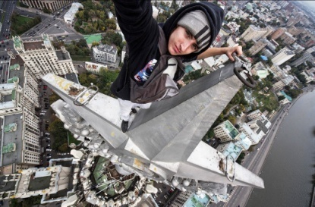
The proliferation of smartphones with cameras that can take self-portraits or selfies as they are popularly called has liberated us. We can now document every moment of our life and instantly share it with the world through the myriad of social networking websites. However, some believe that the incessant quest to capture the "ultimate" selfie is causing people to take unnecessary risks that in some cases are proving to be deadly!
So how bad is the problem? According to recent news reports, the desire to take a "breathtaking" selfie has killed 12 people this year. Though that may not seem like a lot, it is four (33%) more than the eight people that have died from shark attacks.
While the issues have been known for a while, they came to a head on September 21st, following the accidental death of Hideto Ueda at the Taj Mahal in Agra, India. It turns out that the 66-year-old Japanese national and his travel companion were trying to take a selfie at the mausoleum's Royal Gate when they stumbled down some stairs. While the friend escaped with a fractured leg, Ueda was not as fortunate. He sustained a head injury and passed away soon after.
Other fatal accidents this year include a 21-year-old Russian woman who fell off a bridge while trying to capture an "exciting" self-portrait. Three Indian students suffered a similar fate after they were run over by an oncoming train while taking a selfie on the railway tracks.
The rising number of injuries is forcing officials to take some drastic measures. In July this year, the Russian Interior Ministry began a nationwide awareness program to alert its young citizens about the dangers of this deceptively safe hobby. The campaign's slogan is: "Even a million 'likes' on social media are not worth your life and well-being."
The officials felt it was necessary because, “When a person is trying to photograph themselves, their attention is scattered, they lose their balance, they don’t look around and feel no danger.”
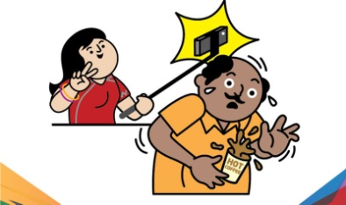
Though no other country has followed their lead, many are banning the tool that has contributed substantially to the rise in injuries - The selfie stick! In the last few months numerous museums, sports arenas, and theme parks including Disney, have prohibited their use. In June, West Japan Railways became the first such institution in the world to ban the sticks both inside Japan's bullet trains as well as out on the railway platforms.
While these measures may help reduce the incidents, the only way to stop selfie-related injuries and deaths is if everyone takes responsibility - not just for themselves, but also, their friends. So the next time you or your best pal decide to take a selfie that appears a little risky, be sure to stop and ask yourself - Is it worth it?
Questions
1) Find the definitions to the following words: (6 marks)
Words | Definition
Proliferation
Liberated
Myriad
Incessant
Fatal
Prohibited

2a) What is the purpose of this text? Tick the correct box. (1 mark)
- To entertain the reader with interesting information about the selfie stick.
- To persuade the reader to be more aware of dangers when taking selfies.
- To persuade the reader to take lots of interesting and exciting selfies.

2b) Name and quote a technique from the article that helped you choose your answer to 2a).
(2 marks)

3) Think about the intended audience for this passage. Who do you think this passage is aimed at? (1 mark)

4a) Look at paragraph 1. Using your definitions from question 1, what are the connotations of the word ‘myriad’? (1 mark)

4b) What does this tell you about the writers thoughts/attitude towards social media networking sites? (1 mark)
5) Look at paragraph 2. Why do you think the author makes the point that more people have died from taking dangerous selfies than being killed by sharks? (1 mark)

5)a) Look at line ____ “The vegetal system also acts as a windscreen…” what technique has the writer used here? (1 mark)
- Simile
- Metaphor

b) By comparing the “vegetal system” (all the plants/trees on the buildings) to a windscreen implies that the system does what? (2 marks)

- _______________________________________________________________________________________________________________________________________________________________________________________________________________
- ___________________________________________________________________
___________________________________________________________________
- ________________________________________________________________________________________________________________________________________
- Name of technique:____________________________________________________
- Quote: ______________________________________________________________
____________________________________________________________________
6) Look at paragraph 5, 6 and 7. Both Russia and Japan have taken minor steps to help try and reduce the number of fatalities through selfies. Explain in your own words what both of these places have done. (2 marks)

7) In your own words, summarise in one sentence, what this article is about. (1 mark)

8a) Name the technique the author uses in the final line of the article: (1 mark)

8b) Why do you think the author uses that technique to close the article? (1 mark)

Total: /18

- ________________________________________________________________________________________________________________________________________
- ________________________________________________________________________________________________________________________________________________________________________________________________________________________________________________________________________________
- ________________________________________________________________________________________________________________________________________
- _________________________________________________________________________________________________________________________________________

Your Next Smartphone May Have A Self-Healing Screen
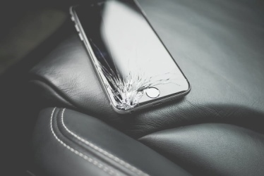
While smartphones continue to get increasingly sophisticated and resilient, the same cannot be said about the display screen. The Gorilla Glass cover used for most high-end cell phones tends to shatter easily, leaving owners with little choice but to pay for an expensive replacement screen or buy a new device altogether. However, this issue may soon be a thing of the past thanks to a new self-healing, Wolverine-inspired material which automatically repairs itself within 24 hours.
Dr. Chao Wang, the leading researcher of the UC Riverside team who developed the material, says, “When I was young, my idol was Wolverine from the X-Men. He could save the world, but only because he could heal himself. A self-healing material, when carved into two parts, can go back together like nothing has happened, just like our human skin. I’ve been researching making a self-healing lithium ion battery, so when you drop your cell phone, it could fix itself and last much longer.”
Cell phones with self-healing technology is not a new concept — the LG smartphone model G Flex 2, released in 2015, already has a self-healing back panel which can repair everyday scratches within minutes. However, the material is held together by hydrogen bonds that are unable to conduct electricity and hence unsuitable for display screens, given that most smartphones rely on a grid of electrodes underneath the screen. When the human finger touches the screen, a tiny electrical charge transfers to the finger to complete the circuit and tells the phone what you are trying to accomplish.
To overcome the shortcoming, the UC Riverside team turned to a different kind of chemical bonding. Called ion-dipole interaction, it is a type of intermolecular force between fully charged ions and partially charged polar molecules. For their self-healing material, the researchers selected salt ions and a transparent polymer that can be stretched to 50 times its normal size.
To see if it worked, the scientists tore it in half. Sure enough, the dynamic bond between the ions and polymer molecules caused the torn parts to align themselves back to their original configuration within a day.
To test the material’s conductivity, the researchers created an “artificial muscle” by placing a non-conductive membrane between two layers of the newly created material. When an electric current was applied, the “artificial muscle” responded by moving, similar to how the human bicep moves upon receiving a signal from the brain.
The team now plans to work on improving the properties of the polymer so that is it durable even when exposed to harsh external conditions such as high humidity. According to Wang, previous self-healing polymers have not held up well when exposed to moisture, and therefore, not been useful for real-world applications. The optimistic researcher believes that self-healing cell phone screens will be a reality within just three years! We sure hope he is right!
Questions
1) Find the definitions to the following words: (6 marks)
Words | Definition
Resilient
Concept
Shortcoming
Align
Durable
Humidity

2) What is the purpose of this text? Tick one box. (1 mark)
- To inform the reader about scientific and technological developments that could
mean phone screens repair themselves.
- To entertain the reader with a fictional story about a self-healing phone.
- To persuade the reader to buy a new brand of phone with a self-healing screen.

3) Who is the intended audience for this text? Give two interests they may have. (2 marks)

4a) Look at paragraph 1. The author says smartphones tend to ‘shatter’ easily. What are the connotations of the word ‘shatter’? (1 mark)

4b) Why do you think the author chose the word ‘shatter’? What is the effect of the word?
(1 mark)

5) Read paragraph 2. Explain in your own words how Dr Chao Wang first came up with the idea for a self-healing smartphone screen. (1 mark)

6) Read the final paragraph. Unfortunately, this invention is not yet ready for the ‘real world’, explain in your own words why this product is unsuitable for use in its current state.
(1 mark)

Total: /13

- ______________________________________________________________________________________________________________________________________
- ______________________________________________________________________________________________________________________________________

- ‘shatter’ has connotations of ___________________________________________
______________________________________________________________________________________________________________________________________

- _________________________________________________________________________________________________________________________________________________________________________________________________________

- _________________________________________________________________________________________________________________________________________________________________________________________________________

- _________________________________________________________________________________________________________________________________________________________________________________________________________

Study Reveals Surprising Facts About Our Choice Of Emojis
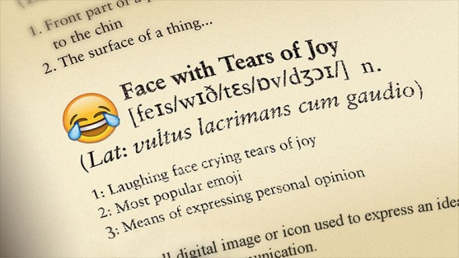
Though they have been around since the late 1990’s, emoji use has escalated sharply with the proliferation of smartphones. A survey conducted by digital start-up Swyft Media revealed that over six billion emoticons or stickers are sent around the world every day. The digital icons have become so ubiquitous that in 2015, the Oxford Dictionary selected the “Face with Tears of Joy” as its “word” of the year. Given their widespread use and popularity, it is not surprising that the tiny images are starting to intrigue researchers as well.
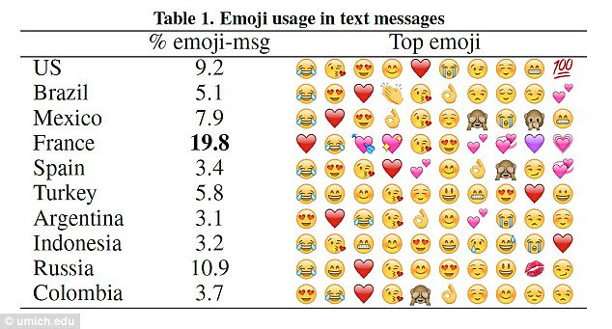
Recently, a team from the University of Michigan and Peking University analyzed 427 million messages sent by users in 212 countries to investigate the differences in emoji use by location and culture. The findings, published in the Journal Ubicomp, revealed that the French are emoji power users and included them in 19.7% of their texts. Though this may not seem like much, it is almost twice that of the second-place winner, Russia, where only 10.9% of the messages contained emojis. Americans came in a close third at 9.2%.
Also, though the ‘Face with Tears of Joy’ emoji handily wins the title as the most popular emoji, the romantic French appear to prefer the ❤. They are also more likely to use variations of the heart emoji, while the rest of the world prefers emojis depicting faces.
Not surprisingly, the study found that women tend to use emojis more extensively in their texts than men. However, they stick to a handful of favorites. Men, on the other hand, are more discerning and appear to go the extra length to find an emoji that matches the situation. But even so, like 90% of the world, they select from the top 119 of the 1,281 emojis available.
Though these findings were interesting, most intriguing was the conclusion that the emoji selection is influenced by societal environment. The researchers say that people living in countries like Australia and France with high levels of individualism – the belief that one person’s need is greater than that of a society or group – used happier emojis. Conversely, those from countries with closer-knit societies, like Colombia, were prone to using sad or angry emojis.
Also, cultures like Turkey and Russia, known for their self-discipline and restraint, appeared to be more content, at least according to the emojis. On the other hand, residents in high-indulgent cultures, like Mexico, seemed unhappy or dissatisfied.
The researchers believe that the findings of this “first large-scale analysis of emoji usage” will help develop input methods to create custom “next to use” suggestions and perhaps even expand our emoji vocabulary! Who knew that the tiny image we add to brighten up our texts could reveal so much about our culture?
Questions
1) Find the definitions to the following words: (6 marks)
Words | Definition
Escalated
Proliferation
Ubiquitous
Depicting
Societal
Individualism

- _______________________________________________________________________________________________________________________________________________________________________________________________________________
- _______________________________________________________________________________________________________________________________________________________________________________________________________________
- __________________________________________________________________________________________________________________________________________
- __________________________________________________________________________________________________________________________________________

2) What is the purpose of this text? Tick one box. (1 mark)
- To persuade the reader to use emoji’s in their text messages.
- To entertain and inform the reader with some interesting facts about emoji use.
- To inform the reader about the effects emoji use has on the human brain.

3a) Think about the intended audience for this article. Who do you think it is aimed at?
(1 mark)

3b) Give a reason for your answer. (1 mark)

4) Look at paragraph 4. Explain in your own words how men and women differ in their emoji usage. (2 marks)

5) Look at paragraph 5. Explain in your own words what the most surprising thing was about the study conducted. Refer to your table in question 1 to help you understand tricky words! (1 mark)

6) Name the technique used in the final line of this article. (1 mark)

Total: /13

- ______________________________________________________________________________________________________________________________________

- ______________________________________________________________________________________________________________________________________

- ______________________________________________________________________________________________________________________________________
- ______________________________________________________________________________________________________________________________________

- ______________________________________________________________________________________________________________________________________

- ______________________________________________________________________________________________________________________________________

Back-To-Back Mass Bleaching Decimates Australia's Great Barrier Reef
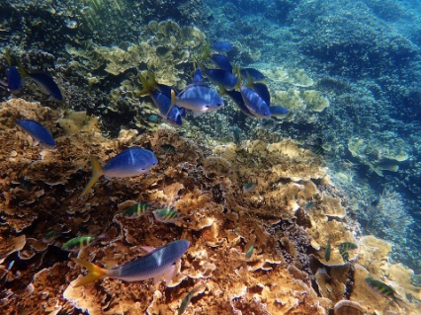
While U.S. President Donald Trump, who pulled out of the Paris climate agreement on June 1, is convinced global warming is a ‘hoax,’ the deteriorating condition of the world’s coral reefs seems to suggest otherwise. Often called “rainforests of the sea,” the incredible ecosystems that occupy less than 0.1 percent of ocean’s surface are home to almost 25 percent of all marine species. Unfortunately, the rising ocean temperatures caused by global warming are wreaking havoc on these fragile organisms.
As you may know, the colourful coral reefs that we all admire are calcium carbonate exoskeletons that provide shelter and protection to colonies of hundreds of thousands of tiny polyps that live and grow together. To survive, the animals have developed a symbiotic relationship with the coral. The coral polyps give the algae a home in exchange for the beautiful colours and nutrition. However, when ocean temperatures rise, the coral polyps lose both their food source and vivid colouring; phenomenon researchers refer to this as “bleaching.” While the tiny animals can recover from mild bleaching, they are unable to survive when it continues for an extended period.
Though the warmer temperatures are impacting coral reef systems worldwide, none have been as devastated as the Great Barrier Reef, that lies off the coast of Queensland, Australia in the Coral Sea. Over the past twenty years, the beautiful ecosystem that is home to over 1,500 species of fish has suffered through four mass “bleaching” events – 1998, 2002, 2016 and again in 2017.
In March and April 2017, the ecosystem suffered a mass bleaching event. The phenomenon is entirely attributed to warmer ocean temperatures caused by climate change. Current estimates peg the damage to 500 km (310 miles) of the central portion of the reef. Additionally, a report released on May 29 found that the 2016 damage was even worse than had been previously believed, impacting an astounding 29 percent of the 2,300 km (1,400 mile) long World Heritage site reef.
To make matters worse, tropical cyclone Debbie, which could have rescued the reefs by cooling the waters, not only came in late but also added to the destruction by causing structural damage to a section which had miraculously escaped the worst of the bleaching. Marine experts say almost half of the reef is now "extremely" bleached, and 91 percent shows at least some signs of bleaching.
Given that it takes more than a decade for the bleached corals to be re-colonized by the algae after the water temperatures return to normal, researchers believe it is unlikely that the Great Barrier Reef will ever fully recover. Great Barrier Reef Marine Park Authority (GBRMPA) Chairman Russell Reichelt says, "We're very concerned about what this means for the Great Barrier Reef itself and what it means for the communities and industries that depend on it."
While local measures such as preventing water pollution and restricting port development can help, they are not enough to save the reef, which is already under extreme heat stress. The only solution, therefore, is a global action to reduce greenhouse gas emissions by curbing fossil fuel burning, something that the 194 countries still part of the Paris climate agreement have vowed to do. If they do not live up to their promise, we may become the only generation in history to have witnessed both the beauty and death of the largest living structure on Earth – the Great Barrier Reef!
Questions
1) Find the definitions to the following words: (3 marks)
Words | Definition
Hoax
Deteriorating
Ecosystems

2) What is the purpose of this text? Tick one box. (1 mark)
- To inform readers about the damage being done to the Great Barrier Reef.
- To persuade the reader that more needs to be done to protect the Great Barrier
Reef.
- To inform readers about the damage being done to the Great Barrier Reef and
persuade the readers that more needs to be done to protect it.

3) Think about the intended audience for this article. Give two interests that a reader of this article might have. (2 marks)

4a) Look at paragraph 1. What is the name of the punctuation surrounding the word ‘hoax’.
(1 mark)

4b) Give two possible reasons why the writer uses this punctuation around the word ‘hoax’.
(2 marks)

5) Look at paragraph 2. Quote two words in the paragraph that show how the author’s affection towards the Great Barrier Reef. (2 marks)

6) Read paragraphs 4 and 5. Explain in your own words what are the two main causes of damage to happen to the barrier reef in the last few years. (2 marks)

Total: /13

- ________________________________________________________________________________________________________________________________________
- ________________________________________________________________________________________________________________________________________

- ___________________________________________________________________

- ________________________________________________________________________________________________________________________________________
- ________________________________________________________________________________________________________________________________________

- ____________________________________________________________________
- ____________________________________________________________________

- ________________________________________________________________________________________________________________________________________
- ___________________________________________________________________________________________________________________________________________

Results
Model Task | /13
Task One | /11
Task Two | /14
Task Three | /9
Task Four | /11
Task Five | /12
Task Six | /17
Task Seven | /18
Task Eight | /13
Task Nine | /13
Task Ten | /13
Overall Total | /144
pupil Target Setting


