
Rosshall Academy
Homework Tasks
Grammar


Name: _______________________________
Class:

_______________________________


Contents
 | Page
Task 1 - Nouns | 3-5
Task 2 - Adjectives | 6-8
Task 3 – The ‘Helping’ Verb | 9-10
Task 4 – Adjectives and Adverbs | 11
Task 5 – The Apostrophe | 12-14
Task 6 – To, Too, Two | 15
Task 7 – No, Know, Now | 16
Task 8 – The Conjunction | 17-18
Task 9 – It’s and Who’s | 19
Task 10 – You’re and Your/There’s and Theirs | 20


Task 1 - Nouns

A Noun is the name of any person, place, animal or thing.
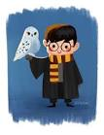
- Proper Nouns
A proper noun is the name of a particular person, animal, place or thing.
Proper nouns always have a capital letter.
For example: William Shakespeare Glasgow Harry Potter

Activity A
There are 10 proper nouns in the box. Write them correctly in the blank spaces
below.

wayne rooney ship box paris flu japan bicycle
dog glasgow edinburgh castle glass river kelvin cage
scotland computers grass world cup robert burns
sunshine coffee buttons queen elizabeth pizza

______________________________ _______________________________
______________________________ _______________________________
______________________________ _______________________________
______________________________ _______________________________
______________________________ _______________________________


2. Collective Nouns

A collective noun is a noun that groups things together.
For example: a herd of cows
a choir of angels

Activity B
Here is a list of collective nouns.
Write the correct noun from the box in the blank spaces.

flowers players books sailors bees soldiers

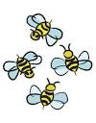
- an army of __________________
- a team of ___________________
- a crew of ___________________
- a library of __________________
- a swarm of __________________
- a bouquet of _________________

Choose a collective noun from the box to go with each of the groups in the list below.

class warehouse orchard pack hanger basket

- a ________________ of apple trees.
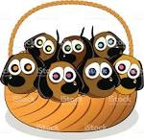
- a ________________ of puppies
- a ________________ of furniture
- a ________________ of wolves
- a ________________ of pupils
- a ________________ of aeroplanes

3. Abstract Nouns
Abstract nouns are the words for all feelings, thoughts and ideas. They are things that you cannot see, touch or hear.

For example: sadness anger friendliness

Activity C
You can make some abstract nouns by adding the letters ‘-ness’ to the end
of a word.

For example: happy - happiness

Make the following into abstract nouns by adding ‘-ness’

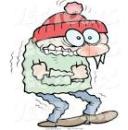
1. kind - __________________________
2. short - __________________________
3. sad - __________________________
4. smooth - __________________________
5. cold - __________________________
6. clever - __________________________

Complete the sentences below by using one of the abstract nouns from the box.
beauty cleverness skill dishonesty courage

1. The thief was accused of ____________________________
2. The hero was known for his _________________________
3. The diamond ring was well known for its _______________
4. The footballer was famous for his _____________________
5. The teacher praised the pupil for his ___________________

Total: /33


Task 2 – Adjectives
1. An adjective is a word that we use to describe something.

For example: a stormy sea a thin man an angry dog

Activity A
Underline the adjectives in the sentences below.
The first has been done as an example.

- The sky was blue and there were fluffy, white clouds.
- The dazzling sun shone in the bright sky.
- The sea was grey and enormous waves shook the tiny ship.
- The fields were green with the new grass in early Spring.
- Tall trees and thick hedges surrounded the ruined castle.
- Heavy rain fell on the dark, shining streets in the old town.
- The elegant woman wore high heels and a smart designer suit.
- Billy was a dreadful child – wild, cunning and dangerous.
- The Queen’s necklace had dark red rubies, and dazzling diamonds.
- The 1970s school was in a bad state with rotting window frames and dull, depressing corridors.

Write 3 short sentences about this picture. Each sentence must contain an adjective.

1) ________________________________
____________________________________________________________________
2) _________________________________________________________
___________________________________________________________3) _________________________________________________________
___________________________________________________________
2) Comparative of Adjectives

We use these adjectives to compare two people or things.

For example: Katie is taller than Eilidh.

There are 2 ways of turning an adjective into a comparative:
1) Add the letters ‘–er’ to the end. For example: tall – taller.
2) Put the word ‘more’ in front of the adjective. For example: interesting – more interesting

Activity B
Write the comparative of the adjectives below. You will have to either add ‘–er’ to the end or put ‘more’ in front.

Hard _____________________
Helpful _____________________
Loud _____________________
Cool _____________________
Kind _____________________
Relaxed _____________________

Few _____________________
Fast _____________________
Old _____________________
New _____________________
Different _____________________
Small _____________________
Important _____________________
Popular _____________________
Beautiful _____________________
Smooth _____________________

3. Superlative of Adjectives

The superlative adjective is used to compare one thing with all other things.

For example: Aidan is tall but James is the tallest in the class.

There are 2 ways to make the superlative of an adjective.
1. Add the letters ‘-est’ to the adjective.
For example: small - smallest

2. Put the word ‘most’ in front of the adjective.
For example: beautiful - most beautiful

Activity C
Write the comparative of the adjectives below. You will have to either add ‘–est’ to the end or put ‘most’ in front.

Fast ______________________
Old ______________________
Helpful ______________________
Big ______________________
Loud ______________________
Important ______________________
New ______________________
Hard ______________________
Modern ______________________
Small ______________________
Kind ______________________
Cool ______________________
Few ______________________
Popular ______________________
Different ______________________
Relaxed ______________________

Total: /42

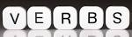
Task 3 – The ‘Helping’ Verb


A verb is a word that tells you what someone did.

For example: Callum walked through the park.

Some verbs are made up of more than one word.
For example: Emma was walking with Angus.

The extra word is called a ‘helping’ verb because it helps us to know more clearly what happened.

Activity A
Choose the correct ‘helping’ verb from the box to complete the sentences below.


- We _________ all talking at once.
- You ________ able to work alone.
- The girls ________ come to see you.
- I _____ not have to do the dishes.
- They ________ stay as long as they liked.
- I _________ not go to the club tomorrow.
- We ________ watch television tonight.
- I ______ not seen the film before.
- They __________ always be on time.
- We ________ not be late for school again.
- I _______ thinking about school.
- They _________ play chess if they knew how.

will could are would had do should am might
were have can


Saw, Seen / Did, Done

Saw and Seen
The word ‘saw’ can be used on its own in a sentence.
For example: Peter saw the tennis match.

The word ‘seen’ cannot be used alone in a sentence. It has to have a helping verb with it.
For example: Peter has seen the tennis match.

Activity B
Fill in either saw or seen in the five sentences below.
- David and I __________ that film last week.
- Both of us had __________ it before you did.
- I ________ you at the disco.
- You were also ___________ by Lauren.
- David _________ us before we had __________ him.

Did and Done
The word ‘did’ can be used on its own in a sentence.
For example: Peter did the maths homework.

The word ‘done’ cannot be used alone in a sentence. It has to have a helping verb with it.
For example: Peter has done the maths homework.
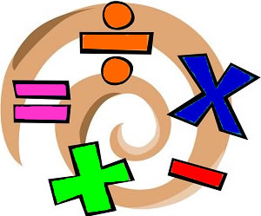
Activity C
Fill in either did or done in the five sentences below.
- Zoe __________ the work by herself and ________ it well.
- After she had ________ the work, she went out.
- We _________ the shopping quickly.
- I have _____________ my work early this week.
- I think I have __________ better in the test this week.

Total: /24

Task 4 – Adjectives and Adverbs

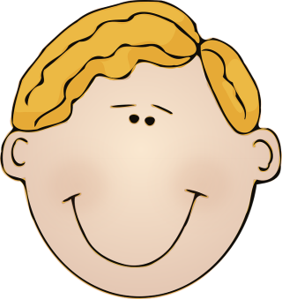
An Adjective is a word that tells you more about a noun
(person, place, animal or thing).

Examples of Adjectives
Hannah is a bad girl. (Bad tells you more about Hannah.)
Aidan is a good boy. (Good tells you more about Aidan.)

An Adverb is a word that tells you more about how
something was done. Adverbs go with verbs (doing words).

Examples of Adverbs
Hannah did her work badly. Badly tells how how Hannah did her work.
Aidan did his work well. Well tells you how Aidan did his work.

Activity A


Write adjective or adverb in the space after each sentence.

1. Stephanie plays the piano badly. _________________

2. Olivia is a tall girl. _________________
3. Robert is feeling angry. _________________
4. Jack is a brilliant footballer _________________
5. Amy does her maths properly. _________________
Choose an adjective or an adverb from the box to complete the sentences below.
loudly
new
beautifully
busy
noisily
clearly
modern

1. The teacher sings ________________.
2. The boys play ________ in the playground.
3. The school is ________ and __________.
4. We like people who speak ____________.
5. Mum and Dad are very __________ today.
6. John played the trumpet _________.
Total: /12
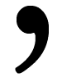
Task 5 – The ‘Shortening’ Apostrophe

Sometimes when we speak we shorten what we say.

For example, we don’t usually say “I am …”.
We shorten it to “I’m …”.

When we write this, we put the two words together and put an apostrophe in instead of one (or sometimes two) of the letters.

I am We are They are are not
I ‘ m We ‘ re They ‘ re aren ’ t

Some other shortened words are:
you are - you’re is not - isn’t who is – who’s
has not – hasn’t was not – wasn’t you have – you’ve
cannot – can’t will not – won’t how is – how’s

Activity A
Write the long version of these shortened words:
1. they’re ______________________
2. can’t ______________________
3. she’s ______________________
4. haven’t ______________________
5. weren’t ______________________

Write the short version of these:

1. is not ______________________
2. he is ______________________
3. you are ______________________
4. they have ______________________
5. I have ______________________

Activity B
Copy the conversations below, shortening all the phrases in bold type by using an apostrophe. The letters that you miss out are underlined.

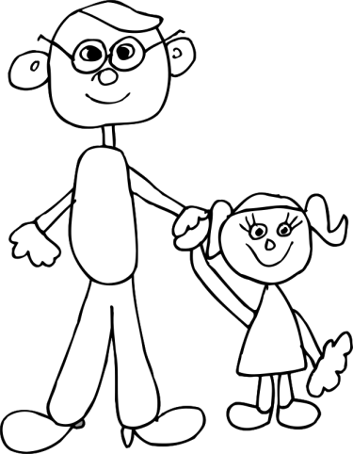
Example He is coming at six o’clock.
He’s coming at six o’clock.

Dad: Where have you been, Alex? We have
been looking for you everywhere!

Alex: I have been to the garden shed because
I am trying to be late for school.

Dad: That is enough cheek! Say you are sorry!

Alex: All right. I am sorry. I do not mean to be cheeky.

Dad: Let us go then or we will be late again!

Dad: ____________________________________________
____________________________________________
Alex: ____________________________________________
____________________________________________

Dad: ____________________________________________
Alex: ____________________________________________
Dad: ____________________________________________

The ‘Ownership’ Apostrophe

You use an apostrophe with an s (‘s) to show that someone or something owns something.

For example:
Rover is Tom’s dog. Richard’s pen is broken.
The restaurant’s food is awful. The hut’s roof is leaking.

Activity C

Re-write these sentences as in the example below to
show that someone owns something.

Example: The feathers of the bird are blue.
The bird’s feathers are blue.

- The car of the teacher is parked in the street.
_____________________________________________
- The bag that John has is blue and white.
______________________________________________
- We don’t like the food of this café.
______________________________________________
- The headmaster of the school is called Mr. Green.
______________________________________________
- The sister of the girl is younger than she is.
______________________________________________
- The captain of the team is called Paul Turner.
______________________________________________

Total: /26
Remember: If your homework task takes you less than 30 minutes – dedicate the remaining time to reading a chapter of your personal reading book!

Task 6 – To, Too, Two

To is the little word that fits into sentences.
’I want to go to town this Saturday to do my shopping at a quarter to nine’.

Too is used to emphasise something. Too can mean ‘also’
’We always get too much homework and it is too difficult.’
Two is the number 2.
‘I want two mugs of coffee, please.’

Activity

Fill in either to, too or two in the sentences below.

- I am going _____ see Manchester United play Manchester City on Saturday.
- I want _____ see that match. Can I come _______?
- Yes, if you want _____. I’ll get _____ tickets.
- Manchester United won their last _____ games by _____ clear goals.
- Manchester City are a good team _____ but they will have _____ improve a lot if they are going _____ beat United.
- No! Manchester United is much _____ good a team for that!
- Don’t you believe it! Manchester United will be number _____ again!

Fill in either to, too or two in the story below.

“Why do you have _____ go _____ ______ meetings in the same evening?” Jane asked her husband.
”It was just how it worked out” replied Jack. “Why is it such a problem _____ you?”
“I want _____ go out and I can’t find a baby-sitter,” said Jane. “It is _____ bad that you’ve make such a poor arrangement. I have only _____ evenings left before I have _____ go _____work on the night shift at the hospital”.

Total: /21
Task 7 – No, Know, Now


Examples:
No I’ve got no idea.
Know I don’t know the answer.
Now I’m going out now, not later this evening.

Activity
Put either no, know or now into the blank spaces in the sentences below.

- __________ person is allowed to go into that room.
- I want to watch television __________.
- I did not __________ all the answers to the quiz questions.
- I don’t want you to talk to me, _______ or ever again.
- The notice on the door said ‘________ Entry’.
- The football match is on the television ___________.
- Do you __________ who won?
- ________ I don’t ___________ but I’ll find out.
- When should I finish my homework, ________ or later?
- I’ve said before that I don’t ________ how to draw figures.

Total: /11

Task 8 - The Conjunction

A conjunction is a word that you use to join two sentences together.
Some conjunctions are:
- and
- because
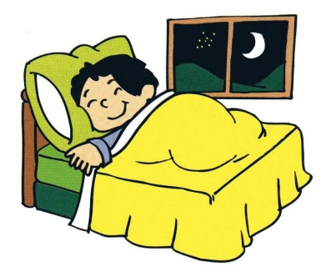
- but
- so
- since

Examples:
Kate came home late last night. She went straight to bed.
Kate came home late last night and went straight to bed.
She went straight to bed. She was very tired.
She went to bed because she was very tired.

Activity A
Join the sentences below together using one of the conjunctions on the list above.
- Jake was chosen for the team. He was a very good player.
_______________________________________________
- He was a striker. The manager put him in goals.
_______________________________________________
- Jake was not happy. He wanted to score goals.
_______________________________________________
- He spoke to the manager. He was allowed to play up front.
_______________________________________________
- Jake was much happier now. He scored lots of goals for the team.
_______________________________________________


Choosing the Conjunction

There are lots and lots of conjunctions.
Conjunctions are words that are used to join sentences together.

More Conjunctions:

Yet for until or nor although
if because since where unless so
then when while before after whether
as and

Activity B
Use one of the conjunctions in the box in each of
the blank spaces below.

- Jamie asked the teacher for a pencil sharpener ___________ he had forgotten his own.
- Sam could not get any pudding __________ he had eaten all his vegetables.
- __________ Billy did his experiment he cleaned up.
- _____________ Katie usually likes P.E. she did not want to do any last week.
- _______ you see Sally, tell her I want to speak to her.
- I can’t tell ____________ Charles likes this book or not.
- You cannot go to see the film ____________ you pay for the ticket now.
- Harry was too late for the football match ________ he watched the tennis instead.
- __________ she didn’t want to speak to her awful cousins, Marian went out with her friends.
- ____________ George and his family were having breakfast, a fire engine arrived outside.
Total: /15
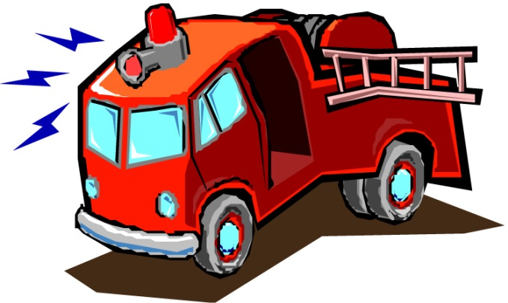

Task 9 - It’s and Who’s

It’s
It’s (with an apostrophe) means it is or it has.
Example It’s been a long, hard day.
Its (without an apostrophe) means belonging to it.
Example Its coat is dark and glossy.
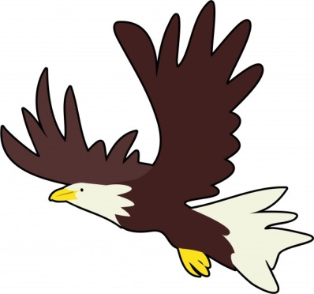

Activity A

In the sentences below, fill in either it’s or its.

- _________ time for us to go home.
- The dog chases __________ own tail.
- I think _________ an eagle.
- ___________ got long feathers and a strong beak.
- _________ claws look dangerous.

Who’s
Who’s (with an apostrophe) means who is or who has.
Example: Who’s got a good job?
Whose (no apostrophe and an e at the end) means belonging to who.
Example: Jake is a boy whose clothes are always dirty.


Activity B
In the sentences below, fill in either who’s or whose.

- I know _____________ coming to the party.
- _____________ bag is this?
- _____________ got a joke they can tell us?
- Can you tell me ______________ marks were best?
- _____________ right and _____________ wrong?
Total: /11
Task 10 - You’re and Your / There’s and Theirs

You’re and Your
You’re (with an apostrophe and an e at the end) means You are.
Example: You’re going to be late!

Your means belonging to you
Example: Your glasses are in your pocket!

Task
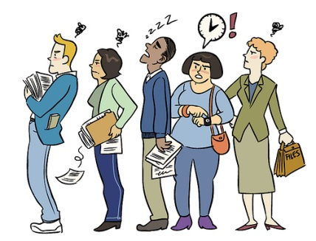
Fill in either you’re or your in the sentences below.
- _____________ in a hurry today!
- I haven’t seen _____________ homework yet.
- Where is ____________ P.E kit?
- I don’t know what _____________ doing.
- _____________ next in the queue.

There’s and Theirs
There’s (with an apostrophe) means there is or there has.
Example There’s a cold wind tonight.

Theirs (different spelling and no apostrophe) means belonging to them.
Example I’ve seen my bicycle but I haven’t seen theirs.

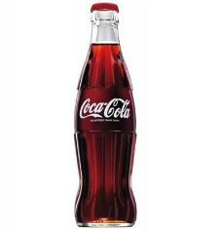
Task
Fill in either there’s or theirs in the sentences below.
- _______________ no time to play any more.
- These sweets are not ______________.
- I’ll do my homework and they can do _____________.
- I don’t think _____________ any Coke left.
- _____________ been an accident in the town centre.
Total: /10
Results
Task One | /33
Task Two | /42
Task Three | /24
Task Four | /12
Task Five | /26
Task Six | /21
Task Seven | /11
Task Eight | /15
Task Nine | /11
Task Ten | /10
Overall Total | /205
pupil Target Setting


