Rosshall Academy

National 5

Practical Metalwork

Worksheets

Signs

Identify the following types of signs and their purpose.

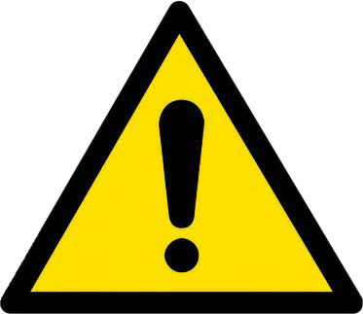
Identify the type of sign.

Colours: Yellow, black and white. Shape: Triangle.
Explain the purpose of this sign type.

Identify the type of sign. Colours: Blue and white.
Shape: Circle.
Explain the purpose of this sign type.

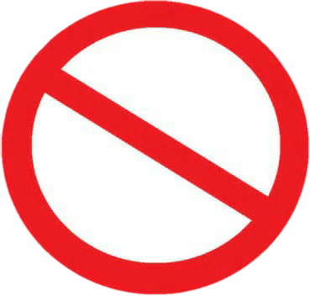
Identify the type of sign. Colours: Red, black and white.
Shape: Circle.
Explain the purpose of this sign type.

Identify the type of sign. Colours: Green and white.
Shape: Rectangle or square.
Explain the purpose of this sign type.

PPE

What does PPE stand for?

Why do we use PPE?

Identify the PPE and its purpose in the table below.

PPE | Name | Purpose
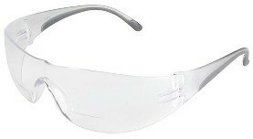

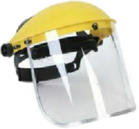
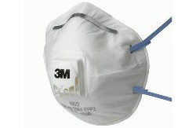
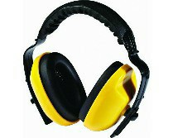
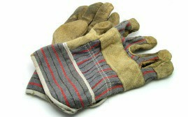
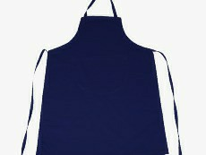

Metal

Complete the table shown.
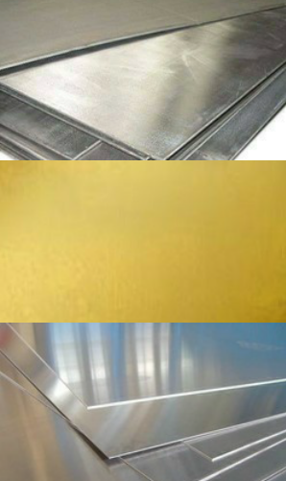
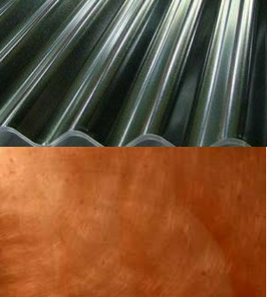
Metal Ferrous/Non Ferrous Properties

Steel

Brass

Aluminium

Iron

Copper

Silver

TIn

Metal Classification

All metals are either pure metals or alloys Name the 2 classification groups of metal.

Explain the difference between these two classifications.

Explain what a pure metal is.

State two examples of pure metals.

Explain what an alloy is.

State two examples of alloys.

Metal Forms

Metal can be supplied in different forms, identify the forms shown below and next page.
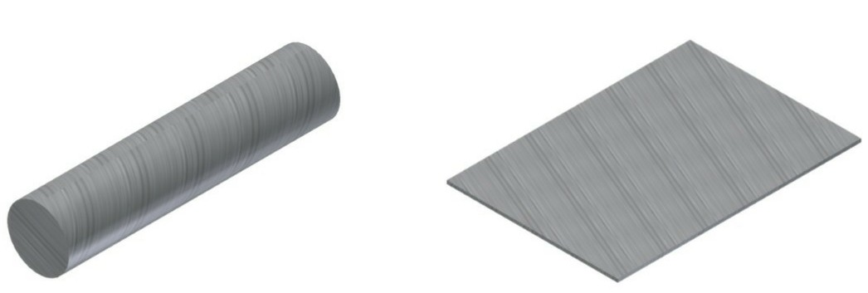

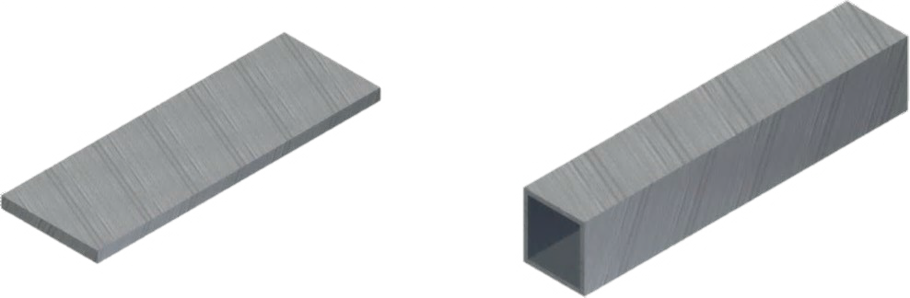
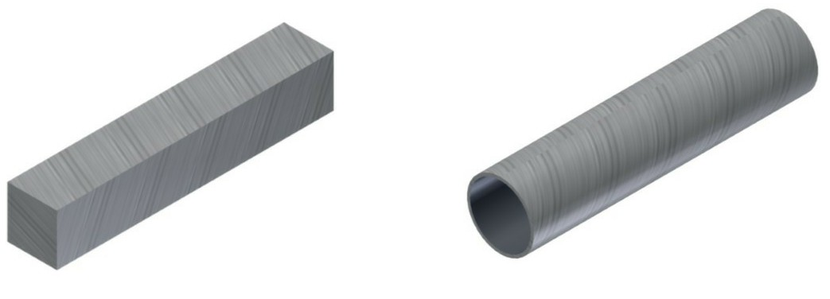

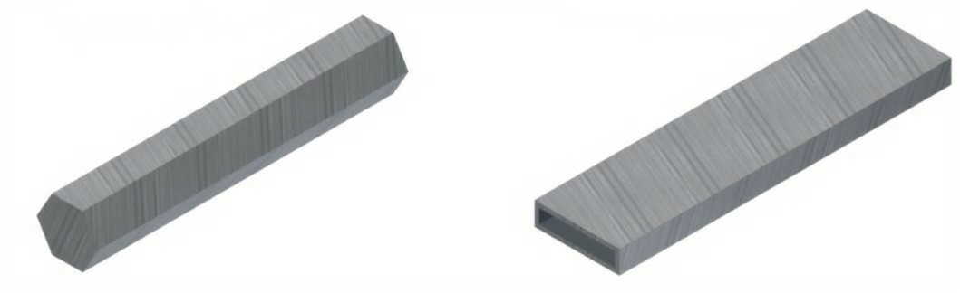

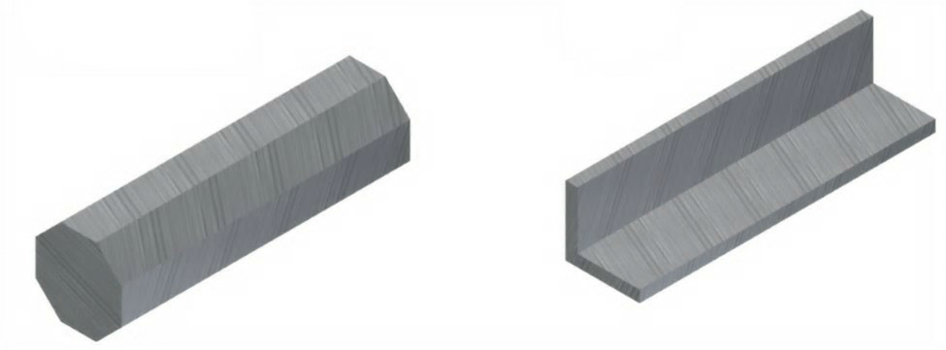

Steel Rule

A steel rule is used for marking out.

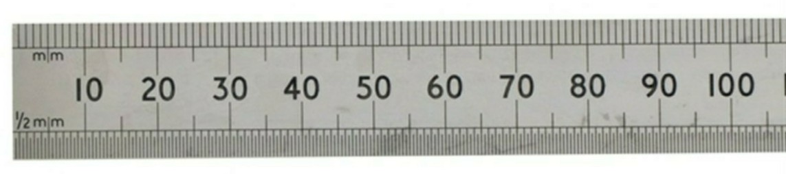

What units does a steel rule use?

Describe the difference between a steel rule and a ruler.

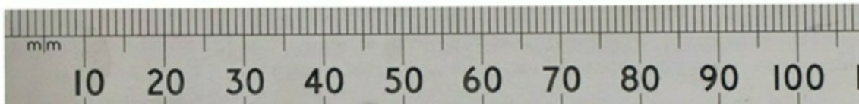
Identify the measurements shown below.

Measure the length of the lines below using a steel rule.

D D D
D

D D

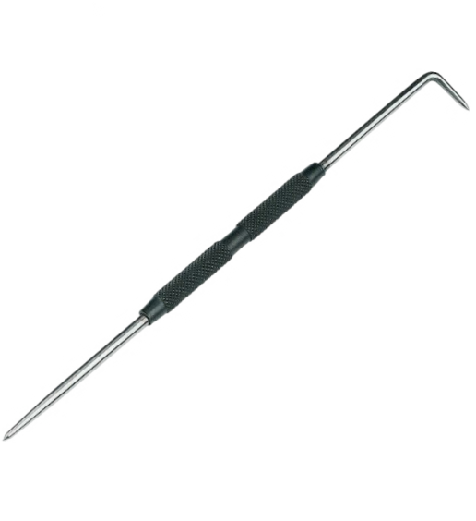
Scriber

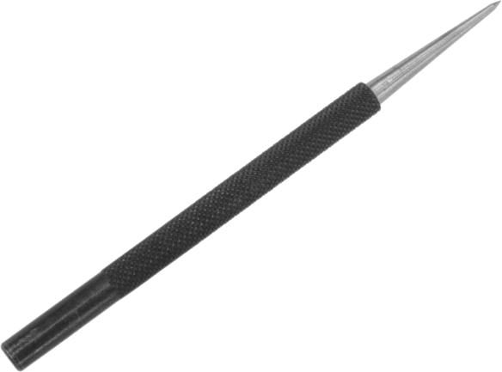
Scribers are shown below.

The purpose of this tool is

What do you apply to metal, to create contrast, to allow marks to easily be seen.

Explain the advantage of using a scriber instead of a pencil or pen to mark out.

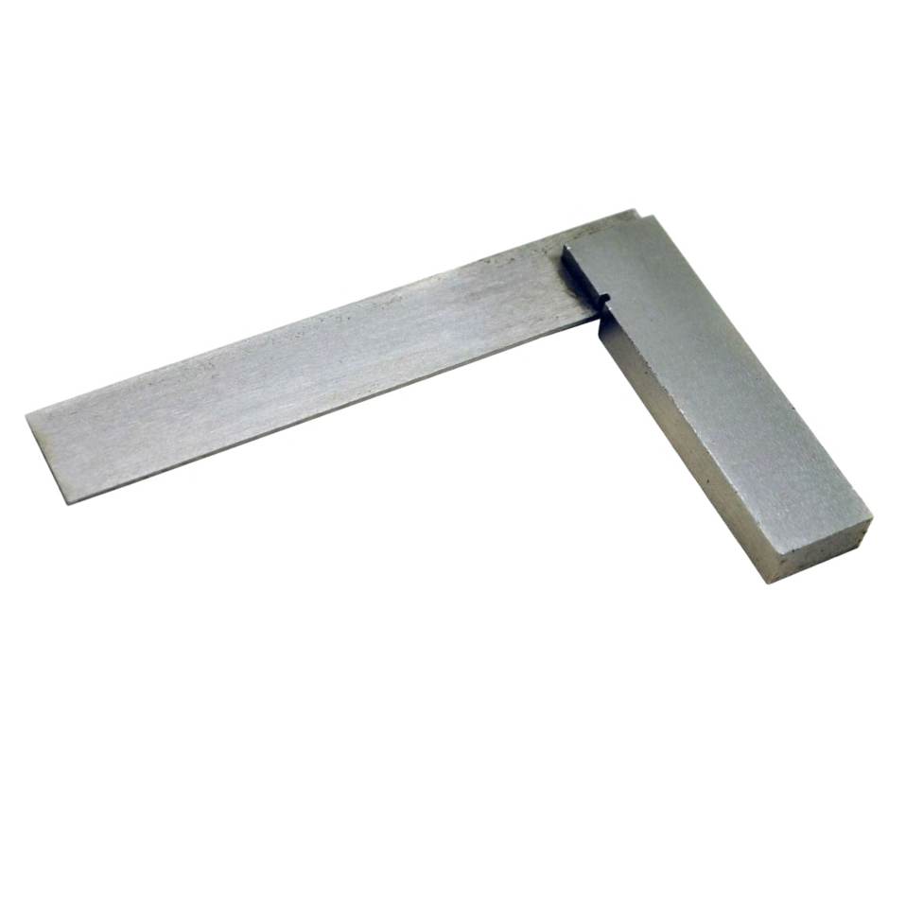
Engineers Square

Engineers square is shown.

Describe the purpose of this tool.

Describe how you would use an engineers square to mark out a 12mm line to the edge. You may use sketches to support your answer.

Odd Leg Callipers

Odd Leg Callipers are shown.
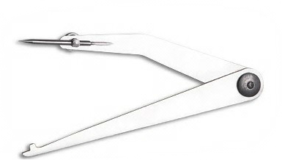

Describe the purpose of this tool.

State the name these callipers are also known as.

Describe what checks you should carry out prior to using these callipers.

Describe two adjustments which can be made to these callipers.

Describe how you would use these callipers to mark out a 7mm line from the edge. You may use sketches to support your answer.

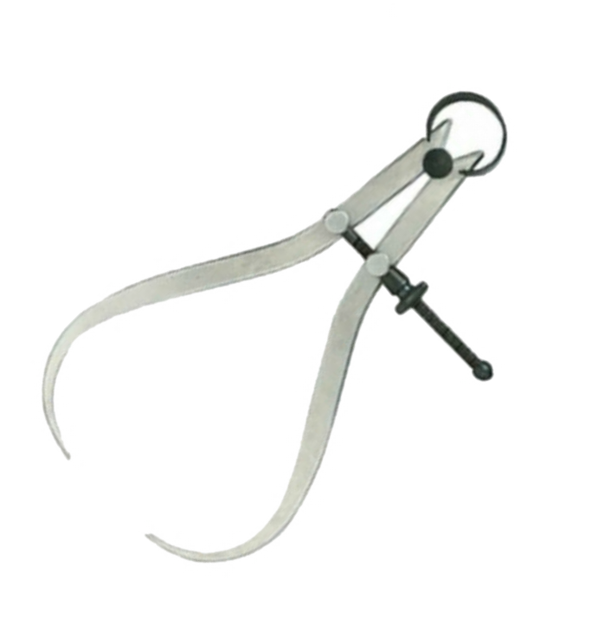
Callipers

Knowledgeable

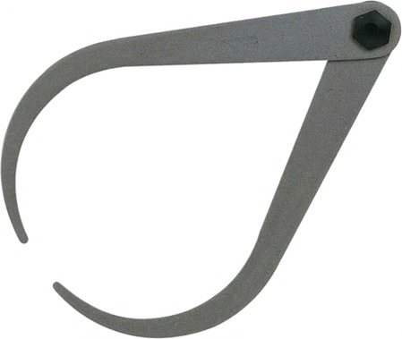

A B

State the name of the tool above

Describe the purpose of the tool.

Describe why using B would be preferred instead of A.

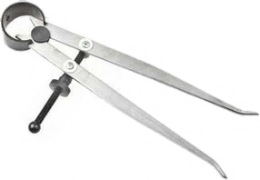

State the name of the tool above

Describe the purpose of the tool.

Describe how you could set this tool up for a 9mm diameter, state all tools required.

Vernier Callipers

Identify the two types of Vernier callipers shown below.

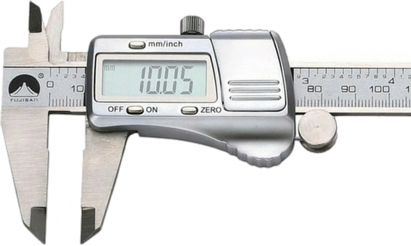
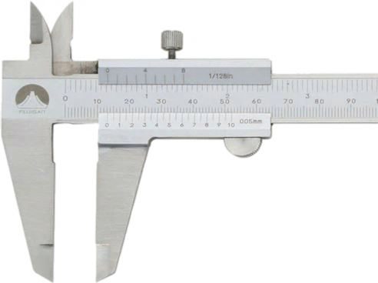

Describe the purpose of the Vernier callipers.

State an adjustment that could be made to this tool to ensure consistency

Reading vernier calliper.
Jaws for measuring inner dimensions

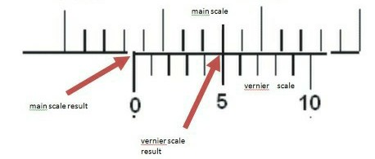
Screw clamp Stem for measuring depths

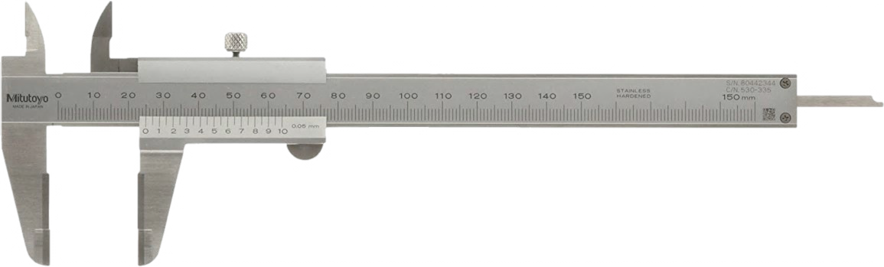

Vernier scale

Jaws for measuiring outer dimensions 0mm
Main scale

Main scale

10mm

Vernier scale

- Read the main scale.
- Read the Vernier scale which matches.

Main scale result

Vernier scale result

Micrometer

Shown below is a micrometer.

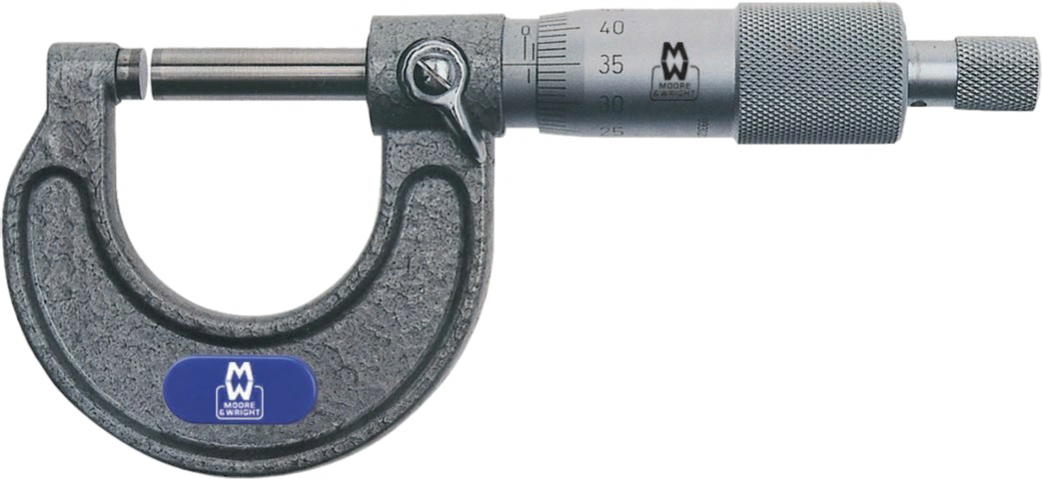

Describe the purpose of the micrometer.

State an adjustment that could be made to this tool to ensure consistency

Reading a micrometer.

Millimetre gauge

½ millimetre gauge

- Read the whole millimetre first.
10th
and 100th
mm micrometer gauge

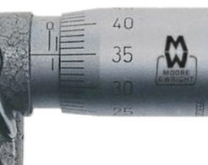
- Read ½ millimetre gauge.
- Read the 10th and 100th gauge.
If the reading is past the ½ mm mark for the reading you need to add 50 to the total after the decimal.

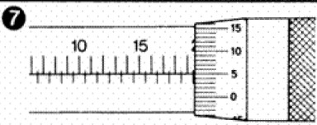
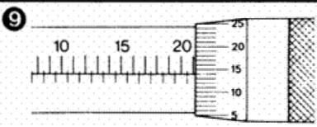
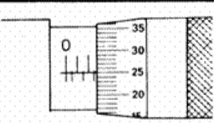

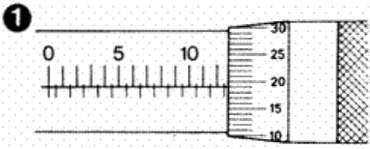 | 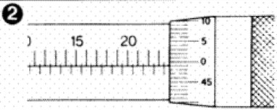
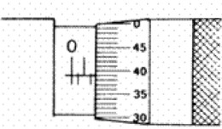 | 0 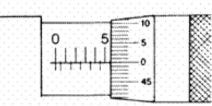
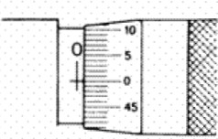 | 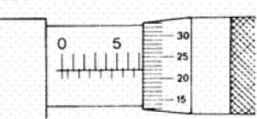
 | 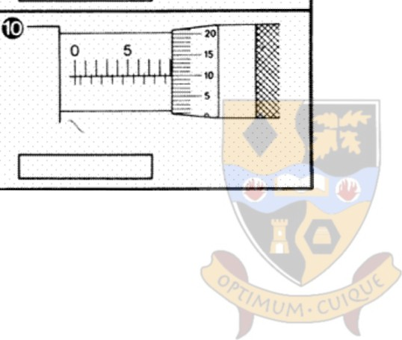

Spring Dividers

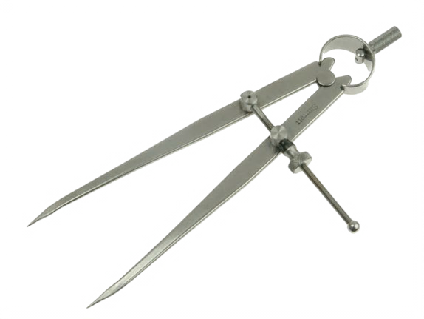
Spring dividers are shown below.

Describe the purpose of this tool.

Describe what checks you should carry out prior to using this tool.

Describe an adjustment which can be made to this tool.

Describe how you could avoid ‘slipping’ when using this tool.

Describe how to use this tool to mark out a Smm curve on four corners of a steel plate. You may use sketches to support your answer.

Centre Punch

A centre punch is shown below.
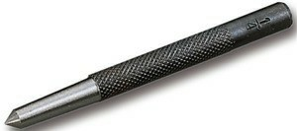
Describe the purpose of this tool.

Explain how this tool is different from a scriber.

When using this tool, what type of surface should be under your metal.

Describe how to use this tool before drilling a hole in metal. You may use sketches to support your answer.

Drill Bits
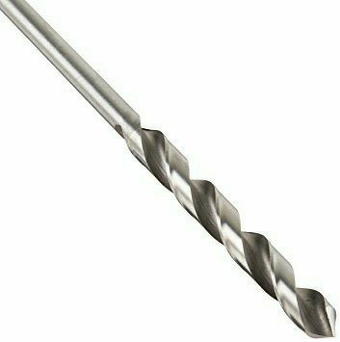

State the type of the drill bit above Describe the purpose of the tool.

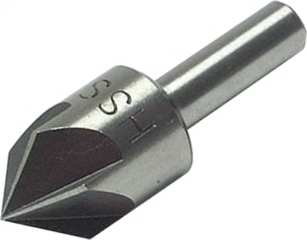
State the type of the drill bit above Describe the purpose of the tool.

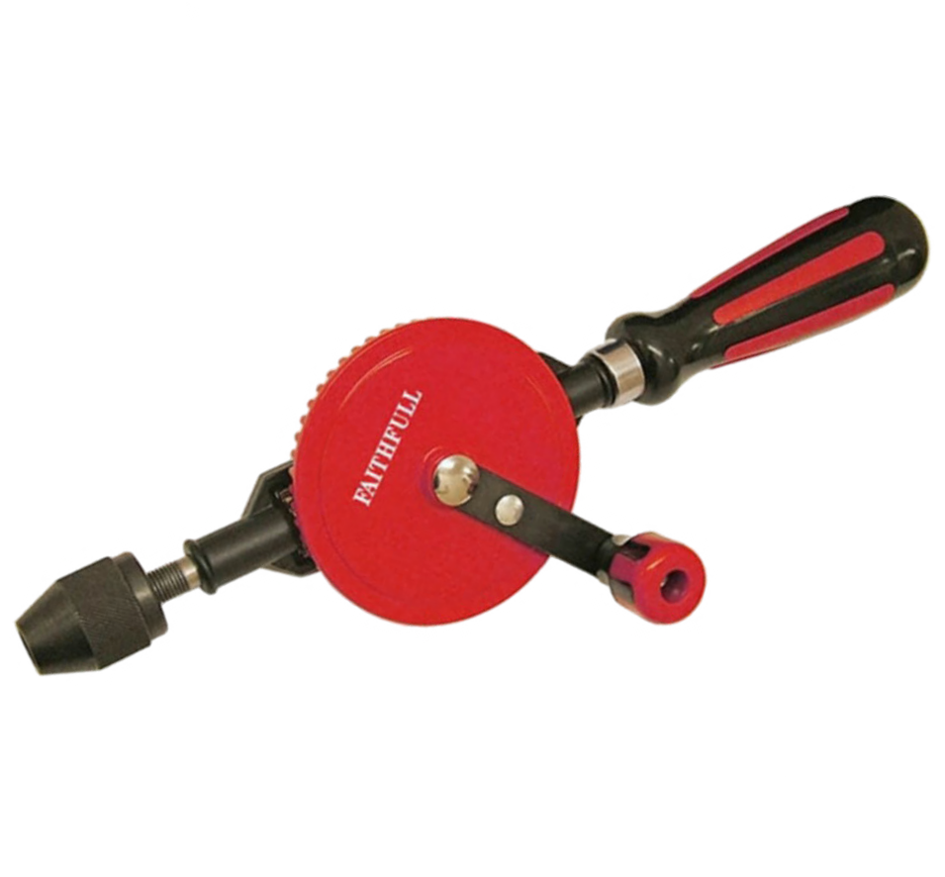
Hand Drill

State the other name this hand drill is known as.

Skil

Describe the purpose of this tool.

Describe what safety checks you would need to carry out prior to using this tool.

Briefly explain how to use this tool to drill a hole to 5mm.

Saws

Identify the type of saw shown

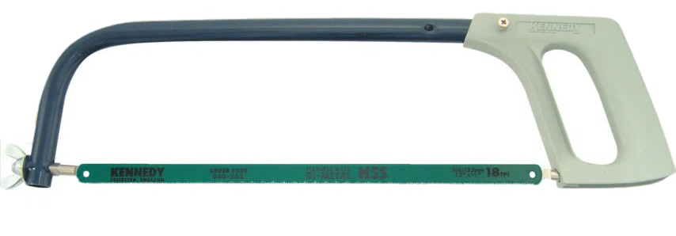
The purpose of this tool is

Describe how you would change and secure the blade.

Which direction should the teeth face.

State three health and safety considerations to observe when using this tool.

Identify the type of saw shown

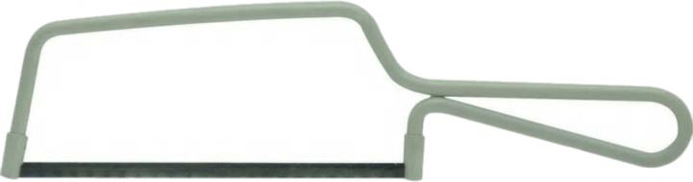

The purpose of this tool is

Describe how to change and secure the blade.

Which direction should the teeth face.

State three health and safety considerations to observe when using this tool.

Tin Snips

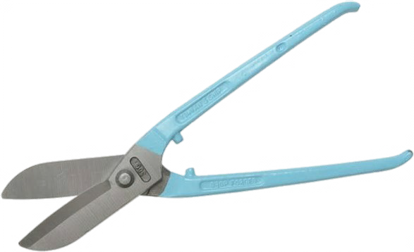

The purpose of this tool is

State the two forms the blade can come in.

Describe how you would use tin snips to cut out a circle.

Files

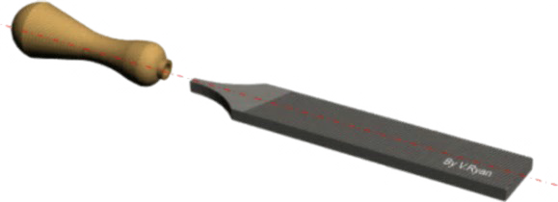
Identify the parts of the file.

Word Bank Tang
Blade Handle Safe Edge
The purpose of a file is

Identify the types of files shown below with their blade section.

A.

B.

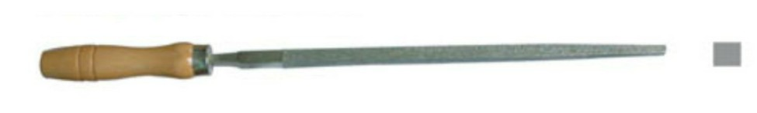
C.

D.

E.

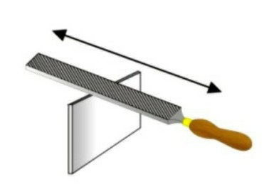
If a file has a loose or missing handle, should you use it.

Describe any safety considerations when using a file.

State the name of this type of filing.

State the purpose of this type of filing.

State the name of this type of filing. 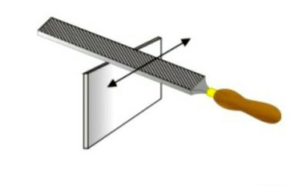 State the purpose of this type of filing.

State the term used to describe waste material clogging the file teeth.

State the name of the tool used to clean the file.

State the purpose of the safe edge.

V Block

Shown below are a couple of V Blocks.
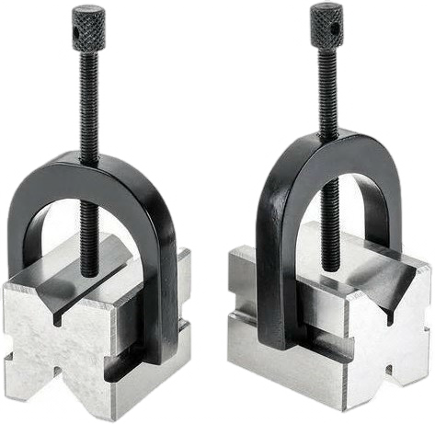

Explain the purpose of the V Block.

Describe how you could use this to drill a 6mm hole in a round bar.

Drilling

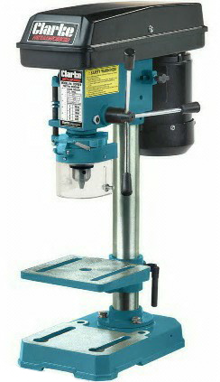
State the name of the drill shown above.

The purpose of this tool is

Explain why the surrounding floor area should be kept free from debris.

State an adjustment which could be made to this tool.

Describe three health and safety checks which must be carried out prior to drilling.

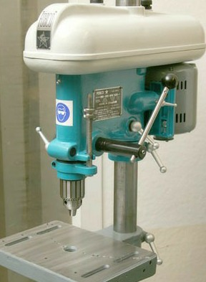
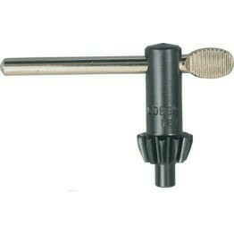

B A

State the name of the part shown at A.

State the name of the tool shown at B.

The purpose of tool B is

Describe two ways you could set your desired depth when drilling.

How could you ensure your material is secure.

What PPE is mandatory with this machine.

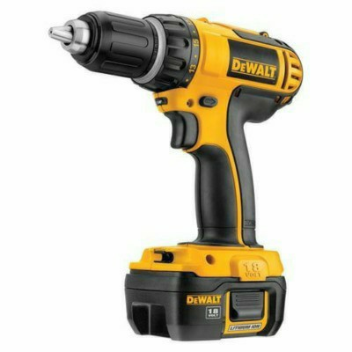
State the name of the drill shown above.

State an advantage of this drill.

What type of power does this drill require.

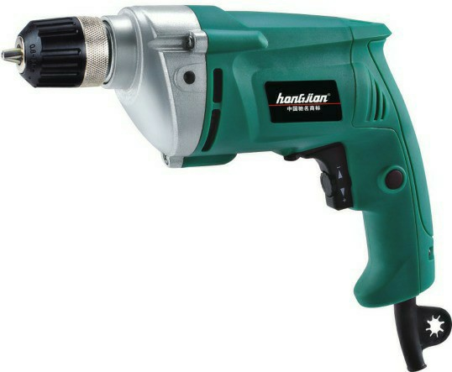
State the name of the drill shown above.

State a disadvantage of this drill.

What type of power does this drill require.

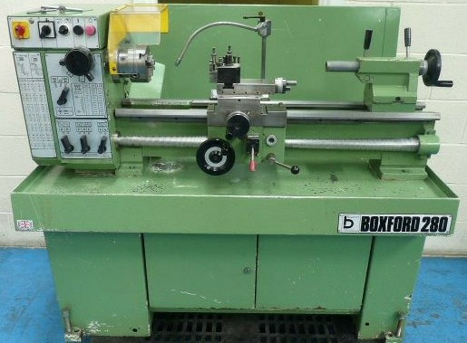
Centre Lathe

State the name of the machine shown above. The purpose of this machine is

What PPE is mandatory using this machine.

Identify the parts below. Word Bank

Tail stock

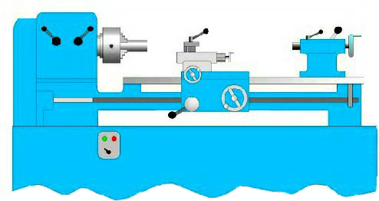
3 Jaw Chuck Tool Post Gear Box Head Stock Cross Slide Saddle
Bed

Apron Wheel Compound Slide

State two checks which need to be carried out prior to using this machine.

ool.

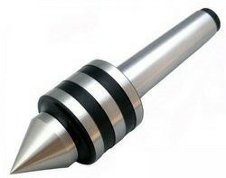
State the name of this tool.

Briefly describe the purpose of this tool.

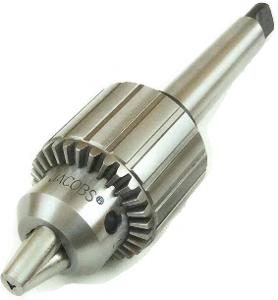
State the name of this tool.

Briefly describe the purpose of this tool.

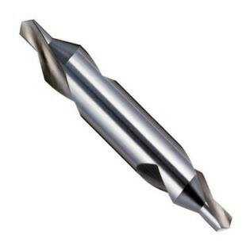
State the name of this tool.

Briefly describe the purpose of this tool.

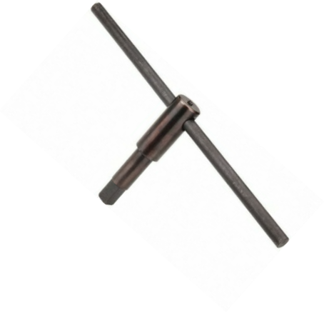

State the name of this tool.

Briefly describe the purpose of this t

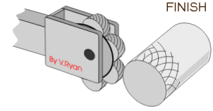
Describe two methods of checking your tool is centred.

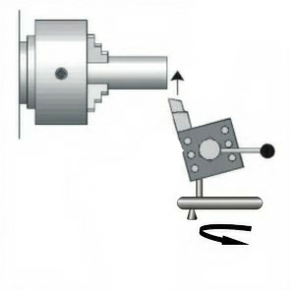
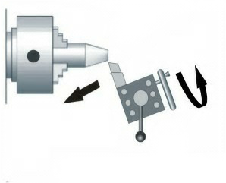
State the name of this process.

Briefly describe the purpose of this process.

Name of the wheel used to complete. State the name of this process.
Briefly describe the purpose of this process.

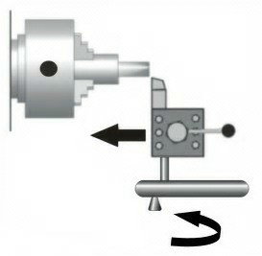
Name of the wheel used to complete. State the name of this process.
Briefly describe the purpose of this process.

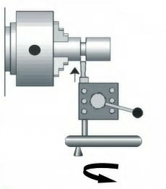
Name of the wheel used to complete. State the name of this process.
Briefly describe the purpose of this process.

Name of the wheel used to complete.

State the name of this process. Briefly describe the purpose of this process.

Name of the wheel used to complete.

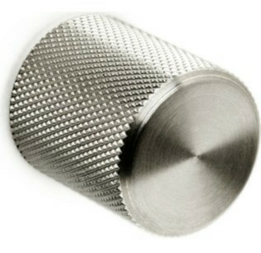
State the name of the defect shown. Explain how this defect is created.

State the name of the textured pattern shown. State a reason for adding a textured pattern.

Describe two adjustments which need to be made to the centre lathe before creating the textured pattern.

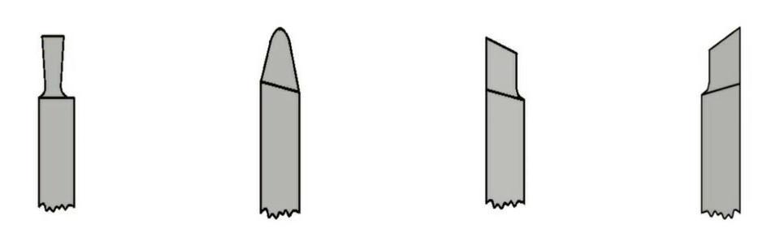
Identify the commonly used centre lathe tools.

A B C D

A B
C D

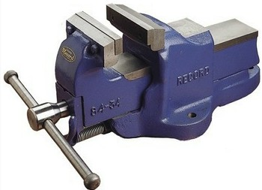
Vices

Identify the vices shown below.

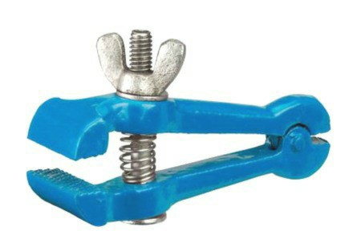
1 2

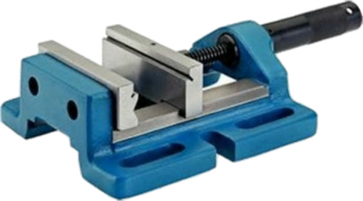
3 4 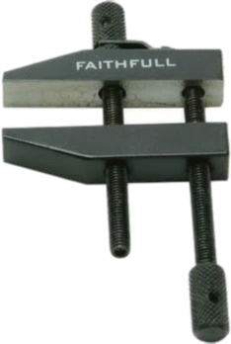

Describe the purpose of each vice shown above.

1

2

3

4

On vice 2, what should be added to the jaws when holding ‘softer’ material.

Explain the purpose of doing this.

Heat Treatment

Explain what the term ‘cold worked’ means.

Explain what the term ‘heat treatment’ means.

Describe how the process of ‘work hardened’ works.

The process of work hardened can result in breaking. State a method of how to prevent this.

Describe the process of ‘annealing’ metal.

What would you apply to the surface of aluminum to check the correct temperature has been reached.

Describe the process of ‘tempering’ metal.

Explain why mild steel cannot be hardened and tempered. How is this resolved.

Explain the property ‘malleability’.

Explain the property ‘ductility’.

Explain the property ‘toughness’.

Explain the property ‘brittle’.

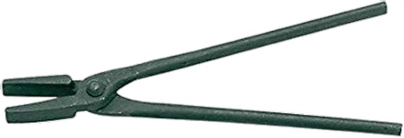

State the name of the tool shown above. Describe the purpose of this tool.

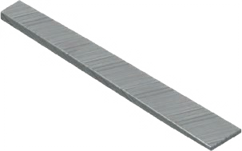
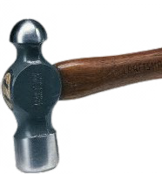
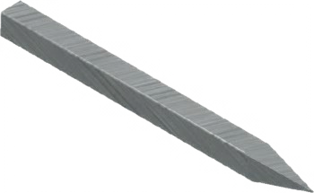
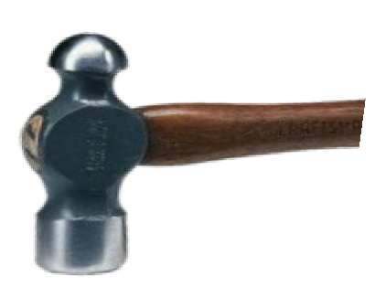
State the name of the process being shown.

Describe how this process is formed.

State the name of the process being shown.

Describe how this process is formed.

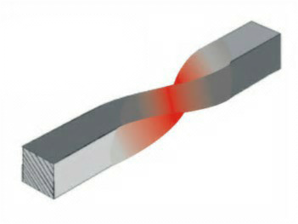
State the name of the process being shown.

Describe how this process is formed.

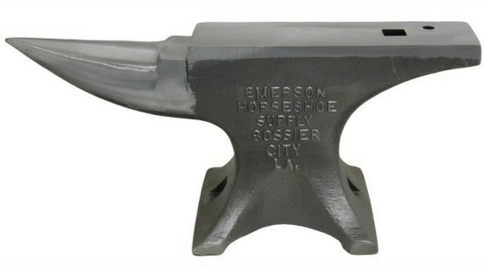
State the name of the tool shown.

Describe the purpose of this tool,

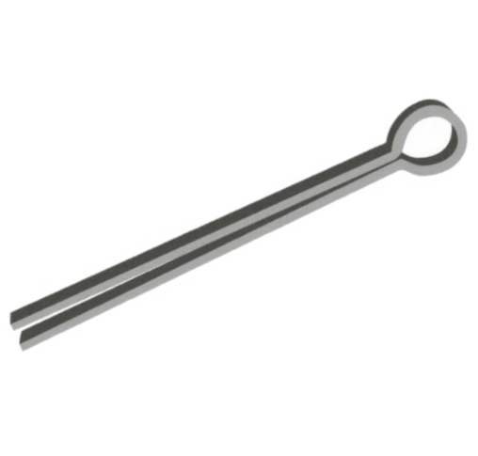
Folding Metal

State the name of the tool shown

The purpose of this tool is

What other tools would be required to use this tool correctly.

Describe how you would set up to use this tool.

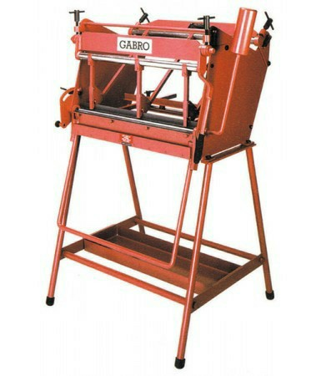
State the name of this tool.

Explain the purpose of this machine.

State two adjustments which could be made to this tool.

Hammer/Mallet

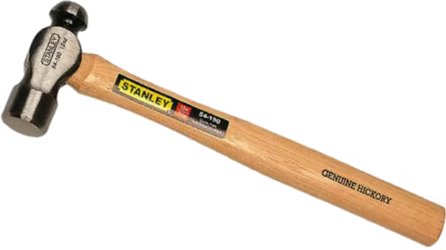

State the name of the Hammer shown above

The purpose of this tool is

Describe how you would use each side of this hammer.

Describe how you would adjust your grip on the handle for power an
d precision.

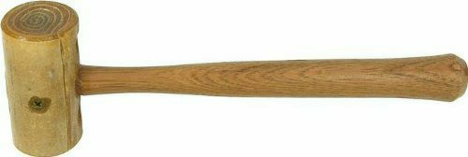

State the full name of the mallet shown above

The purpose of this tool is

Describe why you would use this mallet instead of a hammer.

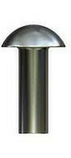
Fixings - Rivets

Explain the term ‘riveting’.

Identify the types of rivets shown below.

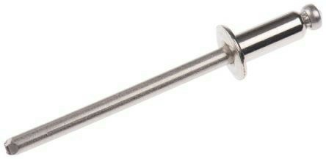

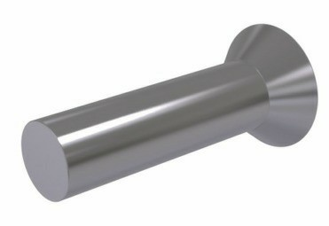
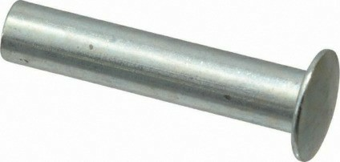

Explain why the rivet should be the same material as the object it is joining.

State how you would identify the appropriate type of rivet to use.

Identify the tools shown below.

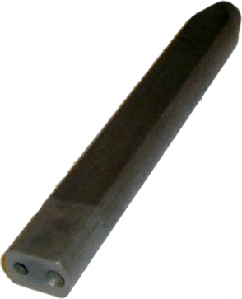
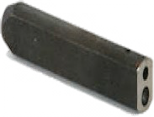
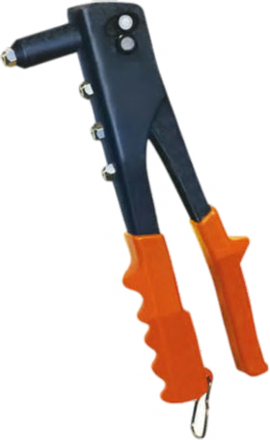

Describe how you would form and secure a snap head rivet. Use sketches to support.

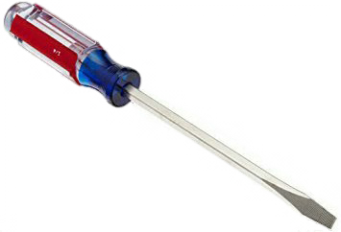
Screwdrivers
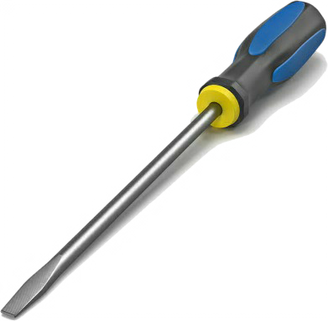

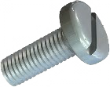

State the name of the tool above

Describe the purpose of the tool.

Describe a disadvantage of this type of screwdriver.

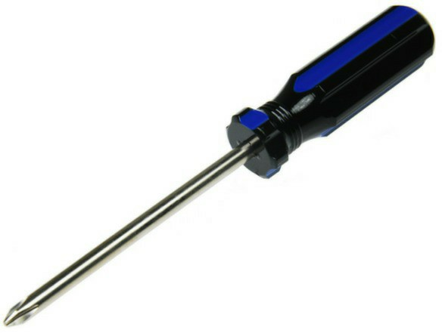
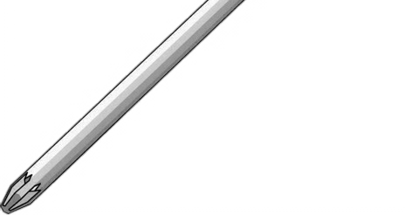
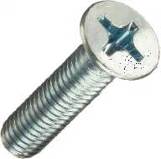

State the name of the tool above

Describe the purpose of the tool.

Describe an advantage of this type of screwdriver.

Thermal Joining

.

made to this machine.

Describe the process of welding.

Describe the process of soldering.

Describe the process of brazing.

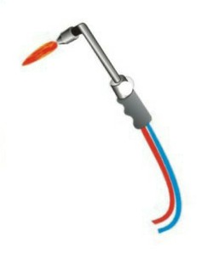
State the name of the tool shown.

What PPE is mandatory using this tool.

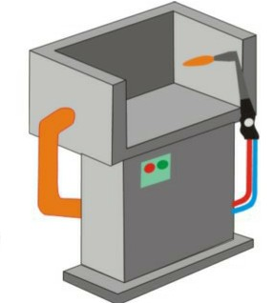

State the name of the tool shown.

What health and safety considerations are required when use this tool.

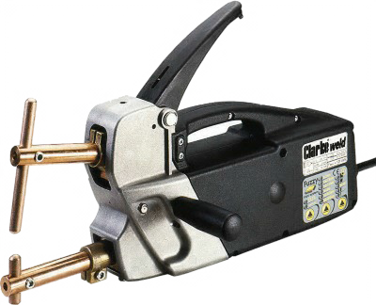

State the name of the machine shown State two adjustments which can be

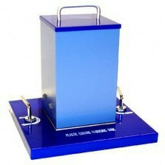
Metal Finishes

Describe the purpose of applying a finish to metal.

State an advantage of using paint as a finish.

Describe the process lacquering metal.

State an advantage of using lacquering as a finish.

Describe the process bluing metal.

State the name of the tool shown.

Describe how this process works.

Describe the stages of prepping sheet metal for applying a finish.

