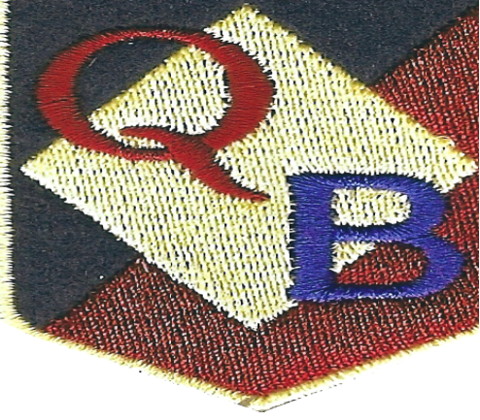
Starting School Handbook
Quarry Brae Primary School

Introduction
We would like to welcome you as a parent/carer of a child about to start at Quarry Brae Primary. This is an exciting time for children, parents and school staff alike. We look forward to working in partnership with you in providing your child with an effective, stimulating and enjoyable learning experience. The purpose of this handbook is to help ensure that your child experiences the best possible start at Quarry Brae and to answer any questions that you might have.
We aim to make your child’s transition to school as smooth and happy as possible. If you require any further information, then please do not hesitate to get in touch.
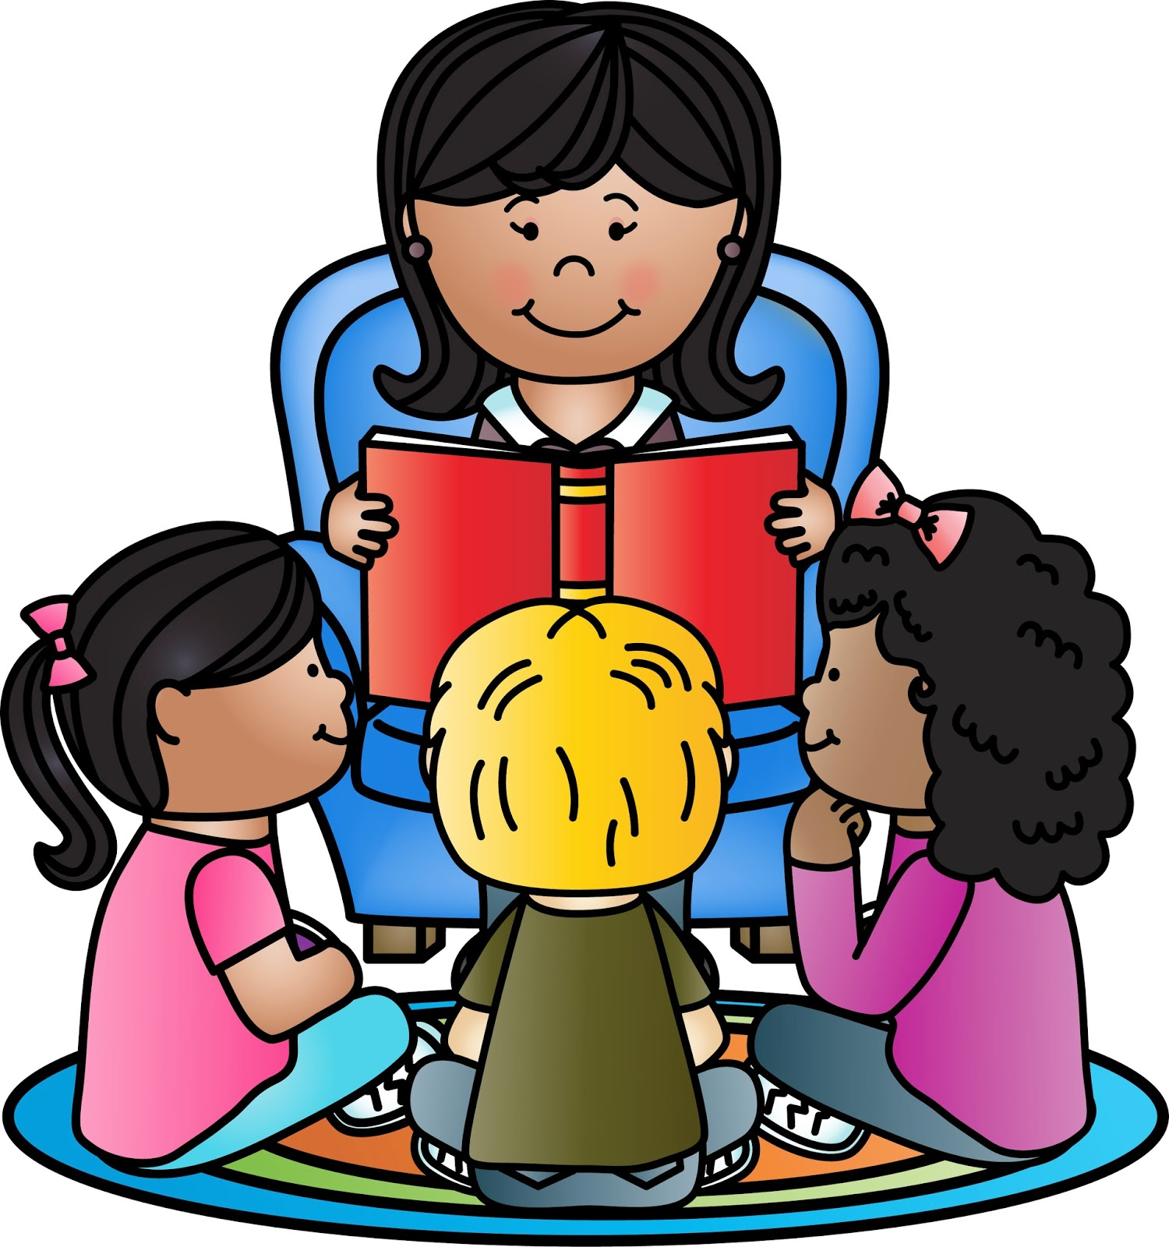

Contact
Quarry Brae Primary School
61 Crail Street
Glasgow
G31 5AL
Tel: 0141 554 1781
Email: Headteacher@quarrybrae-pri.glasgow.sch.uk
An Average School Day
First Week of School
Children will start school on 17th August at 9:30am. They will enter the school through the gate at Crail Street where school staff will greet them. They should not come into the playground before 9:15am as it will be very busy with older children. They will finish at 2:45pm and be collected from the gate at Pharonhill Street (beside the football pitch). Please wait on Pharonhill Street and do not enter the playground area.
This will be the same on 18th August, starting at 9:30am and finishing at 2:45pm.
From Friday 19th August onwards, children will start at 9:00am and finish at 3:00pm.

9:00-10:30am
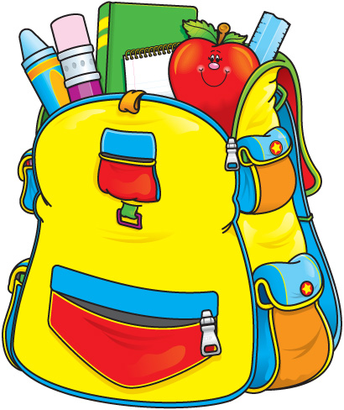
Children will be greeted at the gate by a member of staff from 8:45 onwards, we ask parents to avoid entering the playground. Occasionally children may be upset separating from their parent, and staff would support the child to do this. At 9am the bell will ring, and children will line up in their designated space. The class teacher will greet the children and bring them into the cloakroom area outside their classroom. Pupils hang up bags and jackets, change their outdoor shoes into their indoor shoes (which are kept in their shoe box in the cloakroom). Pupils bring their homework bags into the class. The children will begin their day with the register, and a discussion about the day to come and then begin their tasks including play based learning.
Pupils will then get changed and ready to go out to the playground for their interval at 10:30am.
10:30-10:45am
Pupils take their snacks into the playground. Support for Learning Workers will supervise children in the playground. We do not allow bottles into the playground.
10:45am-12:15pm
The children will participate in class tasks, play and direct teaching during this time. There will be regular brain breaks to give the children a chance to release energy and to calm down.
12:15-1:00pm
Pupils get changed and go to the dinner hall for lunch. Class teachers will explain what the choices are for dinner. Pupils collect their lunch from the counter and sit beside their friends to eat it. When they are finished, they tidy up their space and then go out to play.
1:00-3:00pm
The afternoon session is busy with children taking part in several activities including tooth brushing. We get ready and leave for home at 3:00pm. Pupils who go to after school care go to the office, whilst the rest of the pupils line up and are escorted to the gate at Quarrybrae Street. We take home our homework bags every day.

It can be very busy at the gate at 3pm and we appreciate that families can be anxious to collect their children and leave as quickly as possible. We ask that you wait until the class teacher calls for you to collect your child. If someone else will be collecting your child, then please let the school know as soon as possible.
Healthy Eating at Quarry Brae Primary School
Breakfast Club
A breakfast service is available each school morning between 8:15am and 8:45am. The service offers all pupils who attend a healthy breakfast in a warm, safe environment. Pupils can choose cereal or toast, milk or fruit juice. After breakfast club, pupils are taken outside for a run around before school starts. They are supervised at breakfast club by one of our dinner supervisors.
Fuel Zone (School Lunch)
Information all about the menus on offer, information on nutrition and downloads can be accessed at http://www.fuelzoneprimary.co.uk/index.php
The menu on offer each day included a Standard, a Halal and a Vegetarian choice along with sandwiches and rolls. Pupils can also pick and mix at the fruit and salad bar. A milk carton is offered to all pupils.
Parents who receive income support may be eligible for free school meals and clothing grant for their child. Please see the office for information on applying for this. Currently all P1 children receive a free school meal, we will keep you informed should this change. Pupils who wish to bring packed lunches will be accommodated and supervised in the dining hall.
Lunches need to be ordered in advance for all children getting a school meal via Parent Pay. Details on this will follow.
Refresh - Water
We have fresh,chilled water available for all children. They are given access to this throughout the day. Children are encouraged to bring in a refillable bottle every day. In line with council policy, we do not allow the children to drink juice or flavoured water. Children will be allowed to access water during lessons; each teacher will make their own arrangements for how to facilitate this.
Glasgow Kidz Card
Children aged between 5 and 11 can apply for a Glasgow Kidz Card. Forms can be obtained from the school office. A kidz card has many benefits including:
- Free entry to Take 2 screenings.
Further information can be found https://www.glasgowlife.org.uk/young-glasgow/glasgow-kidz-card


House system
We voted as a whole school to introduce a house system. Your child will be placed into one of our four team which are Bottle Nose Dolphins, Golden Eagles, Red Deer, Red Squirrels. Our houses represent native Scottish wildlife. The pupils at Quarry Brae love being in these houses and are encouraged to win house points. Each term, the house with the most points wins a special treat.
Homework
Reading books are sent home regularly in a special homework bag that the school provides for P1 pupils. Please encourage your child to take care of their book and return it to school each day. Pupils will be set different tasks such as revising the sounds they have been learning in class. Teachers will use the Seesaw app to set homework tasks.
The class teacher will include information on homework in the termly Curriculum Newsletter.

Primary 1 Calendar
Primary 1 is a very busy year for our young people. You will be informed via school newsletters and class curriculum newsletters of any important information and events.
August – Photo taken for the Evening Times
October – Holiday and Halloween
November- Scottish Book Week
December – Christmas Party and Nativity




Buddies
Primary 6 pupils are matched to children enrolling at Quarry Brae in March. The P6 pupils take part in a Buddy Training Programme where they learn about the importance of supporting the new pupils. They write to their buddy and visit them in their nursery. When your child starts school, their P6 buddy will be available in the playground to help them. This programme is very successful. It encourages our P6 pupils to be responsible and caring for younger pupils and gives our new pupils a friendly face in the playground.

School Staff

Head Teacher: Mrs Sara Adam
Depute Head Teacher: Ms Nancy Porteous
Principal Teachers: Mrs Sandra Smith
Miss Louise Bremner

P1a – Miss Lorna Smith
P1b– Mrs Libby Young

Clerical – Mrs Hazel Anderson
Mrs Karen Murray

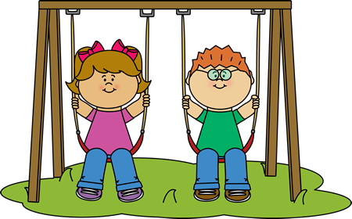

Uniform
At Quarry Brae Primary School we have a school dress code.
We ask that our pupils wear:
Black trousers or skirt
Blue or yellow polo shirt
Navy blue sweater

For P.E. pupils should have:
T-shirt
Jogging Bottoms or shorts
Pupils need to have a change of shoes for when indoors. This is because we are in a new building. We recommend soft black plimsoles.

All items should have your child’s name written clearly on them. It can be very difficult for a teacher to match every child in the class with the items they brought to school if their name is not on it. Remember there may be 20 other children with the same jumper in the class that day.

Pupils need to have a change of shoes for when they are indoors, these need to be suitable for P.E and so should not be slippers or ballet style shoes.


Special Events in the School Year
We have lots of special events in the school year and you will be informed about them through Mrs Adam’s newsletter or class Curriculum Newsletters.
These events include trips, non-uniform days, Scottish Week, Money Week, Comic Relief, Visitors to the school, Nativities, Parties and House Prizes.

Top Tip
Start practising trying on/ changing school clothes now. Practise getting a jumper on and off without adult help.
If your child cannot tie their own laces, avoid choosing shoes for school that need to be tied. Check that they can easily manage to get their shoes on and off as they will do this many times a day.
We recommend avoiding school ties on gym days too!
Quarry Brae Curriculum
At Quarry Brae Primary we follow the Curriculum for Excellence. Within this framework, education in Scottish schools is divided into 8 key curricular areas.
The eight curriculum areas are:
Literacy
Numeracy
Health and Wellbeing
Social Subjects
Technologies
Science
Expressive Arts
Religious and Moral Education

The curriculum also divides its experiences and outcomes into clear levels. The levels are:
Early: Pre-school and Primary 1
First: By the end of Primary 4 but may be earlier for some
Second: By the end of Primary 7 but may be earlier for some

More information on a Curriculum for Excellence can be found at https://education.gov.scot/parentzone/learning-in-scotland/curriculum-areas/
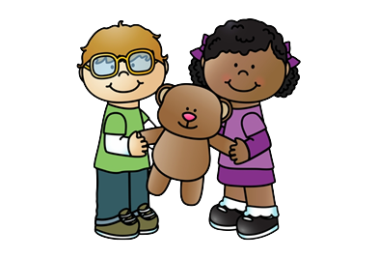


Term Dates 2022-2023
August
- Monday, 15 August 2022 (Return date for Teachers & In-Service Day)
- Tuesday, 16 August 2022 (In-Service Day)
- Wednesday, 17 August 2022 (Return date for Pupils)
September
- Friday, 23 September and Monday, 26 September 2022 (September weekend holiday)
October
- Friday, 14 October 2022 (In-Service Day)
- Monday, 17 to Friday, 21 October 2022 (October Week)
December - Christmas and New Year
- Schools close at 2.30 pm on Thursday, 22 December 2022
- Friday, 23 December 2022 - Tuesday 3 January 2023 (Christmas holidays)
January
- Schools return on Wednesday 4 January 2023
February mid term break
- Monday, 13 February 2023
- Tuesday, 14 February 2023
- Wednesday, 15 February 2023 (In-service day)
April - Spring Holiday (Easter)
- Schools close at 2.30 pm on Friday, 31 March 2023
- Monday, 3 April - Friday, 14 April 2023 (Spring Break)
- Schools return on Monday, 17 April 2023
May
- Monday, 1 May 2023 (May Holiday)
- Thursday, 25 May 2023 (In-service day)
- Friday, 26 May 2023 and Monday, 29 May 2023 (May Weekend)
June
- Schools Close at 1.00 pm on Friday 23 June 2023

