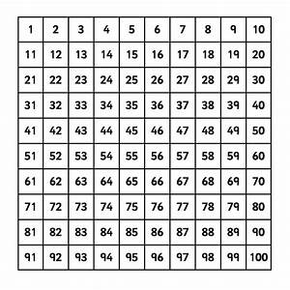
Number of the day:

Find it on the 100 square:

What is 1 more? What is 10 more?

What is 1 less? What is 10 less?

Show the number using the ten frames:

Odd or even?

Hundreds | Tens | Units
Draw it:

