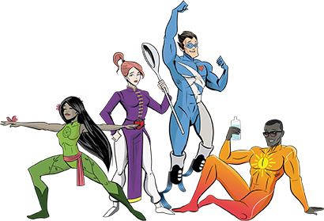
Health Learning Grid

Imagine you could make the healthiest smoothie ever! What healthy fruits and things would you put in it? Give your smoothie a name, write a list of the ingredients and then draw a picture to share with others! | Agent Lifestyle loves being outdoors enjoying the fresh air. Can you design a new pair of sunglasses for him? Remember he thinks he looks pretty cool. | Make a list of 10 different feelings. Can you create an emoji to show each feeling? | Eating the right food, sleeping well and exercising are all important things to keep our heart healthy. Draw a heart outline then draw some things that help our heart inside. Stick the picture up somewhere to remind everyone.
How many bones in your body can you learn? Try and find the proper name for them e.g. back/spine  Have a family sing-along to Heads, Shoulders, Knees and Toes  (no cheating on the toes part!) | Practise the Mindset Warrior pose. Can you teach someone in your family how to do it? Try and create your own yoga type pose, think about how you would breathe, it should make you feel calm and relaxed. | Practise your stamina by creating your own relay task e.g. put some household things in a pile then from a starting point run,jog,skip… to collect them one at a time until you have all the items with you at the starting point. Ask someone to time you, can you get quicker at it? | It is important to keep hydrated- can you remember the foods and drinks that are good for this? Keep a weekly diary of how you keep hydrated. You could make a tick sheet or draw pictures beside the name of each day.
Sleep is really important- try not to stay up too late or spend too much time using technology. Draw and/or write a bedtime story that would help a little child get to sleep. | We know laughing is really important for our health. Can you make up a story, picture and/or joke that would make someone in your house laugh! | What is in our food? Choose some food items in your house and look at the ingredients on the label.  Can you find any items that have the same ingredient? | Make a Thank You card for someone in your house. It is easy to take our special family people for granted, let them know you love them and thank them for what they do.

