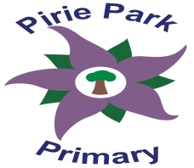
P1-3 Spelling Programme

At Pirie Park Primary we aim to ensure children can confidently read and spell common words.

Red

the and a to in it he was they had said made I on at

Black

up down get for with this her him of were out into go over is you are as his that be have from me my by she we all

Bronze

or one word many not what we when your can there use an each which do how their if

Silver

will other about then them these so some would make like time has look two more write see

Gold

number no way could people than first water been call who oil now find long day did come may part

(P2s have been focusing on red to bronze words and recently started to practise silver words. They could also look at gold words too.)

(P3s can practise from all lists)

