Advanced Higher Music

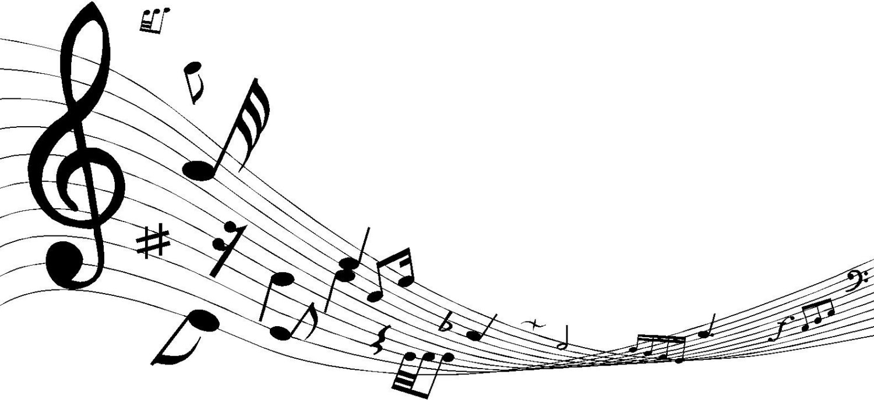Revision

**Useful links:**

<http://www.dunblanehsmusic.co.uk/sqa-past-papers.html>

<http://www.educationscotland.gov.uk/nqmusic/advancedhigher/allconcepts.asp>

HIGHER

<http://files.snacktools.com/iframes/files.edu.flipsnack.com/iframe/embed.html?hash=fzk52nj1&wmode=opaque&forceWidget=1&t=1457730457>

<http://paisleygrammarschool.flipsnackedu.com/browse/fu82za03>

<http://paisleygrammarschool.flipsnackedu.com/browse/fzhne9mh>

AH

<http://paisleygrammarschool.flipsnackedu.com/browse/fup0o58p>

<http://paisleygrammarschool.flipsnackedu.com/browse/fum0r8fn>

**Medieval Period (500–1400)**

Music mainly for the church (sacred), mainly vocal music as not a lot of

instruments invented yet.

**Plainchant** – Monks singing Latin text - unaccompanied – unison - no regular metre (set beats in a bar) the chant follows the natural rhythm of the text.

**Mode/Modal** – Not major or minor – also used in Jazz and pop music.

**Renaissance (1400 – 1600) & Baroque Periods (1600 – 1760)**

Non-religious (secular) music began to flourish, in particular instrumental music. Harpsichord (Basso Continuo) and Organ are now prominent.

Polyphonic texture & lots of string instruments. Complex, flowing melody lines weaving independently.

**Basso Continuo** - Harpsichord and Cello playing bass line and harmonies/chords

**Concerto** - Music for soloist accompanied by an ORCHESTRA

**Concerto Grosso** – Piece for Small Group of Soloists (Concertino) and Orchestra (Ripieno

**Concertino** – Small group of soloists in Concerto Grosso

**Ripieno** – Accompanying Orchestra in Concerto Grosso

**Ritornello** – Section of music which returns again and again.

**Passacaglia** – Variations over a ground bass.

**Obbligato** – A prominent solo instrument part in a piece of vocal music.

**Da Capo Aria** - Aria (solo song) in ternary form (ABA) – repeats first section with added embellishments.

**Mass** – sacred choral work, Latin text, polyphonic texture (further developed in the classical period)

**Oratorio** - a story from the Bible set to music for soloists, chorus and orchestra. Religious version of opera - includes recitatives, arias and chorus.

**Classical Period (1730 – 1800)**

Music is simple, melodic, mainly homophonic (melody & accompaniment), very structured, orchestra still small but now includes the horn, trumpet, clarinet, flute and oboe. Piano main keyboard instrument (no harpsichord).

**Symphony** – Large piece of Music for the whole orchestra.

**Sonata** – Music for soloist accompanied by a PIANO (or for solo piano)

**Coloratura** – florid vocal singing involving scales, runs and ornaments where there are a number of notes sung to the one syllable (melismatic)

**Sonata Form** - structure of the first movement of many sonatas – 3 sections:

Exposition, Development, Recapitulation.

**Exposition** - This describes the first hearing of the 'theme' and is normally associated with compositions structured in sonata form

**Subject** - The main theme in a composition. This then could be the main theme in Sonata form.

**Chamber Music** - classical music that is composed for a small group of instruments.

**Piano Trio**

**String Quartet** - A chamber music ensemble made up from two violins, one viola and one cello.

**Romantic Period (1800 – 1910)**

Dramatic contrasts, chromaticism (sharps and flats), use of discords, much larger orchestra, increase in emotion of music, wide breadth of dynamics.

**Lied** – works for solo voice and piano. German text - voice and piano are equally important.

**Modern Period (1910 – present)**

Very varied, experimental, innovative, individual, explorative &

imaginative.

**Impressionism** – Music creates blurry impression, uses whole tone and

chromatic scales.

**Jazz Funk** – Cross between Jazz, Rock and Funk.

**Musique Concrete** – Recorded natural sounds which are transformed using simple editing techniques.

**Soul Music** – Combination of R&B and Gospel which began in late 1950s. Features vocals, piano, drums, guitar, bass, trumpet & saxophone.

**Time Changes** - changing time signatures frequently in a piece of music.

**Other Higher Concepts**

**Augmentation** – Notes of a melody are doubled in length.

**Diminution** – Notes of a melody are halved in length.

**Through Composed** - A vocal/choral composition in which there is little or no repetition in the musical structure i.e. where the composition is not structured as verse / chorus.eg. Bohemian Rhapsody – (opposite of

Strophic)

**Harmonics** – very lightly touching a string when you play it. On bowed instrument this will sound high pitched ad eerie. On Guitar or Harp it sounds bell like.

**Tremolando** – rapid movement of the bow on same note for strings or between 2 notes a distance apart for other instruments (not the same as a trill).

**3 against 2** - One line of music may be playing quavers in groups of two whilst at the same time another line of music will be playing triplets.

TANGO Vs STRAWBERRY at the same time.

**Irregular Time Signatures** - the music does not naturally fall into equal groupings eg. 7/4 or 5/4 instead or 3/4 or 4/4.

**Interval** – Distance between 2 notes eg C- G = 5th, F-A = 3rd

**Advanced Higher Concepts**

***STYLES***

**Renaissance** - means 'rebirth' and marks a period in history where there was a resurgence of interest in music based on the ideas of the ancient Greeks and Romans.

**Pavan** - A Renaissance court dance linked with the galliard. Slow, stately dance with 2 beats in the bar.

**Galliard** - A Renaissance court dance which follows the pavan. Quick and Lively with 3 beats in the bar.

**Motet** - A sacred choral work from the renaissance period with Latin text and polyphonic texture, usually sung a cappella.

**Madrigal** - A non-religious work from the renaissance period, polyphonic in style, using imitation.

**Ayre/Air** - Song or simple melody, sometimes the title of a movement of a suite.

**Anthem** - Short sacred choral piece sung in English. Sometimes sung by a choir unaccompanied and sometimes accompanied by organ, featuring solo parts.

**Ballett** - A type of madrigal in strophic form which was originally danced to.

**Neo-classical** - From about 1929, composers reacted against Romanticism returning to the structures and styles of earlier periods, combined with dissonant, tonal and even atonal harmonies.

**Serial** - A 20th-century method of musical composition invented by Schoenberg in which the 12 notes of the Chromatic scale are organised into a series or tone row.

**Chorale** - A German hymn tune, written in four parts for soprano, contralto (alto), tenor and bass.

**Nationalist** - Music which incorporates elements of folk music of the composer’s country.

**Electronic dance music** - normally heard in clubs where the DJ combines tracks electronically into one smooth mix. It can encompass music of different genres including house music, dubstep, drum and bass.

**Contemporary jazz** - an umbrella term for all kinds of jazz music being played now - as well as jazz music of the 80s, 90s, 00s & 10s.

***MELODY/HARMONY***

**Appoggiatura** - An ornament which sounds like a leaning note, takes half the value of the main note which follows it or two-thirds if the main note is dotted.

**Turn** - Four notes which turn round the main note with the note above, the main note, the note below, and the main note again.

**Suspension** - This effect occurs when a note from one chord is held over to the next chord creating a discord, and is then resolved by moving one step to make a concord.

**Tritone** - Interval of an augmented 4th, eg C–F sharp or F–B. It is made up of three whole tones.

**Polytonality/bitonality** - The use of two (bitonality) or more keys (polytonality) played or sung at the same time.

**Tone row/note row** - An arrangement of the 12 notes of the octave which forms the basis of a composition.

**Augmented triad** - This chord is formed by a major triad in which the 5th degree is raised by a semitone

***RHYTHM***

**Hemiola** - A rhythmic device giving the impression of a piece of music changing from duple (2) to triple (3) time, or vice versa.

***TEXTURE/STRUCTURE/FORM***

**Fugue** - A contrapuntal piece based on a theme (subject) announced in one voice part alone, then imitated by other voices in close succession.

**Subject** - The main theme in a composition, the main themes in sonata form, or the main theme on which a fugue is based.

**Countersubject** - In a fugue, after the subject or answer is played, the continuation of that same instrument or voice is called the countersubject.

**Answer** - In a fugue, after the subject is played, the same tune appears in another voice or part in the dominant (a 5th higher or a 4th lower). This is called the answer.

**Stretto** - Where voices or instruments enter very quickly one after the other, as in fugue.

**Antiphonal** - Dialogue between voices or instruments - one group of voices or instruments answers the other.

**Bridge** - A link between two themes.

**Leitmotiv** - A theme occurring throughout a work which represents a person, an event or an idea, etc.

**Inversion** - When a musical shape is mirrored; an inverted chord is formed when a note other than the root is in the bass.

**Retrograde** - To go backwards; a melody or a section of music can be written or performed from the end to the beginning.

**Song cycle** - A group of songs linked by a common theme or with a text written by the same author, usually accompanied by piano but sometimes by small ensembles or full orchestra.

***TIMBRE/DYNAMICS***

**Consort** - Dance-like in style; this music could be played by solo instruments such a lutes, harpsichords or virginals, by small groups of instruments of the same family or a group of varied instruments from different families.

**Countertenor** - A male adult voice whose range is higher than a tenor's.

**Sprechgesang** - A technique used in vocal music where the singer is required to use the voice in an expressive manner half-way between singing and speaking.

**Piano trio** - A piano trio is a chamber music ensemble comprising of three instruments; the most common form comprises of a piano, violin and cello.

Transposition

