
6
Physical Education
Physical Activity
School Sport


PEPASS PRIMARY SWIM PROGRAMME 2025 / 2026


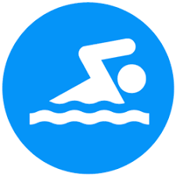
STROKE TECHNIQUE DEVELOPING MOTOR-SKILLS, CO-ORDINATION AND FLUENCY
SWIM SCHOOL
6497
PUPILS
WATER SAFETY DEVELOPING THE UNDERSTANDING THAT SWIMMING IS A LIFE-LONG SKILL
PHYSICAL FITNESS DEVELOPING STAMINA, CORE STABILITY, AND STRENGTH

WATER CONFIDENCE DEVELOPING CONFIDENCE AND SELF ESTEEM

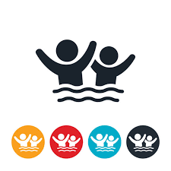


All pupils improving their water confidence
@PEPASSswimteam

17.8 (4-25)
Average Class Size
365
Total number of Classes
8.6
Average Number of Sessions
25M Swim 2307 (45%)
15M Swim 752 (14%)
10M Swim 799 (15%)
3M Swim 1366 (26%)
Week 10 101101010101010
1273 (20%)
Non-Swimmers
5224 (80%) Swimmers
3,176 (49%)
Non-Swimmers
3,321 (51%) Swimmers
Week 1

